

**GANGSTA**

**Review**

**1. Factoring**Remember the following rule and work through the linked worksheet.

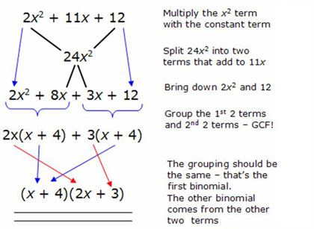

<http://chatfield.k12.mn.us/Math/DConway/Lists/Algebra%20II%20Assignments/Attachments/12/5.2.3%20-%20Factoring%20Quadratic%20Expressions.pdf>

**2. Graphing Polynomial**

Take a graph paper, graph the following functions.

a. f(x)=x3+9x2+15x-25

b. f(x)=x3-3x2-9x+27

c. f(x)=2x3-7x2+2x+3

**3. State a possible function for the following graph.**

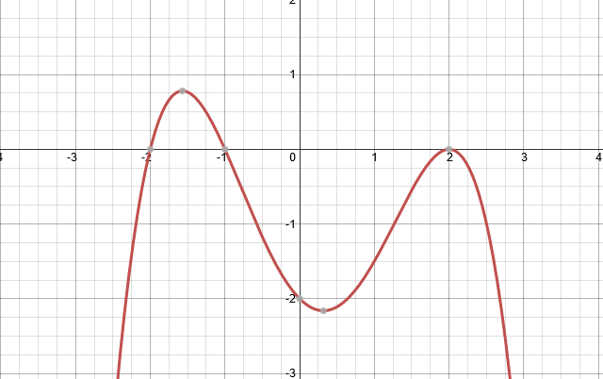

**4. Vertical Asymptotes.**

State the vertical asymptotes of the following functions, if they exist.

a. f(x) = 1/(x+1)

b. f(x) = 2/(x2+4)

c. f(x) = 3/(x3+1)

d. f(x) = x/(x2+4x+3)

e. f(x) = 1/(x2+1)(x-3)2

Remember this:

Limits: What does the value of f(x) approach as x approaches a value?

Remember that for now. We will go more in depth into this as we learn about limits in another unit.

Next Lesson we are going to look at vertical and horizontal asymptotes closely, if we have time we will look at how to determine when are polynomials positive and negative. Which is an extension of last tutorial. You will need to be familiar with factoring and long division, which is already done in this worksheet. Since no prior practice is needed, I’ve included this image of a dancing squirrel.

