Review Practice Package.

0. Solve system of equations.

1. Factoring. (factor the following equations and solve for X)

2. Radicals and Exponents

3. Simple Graphing

4. More Complex Graphing(polynomials)

5. Even More Complex Graphing

6. Generate a function from a graph.

0. Solve system of equation. Solve for x and y and z   
(c is a bit hard, think about eliminating one of the variables)

1. 2*x* + *y* = 9  
   2*x* – *y* = 9
2. 12*x* – 3*y* = 6  
   4*x* – *y* = 2
3. 2x + y + 3z = 1

2x + 6y + 8z = 3

6x + 8y + 18z = 5

1. Factoring (factor the following equation and solve for the unknown variable if possible)

1. 9x2 + 30x =11
2. 4x2 – 8x = 6
3. 25x2 – 20x = - 4
4. x3 – 9x2 – 4x +18 = 0

2. Radicals and Exponents 🡪 Look up and practice tutorial 5 Problems.

3. Simple Graphing.

1. Graph $y=-x$
2. Graph $y=2y+4x-2$
3. Graph
4. Graph

4. More complex graphing.

1. Graph y=x3
2. Graph y=x3 – 9x2 – 4x +18
3. Graph y=
4. Graph y=(x+1) (x+2)3 (x+3)2
5. Graph y=x4

5. Even more complex graphing. D is difficult. The asymptote is a special one.

1. Graph $y=-1/x$
2. Graph $y=2x/(x+1)$
3. Graph
4. Graph

6. State a possible equation for the following functions.

1. 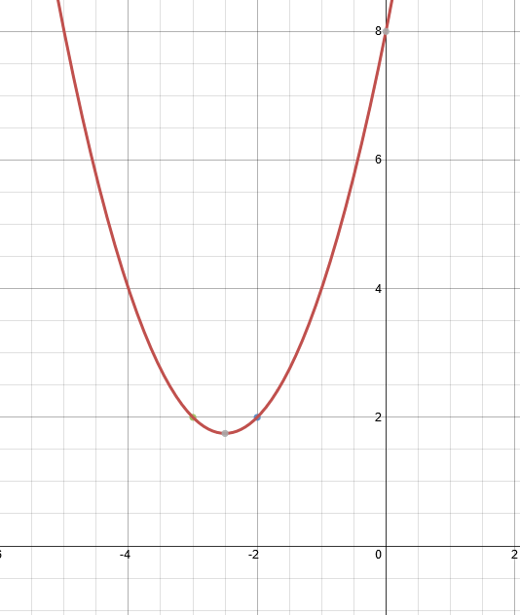

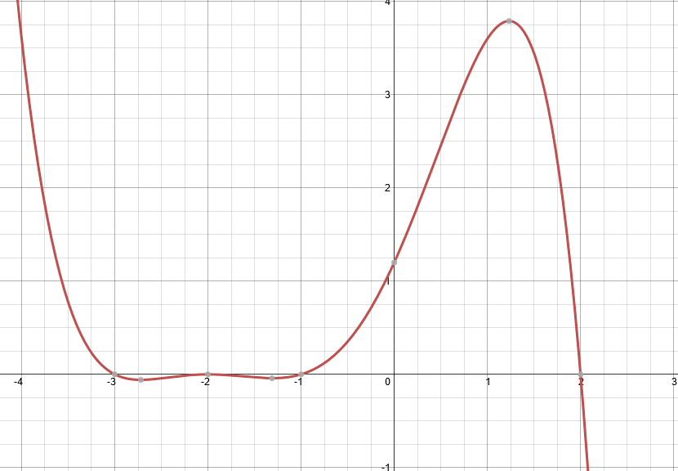

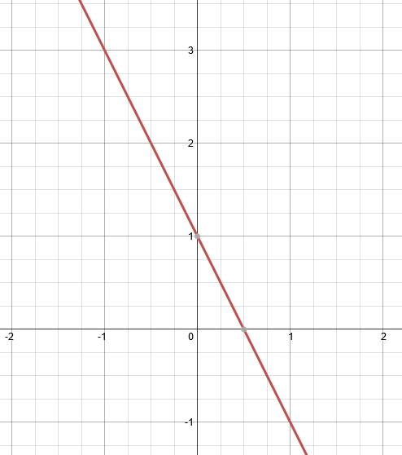

1. The vertical and horizontal line represent asymptotes.

