Kaylee Auguillard

Cheyenne Hathaway

Daniel Wright

ITAI 3377- Capstone Project

Spring 2025

**AI based Predictive Maintenance in IIoT**

**Introduction/Background**

Industry 4.0, known as the Fourth Industrial Revolution, drives the digital transformation of manufacturing through technologies like IIoT, AI, and edge computing. IIoT networks connect machines, sensors, and AI systems to optimize operations, reduce downtime, and improve decision-making. These networks are what enable the creation of smart factories, allowing for real time data analysis to assist in better and more efficient decision making. The integration of AI within IIoT systems is a growing area of focus due to its transformative potential.

**Problem Statement:** Traditional maintenance approaches in industrial settings (regardless of scale) are inefficient. Often there is a reaction to failures after they occur, rather than prevention, or maintenance too frequently, calling for work on machines before it is necessary. Both sides of this are costly both in terms of a decrease in production and the costs of maintenance and repair.

**Solution:** Predictive maintenance aims to resolve this by using data to anticipate issues before they lead to downtime. This will reduce costs, improve safety, and extend equipment life, making it crucial for sectors like energy, transportation, and manufacturing.

**Literature Review**

AI algorithms like LSTM (long short-term memory), CNNs, and autoencoders have been successfully used for tasks such as anomaly detection and RUL (Remaining Useful Life) prediction. These models leverage historical and real-time sensor data to make maintenance decisions.

* LSTM- a kind of RNN that is able to detect small changes over time. These models are trained on historic data, learning the patterns that indicate a future breakdown.
* CNN- Convolutional neural networks specifically look for visual indications of possible issues, such as rust, unusual build up, or even the misalignment of parts.
* Autoencoders- these give a summary of the data collected every second in a smart factory. They learn what the normal behavior of a machine is and indicate when something that is not inline with the norm happens.

As seen, each of these require large amounts of data. However, a major challenge is the lack of real-world labeled data, which limits model training and validation. Additionally, models often perform well in controlled environments but struggle when applied to different machines or industries. Some studies suggest using synthetic data and digital twins to augment training datasets. Others explore federated learning to improve model performance across multiple industrial sites while preserving data privacy, because only the insights of the locally collected data is sent for further analysis.

**Conceptual Architecture/Framework**A robust system for AI-based PdM involves data collection, transmission, processing, and decision-making—all working in real time. This framework emphasizes a modular, scalable design that can be adapted to various industrial contexts and budgets.

* **Data Acquisition:** Sensors monitor parameters like vibration, temperature, and current to detect early signs of failure. Edge devices preprocess this data to reduce noise and transmission costs while ensuring real-time responsiveness. This can also aid in security considerations as edge devices can be run locally prior to transmission to the cloud for further analysis.
* **AI/ML Processing:** AI models deployed on the cloud or edge platforms analyze incoming data streams for patterns indicating degradation or fault in real time. The choice between cloud and edge depends on factors like latency, bandwidth, and processing power, as well as the available budget.
* **Decision Support and Visualization**: The system generates actionable insights, such as predicting failure timelines or recommending specific maintenance actions. These are visualized through intuitive dashboards or integrated into maintenance scheduling platforms, so potential issues can be addressed prior to machine failures or production issues.
* **Feedback and Learning:** A feedback loop allows the system to refine predictions based on actual outcomes and operator feedback. This enables continual learning, ensuring the system adapts to new patterns as well as operational changes.

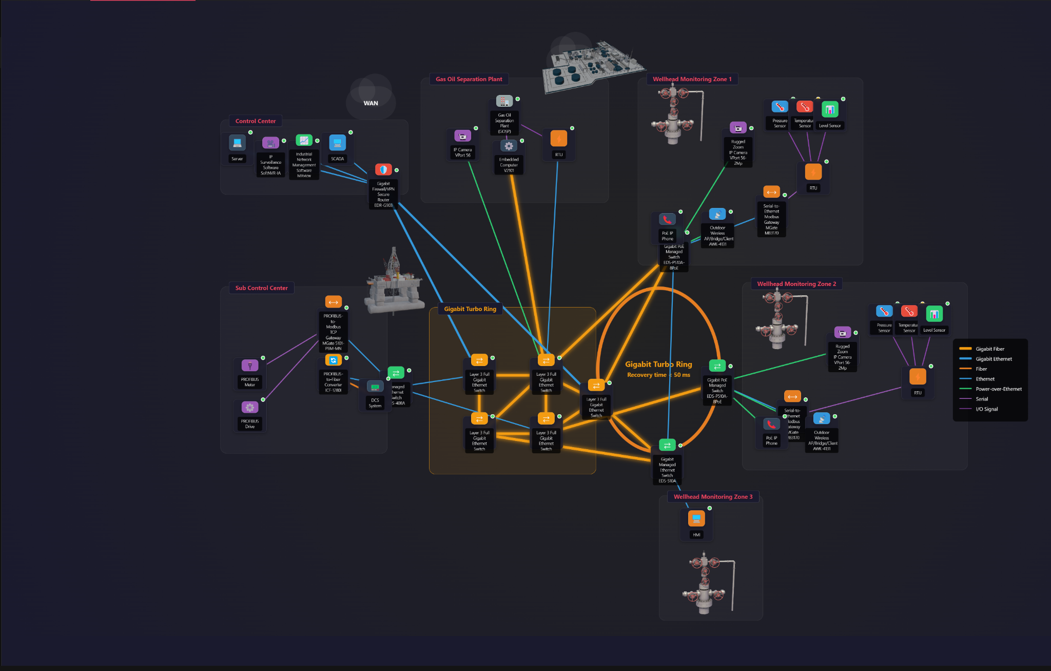

Here is a graph of how devices and sensors might send and receive data and other communications. This is also a good example of network segmentation, something we will discuss under security considerations. This is sourced from Daniel’s simulation at <https://odocha.ngrok.io/>

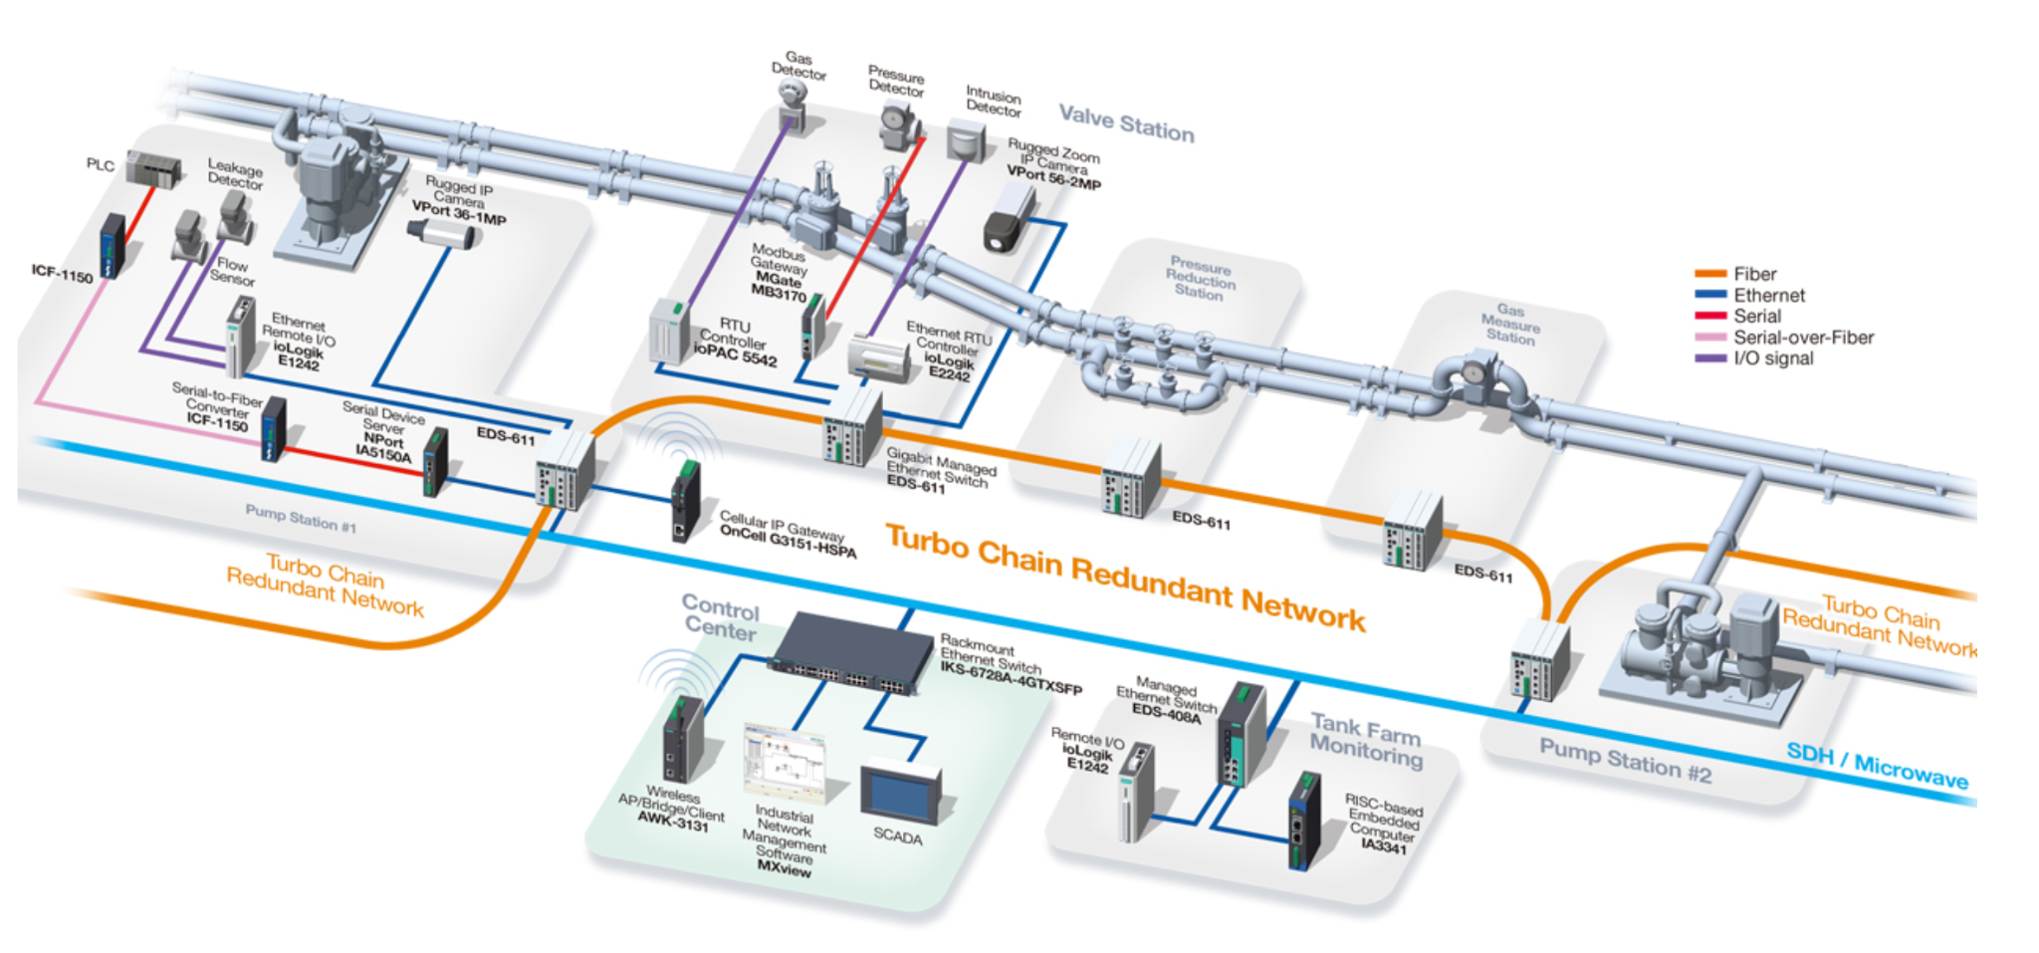

Here is another example from <https://www.s-connect-iberia.com/zeige_reddi_produkt.php?produkt_ID=57>

This also shows a possible set up, including sensors and more.

**Security and Ethical Considerations**

**Security Challenges**: IIoT systems are vulnerable to cyberattacks that can disrupt operations or manipulate data. AI models can also be fooled by adversarial inputs, causing them to make incorrect predictions. Here are a few ways to mitigate this:

* Zero-Trust Architecture: Every device and user request must be authenticated and authorized. Additionally, no person or device is allowed access to any part of the system unless absolutely necessary.
* Network Segmentation: Factory networks are divided into secure zones to limit the spread of attacks and limit unnecessary access.
* Secure Software Development: Regular firmware updates, strong password policies, MFA (Multi-Factor Authentication), and encrypted communication channels (VPN, SSL/TLS) should all be utilized.
* Secure AI Development: Protect models from adversarial attacks by validating input data sources and applying anomaly detection systems for malicious data patterns.
* A few other ways to keep the system secure include taking regular snapshots to revert back to in case of issues, as well as keeping the system and data local when possible.

**Ethical Issues**:

* Job Displacement: Automation of maintenance tasks could replace human roles, though these systems do still require human input, action, and intervention.
* Bias and Transparency: AI predictions must be explainable to avoid blind trust in incorrect outcomes. Models must consistently be assessed for bias and accuracy.
* Data Privacy: Industrial and operational data must be protected to prevent competitive or regulatory exposure.

**Feasibility Analysis**

* **Technical Feasibility:** Implementing predictive maintenance requires smart sensors, reliable edge devices, secure networking, and integration with existing ICS like PLCs and SCADA. Local edge processing reduces dependence on cloud reliability and protects confidentiality. These items and softwares are all readily available. Many are designed to integrate with existing systems, but if the existing architecture is over about 10 years old, there can be problems with compatibility.
* **Economic Feasibility:** Initial costs (hardware, AI training, cybersecurity) are high but can be offset by long-term savings through reduced downtime, fewer catastrophic failures, and better resource utilization. Data from smart factory studies show up to a 40% cost reduction in maintenance operations. It is also possible to slowly integrate many of the proposed technologies to aid in the initial costs. It is worth noting there are additional benefits in a slow transition, such as a decrease in machine downtime (as updates can be done in stages) and because it allows people to get used to new tech.
* **Scalability and Future Trends:**
  + Adoption of federated learning across industrial sites will enhance scalability while preserving data privacy.
  + Integration with digital twins will allow predictive maintenance simulations in virtual environments.
  + Future use of AI accelerators and private 5G will further enable real-time inference and broader deployment.

**Conclusion and Recommendations**

**Summary of findings**:

AI-based predictive maintenance in IIoT environments can drastically reduce downtime, optimize resource usage, and extend machine lifecycles. However, it requires robust security measures to ensure system integrity, continuous model updates, and ethical considerations in terms of the workforce. Additionally, it can be expensive to switch to this system, and depending on the age of the current system, it may not be able to integrate into it without drastic changes in equipment and software.

**Recommendations:**

* Build secure-by-design infrastructure with strong authentication and encrypted communication.
* Invest in continuous data quality management and explainable AI techniques.
* Create regulatory and compliance frameworks for ethical AI integration in industrial environments.
* Train employees in cybersecurity awareness and human-machine collaboration.
* A slow transition to a smart factory is recommended both due to costs and employee training.

**Future Research Directions:**

* Develop open benchmarks and datasets for industrial predictive maintenance.
* Explore lightweight AI models for edge deployment with limited compute resources.
* Analyze data of a smart factory compared to a traditional factory to accurately estimate the savings over time.

**Sources:**

* IBM. (n.d.). *What is Industry 4.0?* IBM. Retrieved April 28, 2025, from<https://www.ibm.com/think/topics/industry-4-0>
* Rutgers School of Engineering. (n.d.). *Industry 4.0 vs. 5.0: What’s the difference?* Rutgers School of Engineering. Retrieved April 28, 2025, from<https://engineeringmastersonline.rutgers.edu/articles/industry-4-0-vs-5-0-whats-the-difference/>
* Prakash, P. (2021, March 5). *Introduction to long short-term memory (LSTM)*. Analytics Vidhya. Retrieved April 28, 2025, from<https://www.analyticsvidhya.com/blog/2021/03/introduction-to-long-short-term-memory-lstm/>
* Shamsi, J. A., & Ajmal, A. (2024). *AI-powered predictive maintenance for industrial IoT systems*. ResearchGate.<https://www.researchgate.net/publication/380969569_AI-Powered_Predictive_Maintenance_for_Industrial_IoT_Systems>
* Neural Concept. (2023, November 22). *How AI is used in predictive maintenance*. Neural Concept. Retrieved April 28, 2025, from<https://www.neuralconcept.com/post/how-ai-is-used-in-predictive-maintenance>