**Assignment 1**

|  |  |  |  |
| --- | --- | --- | --- |
| **Course Title:** | Fundamentals of AI | **Course Code:** | CCAI-221 |
| **Weightage:** | 5% | **Due Date** | 05-01-2023 |
| **Remarks:** | The submission is online, and system will not allow submission after due date. | | |

**Question 1:**

Consider the state space graph below. For each of the following search strategies, work out the path returned by the search on the graph shown below. Draw the search tree and the returned path. In all cases, assume ties resolve in such a way that states with earlier alphabetical order are expanded first. Note: “S” is the initial state and “G” is the goal state.

1. 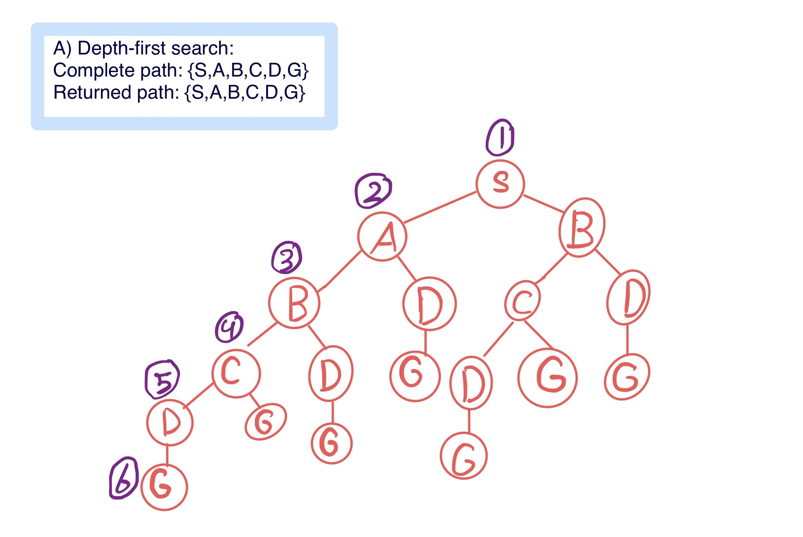Depth-first search
2. Depth limited search (L=2)

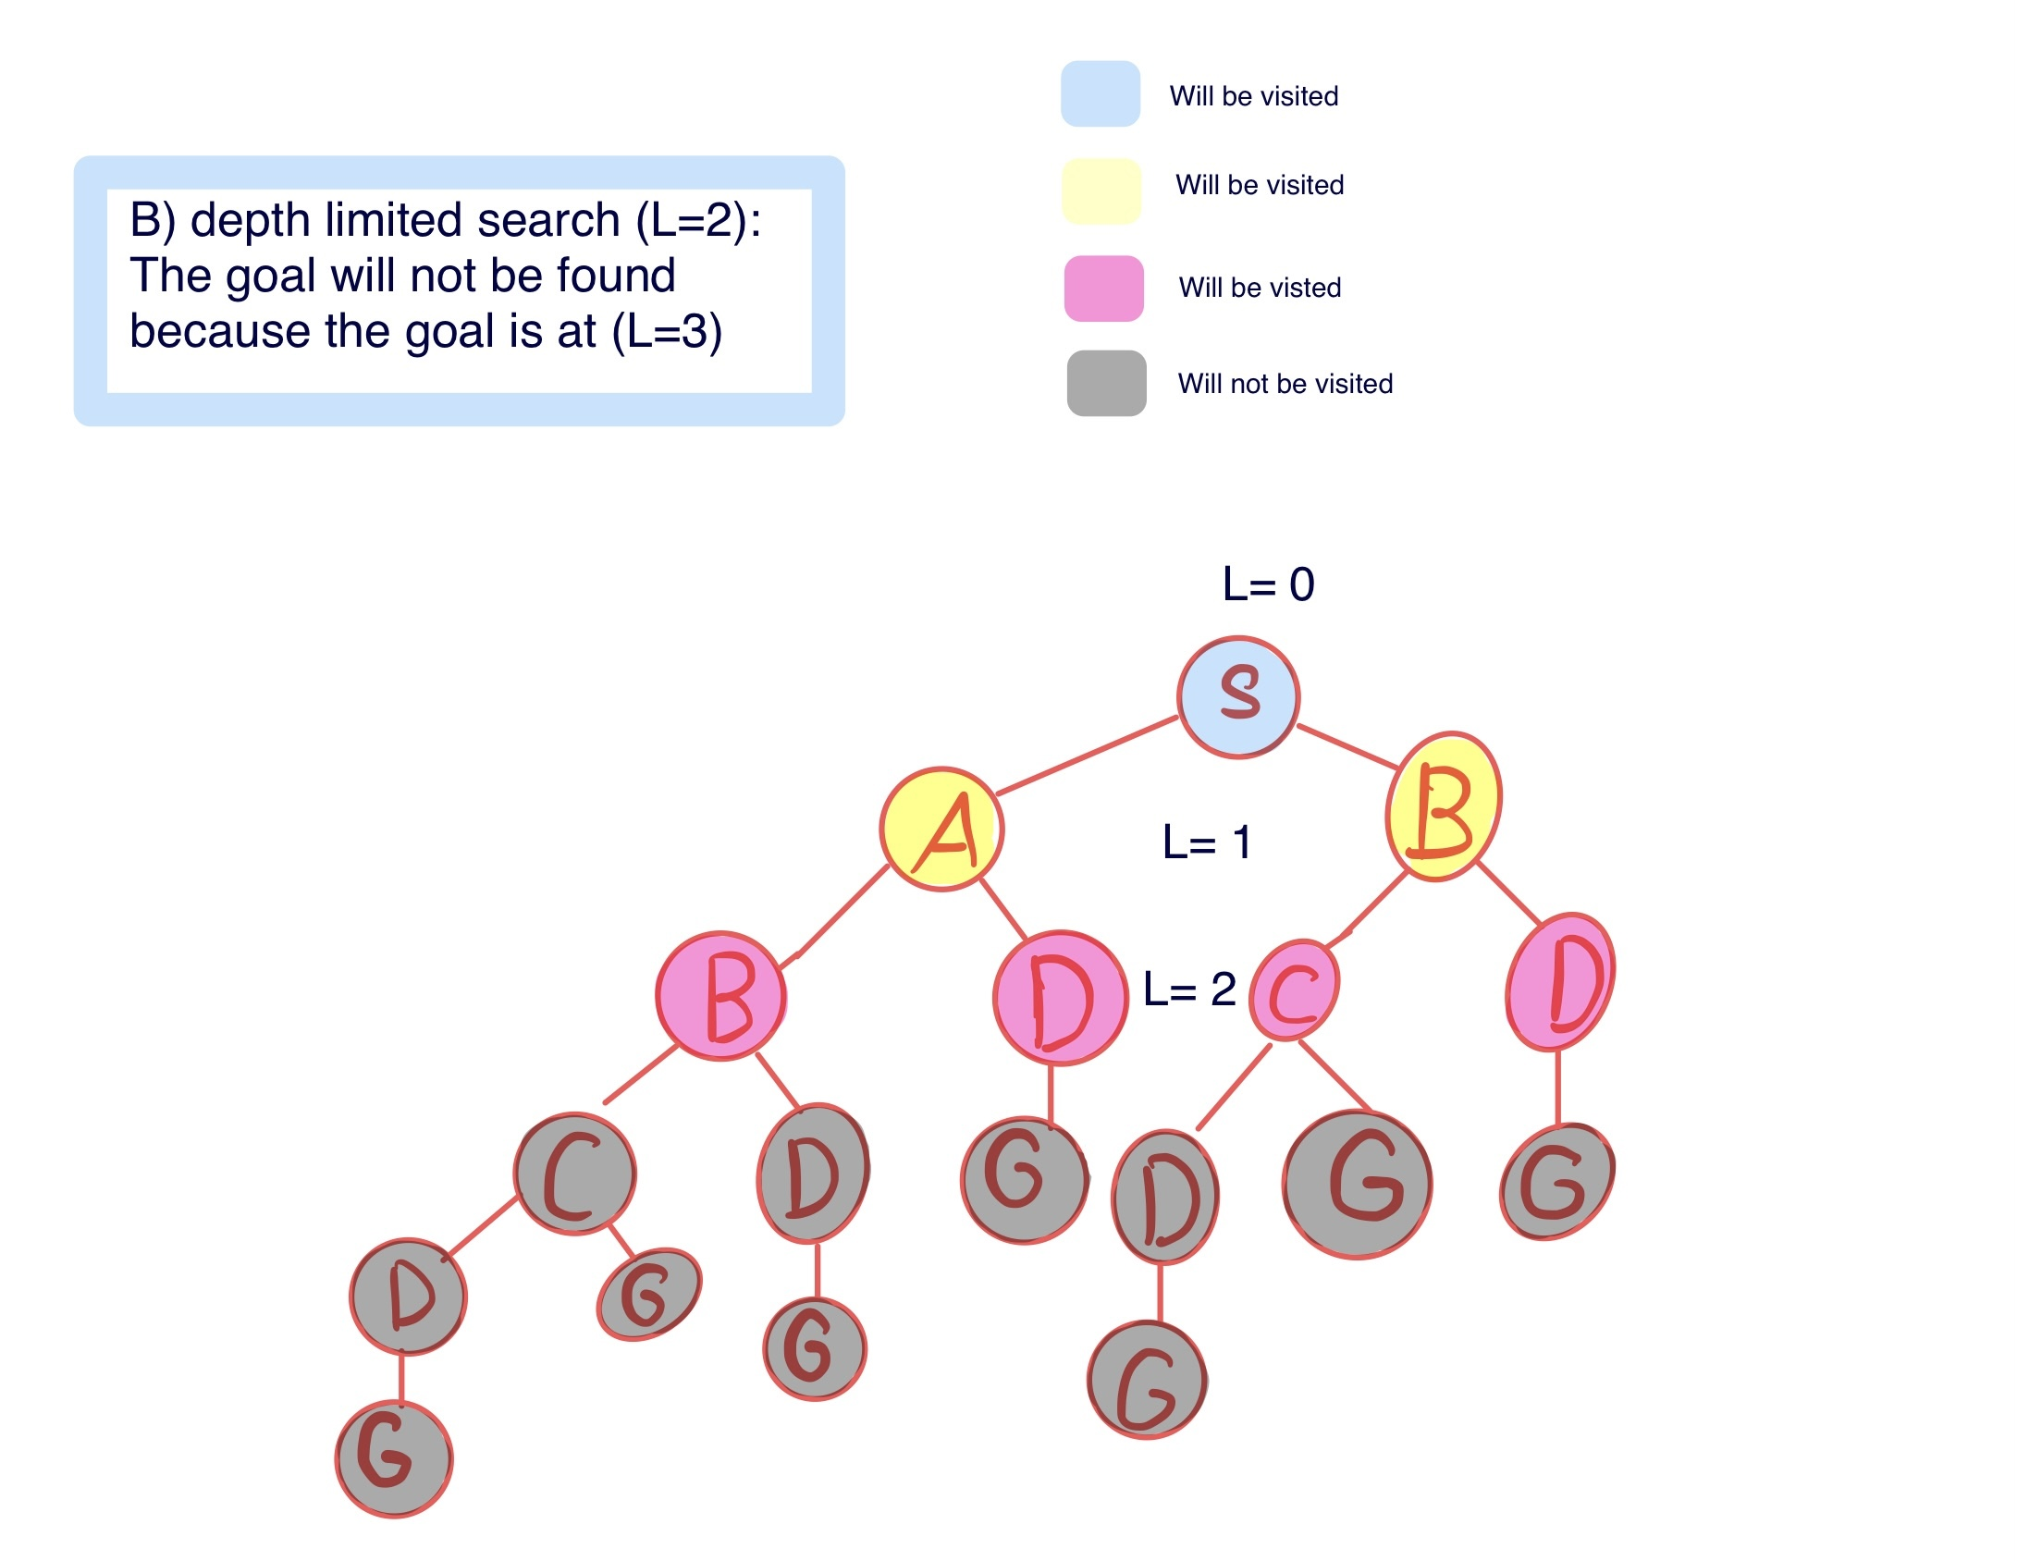

1. 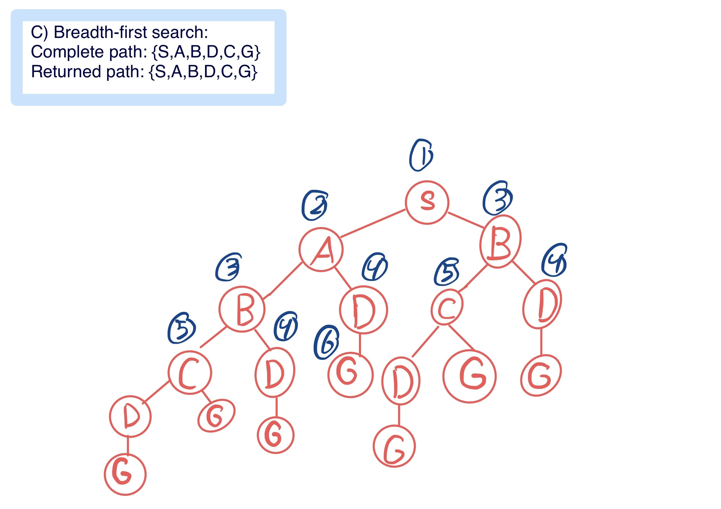Breadth-first search
2. 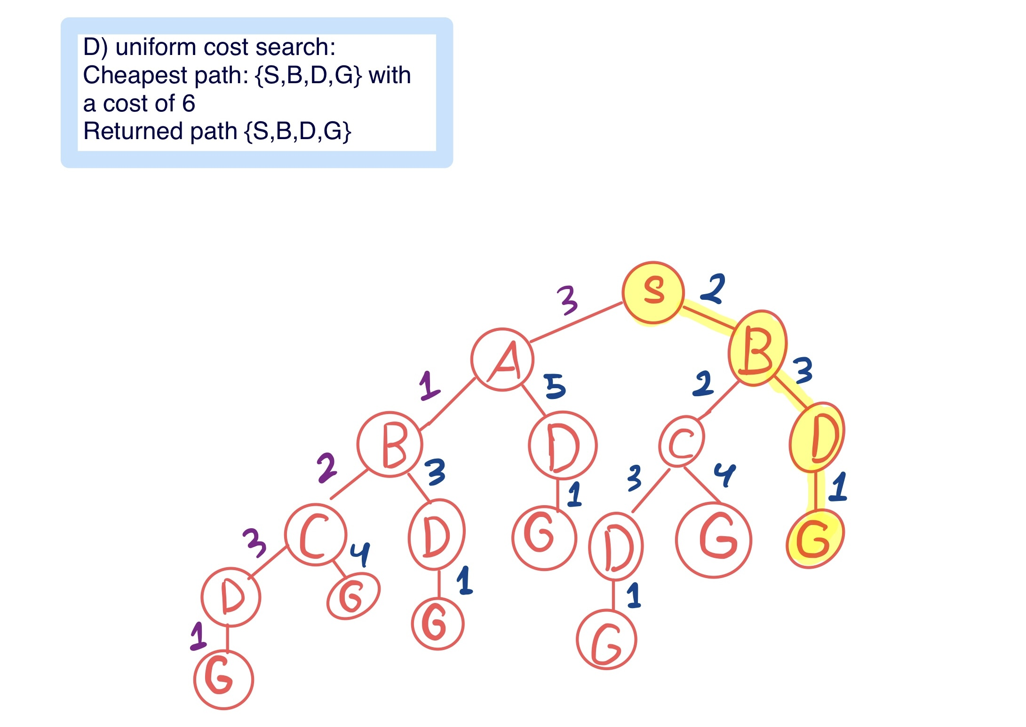Uniform-cost search
3. 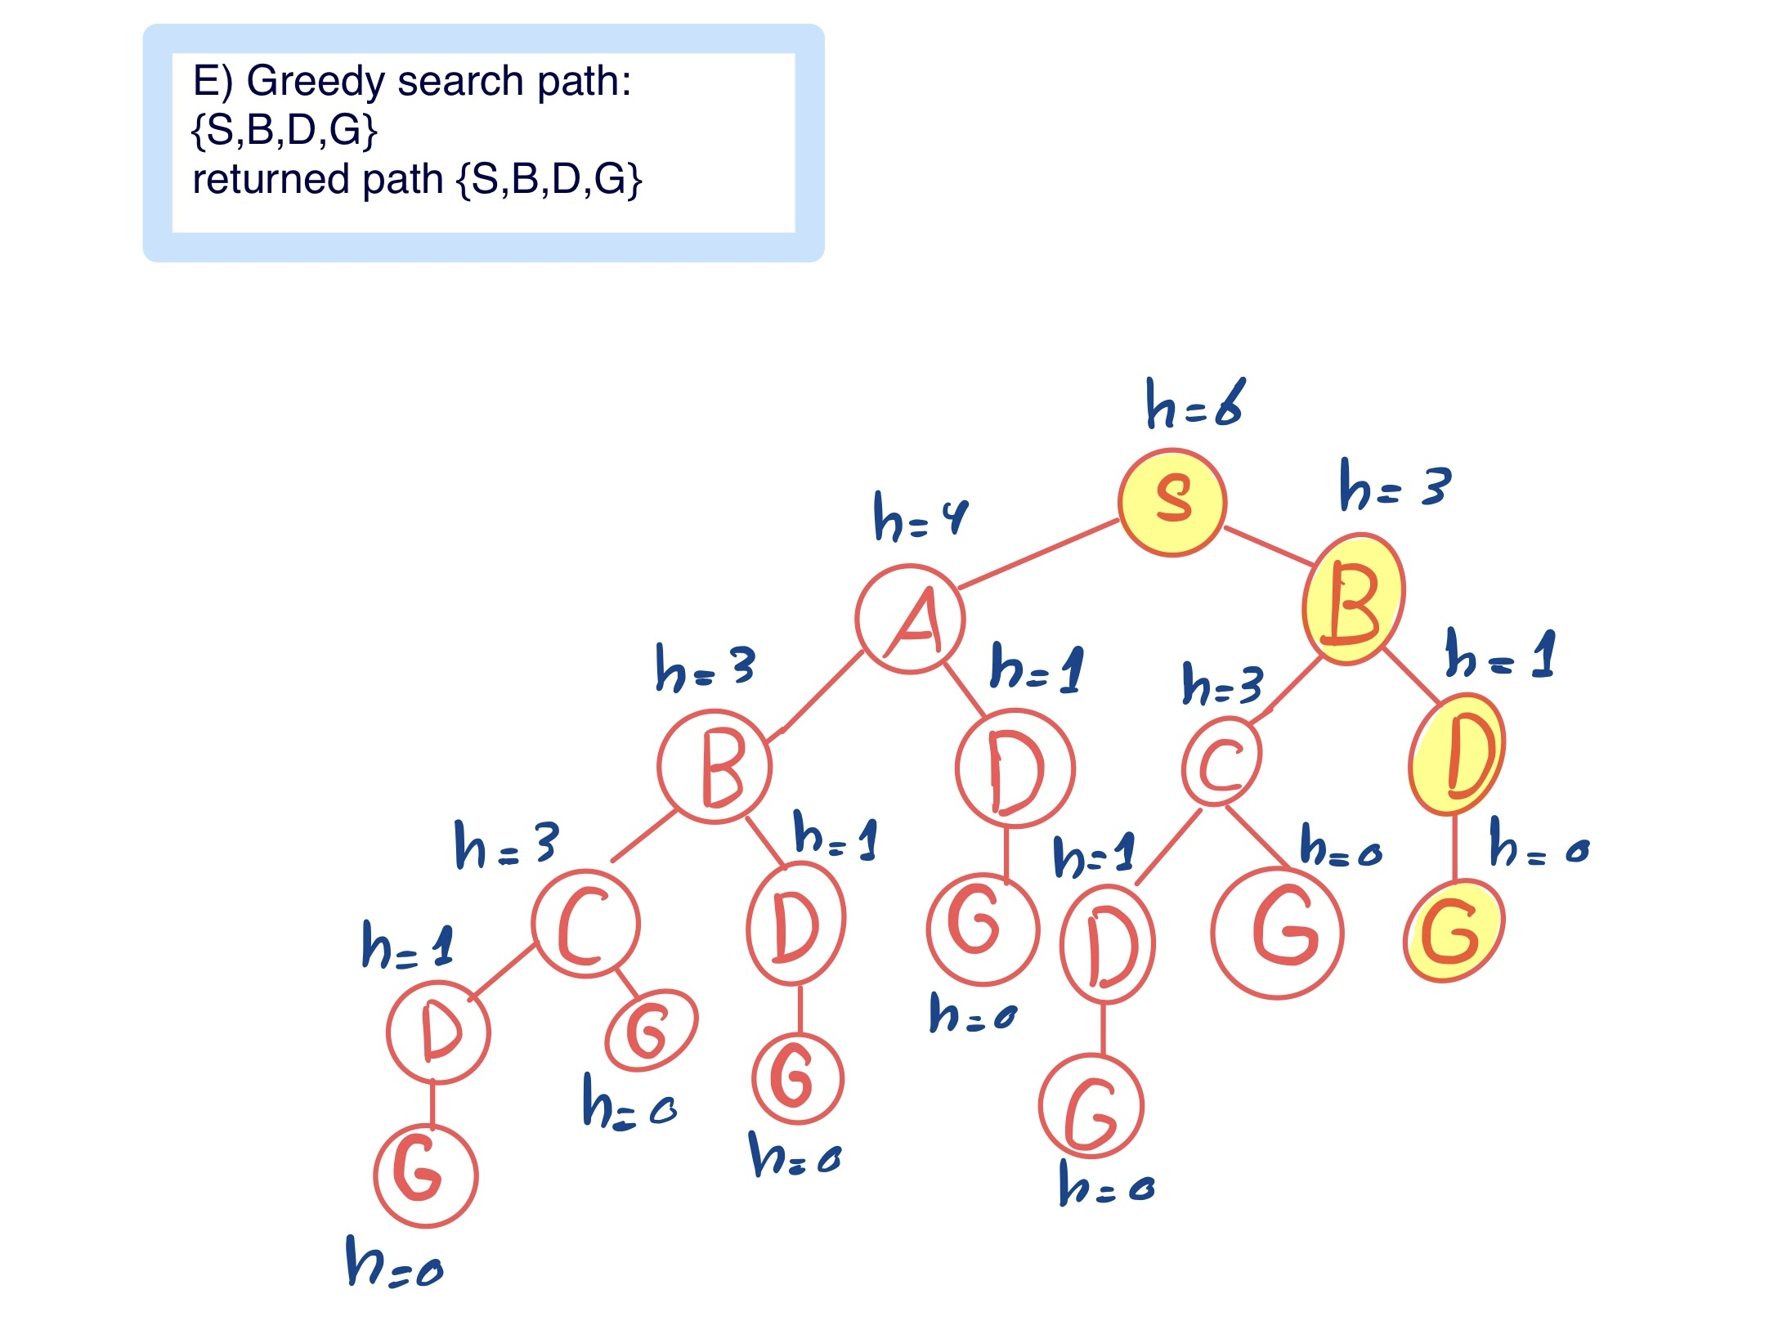Greedy search
4. 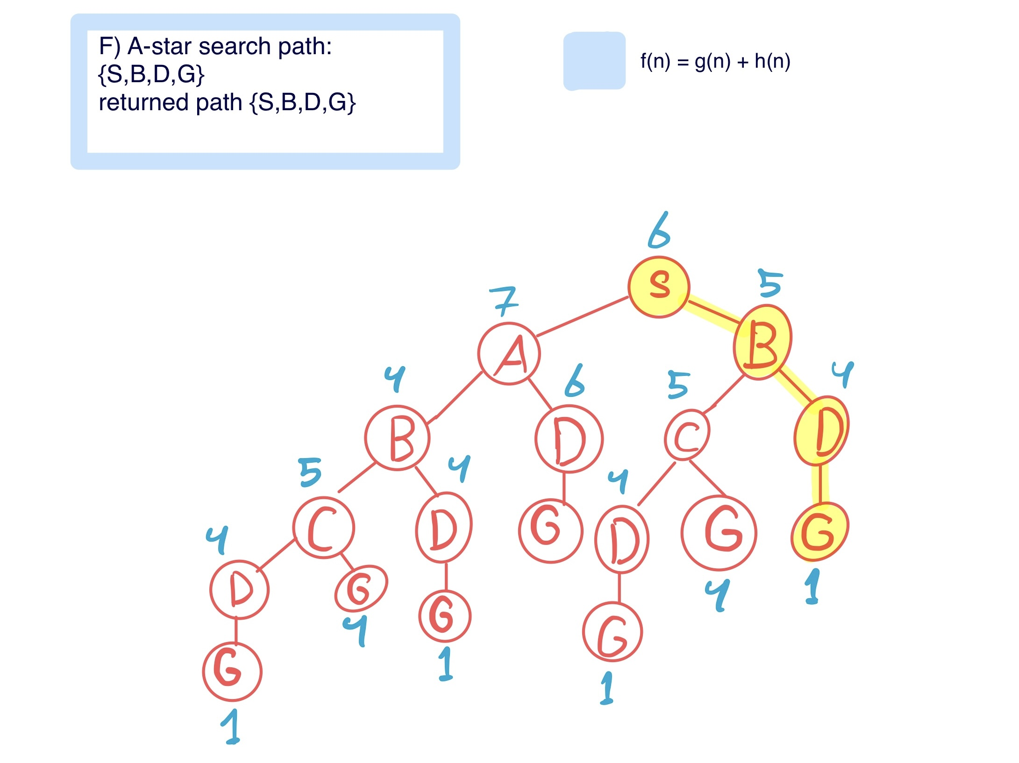A-star search

**Question 2:**

Solve this problem using the following algorithms. Give a description of the heuristic you will use. Note: ignore moves that returns you to the previous state.

1. 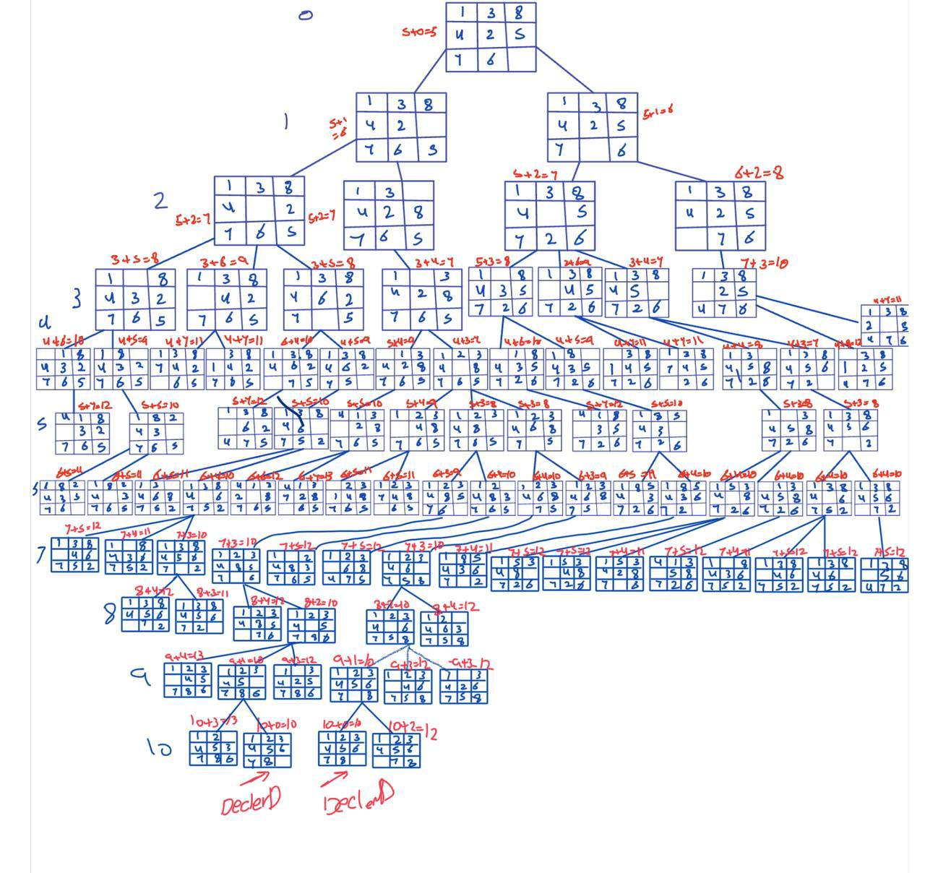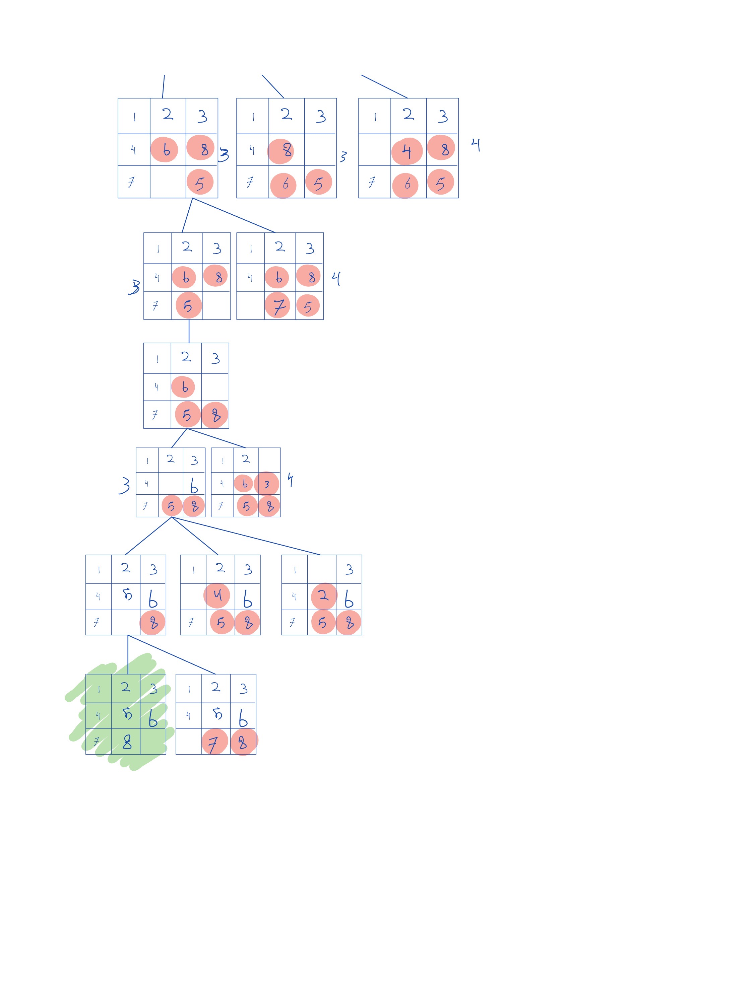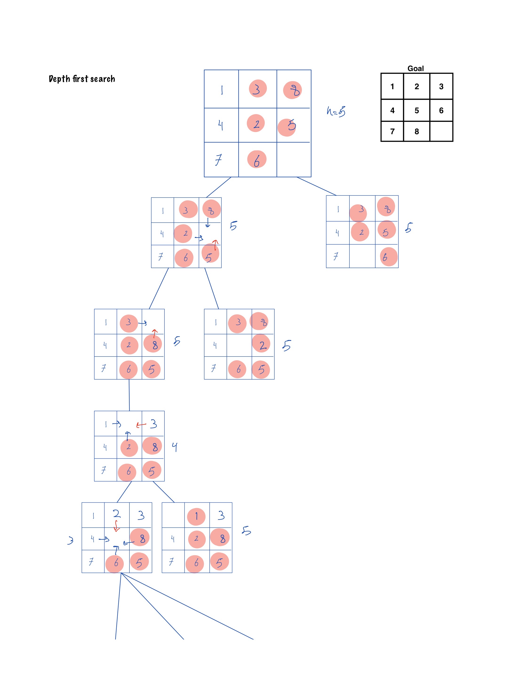Depth First Search
2. A* algorithm

**Student name: khalid nimri**