Bulk Crap Uninstaller

Documentation
Table of Contents
1 Introduction 1
2 Main Window 2
2.1 Application List 2
2.1.1 Highlight Colors 2
2.1.2 Certificates and verification 2
2.1.3 User rating 3
2.2 Left sidebar 3
2.3 Functions 3
2.3.1 Uninstall / Uninstall quietly 3
2.3.2 Uninstall using MsiExec / Windows Installer 3
2.3.3 Uninstall manually 3
2.3.4 Clean up “Program Files” folders 3
2.3.5 Find by window 3
2.3.6 Uninstall Windows Features 4
3 Application properties 4
3.1 Missing uninstaller 4
3.2 Orphaned application 4
3.3 Protected 4
3.4 Store App 4
3.5 System component 4
3.6 Update 4
4 Settings 4
4.1 Uninstallation 5
4.1.1 Concurrent uninstallation 5
5 Advanced copy to clipboard 5
6 Advanced filtering / Uninstall lists 6
6.1 Enabling advanced filtering 6
6.2 Filters 6
6.3 Conditions 6
6.3.1 Comparison methods 7
6.3.2 Target property 7
7 Command line options 7
7.1 BCUninstaller.exe 7
7.2 StoreAppHelper.exe 7

Introduction
Bulk Crap Uninstaller is a free (as in speech) program uninstaller. It excels at removing large amounts of applications with minimal user input. It can clean up leftovers, detect orphaned applications, run uninstallers according to premade lists, and much more!
Official website and a contact form can be found at http://klocmansoftware.weebly.com/
Get the latest version or view the code at https://sourceforge.net/projects/bulk-crap-uninstaller/

Main Window
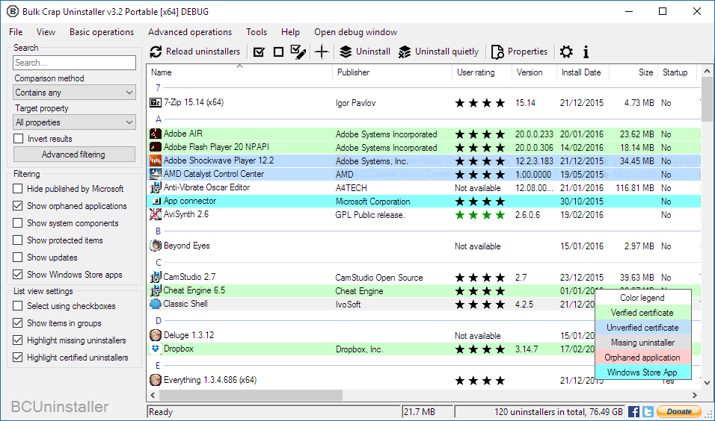

Application List
Main window is mostly taken up by a list of applications that BCU managed to find in your system. The list can be sorted by the columns and filtered using options on the left.

Highlight Colors
By default many items on the list have colored backgrounds according to their properties. Their meanings can be found in the Color legend in the bottom right corner. If the list is not visible it can be enabled from the “View” menu.
Items with white backgrounds have no special properties.

Certificates and verification
BCU can read and verify certificates of uninstallers. Their details can be viewed in the properties window. This function not meant to indicate good or bad applications, use it only as a hint.
Verified certificate mean that the executable is guaranteed to not have been modified in any way since leaving its publisher.
Unverified certificate can mean that:
- It was impossible to verify the certificate because of invalid root certificates or no internet connection.
- At some point the executable has been modified in some way. This is normal for Windows Installer (MsiExec) uninstallers – they are automatically modified by the system.
- The certificate has been self-signed and is therefore impossible to verify.

User rating
Most applications can be rated by users of BCU. The ratings are automatically synchronized with the statistics server. The rating can be between 0 and 4 stars, color of the stars corresponds to their number.
If the stars are black it means that they represent your own vote instead of the user average. You can hover over the stars to see the average rating.

Left sidebar
The settings sidebar contains mostly filtering options for the application list. It can be hidden from the “View” menu.
Search box is the same as a condition used in advanced filtering, check 6.3 Conditions for more information.
If Advanced filtering is enabled the sidebar is automatically hidden.

Functions

Uninstall / Uninstall quietly
Begins uninstallation of selected applications. Quiet uninstallation means that you do not have to click anything – the process is automatic. If it is not possible to quietly uninstall some items a dialog will be shown with ability to remove the “loud” uninstallers from the selection.

Uninstall using MsiExec / Windows Installer
If the application has a Product code / GUID attached to it you can try using MsiExec to uninstall it. It is not guaranteed to work on all applications.

Uninstall manually
Skips running the uninstaller (if it is available) and instead gives a list of files and registry keys that you can choose to delete manually.
It is not recommended to use this method unless it is impossible to uninstall the application in any other way.

Clean up “Program Files” folders
Search all folders that are defined as default installation locations (usually only the Program Files folders) for leftovers. This includes empty folders and partially uninstalled applications. You will be given a choice of items to remove.

Find by window
Opens a small tool window. Drag and drop the cross over a window you want to scan. BCU will try to find the application that owns the specified window and show it on the list.

Uninstall Windows Features
Scan the system for installed Windows Features and add them to the application list. They are treated as normal applications after that point and can be uninstalled in bulk. The scan can take a while.

Application properties
Some of the properties are displayed as background colors, check 2.1.1 Highlight Colors for more information.
Additional information not displayed on the list is available in the properties window.

Missing uninstaller
The application is registered in the system registry, but its uninstaller is either corrupted or missing. It will have to be removed manually.

Orphaned application
The application is not registered in the system registry, but is present in one of the default installation locations. If the application still has a working uninstaller BCU can often manage to find it and let you run it. If it is not found the application will have to be removed manually.

Protected
The application is marked as protected in system registry. This is often used to indicate that it is a part of another package, or is required by other applications.

Store App
The new Windows 10 – styled applications are all called Store Apps, even if they do not come from Windows Store. They normally require a completely different method of removal, but BCU presents them as normal applications.

System component
The application is marked to be important in some way to your system. Drivers and parts of bigger software packages are often marked as system components to hide them from the user. They are not actually required by the operating system.

Update
Means that the item is an update to another application, or the OS. Uninstalling the actual application will usually remove all related updates automatically.

Settings
Settings are automatically applied and saved on application exit. It is possible to reset settings to their defaults by “Help\Reset settings” menu option, or by removing the “BCUninstaller.settings” file in BCU's directory.

Uninstallation
- Prevent shutdown/restart will attempt to stop uninstallers from restarting the system.
- Intelligent uninstaller sorting will sort applications during bulk uninstallation to speed up the process. It will place loud uninstallers first so you can leave the computer earlier.
- Disable protection will stop blocking protected applications from being uninstalled.
- Turning Simulate uninstallation on will prevent BCU from uninstalling or removing anything from your system.

Concurrent uninstallation
Concurrent uninstallation is an experimental feature that will schedule multiple uninstallers to be ran at the same time. It will do its best to prevent any collisions and sometimes this functionality will be completely unavailable.
It is not recommended to run more than 2 uninstallers at the same time unless you are using a fast SSD.
You can manually force uninstallers to run concurrently from the bulk uninstall window. Doing so will still be tested for collisions, but the check can be disabled (not recommended).

Advanced copy to clipboard
The pattern is a Composite Format String. It is automatically processed when written.
To enable use of escaped characters (\r, \t, \n, etc.) enable the “Unescape” check-box. It will convert any escaped characters to their unescaped form.
To insert a newline add “\r\n” (standard newline on Windows) to the pattern and enable “Unescape“. You should see the newline appear in the Results box.
The combo box contains all available variables that can be added to the pattern. Selecting one of the variables will automatically paste it at cursor position.

Advanced filtering / Uninstall lists
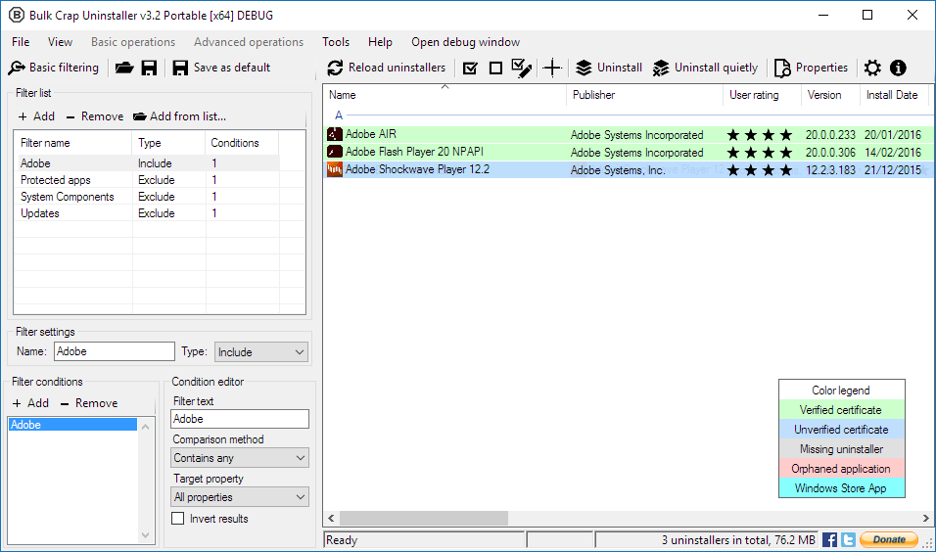

Enabling advanced filtering
Advanced filtering can be enabled by clicking the “Advanced button” on the sidebar or by opening an existing uninstall list from the “File” menu.
If an uninstall list is loaded its path is displayed in the application's title bar.
When advanced filtering is enabled all of the basic filtering settings are ignored.

Filters
Filters are displayed in the “Filter list”. Each filter can contain multiple conditions.
It is possible to add filters from an existing uninstall list by the option on the toolbar. New filters are appended to the end of the list.
If the filter's type is set to include it will only allow applications that match all of its conditions to appear on the list. They are executed before the exclude filters.
If the type is set to exclude the filter will remove all applications that match all of its conditions from the list. They override the include filters.
If there are only exclude filters all applications are automatically included.

Conditions
For a filter to match an application all of its conditions must match it. If any of the conditions fails to match the application the entire filter fails the match.
The filter text is compared against target property using selected comparison method. The result of the comparison can be optionally inverted (negated).

Comparison methods
- Contains – Property contains the entire filter text.
- Contains any – Property contains any of the words in the filter text. They are separated by spaces.
- Equals – Property is exactly the same as the filter text.
- Starts with / Ends with – Property either starts or ends with the filter text.
- Regex – Filter text is matched to the property using a Regex engine. Regex online manual.

Target property
Property of the application that will be compared against. “All properties” will try to match the filter text to any of the available properties.
The properties can be previewed by viewing properties of the applications.

Command line options

BCUninstaller.exe
BCUninstaller [drive:][path]filename

[drive:][path] – Specifies drive and directory of the uninstall list.
filename – Specifies filename of the uninstall list

BCUninstaller.exe has only very basic command line options at the moment, subject to change.

StoreAppHelper.exe
StoreAppHelper /query
StoreAppHelper /uninstall FullName

query – Returns a list of installed Store Apps for current user in the following format:
FullName:
DisplayName:
PublisherDisplayName:
Logo:
InstalledLocation:

uninstall – Uninstalls a single Store App specified by its FullName.

