Kloudgis

Introduction
Kloudgis is a web based GIS application.

Specifications

Client
The solution for the client part of this web application is the Sproutcore framework. It’s using javascript and HTML5 to render the application in the browser. To communicate with the server sproutcore uses XmlHttpRequest, AJAX requests. Sproutcore works the best with a RESTful backend server. The expected input and output format in communication is JSON. To transfer an object, both sides need a file to map the corresponding attributes. On the server, it’s a class with the @XmlRootElement annotation. On the client, it’s a model javascript file that extend SC.Record. All object must have an number attribute called “guid” make sproutcore to work properly.

To host the client, the preferred web container is apache2. The client is mostly composed of static content. Apache2 is optimized to do so and is very reliable. It also allow proxies to forward some requests to the backend server (tomcat). The communication between apache2 and tomcat is very fast because it uses AJP with a connection pool.

Server
The backend server solution is composed of Jersey to handle HTTP requests and JPA(java persistence api) with Hibernate to handle databases.

Jersey

This framework is from SUN. It dispatch the requests to the desired class. It uses annotations instead of XML config files. To add support of an URI, you need a class like this:
@Path("/groups")
public class GroupAdminResourceBean {

@GET
@Produces({"application/json"})
public List<Group> getGroups(@Context HttpServletRequest req, @Context ServletContext sContext) throws WebApplicationException {
//...
}
}

This bean listen /groups URI for a GET HTTP request. It returns a list of Group objects. These will be converted to JSON automatically (see @Produces).

To know how to build the JSON for Group, the Group class (POJO => Plain Old Java Object) needs some annotations:

@XmlRootElement
public class Group {

private Long id;
private String name;
private List<String> members;
private List<String> privileges;

public Group() {
}

public Group(Long id) {
this();
this.id = id;
}

@XmlElement(name = "guid")
public Long getId() {
return id;
}

/**
* @return the name
*/
@XmlElement
public String getName() {
return name;
}
//...
}

JPA
JPA is an API to talk to a Persistence provider. In our case, the provider is Hibernate. An provider is layer between the server and the Databases. It takes care of the connections, create the schema if necessary and generate the SQL to perform SELECT, INSERT, UPDATE or DELETE. To handle Geometry types, we need the Hibernate Spatial module. It’s permit to make spatial predicates and to use annotations for Geometry.

Each table to manipulate needs a corresponding class to map the attributes.

@Entity
@Table(name = "GROUPS")
@NamedQueries({
@NamedQuery(name = "Group.findAll", query = "SELECT c FROM GroupDbEntity c")})
public class GroupDbEntity implements Serializable {

@Id
@GeneratedValue(strategy = GenerationType.AUTO)
private Long id;
@Column(length = 30)
private String name;
@ManyToMany(fetch = FetchType.EAGER)
@JoinTable(name = "CONNECTS_GROUP_PRIVILEGES",
joinColumns =
@JoinColumn(name = "GROUP_ID", referencedColumnName = "ID"),
inverseJoinColumns =
@JoinColumn(name = "PRIVILEGES_ID", referencedColumnName = "ID"))
@OrderBy("name ASC")
private List<PrivilegeDbEntity> privileges;
@OneToMany(mappedBy = "group")
@OrderBy("name ASC")
private List<UserDbEntity> members;
//...
}

This entity has an Id column auto-generated, a text column of 30 chars , a join ManyToMany and a join OneToMany. Many options are available to customize the behavior.

@Table is to provide a custom name for the table (default is the class name).
@NamedQueries is to define a query and use it from anywhere.
@Id is for an Id column
@GeneratedValue is to make the Id auto-generated
@Column is to define a column in the database. The Java type (String, Integer, ...) is reflected in the database.
@ManyToMany is to join this to an other class with a Many To Many relationship. This kind of relationship needs a third table. The @JoinTable define this table.
@OrderBy is to sort the list (joins)
@OneToMany is to join this to and other class with a One to Many relationship. In this example, ONE group can have MANY members.

JPA + HIBERNATE

To interact with the databases, the application needs the persistence.xml file to setup the database access (username, password, ...) and the persistence unit identifier. This identifier is used by JPA to create the persistence factory :

Persistence.createEntityManagerFactory("webserverPU");

Here the identifier is "webserverPU".

The persistence factory is the access point to the EntityManager, the way to manipulate the entities.

EntityManager em = PersistenceManager.getInstance().getEntityManagerFactoryAdmin().createEntityManager();
List<GroupDbEntity> lstDb = em.createNamedQuery("Group.findAll").getResultList();
List<Group> lstG = EntityFactory.toGroupEntities(lstDb);
em.close();
return lstG;

This code will get all the groups from the database (GroupDbEntity). It uses the predefined query “Group.findAll” and call getResultList() to excute the query. The list of persistance entity are then converted to Group POJO using a home made method EntityFactory.toGroupEntities in oder to produce JSON.

To add a new row in the database, you only need to create a new instance of the Entity inside a transaction and call persist() followed by commit().

EntityManager em = PersistenceManager.getInstance().getEntityManagerFactoryAdmin().createEntityManager();
em.getTransaction().begin();
GroupDbEntity uDb = group.toDbEntity(em);//create a new instance of GroupDbEntity
em.persist(uDb);
em.getTransaction().commit();
group.setId(uDb.getId());
em.close();

Similarly, to remove a row, call the remove() method and commit. Finally, to update, just set the new values inside a transaction.

em.getTransaction().begin();
groupDb.setName(“toto”);
em.getTransaction().commit();

To work with Geometry, it needs a bit more work. The geometry attributes need to be declared like this :
@Column(name = "limiteslot")
@Type(type = "org.hibernatespatial.GeometryUserType")
private Geometry location;
To filter a geometry attribute, the HibernateSpatial API is required.
*** This break the compatibility to use an other engine.

HibernateEntityManager em = PersistenceManager.getInstance().getEntityManagerData();
Criteria c = em.getSession().createCriteria(LotOccupeDbEntity.class);
c.add(SpatialRestrictions.intersects("location", new Point(new CoordinateArraySequence(new Coordinate[]{new Coordinate(1,1)}), new GeometryFactory(new PrecisionModel(PrecisionModel.FLOATING_SINGLE), -1))));
List results = c.list();

This get all the LotOccupeDbEntity that intersect the POINT(1,1). The geometry object are JTS object. The statement SpatialRestrictions.intersects will later create the SQL to perform the intersection.

DATA FLOW
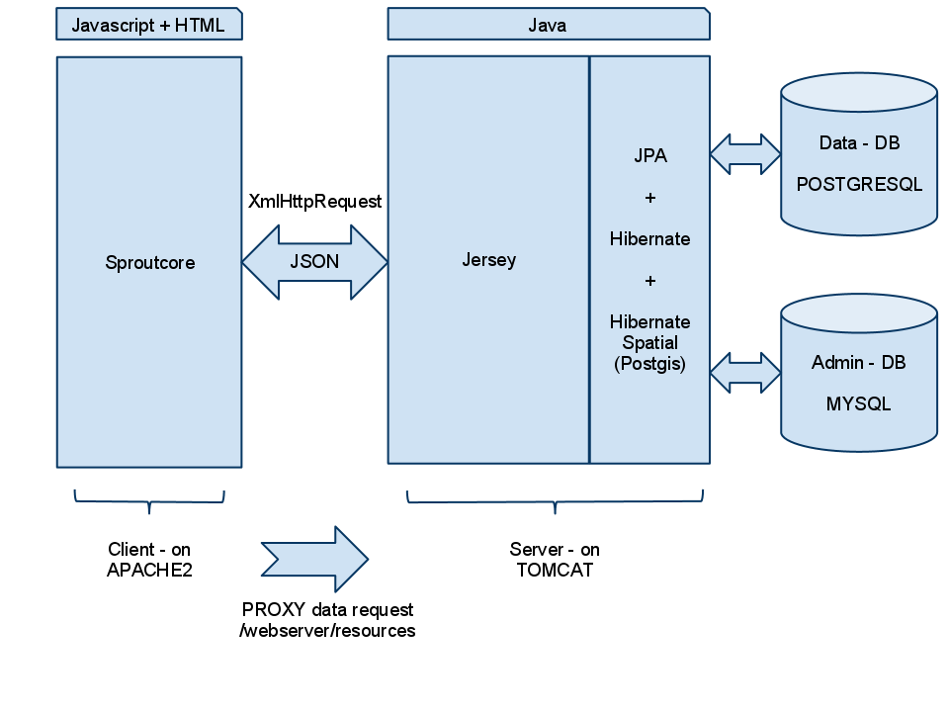

FeatureType Integration

The section show what are the requirements to use a FeatureType in Kloudgis.
Example with Lotoccupe.

  - Server Side
    - A entity class to match the database schema used by JPA. (LotOccupeDbEntity). This entiry must be registered in the file persistence.xml.
    - A POJO class to set the JSON schema. (LotOccupe)
    - A row in the FEATURETYPES table containing:
      - name
      - label
      - feature_class
    - A row in the COLUMN table for each attribute to show in a table view. This table is joined to the table FEATURETYPES and contains:
      - name
      - label
      - col_size (column size of the table)
    - A resource Bean to handle the URI and queries. (LotOccupeResourceBean)
      - The URI .../features/feature_class
  - Client Side
    - A model javascript file to match the JSON schema. The file name must match the FeatureType’s feature_class value.

  - Security
    - Groups
A group can extend an other one. This is done by setting the parent_group_id column of the child group. The child group inherit from all the parent’s settings but can override or add more settings.
    - Columns
It describe a column in the client tableview. It specify the attribute to read, the label to show and the column width. A column can be associate with all groups (group_id is null) or to a specific group (group_id = XXX). Of course, a group that extent an other one inherit from the parents columns but can override the width or label.

OpenLayers
In order to show a openlayers map in sproutcore, you need some prerequisites:
    - Add openlayer javascript file to reference.
One way is to add this script to loading.rhtml:
<script type="text/javascript" src='http://openlayers.org/api/OpenLayers.js'></script>

To support google map, also add the google api script:
<script type="text/javascript" src="http://www.google.com/jsapi?key=ABCDEFG"></script>
<script type="text/javascript">
google.load("maps", "2");
</script>
    - Set the parameters.
Somewhere is the javascript implementation, add the following:
//add the style.css reference
var remoteHref = "http://openlayers.org/api/theme/default/style.css";
var headElement = document.getElementsByTagName("head")[0];
var items = headElement.getElementsByTagName("link");
var include = NO;
for (var i = 0; i < items.length; i++) {
var item = items[i];
var name = item.rel;
console.log(item.href);
if (name == 'stylesheet' && item.href == remoteHref) {
include = YES;
}
}
if (!include) {
var styles = document.createElement('link');
styles.type = "text/css";
styles.rel = "stylesheet";
styles.href = remoteHref;
headElement.appendChild(styles);
}
//set the paths
OpenLayers.ImgPath = 'http://openlayers.org/api/img/';
OpenLayers.theme = 'http://openlayers.org/api/theme';

    - Create and add the map to the HTML. (can be in didAppendToDocument function from the sproutcore view)

//create the map
//the div id for parent spoutcore component
var mapCanvasId = this.get("layerId");
var map = new OpenLayers.Map(mapCanvasId, {

projection: new OpenLayers.Projection("EPSG:4326"),
displayProjection: new OpenLayers.Projection("EPSG:4326"),
maxExtent: new OpenLayers.Bounds(143.834,-43.648,148.479,-39.573),
units: "m",
maxResolution: 156543.0339,
maxExtent: new OpenLayers.Bounds( - 20037508.34, -20037508.34, 20037508.34, 20037508.34)*/
});

    - Add a layer to the map.
//google map
var gmap = new OpenLayers.Layer.Google("Google", {
//type: G_SATELLITE_MAP,
sphericalMercator: true,

});
map.addLayers([gmap]);

    - Add controls to the map.
map.addControl(new OpenLayers.Control.LayerSwitcher());
map.addControl(new OpenLayers.Control.MousePosition());
map.addControl(new OpenLayers.Control.Navigation());

    - To support getfeatureinfo and WFS, a proxy file is needed.
      - On the linux machine hosting the client (sproutcore) using apache2, add proxy.cgi to /usr/lib/cgi-bin.
See http://trac.openlayers.org/wiki/FrequentlyAskedQuestions#ProxyHost
      - The proxy file must contain the geoserver host in the allowedHost array. Ex: 192.168.12.186:8080.
      - An other openlayers parameter must set to inform openlayer about the proxy:
OpenLayers.ProxyHost = "/cgi-bin/proxy.cgi?url=";

    - Selection can be done using getfeatureinfo command.
      - To highlight a feature with WMS, you need to create a vector layer and add/remove features from it.
...
highlightLayer.destroyFeatures();//remove all features
highlightLayer.addFeatures(evt.features);//add selection
highlightLayer.redraw();

The tool to use in order to make a selection is: WMSGetFeatureInfo

var click: new OpenLayers.Control.WMSGetFeatureInfo({
url: url,
title: 'Identify features by clicking',
layers: [water],
queryVisible: true
});
...
click.events.register("getfeatureinfo", this, this.showInfo);
click.infoFormat = 'application/vnd.ogc.gml';
map.addControl(click);
    - Controls
      - Edition (Vector layers only)
        - SelectFeature : selected features become rendered with the ‘select’ style.
        - GetFeature : get the features underneath the mouse cursor.
        - ModifyFeature : Reshape, Rotate, Resize or Drag.
        - TransformFeature: Reshape using a transform box.
        - DragFeature: Move feature.
        - DrawFeature: Point, Line or Polygon.
        - Snapping: Snap agent while editing. Can snap node (first and last vertex), vertex and edge.
        - Measure
        - Split
      - Goodies
        - Navigation : dragging, double-clicking, and scrolling the wheel.
        - NavigationHistory
        - LayerSwitcher : the layer panel.
        - Pan
        - PanZoom
        - Zoom : Box, In, Out, ToMaxExtent
        - Scale : Ex: 1 : 1000
        - SclaleLine : graphic scale.
        - Permalink : Hyperlink on the map.
        - KeyBoardDefaults : keyboard shortcuts
        - Graticule : Grid on the map
        - MousePosition : XY
        - OverviewMap : Minimap.
    - Options
      - Layers
        - Buffer : nb tiles outside the visilbe area.
        - TransitionEffect : Default nothing. ‘resize’ will zoom the image.
        - SingleTile : true/false. One big tile if true.
        - backgroundGraphic, backgroundX(Y)Offset, backgroundGraphicZIndex : to render shadow.
        - Format (vector) : GML, KML, GeoJSON,...
        - Protocol (vector): HTTP, WFS
        - Strategy :
          - BBOX : Fetch bounding box.
          - Fixed : Fetch ALL, once.
          - Cluster : aggregate close points.
          - Paging : Get the features per block manage client side.
          - Save : Commit local changes to server.
          - Refresh : Auto refresh layer...
    - Geoserver Security
To secure the access, the request need to provide a username and password. Because we use the openlayers implementation that limit the possible customization of the requests and it would have been not secure, the solution is to have a custom filter in the geoserver web context.
How it works:
The client app provide a geo_id (obtains on successful login) in each requests to geoserver as a parameter.

On the server side, add a custom jar to the geoserver library (AuthorizationFilter.jar) and activate it in the web.xml:
<filter>
<filter-name>AuthorizationFilter</filter-name>
<filter-class>org.kloudgis.authorizationfilter.AuthorizationFilter</filter-class>
</filter>

<filter-mapping>
<filter-name>AuthorizationFilter</filter-name>
<url-pattern>/*</url-pattern>
</filter-mapping>

This filter class query the MYSQL database to find the username/password corresponding to the geo_id. It also make sure the session associate with the geo_id is still valid. It then add the Authorization header parameter with the proper credentials. Then modified request reaches the geoserver authorization system.

To speed up the process, a cache containing the geo_id and corresponding credentials should be implemented. The cache can be emptied after some time.

Google Visualization
In order to show a gv chart in sproutcore, you need some prerequisites:
    - Add google api javascript file to reference.
One way is to add this script to loading.rhtml:
<script type="text/javascript" src="http://www.google.com/jsapi"></script>
<script type="text/javascript">
google.load('visualization', '1', {packages: ['piechart']});
</script>
    - Create a sproutcore view.
Googlevisualization.GVView = SC.View.extend(
{
didAppendToDocument: function() {
this.initGV();
},
initGV: function() {
// initialize the map
var data = new google.visualization.DataTable();
data.addColumn('string', 'Month');
data.addColumn('number', 'Sales');
data.addRows([['January', {
v: 20,
f: '$20M'
}], ['February', {
v: 31,
f: '$31M'
}], ['March', {
v: 61,
f: '$61M'
}], ['April', {
v: 26,
f: '$26M'
}]]);
this.drawData(data);
},
drawData: function(data){
// intelligently get the id of the map container
var mapCanvasId = this.get("layerId");
// Create and draw the visualization.
new google.visualization.PieChart(
document.getElementById(mapCanvasId)).
draw(data, {
is3D: true
});
}
});
    - To change the chart, call the drawData function with a new data table.
Ex:
loadChart: function() {
console.log("loadChart");
SC.Request.getUrl('/webserver/resources/charts/status').json().notify(this, 'didFetchChart').send();

},

didFetchChart : function(response){
var data = new google.visualization.DataTable();
if (SC.ok(response)) {
var body = response.get('body');
if(body){
data = new google.visualization.DataTable(body);
}
}
Googlevisualization.mainPage.mainPane.gvView.drawData(data);
}

