

**Thanks for your purchase.**

First of all, you have to get [DOTWEEN](http://u3d.as/aZ1) from the Asset Store :

<http://u3d.as/aZ1>

(it’s free)

1/ Import Dotween from the asset store : <http://u3d.as/aZ1>

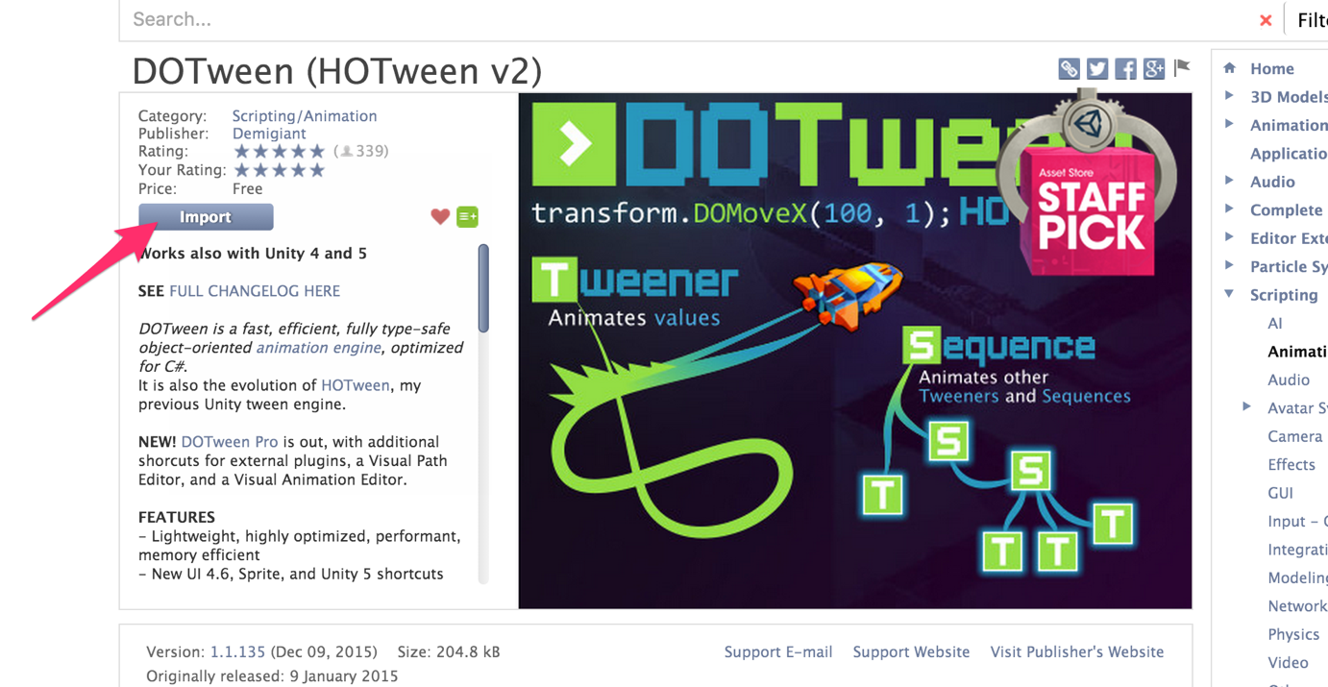

2/ Import the package into Unity

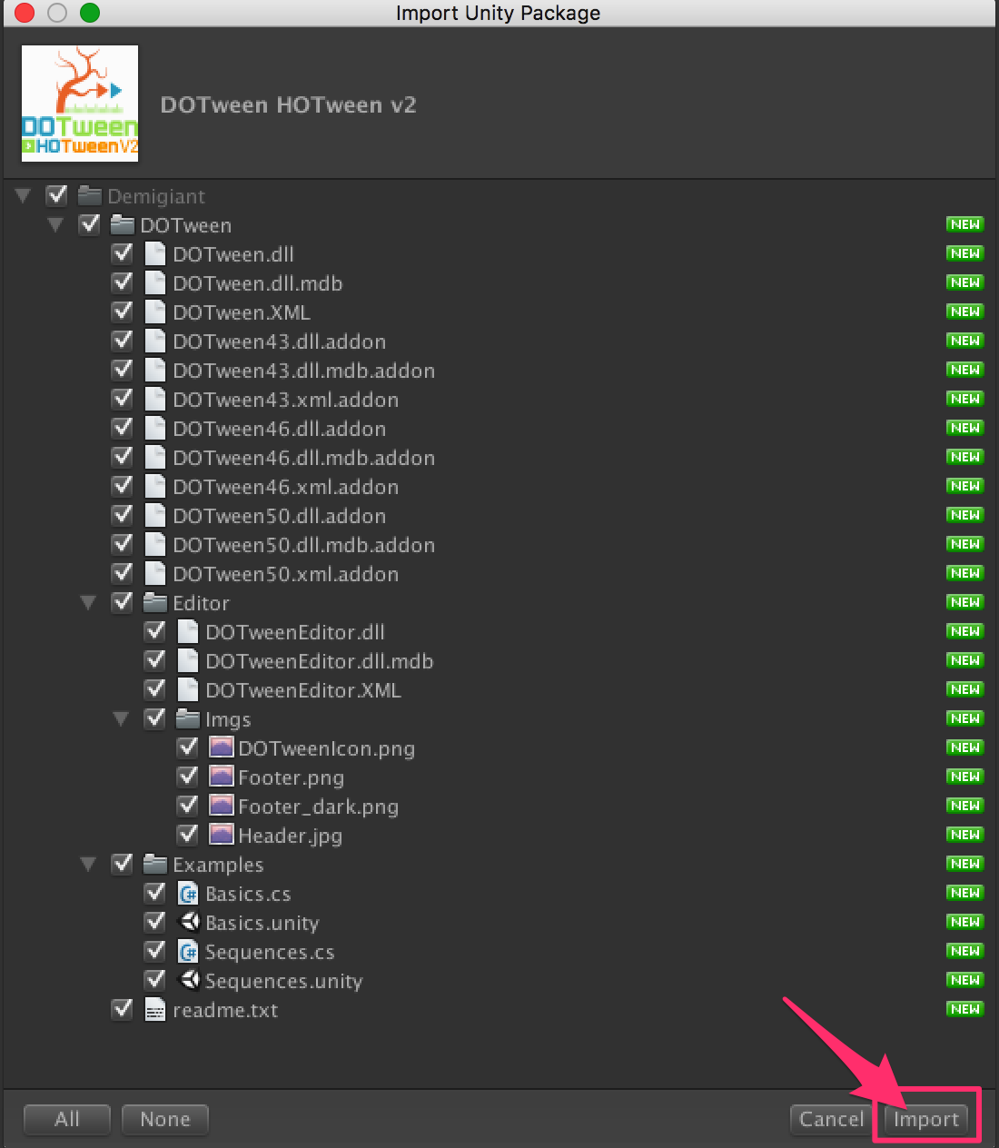

3/If you don’t see the « Tools » in the top of the Unity Screen, please do this :

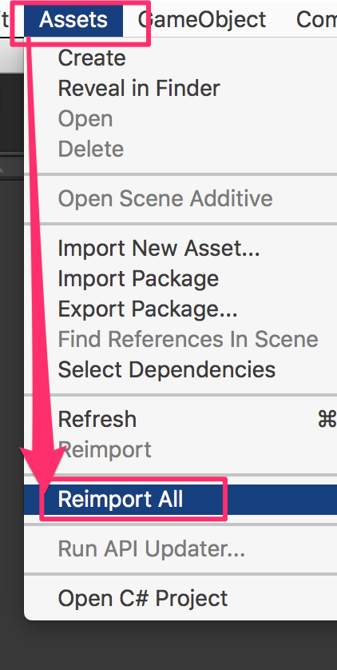

4/Now you have the « Tools ». Open it and click on « DOTween Utility Panel ».

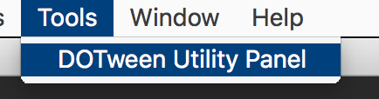

5/Click on « Setup DOTween ».

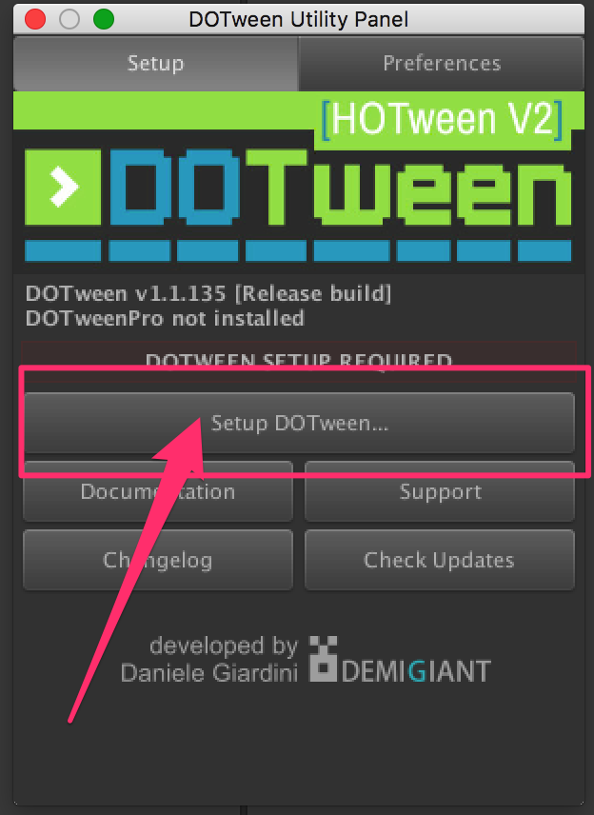

6/And to finish, click on the « OK » button.

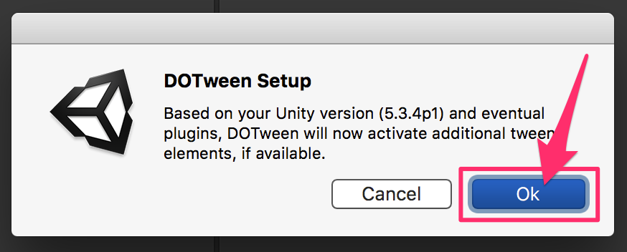

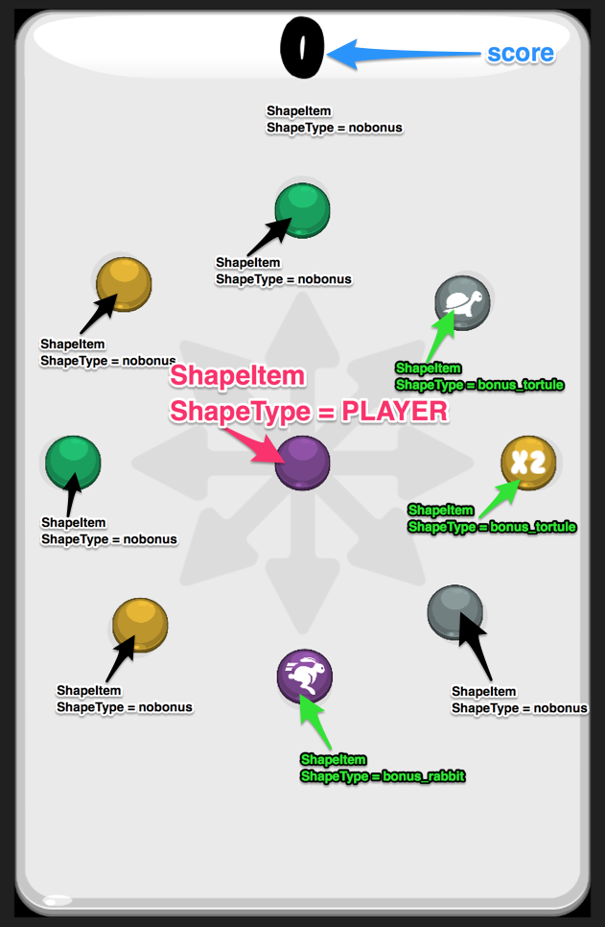

All the classes are fully documented. You can find all the class descriptions here :

[https://dl.dropboxusercontent.com/u/8289407/Color%20Swipe%20Asset%20Store/Documentation/html/annotated.html](https://dl.dropboxusercontent.com/u/8289407/Color Swipe Asset Store/Documentation/html/annotated.html)

ShapeItem (prefab) :

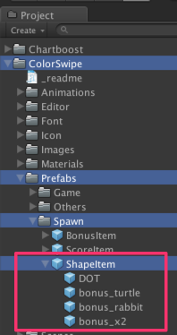

The shapeItem are the objects who moved during the game.

There are spawned by the SpawnManager.

The centered ShapeItem is the « player » : his type is : ShapeType.player.

It’s the shape the player move with swipe.

The other ShapeItem can be :

* type = ShapeType.nobonus (just the shape itself)
* type = ShapeType.bonus_turtle (with the turtle image. If the player gets it, the speed decreases a little bit)
* type = ShapeType.bonus_rabbit (with the rabbit image. If the player gets it, the speed increses a little bit)
* type = ShapeType.multi2 (with a « x2 » text . If the player gets it, all the point are multiply by 2 during a short period)

To implements ads, please refer to the documentation : « _Ads_Integration_Documentation.PDF ».

For more information about the code, please refer to :

<https://dl.dropboxusercontent.com/u/8289407/Color%20Swipe%20Asset%20Store/Documentation/html/index.html>

Video tutorial available on my Youtube channel :

<https://www.youtube.com/channel/UC5cMgK5r_rzTiarF-So3Rtg>

**ADS :**

Everything is done for you : « Very Simple Ad » is already implemented.

Get it here : http://u3d.as/oWD

Thanks !

Our other assets : <http://u3d.as/9cs>

Contact : [contact@app-advisory.com](mailto:contact@app-advisory.com)