- Guidance for the use of AI tools available in RES
Article metadata. Revised by Euan George
This article was updated• 19d ago19 days ago
This article has 57 views.• 57 Views This article has average rating: 4 out of 5 stars• (*)(*) (*) (*) ( )

- Summary
The purpose of this article is to inform you of:
- Which AI tools are permitted for use in RES
- The type of data you are permitted to prompt these AI tools with
- Considerations you should make before entering data into these AI tools (incl. recording your Teams meetings)



We only permit the use of AI tools for use with RES data, that have been approved by the RES IT team following a supportability and cyber security review. This includes AI add-ins for software applications such as Microsoft Teams. Please ensure you are familiar with the RES IT Acceptable Use Policy (link below) before using any AI tooling with RES data or IT hardware.
WHEN USING RES IT HARDWARE OR DATA, DO NOT SUBSCRIBE TO OR USE 3rd PARTY AI TOOLS THAT ARE NOT EXPLICITLY AUTHORISED BY THE RES IT TEAM.



- AI Tools Authorised for use in RES
AI Tool | Permitted Scope of Use
Copilot for Windows | Any type of prompt allowed.
Copilot for MS Teams | Any type of prompt allowed.  WARNING: Requires you to record meetings and/or transcripts.
Copilot for M365 | Any type of prompt allowed.
Chat GPT | DO NOT include RES data (that is not available to the general public) in any prompts.
Azure OpenAI | Subject to approval from the Azure Subscription Owner.
Claude AI | Permitted for use on a RES subscription (contact IT)  How to Use Claude AI

- Copilot for Windows (free)
This is a Microsoft chat engine (also known as generative AI) that accesses data available over the public internet. It uses AI models that do NOT have access to RES data (i.e. this tool cannot be used to query data inside of RES's systems).
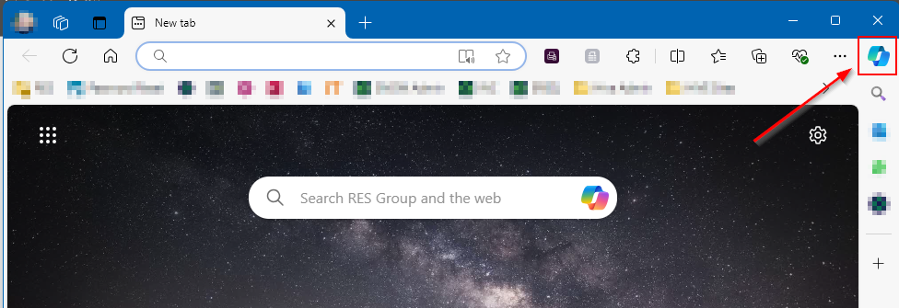



- Copilot for Microsoft Teams (licensed)
Microsoft offer AI functionality for Teams meetings - this can be used to summarise the discussed topics and actions from a meeting, as well as translate live transcriptions to other languages. For information on how to get access please see the link below.
IMPORTANT: These AI features require you to record your meeting. You should consider the ramifications of creating a permanent record of your meeting before using this feature. For example
- RES could be required to disclose recordings as discovery evidence in a dispute.
- AI is not infallible - transcriptions & meeting summaries can contain errors.



- Copilot for M365 (licensed)
Copilot for M365 is not yet generally available to staff in RES. There is an ongoing project to pilot the tool to a large business unit and, following this trial, there will be more information on how you can get access. In the meantime, you can access the free version of copilot
Copilot for M365 can access corporate data within an organisation's Microsoft environment (e.g. data within SharePoint & OneDrive). See the link below for more information about Copilot for M365.



If you feel there is a case for you to get early access to Copilot, then please submit a request here.


- ChatGPT (free & licensed)
IMPORTANT: Do not enter confidential company data into this tool.
RES IT do not offer licensing or support for this tool.
ChatGPT is a conversational AI model developed by OpenAI. It's designed to understand and generate human-like text based on the input it receives.

- Azure OpenAI
This service enables organisations to deploy AI models to analyse & query data stored within Azure.
RES IT can facilitate the deployment of this service to subscriptions within Azure. See the link below for more information about Azure OpenAI, including use cases, security, governance, and learning materials.



Start typing

