Personal Info

Name: Øyvind Iversen (Commonly Known as Wirtual)
Date of Birth: 12/09/1999 (age: 25)
Place of Birth: Unknown (assumed as Norway)
Nationality: Norwegian
Residency: Norway, estimated in Oslo or around Oslo
Occupation: Commentator, Player & Streamer (game: Trackmania)
Marital Status: Single (in Relationship with Anna Cramling)
Hobbies: soccer and many unknown stuffs
Vehicle: Renault Logan III
Email: Wirtual@evolved.gg (business) personal email unknown
Links: https://www.youtube.com/Wirtual
https://www.youtube.com/channel/UCf-vV5woXPFpkvZKwooWoyw
https://www.youtube.com/channel/UC2QjlMMSdO2aITpYlwdqZQw
https://www.twitch.tv/Wirtual
https://x.com/WirtualTM?mx=2
https://www.instagram.com/wirtualtm/

Description
Øyvind Iversen is a Norwegian streamer, YouTuber, and a commentator of Trackmania league.
His first car is Renault Logan III.
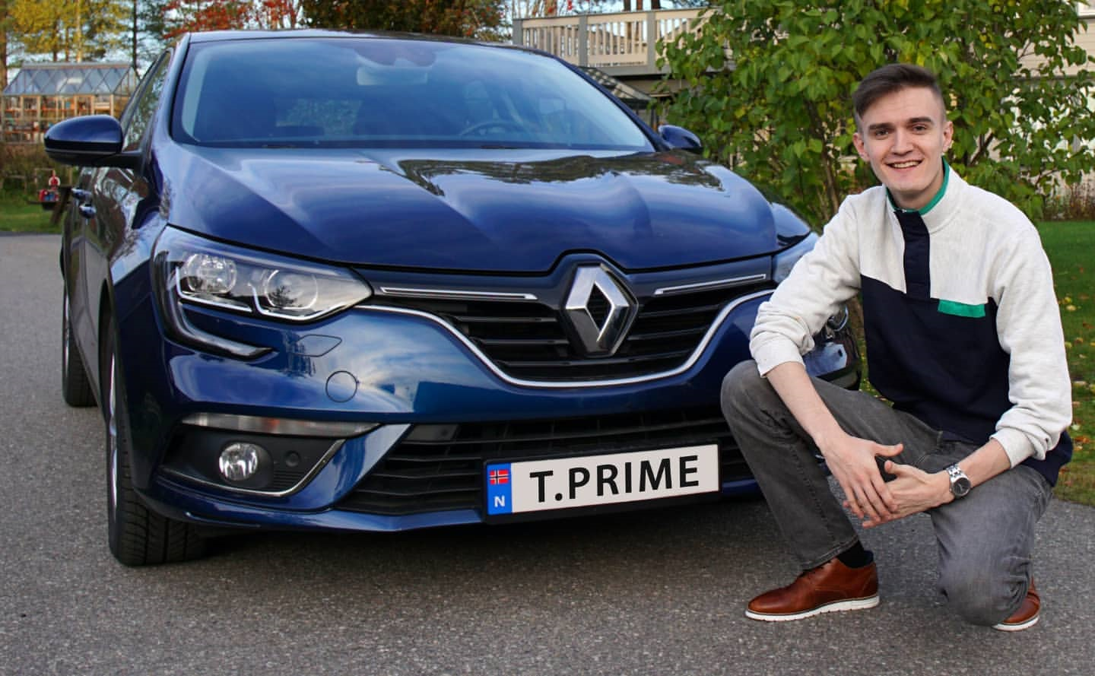

In 2023, he won the streamer award in racing category.
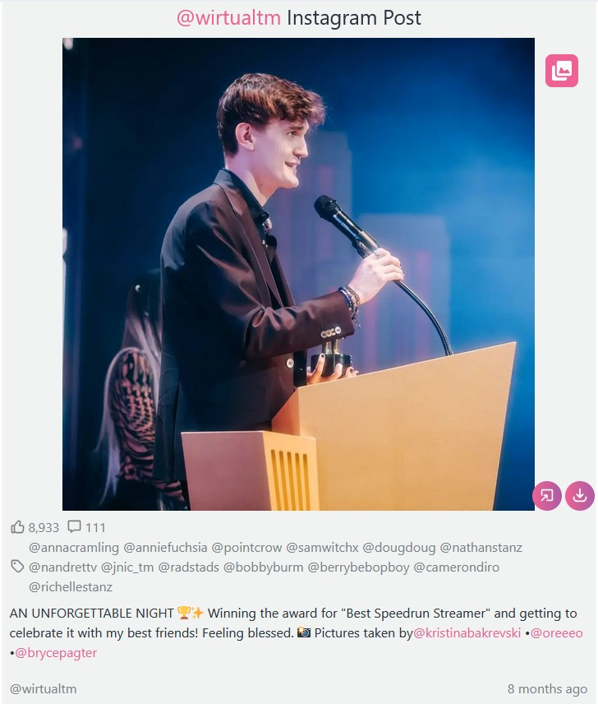

Travel History & Events
Recently, Wirtual uploads stories on Instagram much less, so it is impossible to keep track of every single travel logs. He travels to Sweden often to meet his girlfriend, Anna Cramling.

USA: Lost Angeles (LA), December 2024
Streamer Awards 2024 (December 7th 3 PM (PST)).
Arrival Date: estimated as 6th December 2024
Departure Date: December 10th 2024

USA: Lost Angeles (LA), March 2023
Attends Streamer Awards annually
Streamer Awards 2023 March 11 in LA at The Wiltern Building
Arrival Date in LA: Estimated between March 5th and 11th at LA International Airport
Departure Date in LA: March 21 2024
Arrival Date in Oslo: March 22 2023 at Oslo International Airport
Stayed at least approximately a week in the US
Nominated as one of the candidates for the award of Best Speedrun Streamer

USA: Lost Angeles (LA), February 17th 2024
Streamer Awards 2024 February 17th in LA at The Wiltern Building
Arrival Date in LA: Unknown (estimated between February 12th and 17th)
Departure Date in LA: Unknown
Arrival Date in Oslo: Unknown
Won the Award of Best Speedrun Streamer

Sweden: Uppsala and Karlskrona, June 27 2024
Arrival Date in Madrid: Unknown
Departure Date: Unknown
All pictures of the trip were uploaded on June 27.
The arrival date is estimated around the week of June 20^{th.}

Spain: Madrid, July 13th 2024
Arrival Date in Madrid: Unknown
Departure Date: Unkown
On July 13th, Anna Cramling uploaded a picture at Spain in Santiago Bernabéu Stadium for the event “La Velada del Año,” an amateur boxing event in Spain.
Event Date: July 13th 2024

Sweden: City Unknown on November 20th 2024
Arrival Date: Unknown
Departure Date: Unknown
Wirtual traveled with his close co-worker and friend (Jake) to Sweden in order to meet a friend on November 20th. The exact location is unknown.

Øyvind Iversen’s Circle
The circle of Øyvind Iversen is mostly filled with streamers and YouTubers. The people he associates are mostly content creators, and some of them are not a public figures. The majority of are Scandinavians, typically Swedish or Norwegian and are in their 20s or 30s. None of them are known to be married.

Jake: Co-worker & Friend
Date of Birth: 20/09/1995 (age: 29)
Nationality: Norwegian
Residency: Norway, Oslo
Occupation: Streamer & Caster
His last name is unknown
Has tattoo on his right arm

Links: https://www.twitch.tv/jnic
https://www.youtube.com/JnicTM
https://twitter.com/Jnic_TM
https://www.tiktok.com/@jnic_tm

Jake is known as the closest person in Iversen’s circle. They hang out and travels together frequently.
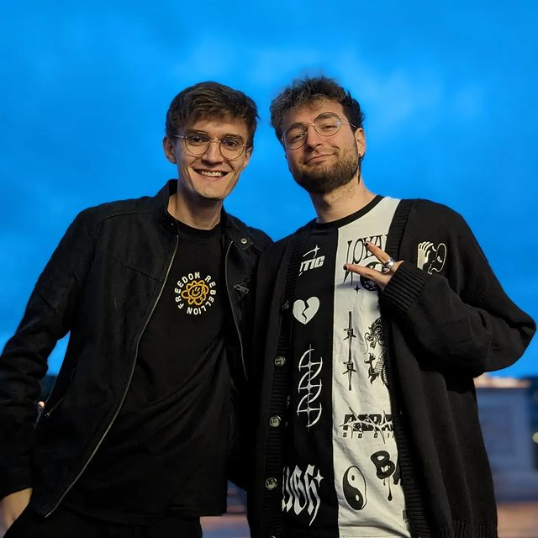


Name: Anna Cramling (Girlfriend)
Date of Birth: 30/04/2002 (age: 22)
Nationality: Spanish & Swedish
Residency: Sweden, Stockholm
Occupation: Streamer & Professional Chess Player
Links: https://www.youtube.com/annacramling
https://annacramling.com/fbclid=PAZXh0bgNhZW0CMTEAAabAXkeh1o93RaP6YBWSyhmrn9b6Zr6d2-GxUe3gQFJGC5XNtjs43yV9bJ4_aem_4qq9-de9Fl8s8dSo6b7awg

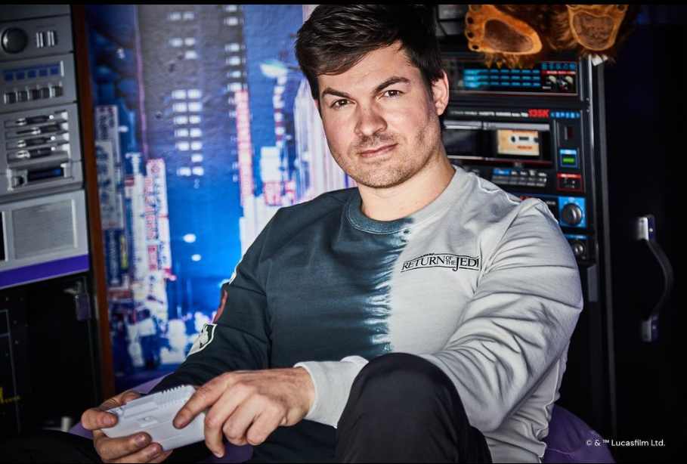
Name: Jonas Navarsete (known as AverageJonas)
Date of Birth: 20/08/1989 (age: 35)
Nationality: Norwegian
Residence: LA, US
Occupation: Streamer & Caster
Team: TeamLiquid
Links: https://www.twitch.tv/AverageJonas
https://www.instagram.com/average_jonas
https://x.com/Average_Jonas

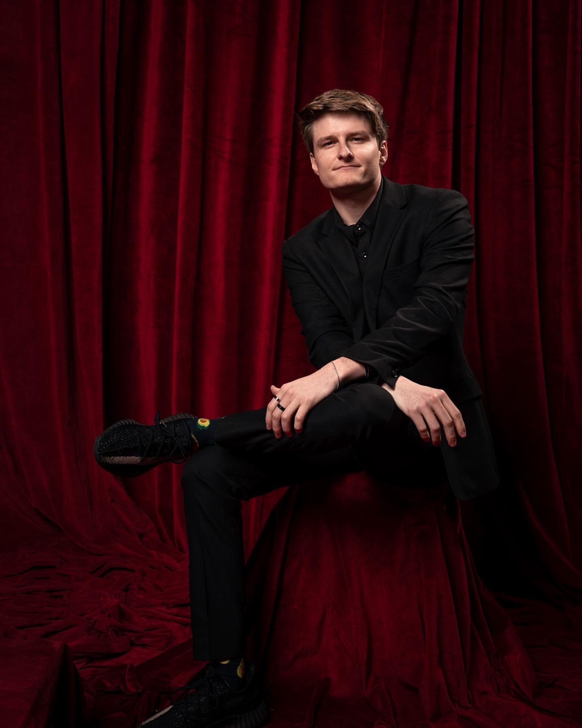
Name: Joseph Winkler (known as Keeoh)
Date of Birth: 28/07/1998 (age: 26)
Nationality: American
Occupation: Professional Fortnite Player & Streamer
Links: https://www.youtube.com/keeoh
https://www.twitch.tv/keeoh
https://x.com/keeoh
https://www.instagram.com/keeoh
Wirtual and Keeoh met at the Streamer Awards 2023
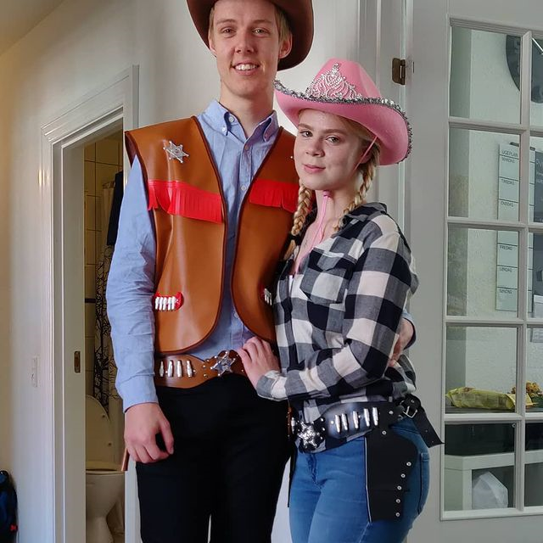
Name: Johan Løhde Thomsen
Date of Birth: unknown
Nationality: Swedish
Occupation: Unknown
Marital Status: Single (in relationship)
Hobby: skiing & video game (CS GO)


Name: Bendik Olsennn
Date of Birth: unknown
Nationality: Norwegian or Swedish
Occupation: Unknown
Marital Status: Single (unknown if in relationship or not)
Link: https://vsco.co/bendikolsen/gallery


Name: Jacob Krull (known as Jaxstyle1337)
Date of Birth: unknown
Nationality: Swedish
Occupation: Streamer (FPS games) & DJ
Marital Status: Single (in relationship with Liv Katarina,
who is a streamer as well)
Katarina’s Twitch Link: https://www.twitch.tv/livkatarina?fbclid=PAZXh0bgNhZW0CMTEAAaYi1wckPApbe8fyijdAB1nsWB2masZtt-9hI0Hu9UnJDEcMe30AbOTRXAA_aem_BNs2Sd7TmHF0tymF1PhOnA

Links: https://www.youtube.com/@JaxstyleProductions
https://www.twitch.tv/jaxstyle
https://x.com/jaxstyle1337?lang=en
https://www.snapchat.com/add/jaxstyle1337
https://www.tiktok.com/@jaxstyle1337?lang=en


Name: Kerry Perral
Date of Birth: unknown (age estimated between 20 ~ 30)
Nationality: British
Occupation: Streamer (FPS & Horror games) & YouTuber
Marital Status: single
Links: https://www.twitch.tv/perrikaryal
https://www.youtube.com/channel/UC_7SR20ovhbKc- k3NwMcgWQ
https://www.instagram.com/perrikaryal/
https://x.com/perrikaryal
https://www.tiktok.com/@perrikaryal
https://discord.com/invite/Qvg7McqrB8

Pictures & Geolocations

USA: Lost Angeles (LA), March 2023

Rock Climbing
Location: Hollywood Boulders
address: 1107 N Bronson Avr Los Angeles, CA 90038



Super Nintendo World
address: 100 Universal City plaza Universal City, CA 91608


Red Bull
address: 1630 Stewart St, Santa Monica, CA 90404



Sweden: June 27 2024

Bordsvägen 7, 556 52 Jönköping
https://vroom.se/kontakt/
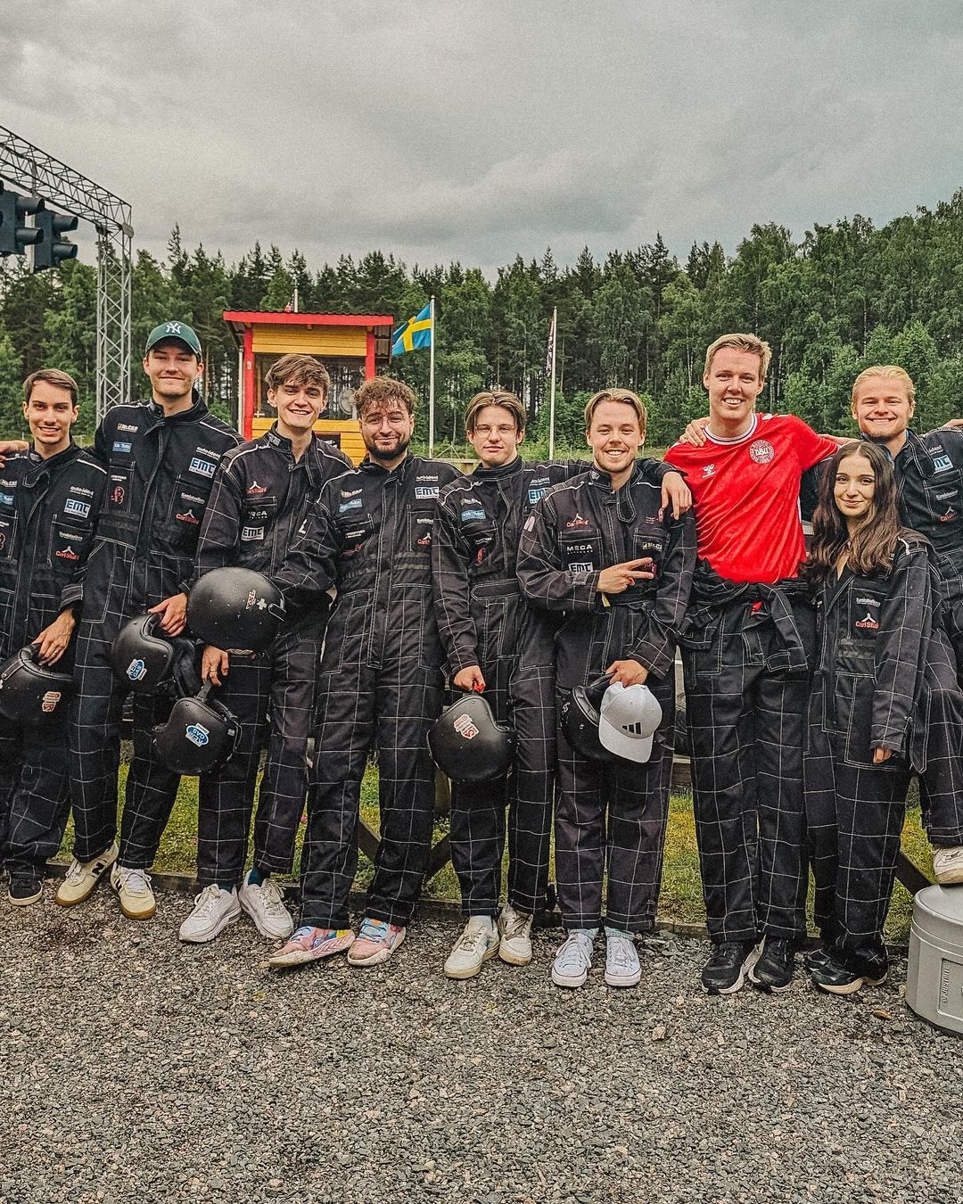
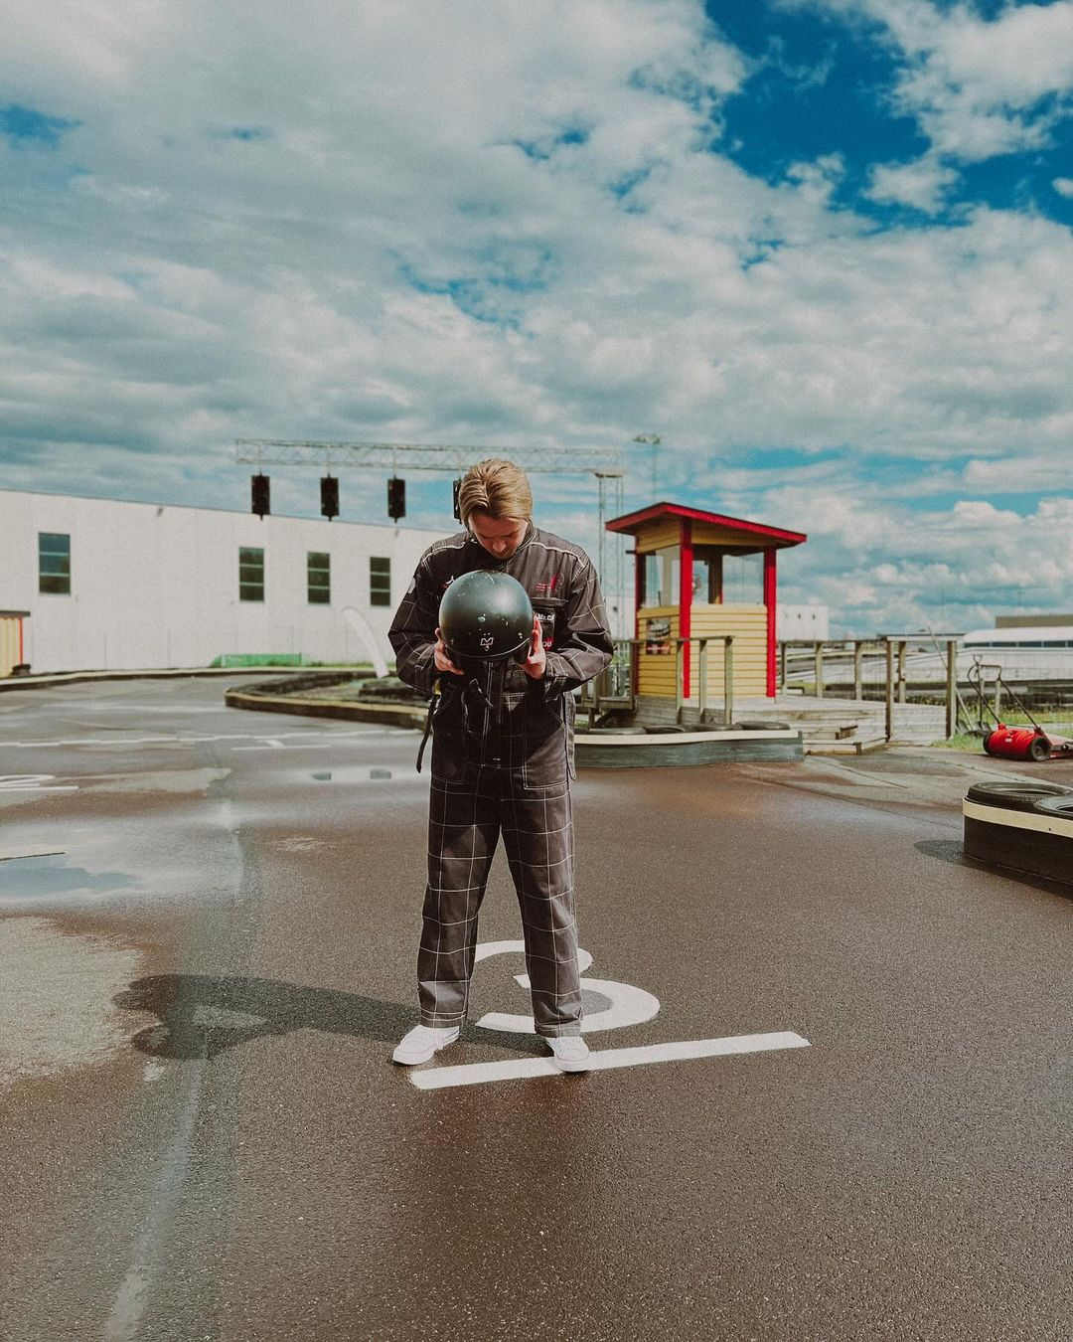

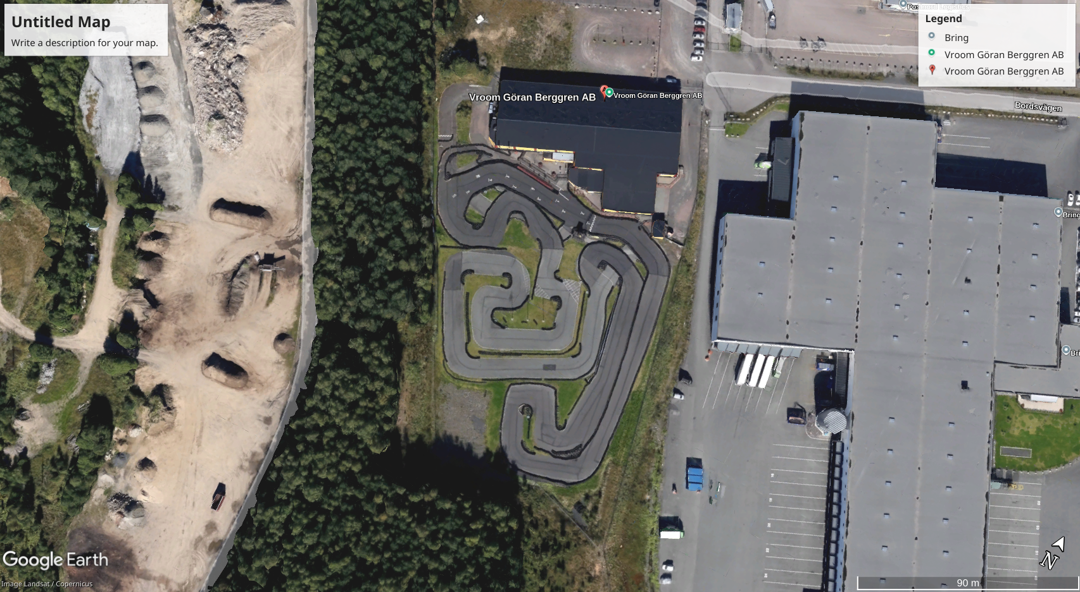

March 22 2023 at Oslo International Airport


