Name: Keene Lu NetID: KLJ3464 Project A: Hostile Minecraft Mobs

**About this project:**

The two assemblies within this project were based on creatures from the video game Minecraft, the Guardian (the fish like creature) and the Wither (the skeletal creature).

One thing I want to explicitly point out is the two 3D ‘parts’ that I designed myself. One of them is the extruded cube, which is a component on the ‘Guardian’. It was created by cutting away the edges of a cube by overlaying it with a box frame in TinkerCAD, then inverting the box frame to being a hole. Meanwhile, the other is a hexagonal prism, which is the tube that runs along the spine of the Wither. It was made in TinkerCAD as a hexagon that was then extruded up to create a certain amount of height.

**User’s Guide:**

There are 3 types of controls on this project: keyboard, mouse, and onscreen clickables.

Clickables:

* Run/Stop: plays/pauses the general looping motions (ie, the wither floating around and the guardian’s tail flapping)
* Heads Turn Rate +/-: these two buttons will modify the rate at which the two heads on stalks (the smaller ones) turn and scan. The default for the turn rate is 45 on a scale from 0 to 100.
* Set Heads Turn Rate to max (100): as its name suggests, sets the head turn rate to the max value of 100.
* Blink: Causes the eye of the wither to blink (ie, close and open). The pupil will disappear and reappear during this process as the eye opens and closes.
* Roll: makes the guardian do a barrel roll.
* Dance: Consists of two parts- the ‘Dance’ button and the slider. The dance button causes the Wither to do a little wiggly dance. The slider controls the minimum duration of the wiggling (if the duration passes and the Wither has not completely returned to the neutral position, it will finish up and return to neutral. The duration is displayed below the slider.

Keyboard:

* A/a will cause the guardian to turn towards its right.
* S/s will cause the guardian to turn toward its left.

Mouse:

* This is connected to the toggle checkbox under **Other Things**, which represents what the mouse drag currently does.
* When the checkbox is selected, the mouse will affect the Guardian’s eyeball. On dragging the mouse, the pupil will translate to aim towards the location of the mouse, making it look like the guardian is staring at the mouse pointer.
* When the checkbox is deselected, the mouse will affect the Wither’s main head. Dragging around makes the wither’s main head look around towards the total/net drag amount in the x and y locations.

**Results:**

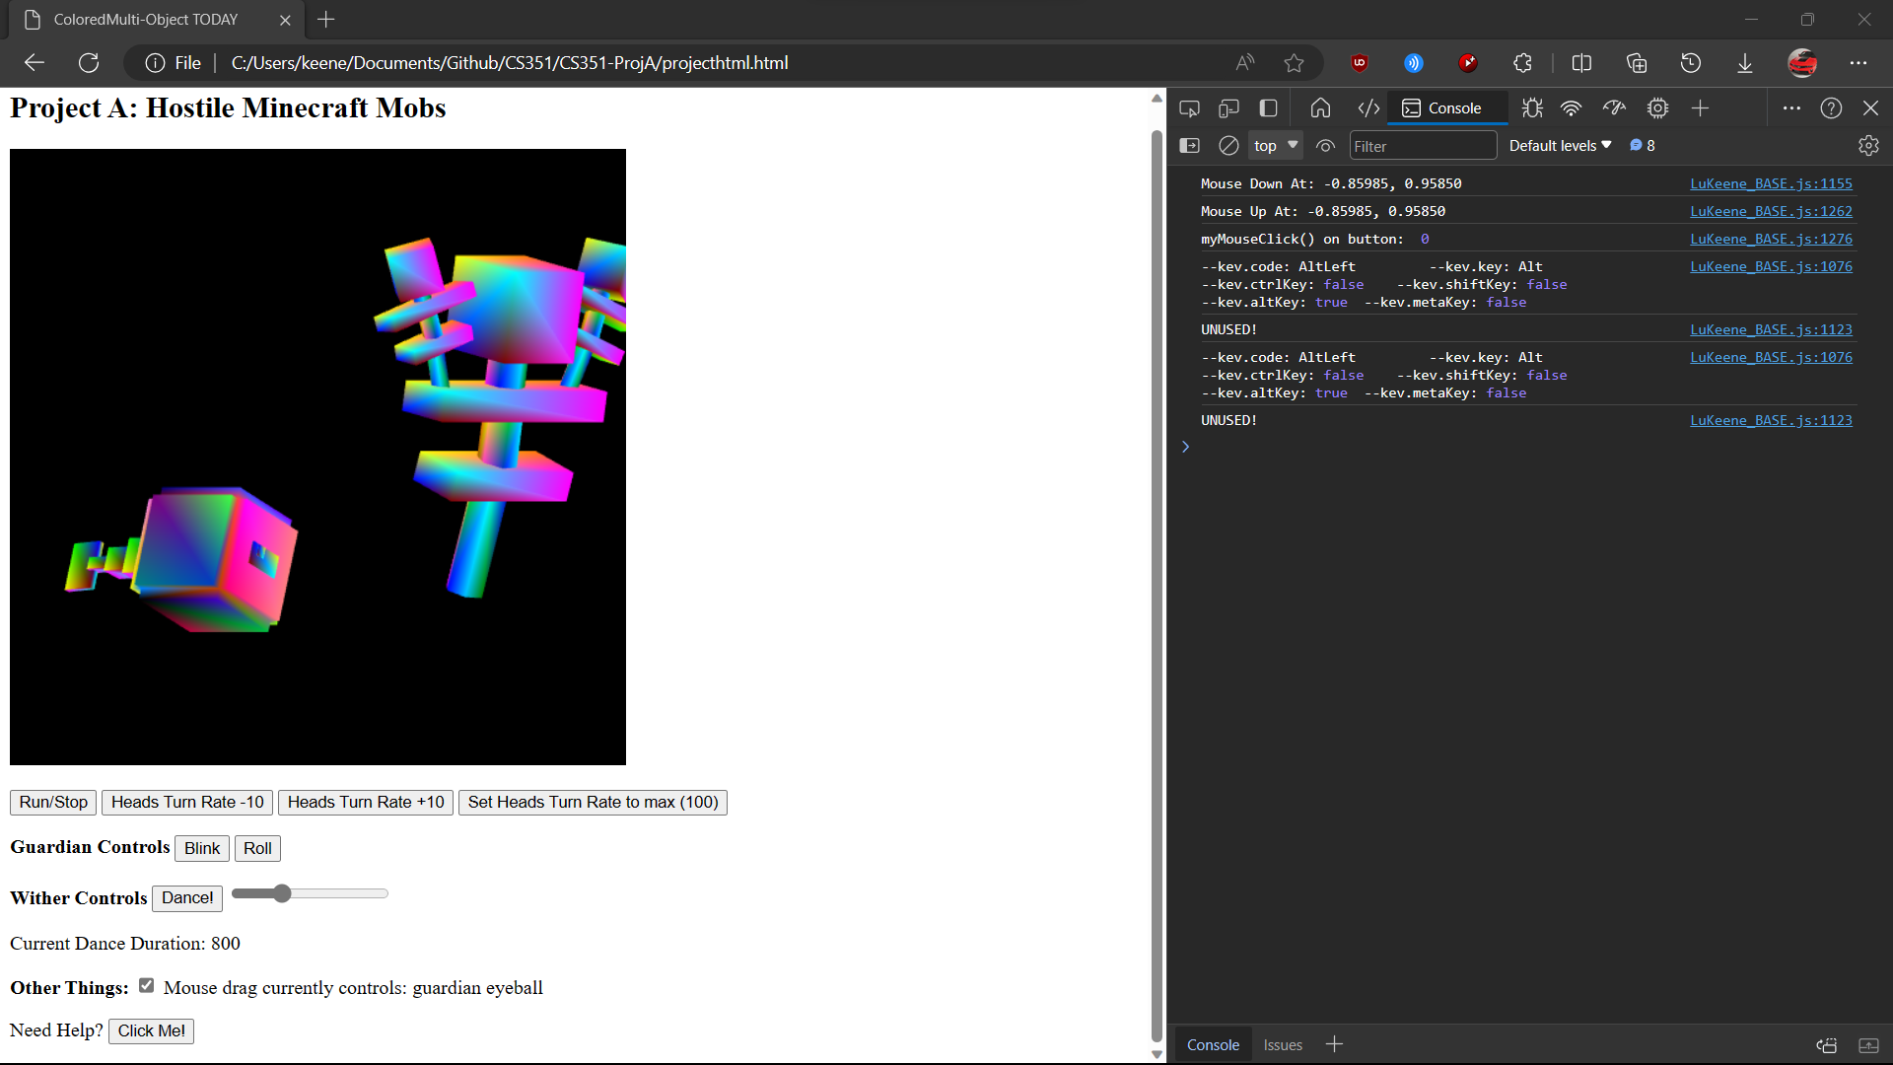

*Image 1: idling animation*

Here the Wither and Guardian are running through their basic loops. The Guardian is flapping its tail while the Wither is floating around, moving back and forth across the screen.

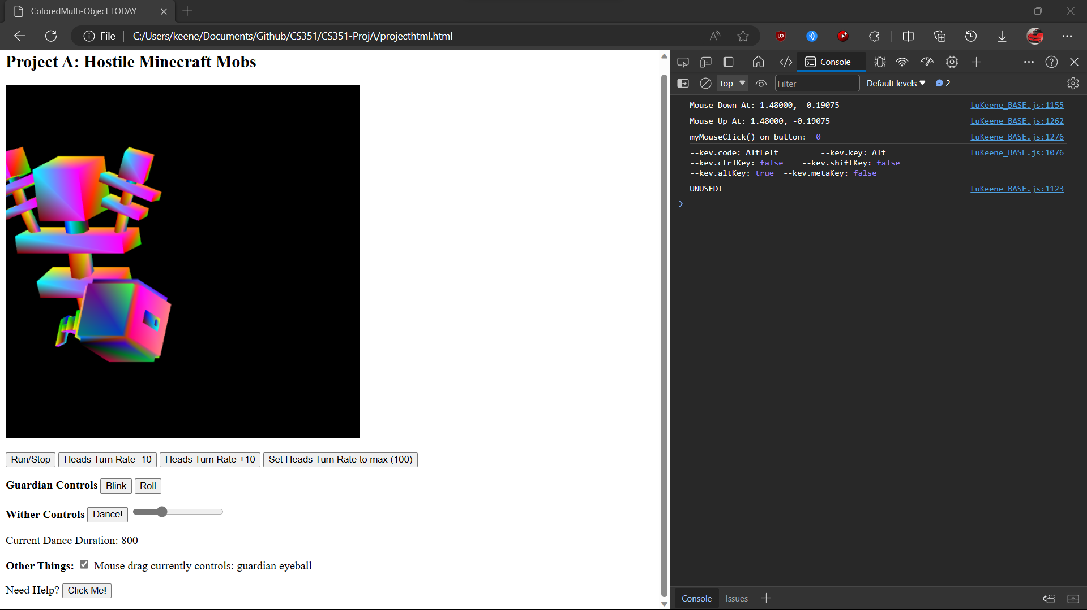

*Image 2: idling animation continued*

Here the basic loops for the Wither and Guardian are clearly at a different state than in image 1. The Guardian is has its tail further curved, and the Wither has moved to a different location.

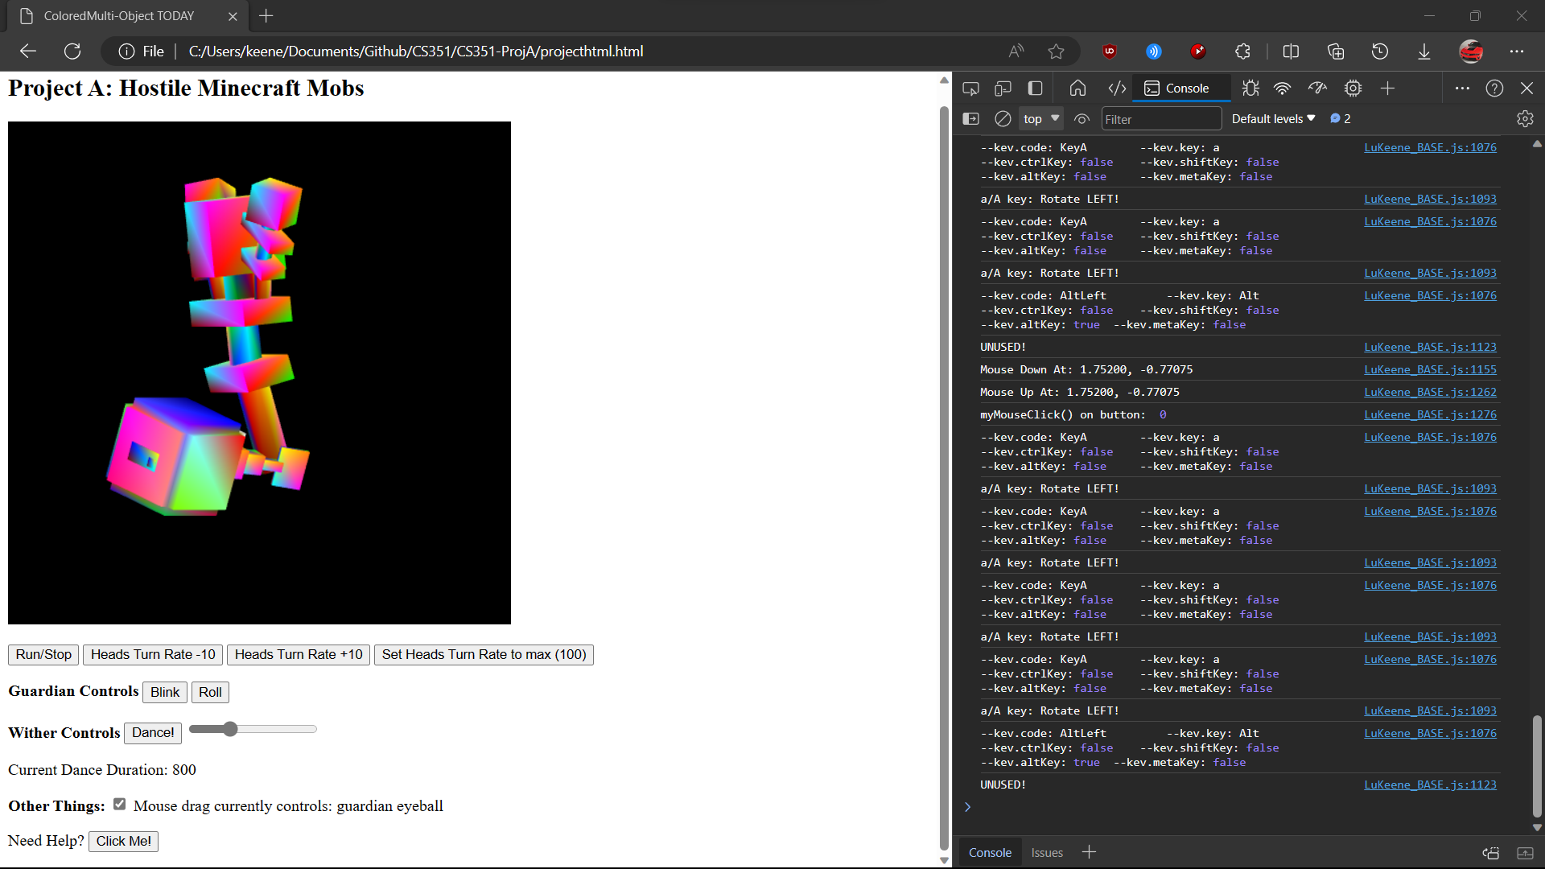

*Image 3: demonstration of keyboard input*

The use of the “A” key made the Guardian turn towards its right.

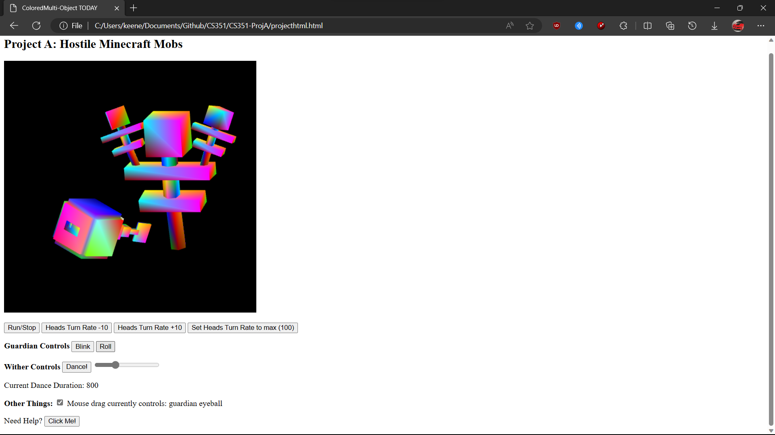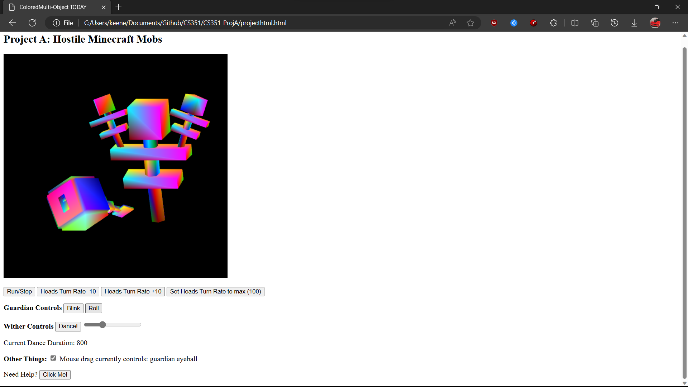

*Image 4, 5: demonstration of ‘Roll’ action under stopped idle animation.*

By clicking on the roll button, the guardian does a barrel roll, as seen by its differing rotation between the two images. Note that the Wither is in the same location across these two places, as the Run/Stop button was pressed to pause the idle animation.

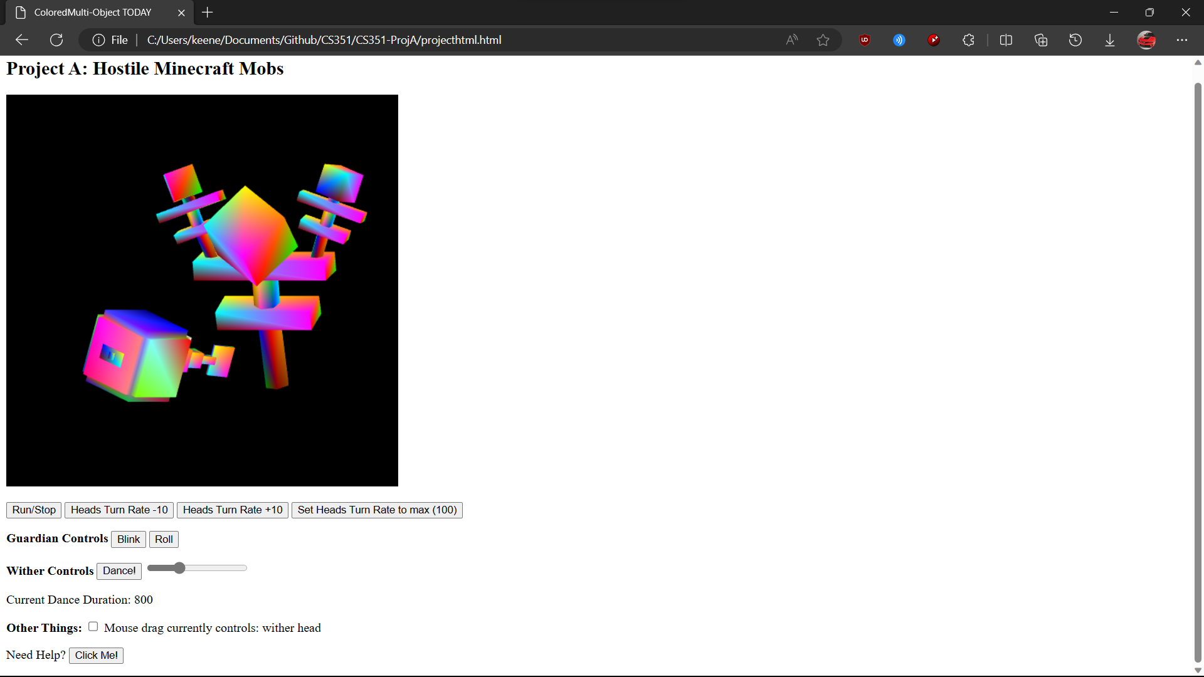

*Image 6: The effect of mouse drag on the wither’s head*

In this image, the user has deselected the mouse drag checkbox under “Other Things,” and then dragged around to make the wither’s primary head look towards the Guardian.