INTERNAL BUSINESS TOOL · SCOPE, FLOW & DESIGN
Long-Term Rental Deal Finder
A private tool for two authorised users. It searches Skyscanner every day for the cheapest complete 330-day rentals near a customer’s ZIP code, tracks how prices change, and lists the best deals for the team to review before presenting one to the customer.

Key point | Decision
Data source | Skyscanner car-rental inventory only
Rental period | Exactly 330 days, one pickup date, same location
Search area | Starting ZIP + max distance in miles + optional states
Vehicles | All categories; minivan, large SUV and passenger van filters
Price | Full price incl. taxes & fees; average 30-day = total ÷ 11
Tracking | Saved searches run daily with price history
Users | Maximum 2 internal users, simple secure login, nothing public

Prepared 17 September 2026 · Based on the client’s confirmed scope

Contents

If the contents list is empty, right-click it in Word and choose “Update Field”.

1. Project goal and business workflow

Goal
Find the lowest-priced long-term car-rental deals. The search is not about a specific city or rental location: the price of the deal is the priority. The main priority for Version 1 is to search Skyscanner efficiently and find the lowest-priced 330-day rental deals within the selected distance from a ZIP code.

How the business uses the tool
Customers never use the system or see raw Skyscanner results. Everything passes through the internal team.
- Customer: asks the business to find a long-term rental deal.
- Internal user: enters the customer’s requirements as a saved search.
- System: searches Skyscanner and ranks the best deals.
- Internal user: reviews the results and picks a deal to present.
- Business: presents the deal and charges the customer a service fee.

Internal use only
- Maximum of two authorised internal users.
- No public registration, customer accounts or public search page.
- Simple, secure login only.
- Not built for heavy traffic; infrastructure, search costs and capacity are sized for light internal use.
- Priorities: accurate searches, low search cost, saved results and easy internal use.

2. How a search works
Step 1 Sign in Internal user
- Simple, secure login for a maximum of two authorised users.
Step 2 Create a saved search Internal user
- Inputs: starting ZIP, maximum distance in miles, one or more states (optional), one pickup date.
- Return date = pickup date + 330 days, at the same location.
- Skyscanner is searched for the complete 330-day reservation, never split into 30-day rentals.
- A rental company may renew or rewrite the contract every 30 days. That happens after booking and does not change the search.
Step 3 Find every Skyscanner location in range System
- The ZIP code is converted to map coordinates.
- Every Skyscanner rental location within the distance (and chosen states) is selected: airports, city locations, neighbourhood branches and smaller locations, not only major airports.
- Each location’s distance from the ZIP is recorded.
Step 4 Search Skyscanner for each location System → Skyscanner
- One 330-day search per location through a managed Skyscanner car-hire data service (Apify).
- Every offer is collected for every vehicle category: rental company, booking provider, vehicle, total price, taxes and fees, mileage, conditions and booking link.
Step 5 Clean up and label each offer System
- Label the vehicle category; minivans, large SUVs and true passenger vans get their own filters, and all other categories are kept.
- Remove duplicate offers.
- Use the complete estimated price, including taxes and mandatory fees, to calculate the average 30-day price (below).
Average 30-day price = total 330-day price ÷ 11
Step 6 Save and compare with the previous run System
- Every result is saved to build price history.
- Each deal is compared with the previous day and flagged as: New deal, Price decrease, Price increase, or No longer available.
Step 7 Review the deals Internal user
- Sorted from the lowest average 30-day price to the highest.
- Filter and sort by vehicle type, rental company, booking provider, distance, state and price.
- The $1,100 per month target is highlighted; deals above it are still shown.
Step 8 Present the selected deal Internal user → Customer
- The team checks the deal on Skyscanner using its link and presents it to the customer.

Every day, automatically: each saved search re-runs steps 3 to 6 once a day, so results and price history stay current without anyone pressing a button.

3. What each deal shows
Field | Description
Vehicle | Vehicle category and an example vehicle (e.g. Passenger van – Ford Transit 12-seat)
Rental company | The company supplying the car (e.g. Budget, Enterprise, Hertz)
Booking provider | Who Skyscanner shows as selling the deal
Location | Pickup and return location (the same location)
Distance | Miles from the entered ZIP code
Dates | Pickup date and return date (pickup + 330 days)
330-day total | Complete estimated price incl. taxes and mandatory fees
Average per 30 days | Total ÷ 11
Taxes & fees | Shown when Skyscanner provides them
Mileage | Unlimited, or the included mileage allowance
Conditions | Important rental conditions available from Skyscanner
Status | New deal / Price decrease / Price increase / No longer available
Link | Link to view or book the deal on Skyscanner

Example results
Example rows for illustration only, not real prices.
Vehicle | Company | Booked via | Location | Distance | 330-day total | Avg / 30 days | Status
Passenger van (Ford Transit 12-seat) | Budget | Budget | Atlanta Airport | 14 mi | $11,880 | $1,080 | Price decrease
Minivan (Chrysler Pacifica) | Enterprise | Expedia | Marietta branch | 22 mi | $12,540 | $1,140 | New deal
Large SUV (Chevrolet Tahoe) | Hertz | Priceline | Decatur branch | 9 mi | $15,070 | $1,370 | Price increase

4. Version 1 and Version 2
Version 1 is everything the client confirmed. Version 2 holds the flexible-date feature the client asked for later, plus optional ideas, clearly marked, for the client to accept or drop.

Version 1 — build now: one pickup date, searched well
SEARCH
- Skyscanner car-rental inventory only.
- One pickup date per search; return = pickup + 330 days, same location.
- Starting ZIP + maximum miles + optional states.
- Every Skyscanner location in range, including small branches.
- Every vehicle category.
RESULTS
- Complete price including taxes and mandatory fees; average 30-day price = total ÷ 11.
- Sorted lowest average first; $1,100 is a target, not a maximum.
- All result fields listed in section 3.
- Separate filters for minivan, large SUV and passenger van.
TRACKING
- Saved searches run daily.
- Price history with new / decrease / increase / no-longer-available flags.
- Filter and sort results.
ACCESS & RUNNING
- Two internal users, simple secure login, nothing public.
- Sized for light internal use, with a daily search-cost cap.

Version 2 — later: flexible dates & convenience
REQUESTED BY CLIENT
- Flexible pickup dates: automatically test several pickup dates, for example every date in the next 30 days, and show the cheapest. Built only once the cost per search is known, with a daily budget limit.
OPTIONAL IDEAS, NOT REQUESTED
- Email alert when a deal drops below the $1,100 target.
- Price-history chart for a single deal.
- One-click customer-ready deal summary (PDF or shareable text).
- Search-cost dashboard: spend per search and per day.
- Mark deals as shortlisted, presented or booked, with notes.

5. Requirement checklist
Every point in the client’s confirmed scope, and where this design covers it.
Scope | Requirement | Covered by | Status
Goal | Lowest price is the priority, not a specific city | Search by distance from ZIP; ranked by average 30-day price | Covered
1 | Skyscanner only; all deals with rental company and booking provider | Step 4; result fields | Covered
2 | Exactly 330 days, one pickup date, automatic return date, same location, not split into 30-day rentals | Steps 2 and 4 | Covered – needs live test
3 | ZIP, max miles, one or more states; all locations incl. small branches | Steps 2 and 3 | Covered – needs location check
4 | All categories; clear type; separate filters for minivan, large SUV, passenger van | Step 5; filters in step 7 | Covered
5 | Full price incl. taxes & fees; total ÷ 11; lowest first; $1,100 is a target | Steps 5 and 7 | Covered
6 | All listed result fields | Section 3 | Covered where Skyscanner provides it
7 | Daily run, price history, new / up / down / gone, filter & sort | Step 6 and daily run | Covered
Future | Test multiple pickup dates automatically | Version 2 | Planned
Internal | Max 2 users, no public access, simple secure login, customers never see raw results | Step 1; business workflow | Covered
Internal | Accurate searches, low search cost, saved results, easy use, light infrastructure | Daily cost cap, saved searches, small single-server setup | Covered

6. Technical design
A small setup sized for two internal users: one web app, one backend server, one database, and the Skyscanner data service.

Technology
Part | Technology | Role
Web app | React | Login, saved searches, deals list, filters and history
Backend | NestJS (Node.js, TypeScript) | API, search logic, pricing, deal comparison
Scheduler | Cron job in the backend | Runs every saved search once a day
Data service | Apify – Skyscanner car-hire scraper | Returns Skyscanner offers for each location
Database | PostgreSQL | Users, searches, locations, quotes, price history

System architecture
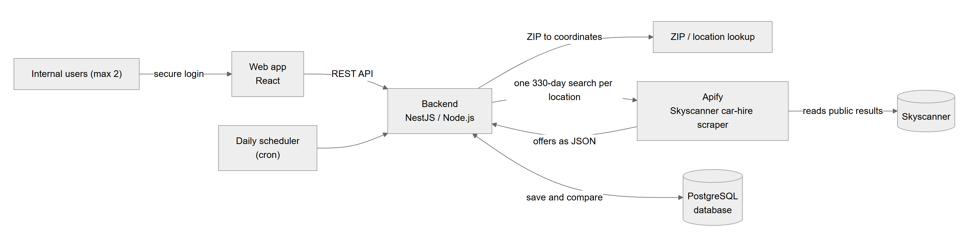
Figure 1 – How the parts of the system connect

Daily run, step by step
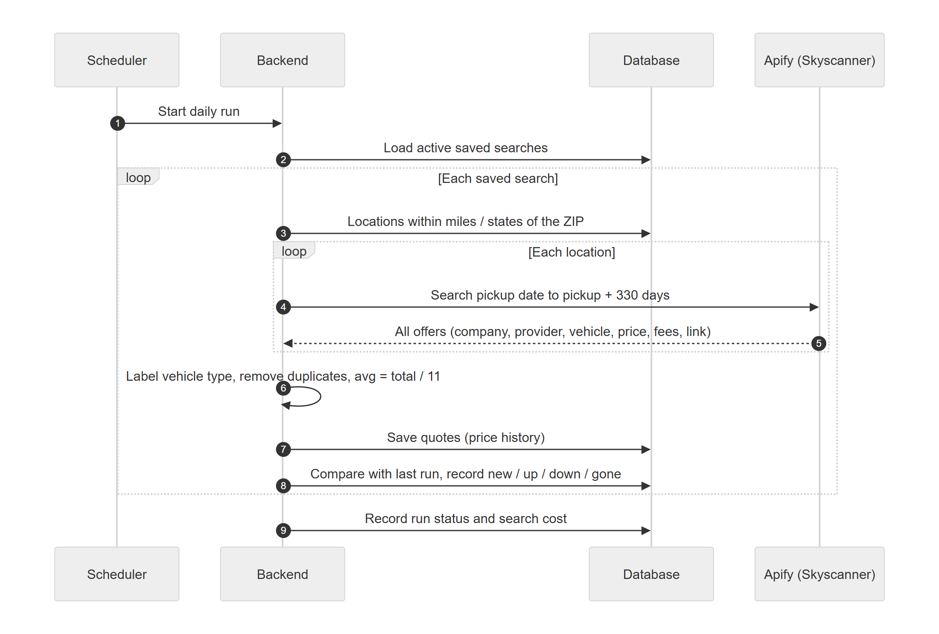
Figure 2 – What happens when the daily scheduler runs a saved search

Database (entity-relationship diagram)
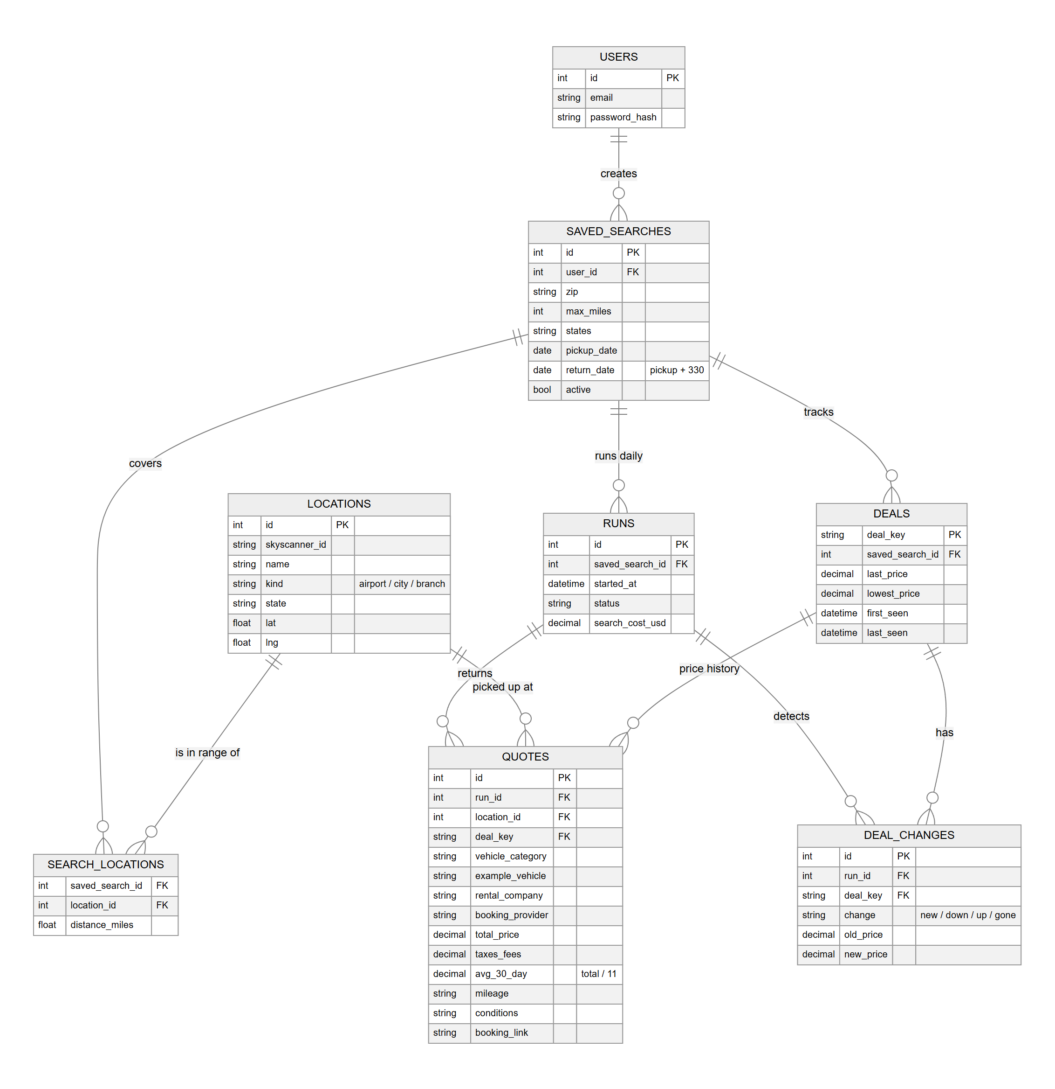
Figure 3 – Database tables and how they relate

Tables
Table | Purpose
users | The two authorised internal users and their login details
saved_searches | ZIP, max miles, states, pickup date and return date (pickup + 330)
locations | Skyscanner rental locations with type (airport / city / branch), state and coordinates
search_locations | Which locations are in range of each saved search, with distance in miles
runs | One row per daily run: status and search cost
quotes | Every offer returned: vehicle, company, provider, prices, fees, mileage, conditions, link
deals | One row per unique deal: last price, lowest price, first and last seen
deal_changes | Changes found in each run: new, price down, price up, gone

7. To confirm before building

Needs a live test
- 330-day results on Skyscanner: the Budget screenshot shows Budget’s own website can quote a 330-day rental. We still need to confirm Skyscanner returns 330-day offers.
- Location coverage: confirm we can list every Skyscanner branch near a ZIP code, not only airports.
- Taxes, fees, mileage and conditions: shown where Skyscanner provides them; some offers may omit details.

Cost and data access
- Cost per search: each location searched is a paid lookup, so a wider radius costs more per day. A daily spending cap keeps this controlled.
- Data access: Skyscanner offers no open API for this, so data comes from a third-party service that reads Skyscanner’s website. This is against Skyscanner’s terms, and searches can occasionally be blocked.

