BAUTISTA, Corvin Howell M.

FOPM01 – ITS152L

A.Installation

Class Library

P.S sorry ma’am this is the only available updated supported version rather than .NET 6.0

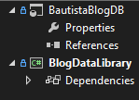

B. Setting Up Database

C. Adding rows through SQL Server Object Explorer

D. Setting up Models

E. Setting up dependency injection

<https://github.com/Klyceric/BAUTISTA-IT128>

<https://github.com/Klyceric/BAUTISTA-IT128>

<https://github.com/Klyceric/BAUTISTA-IT128>