**Octowhere Records**

1. **Presentation**

This website was designed specifically for a recording studio, offering unique functionalities tailored to the needs of both the studio and its clients. The primary features of this website include:

Date Registration Capability: Registered users can easily reserve dates for their recording sessions through a user-friendly reservation system. This feature is essential for clients who wish to plan and secure their studio time in advance.

Portfolio Viewing: The website showcases the studio's portfolio, allowing potential and existing clients to listen to samples of previous recordings. This feature is a crucial tool for the studio to display its expertise and the quality of its work, helping to attract new clients and retain existing ones.

The combination of these features not only enhances the user experience but also streamlines the studio's booking and client management processes.

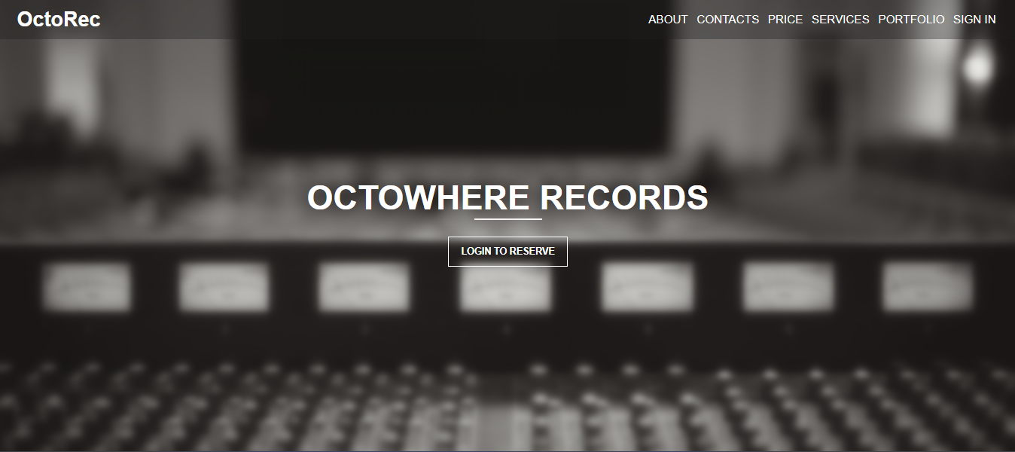

The main page of the recording studio's website consists of several key sections, each designed to provide specific information and enhance the user experience. Here are the main parts:

* About Section: This section offers general information about the studio, including its history, mission, and key achievements. It may feature the studio's founders, its team, and unique aspects that set it apart from competitors.

* Services Section: This part lists the services offered by the studio. This might include recording, mixing, mastering, and other specialized services. Descriptions, benefits, and possibly even indicative pricing for each service might be provided.

* Portfolio Section: Here, samples of the studio's work are showcased. This could include audio recordings from various projects that the studio has been involved with. The portfolio helps clients assess the quality and style of the studio's work.

* Contact Section: This section contains all the contact information of the studio, including the address, phone number, email. Links to the studio's social media and a map showing its location can also be included, making it easier for clients to connect with the studio.

* The website also includes a Pricing Page, which succinctly outlines the cost of services. Key features of this page include:
* Individual Service Prices: Lists prices for each service like recording, mixing, and mastering.
* Service Packages: Details bundled offers, combining services at discounted rates.
* Extras and Custom Options: Describes additional customizable services and their costs.

1. **Functions**

To access the date reservation feature on the recording studio's website, users must first log in to their account.

If a visitor does not have an account, they need to go through the registration process. Once successfully logged in or registered, users gain the ability to reserve recording dates.

Additionally, registered users gain access to their personal profile, where they can interact with various settings. This includes changing scheduled recording dates, updating personal details like nickname and password, and the option to upload or change their avatar. These features make the user's interaction with the website more personalized and convenient.

