RNAflow: an integrated, reproducible R/Shiny platform for end-to-end bulk RNA-seq analysis and interpretation
Karim Matmat^{1,*}
2026
¹ TODO: affiliation — institution, department, city, country. ORCID: TODO: 0000-0000-0000-0000.
* Correspondence: TODO: e-mail.

Abstract
Background. Bulk RNA-sequencing is a routine assay, but turning a count matrix into biological insight still requires stitching together many specialised tools for quality control, differential expression, dimensionality reduction, functional enrichment, co-expression networks, and activity inference. In practice this is done either with bespoke scripts that are hard to reuse and audit, or with interactive web applications that are convenient but often act as black boxes, cover only part of the workflow, and make it difficult to recover exactly what was run. Reproducibility — regenerating a figure or a table from the same inputs months later — is frequently an afterthought.
Results. We present RNAflow, an open-source platform that covers the bulk RNA-seq analysis workflow end to end — from a raw count matrix and sample metadata through differential expression (DESeq2), sample-level exploration (PCA / UMAP), multi-contrast comparison, functional enrichment (gene-set enrichment and over-representation analysis), weighted gene co-expression network analysis (WGCNA), transcription-factor and pathway activity inference (decoupleR), per-sample gene-set signatures (GSVA), and optional AI-assisted interpretation. RNAflow is distributed not as a monolithic script but as a properly engineered R package: all analysis and figure logic lives in a pure, unit-tested function layer (more than 440 automated tests), and the Shiny user interface is a thin wrapper over that public API. Every analysis can be saved as a portable session and exported as a runnable R script, a Methods paragraph, and a self-contained HTML report, and the whole environment is pinned in a Docker image, so a point-and-click exploration always maps back to a reproducible record. We demonstrate the platform on two published human datasets of contrasting complexity: a simple two-group glucocorticoid-treatment study and a 120-sample, eight-cancer-type subset of The Cancer Genome Atlas. We further validate correctness and reproducibility directly — an exported analysis re-runs bit-identically, the all-pairwise mode matches independent model fits exactly, and results concord with an independent limma-voom analysis.
Conclusions. RNAflow lowers the barrier to a complete, modern bulk RNA-seq analysis while keeping the result transparent and reproducible. It is available under the MIT licence at https://github.com/KmBioChemo/RNAflow.
Keywords: RNA-seq; differential expression; functional enrichment; co-expression networks; reproducibility; Shiny; R; Bioconductor.

Background
RNA-sequencing is the standard method for genome-wide transcript quantification, and it underpins a large fraction of contemporary molecular biology. A bulk RNA-seq experiment now routinely feeds a long analytical chain: quality control and normalisation; differential-expression testing between conditions; low-dimensional visualisation to inspect sample structure; functional enrichment to move from gene lists to pathways; and, increasingly, network- and knowledge-based interpretation such as co-expression modules and inferred regulator activity. Each of these steps is served by mature, well-validated software — DESeq2 for differential expression (Love et al. 2014), fgsea and clusterProfiler for enrichment (Korotkevich et al. 2021; Wu et al. 2021), WGCNA for co-expression networks (Langfelder and Horvath 2008), decoupleR for regulator and pathway activity (Badia-i-Mompel et al. 2022), and GSVA for per-sample signatures (Hänzelmann et al. 2013) — but assembling these components into a coherent, correct, and repeatable analysis remains the analyst’s responsibility, and it is where much of the practical difficulty and irreproducibility of transcriptomics lies.
Two broad strategies dominate in practice, and each carries a characteristic weakness. The first is a bespoke analysis script or computational notebook. This is maximally flexible and, if written carefully, fully reproducible; but in reality such scripts are usually written for a single project, encode implicit assumptions, are rarely reused, and are easy to get subtly wrong — a mismatched sample order, an un-relevelled factor, or a silent coercion can invalidate an entire analysis without any error being raised. Writing them also presupposes a level of programming fluency that many bench scientists reasonably do not have.
The second strategy is an interactive application, and a number of excellent web and Shiny tools exist for exploratory RNA-seq analysis. iDEP provides an integrated web workflow spanning differential expression, clustering, and pathway analysis (Ge et al. 2018); DEBrowser offers interactive DE and visualisation with quality diagnostics (Kucukural et al. 2019); pcaExplorer focuses on principal-component exploration with gene-set context (Marini and Binder 2019); GeneTonic streamlines the joint interpretation of DE results and enrichment (Marini et al. 2021); and ExpressAnalyst supports comprehensive expression and enrichment-network analysis across species (Ewald et al. 2023). These tools have dramatically lowered the barrier to entry and are widely and deservedly used. Yet they tend to share some limitations. Many are hosted web services, which requires uploading potentially sensitive data to a third party and ties the analysis to the availability of an external server. Most cover a subset of the full workflow — for example differential expression and enrichment, but not co-expression networks, activity inference, or per-sample signatures — so an analyst must still move between tools, re-exporting and re-importing data and losing provenance at every hop. And, crucially, the interactive session is often difficult to turn back into an exact, re-runnable record: the very interactivity that makes these tools accessible can make the resulting analysis opaque.
Underlying both strategies is a software-engineering gap. Interactive analysis tools are frequently built as a single large Shiny application in which the analysis logic and the user-interface code are interwoven. Such applications are hard to test, hard to reuse outside the graphical interface, and hard to maintain; the scientific core cannot be called from a script or covered by unit tests independently of the UI. For a tool whose outputs inform biological conclusions, this lack of testability is a genuine concern.
RNAflow is designed to address these gaps simultaneously, and its design follows three explicit principles. (i) Breadth: it covers the workflow from count matrix to functional and network-level interpretation in a single, internally consistent tool, so that enrichment, co-expression, activity inference, and signature scoring are all available on the same loaded dataset without leaving the application. (ii) Reproducibility: every analysis is a saveable session that can be exported as a runnable script, a Methods paragraph, and a self-contained report, and the software stack is pinned in a container, so that the convenience of a graphical interface never comes at the cost of a transparent record. (iii) Software engineering: RNAflow is built as a tested R package with a pure, reusable function layer rather than a single monolithic application, so its components can be scripted, tested, and maintained independently of the interface. This article describes RNAflow’s architecture and each analysis module in detail, sets out the design rationale and intended audience, and demonstrates the platform on two published human datasets of contrasting complexity.

Implementation
Figure 1 gives an overview of the platform. From a single loaded dataset — a count matrix and sample metadata for human, mouse, or rat — RNAflow runs a suite of interoperable analysis modules (differential expression, quality control, sample exploration, functional enrichment, co-expression networks, activity inference, per-sample signatures, multi-contrast comparison, and optional AI-assisted interpretation) and exports the whole analysis as reproducible artefacts. We describe each component in turn.
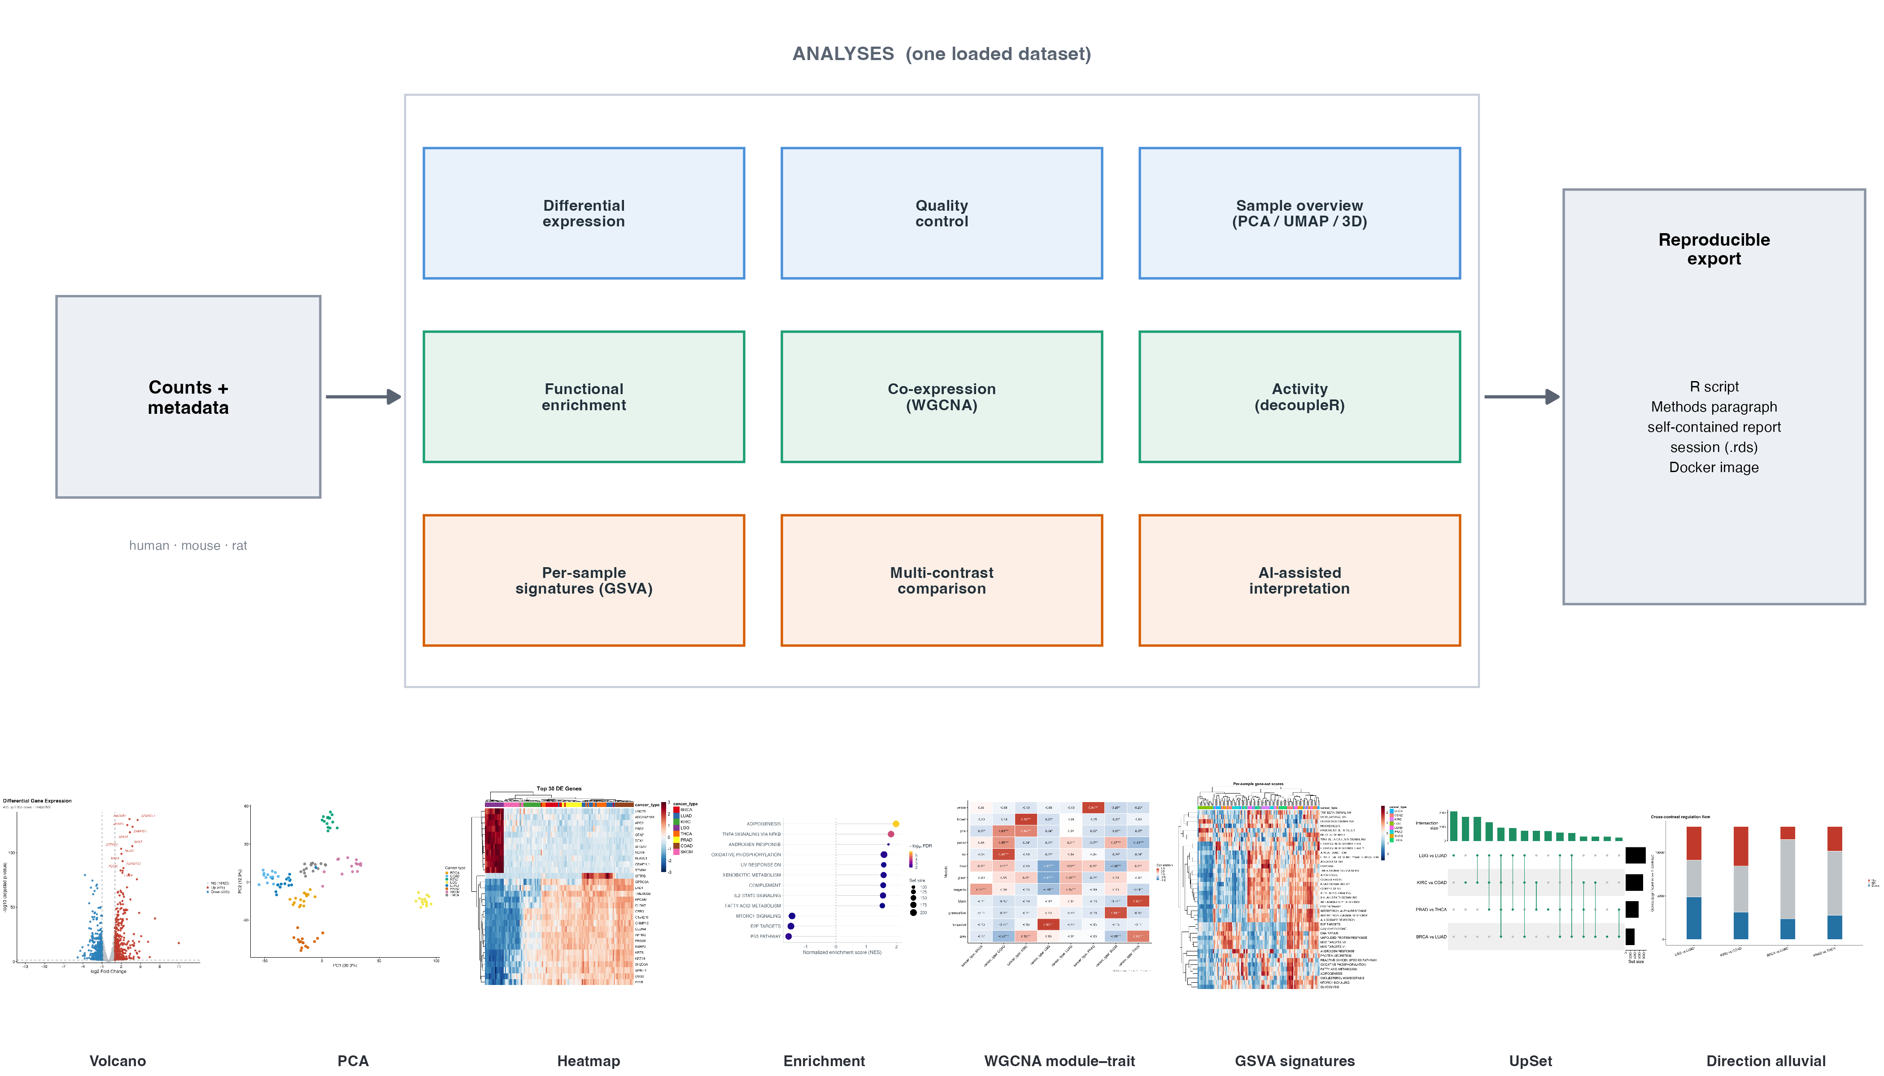
Figure 1. Overview of RNAflow. From a count matrix and sample metadata (human, mouse, or rat), a single loaded dataset is analysed by nine interoperable modules — differential expression, quality control, sample exploration (PCA / UMAP / 3D), functional enrichment, co-expression networks (WGCNA), regulator and pathway activity (decoupleR), per-sample signatures (GSVA), multi-contrast comparison, and optional AI-assisted interpretation — and exported as reproducible artefacts (a runnable R script, a Methods paragraph, a self-contained report, a portable session, and a Docker image). Bottom row: representative real outputs from the two demonstration datasets.

Software architecture and design
RNAflow is an R package built on the Shiny web-application framework (Chang et al. 2024) and the bslib theming system (Sievert et al. 2024). Its central design decision is a strict separation between pure and impure code. All analysis and figure logic is implemented as ordinary R functions that take data in and return data or graphics out, with no dependence on the Shiny reactive runtime; by convention these are prefixed read_*, validate_*, run_*, compute_*, and fig_*, and together they form a documented public API that can be used from any R script. The interactive layer is a set of Shiny modules (prefixed mod_*), each of which is a thin wrapper that binds user inputs to the pure functions and renders their outputs. No analysis is implemented inside a module.
This architecture has three practical consequences. First, the scientific core is independently testable: the package ships more than 440 automated unit tests (using testthat) that exercise the analysis and figure functions directly, without a browser, so a regression in, say, the differential-expression wrapper is caught by continuous integration rather than by a user. Second, the core is reusable: any function shown in the interface can be called programmatically, which is what makes the exported reproducibility scripts (below) possible. Third, the package is maintainable and conforms to standard R packaging practice — documentation is generated with roxygen2, a reference website is built with pkgdown, and the package passes R CMD check cleanly.
Dependency management reflects the same discipline. Lightweight, universally needed packages are hard dependencies, whereas heavy or specialised Bioconductor packages (for example WGCNA, GSVA, decoupleR, and the organism annotation databases) are optional and are guarded at the point of use with requireNamespace, so that a missing optional dependency produces an informative, actionable message rather than an obscure failure, and the corresponding feature degrades gracefully. The user-interface styling is served through a single token-based stylesheet registered as a package resource, giving a consistent, professional look without embedding styling in the R code.

Input, validation, and identifiers
RNAflow takes two inputs: a counts matrix (genes in rows, samples in columns, gene identifiers in the first column) and a sample-metadata table (sample identifiers in the first column, annotations thereafter). CSV, TSV, plain-text, and Excel formats are accepted. Both inputs pass through strict validation (validate_counts, validate_metadata) that fails fast with an explicit, human-readable message on the common sources of error: non-numeric or negative counts, duplicated or missing gene identifiers, missing values, and — most importantly — any mismatch between the samples named in the counts matrix and those in the metadata. Catching these at the door prevents the confusing downstream failures that otherwise consume analyst time. Gene identifiers may be symbols, Ensembl gene IDs (with or without version suffixes), or Entrez IDs; where a downstream method requires a particular identifier space — for example Entrez IDs for some enrichment databases — RNAflow performs the mapping internally through the appropriate organism annotation package. Human, mouse, and rat are supported.

Differential expression
Differential expression is computed with DESeq2 (Love et al. 2014). The user selects the design variable and, optionally, one or more covariates to adjust for (for example a batch or a paired-subject identifier); covariates are placed ahead of the variable of interest in the model formula so that the reported contrast is the conditional effect of interest. A minimum row-count filter removes undetected genes before fitting, and independent filtering is applied at a user-set target false-discovery rate. Effect sizes can be shrunk with the apeglm estimator (Zhu et al. 2019), with automatic fallback to the ashr or normal estimators when apeglm is unavailable or inapplicable to the requested contrast.
A deliberate design choice is that inference and effect-size estimation are kept separate. P-values and the Wald test statistic always come from the unshrunken model, while shrinkage only adjusts the reported log-fold-change and its standard error for ranking and visualisation. This guarantees a well-defined test statistic — and therefore a valid ranking metric for downstream gene-set enrichment — even when apeglm, which does not itself return a test statistic, is used for the effect size.
Beyond a single user-specified contrast, RNAflow can compute all pairwise comparisons of a multi-level design variable from a single model fit (run_deseq2_all_pairs). Because the dispersion estimates and the fitted model are shared across contrasts, this is far cheaper than refitting for each pair, and it adds every pairwise result to a named contrast store for immediate comparison. When shrinkage is requested in this mode, RNAflow uses a contrast-compatible estimator, since apeglm requires a model coefficient matching each specific pair. This capability is particularly useful for designs with many groups — a multi-tissue or multi-genotype panel — where every pairwise difference is potentially of interest.

Normalisation and sample-level exploration
For visualisation and clustering, counts are transformed with the variance-stabilising transformation (VST) or the regularised logarithm from DESeq2, with a simple log-counts-per-million option for speed on large matrices. Samples are then projected with principal-component analysis, an interactive three-dimensional PCA, and UMAP (McInnes et al. 2018); each projection is computed on the most variable genes (a user-set number), can be coloured by any metadata variable, and offers an optional toggle for on-plot sample labels so that dense cohorts remain legible. UMAP embeddings are seeded and the random-number state is restored, so the projection is deterministic and reproducible across sessions. These low-dimensional maps are the first place a mislabelled sample or an unwanted batch effect becomes visible, before it contaminates downstream results, and in practice they are among the most consulted views in the application.

Multi-contrast comparison
When several contrasts have been computed — whether one at a time or through the all-pairwise mode — RNAflow compares them directly through a named contrast store. Comparison views include significant-gene set overlaps as Venn and UpSet (Conway et al. 2017) diagrams, a grid of volcano plots on a common scale, a log-fold-change heatmap of genes across contrasts, and an alluvial diagram tracing how genes move between up-regulated, down-regulated, and non-significant states across contrasts. Together these turn a collection of separate differential-expression runs into a single comparative picture, which is essential for multi-condition and time-course designs.

Functional enrichment
RNAflow provides both major flavours of enrichment, which answer different questions. Gene-set enrichment analysis (GSEA) is computed over the entire ranked gene list with fgsea (Korotkevich et al. 2021; Subramanian et al. 2005), using the Wald statistic as the ranking metric, and asks whether a gene set is coordinately shifted toward one end of the ranking. Over-representation analysis (ORA) tests whether the set of significantly differentially expressed genes is enriched for a category relative to a background universe, using clusterProfiler (Wu et al. 2021). Gene-set collections include the MSigDB Hallmark and curated collections (Liberzon et al. 2015; Dolgalev 2022), Gene Ontology (biological process, molecular function, cellular component), KEGG, and Reactome (Yu and He 2016). Results are presented as dot- and bar-plots, running-enrichment curves, and both a static and an interactive network map in which enriched terms are connected by shared-gene (Jaccard) overlap, so that redundant terms cluster and the dominant themes become visible at a glance.

Co-expression networks
Weighted gene co-expression network analysis is available through WGCNA (Langfelder and Horvath 2008). RNAflow guides the user through the standard workflow: selecting the most variable genes, choosing a soft-thresholding power by the scale-free-topology criterion, detecting modules on a signed topological-overlap network, correlating module eigengenes with sample traits, extracting per-module hub genes by intramodular connectivity, and running functional enrichment on each module. This exposes coordinated programmes of gene expression and relates them to phenotype, complementing the gene-by-gene view of differential expression with a systems-level one.

Regulator and pathway activity
RNAflow infers upstream activity with decoupleR (Badia-i-Mompel et al. 2022), estimating transcription-factor activity from the CollecTRI regulon (Müller-Dott et al. 2023) and pathway activity with PROGENy (Schubert et al. 2018); the underlying prior-knowledge networks are retrieved through OmniPath (Türei et al. 2021). Activity is estimated from the DE statistics with a univariate linear model and displayed as ranked activity scores. Because the prior-knowledge networks are fetched from a live resource, this module is written to degrade gracefully and to report the underlying cause when a network cannot be retrieved, rather than failing silently. Activity inference shifts interpretation from individual differentially expressed genes to the regulators and pathways that plausibly drive them.

Per-sample signatures
Gene-set variation analysis (Hänzelmann et al. 2013) scores every sample against a chosen gene-set collection, producing a sets-by-samples signature matrix (via the GSVA or ssGSEA method) that is displayed as an annotated heatmap. Counts are first mapped to gene symbols so that projects using Ensembl or Entrez identifiers score correctly. Unlike contrast-based enrichment, which summarises a comparison, this yields a per-sample activity profile suitable for stratifying heterogeneous cohorts, relating signature activity to continuous phenotypes, or identifying outliers.

AI-assisted interpretation
As an optional aid, RNAflow can assemble a structured prompt from a contrast — its top up- and down-regulated genes and its most enriched terms — and query a large-language-model API to draft a narrative interpretation. This feature is strictly opt-in and privacy-preserving: it is inactive unless the user supplies their own API key, which is held only in memory for the session and is never stored, logged, or committed, and no data leave the machine unless the user explicitly runs the feature. Its output is presented as a hypothesis-generating draft to be verified against the primary results and the literature, never as an authoritative conclusion. The intent is to help a user orient quickly in an unfamiliar biological area, not to replace expert interpretation.

Reproducibility and export
Reproducibility is a first-class feature rather than an add-on. A complete analysis — inputs, DE results, the contrast store, enrichment, signatures, activity, and all settings — can be saved to a single portable session file and reopened later, with backward compatibility so that sessions saved by earlier versions still load. From any analysis, RNAflow generates three complementary artefacts. A runnable R script reproduces the pipeline using the package’s public functions, so the interactive analysis can be re-executed, version controlled, or adapted without the interface. A Methods paragraph summarises the analysis in prose suitable for a manuscript, with the software versions used. And a self-contained HTML report embeds the figures and results in a single file that requires no external renderer such as pandoc or a LaTeX installation, so it can be shared with collaborators directly. To pin the computational environment itself, the repository ships a Docker image built on the official Bioconductor base image (R 4.5 / Bioconductor 3.22), so that the heavy dependency stack resolves identically on any machine; an optional package lockfile can pin exact versions on top for byte-level reproducibility.

Figures and bundled data
Every figure function offers an exploration mode for interactive work and a publication mode with strict, compact styling — a small serif-free font, minimal chart junk, and defined dimensions — ready to drop into a manuscript panel. Interactive figures share a common plotly styling (Sievert 2020) for a consistent look, and static figures build on ggplot2 (Wickham 2016) and ComplexHeatmap (Gu et al. 2016), with export to vector (PDF, SVG) and raster (PNG) formats. Two real, published human datasets are bundled for demonstration and testing, and each is reproducibly regenerated from its Bioconductor source by a script in the repository: the airway dataset (Himes et al. 2014), a simple two-group glucocorticoid-treatment study, and a TCGA pan-cancer subset (Rahman et al. 2015; Weinstein et al. 2013), a complex eight-cancer-type cohort described below.
Table 1 summarises the analysis modules, the methods and packages behind them, and their principal outputs.
Table 1. RNAflow analysis modules.
Module | Method / package | Principal outputs
Differential expression | DESeq2, apeglm (Love et al. 2014; Zhu et al. 2019) | DE table; volcano; all-pairwise contrasts
Normalisation | VST / rlog / logCPM (Love et al. 2014) | transformed matrix
Sample overview | PCA, UMAP (McInnes et al. 2018) | 2D/3D PCA, UMAP; QC diagnostics
Multi-contrast | contrast store | Venn/UpSet, volcano grid, LFC heatmap, alluvial
Enrichment (GSEA) | fgsea (Korotkevich et al. 2021; Subramanian et al. 2005) | dotplot, running-enrichment curve
Enrichment (ORA) | clusterProfiler (Wu et al. 2021) | bar/dotplot; term-overlap network
Co-expression | WGCNA (Langfelder and Horvath 2008) | modules, module–trait, hub genes
Activity | decoupleR (Badia-i-Mompel et al. 2022) | TF (CollecTRI) & pathway (PROGENy) activity
Signatures | GSVA / ssGSEA (Hänzelmann et al. 2013) | per-sample signature heatmap
Interpretation | LLM API (opt-in) | narrative draft (to verify)
Reproducibility | base R / Docker | session file, R script, Methods text, HTML report

Statistical methods and defaults
Each analysis uses the field-standard method with documented, user-adjustable defaults (Table 2). Two conventions are worth highlighting. First, differential-expression inference and effect-size shrinkage are kept separate: p-values and the test statistic always come from the unshrunken DESeq2 Wald test, while apeglm shrinkage only adjusts the reported log-fold-change — so the Wald statistic, and therefore the GSEA ranking that consumes it, is always well defined. Second, the all-pairwise mode fits the model once and extracts each pairwise contrast from that shared fit, which is both statistically consistent (common dispersion estimates) and far cheaper than independent fits.
Table 2. Statistical methods and default parameters (all user-adjustable).
Step | Method / test | Multiple testing | Key defaults
Pre-filtering | drop low-count genes | — | row sum >= 10
Differential expression | DESeq2 negative-binomial GLM, Wald test | Benjamini–Hochberg | covariates + variable of interest; independent filtering at alpha = 0.05; apeglm LFC shrinkage
All-pairwise DE | one DESeq2 fit, results() per pair | Benjamini–Hochberg | contrast-based normal/ashr shrinkage
Normalisation | VST (n >= 4) / rlog / log2-CPM | — | VST, blind
PCA | prcomp on top-variable genes | — | 500 most variable (VST)
UMAP | uwot | — | 500 genes; neighbours = 15; min-dist = 0.1; seeded
GSEA | fgsea | Benjamini–Hochberg | ranked by Wald statistic
ORA | clusterProfiler hypergeometric test | Benjamini–Hochberg | universe = tested genes; significant = padj < 0.05 and |log2FC| > 1
Co-expression | WGCNA, signed network | — | soft power at scale-free R² >= 0.8; dynamic tree cut, min module 30, deepSplit 2, merge height 0.25
Module–trait | Pearson eigengene–trait correlation | — | correlation p-values
Activity | decoupleR univariate linear model | — | CollecTRI / PROGENy priors; min set size 5
Signatures | GSVA (Gaussian kernel) / ssGSEA | — | set size in [5, 500]
Gene-set collections are MSigDB (Hallmark, curated C2, ontology C5) via msigdbr, plus GO, KEGG, and Reactome.

Performance
RNAflow is built to stay interactive on a laptop. On the 120-sample TCGA cohort (18,686 genes) and the 8-sample airway dataset, running on a current laptop (Apple M-series, R 4.5 / Bioconductor 3.22), representative steps took: the variance-stabilising transform 0.5 s, PCA < 0.1 s, UMAP 0.9 s, GSEA 1.0 s, GSVA (120 samples × 50 signatures) 1.4 s, and WGCNA (3,500 genes) 7.4 s. The compute-bound steps are the DESeq2 fits: a single 120-sample contrast with shrinkage took 25 s and over-representation analysis 15 s, while — the payoff of the shared-fit design — all 28 pairwise contrasts together took 30 s, versus the several minutes that 28 independent fits would require. A complete reference analysis of the pan-cancer cohort therefore runs end to end in a couple of minutes and within a few gigabytes of memory, well inside the envelope of an interactive session.

Design rationale and intended use
RNAflow is aimed at the researcher who needs a complete, credible bulk RNA-seq analysis but does not want either to write and validate the whole pipeline by hand or to surrender provenance to a web service — typically a bench biologist, a graduate student, or a core-facility analyst supporting many projects. Its guiding idea is reproducible interactivity: the tool should be as easy to use as a graphical application, yet every action should leave behind the code and the record needed to reproduce it. This is why export is not a peripheral feature but a design centre of gravity, and why the software is structured as a callable, tested library rather than a closed application — the interface and the script it generates are two views of the same underlying functions.
RNAflow is deliberately positioned on the downstream, interpretive half of the RNA-seq workflow. Upstream read processing — alignment and quantification — is already well served by robust, automatable pipelines, and RNAflow does not duplicate them; it begins where they end, at the count matrix. Equally, it is not intended to replace a fully scripted analysis for a large consortium study, where a bespoke, version-controlled pipeline remains appropriate. Its niche is the very common case of a single investigator or small group with a count matrix and a biological question, for whom the combination of breadth, interactivity, and built-in reproducibility removes most of the friction between data and interpretation.

Results and discussion
To demonstrate RNAflow end to end, we analysed the two bundled datasets, chosen to probe opposite ends of the difficulty spectrum: airway, a small, well-understood two-group study that tests whether the tool recovers known biology, and a 120-sample, eight-class subset of TCGA that tests whether it scales to complex, multi-group data. All results were produced with RNAflow’s public functions, and the three main figures are composed from the tool’s own figure outputs (per-panel renders and layouts are in the repository).

RNAflow recovers established biology on a known study
We first confirmed that RNAflow reproduces the biology of a well-characterised experiment (Figure 2). In the airway dataset (Himes et al. 2014) — airway smooth-muscle cells treated with dexamethasone versus control across four cell lines — modelling ~ cell + condition to adjust for the paired cell line, RNAflow identified 770 differentially expressed genes (415 up, 355 down; adjusted p < 0.05, absolute log2 fold change > 1) of 17,190 tested (Figure 2A). The MA plot and a well-behaved p-value distribution confirm a sound test (Figure 2B, C), and a heatmap of the top genes cleanly separates treated from control samples (Figure 2D). The most strongly induced genes are canonical glucocorticoid-response genes (ZBTB16, STEAP4, ALOX15B, DUSP1, SPARCL1), and functional enrichment recovers the expected programme: gene-set enrichment against MSigDB Hallmark returns 19 significantly enriched sets (Figure 2E) and over-representation analysis against Gene Ontology agrees (Figure 2F). This confirms both the differential-expression pipeline and that enrichment ranking on the preserved Wald statistic behaves correctly.

Molecular characterisation of the pan-cancer cohort
The same tool then characterised the complex cohort from several angles (Figure 3). The TCGA subset comprises 120 tumours across eight molecularly distinct cancer types (BRCA, LUAD, KIRC, LGG, THCA, PRAD, COAD, SKCM; 18,686 genes (Rahman et al. 2015; Weinstein et al. 2013)). Per-sample gene-set variation analysis against the Hallmark collection scores every tumour on 45 pathway signatures; clustered, these group the tumours by cancer type and expose coherent programmes — proliferation (E2F, MYC, G2M), interferon and inflammatory signalling, and metabolism (Figure 3A). Principal-component analysis confirms the same separation (Figure 3B; the first two components explaining 30.3% and 12.9% of variance). Weighted co-expression analysis then ties this structure to gene programmes: after scale-free soft-threshold selection (Figure 3C), WGCNA recovers 11 modules whose eigengenes correlate strongly and specifically with cancer type (Figure 3D) — the clearest being the turquoise module with glioma at r = 0.96, with comparably strong module–type pairs for each remaining cancer — and functional enrichment of the modules (Figure 3E) recovers cell-cycle, immune, extracellular-matrix, and tissue-specific programmes, moving interpretation from single genes to coordinated, annotated modules.

Multi-contrast comparison across cancer types
With eight groups, every pairwise difference is potentially informative. RNAflow’s all-pairwise mode fits the model once and extracts all 28 contrasts; across them the number of differentially expressed genes ranges from 3,852 to 9,583 (median 6,523; adjusted p < 0.05, absolute log2 fold change > 1). The comparison views turn this into interpretable structure (Figure 4): a grid of pairwise volcano plots in which tissue-appropriate markers surface automatically (thyroglobulin for thyroid, surfactant and napsin genes for lung; Figure 4A); UpSet and Venn views of the significant-gene overlap that separate a shared, pan-cancer component from contrast-specific genes (Figure 4B, C); a log-fold-change heatmap of genes across contrasts (Figure 4D); and an alluvial diagram tracing how genes move between up-, down-, and not-significant across contrasts (Figure 4E).

AI-assisted interpretation
As an optional final step, RNAflow can draft a biological interpretation of a contrast — the feature that most distinguishes it from other tools. It assembles a structured prompt from the contrast (the top up- and down-regulated genes with their statistics and the most enriched gene sets) and queries a large language model under a system prompt that instructs the model to stay grounded in the supplied data, distinguish established biology from speculation, and note caveats. For the airway contrast, the feature returns a concise narrative that correctly identifies the canonical glucocorticoid-receptor signature and its anti-inflammatory counterpart (Box 1). We stress that this is a hypothesis-generating aid, not a source of ground truth: it runs only when the user supplies their own API key, no data leave the machine otherwise, and its statements — like any interpretation — must be verified against the primary results and the literature. Its value is to help a user orient quickly in an unfamiliar area and to draft a first version of a Methods or Discussion narrative that the analyst then checks and edits; the exact wording is model- and version-dependent and is regenerated, not fixed.
Box 1 · Example AI-assisted interpretation (airway, dexamethasone vs control; produced by the feature with Claude Opus 4.8 from the exported contrast, abridged). Illustrative and hypothesis-generating; to be verified.
The contrast is dominated by a canonical glucocorticoid-receptor (GR) transcriptional signature. The most strongly induced genes include well-established glucocorticoid-responsive genes — FKBP5 (a classical direct GR target), KLF15, ZBTB16, SAMHD1, and STEAP4 — together with CIDEC, ANGPTL7, and other genes consistent with the metabolic/adipogenic arm of glucocorticoid action, matching the Hallmark adipogenesis enrichment. Conversely, the down-regulated set includes pro-inflammatory and cell-adhesion genes (VCAM1, CCL8, WNT2), consistent with the well-documented anti-inflammatory effect of dexamethasone and the suppression of TNFalpha/NF-kB signalling seen in the enrichment.
Overall this is the expected biology of glucocorticoid exposure in airway smooth muscle. Two caveats: enrichment reflects the ranked gene list rather than proof of mechanism, and the four cell lines are a limited sample. A reasonable next step is to confirm representative GR targets (e.g. FKBP5) and test for GR-binding motifs among the induced genes.

Validation and reproducibility
We validated RNAflow’s correctness and reproducibility directly (Figure 5). Reproducibility. Exporting the airway session as an R script and re-running it in a clean R process regenerated the differential-expression table bit for bit: across all 17,190 tested genes the largest absolute difference in log2 fold change was 3 × 10⁻¹⁴ — numerical noise — and its correlation with the interactive result was 1.000 (Figure 5A). An interactive analysis is therefore exactly recoverable as code, not merely approximately. All-pairwise consistency. The all-pairwise mode, which extracts every contrast from a single model fit, is statistically identical to fitting each contrast independently: across three representative TCGA contrasts the log-fold-changes and Wald statistics matched the independently fitted values exactly (maximum absolute difference 0; Figure 5B), confirming that the shared-fit shortcut changes only the run time. Method concordance. On the airway contrast, RNAflow’s DESeq2 log-fold-changes agree closely with an independent limma-voom analysis of the same data (Pearson r = 0.97, Spearman rho = 0.99 across 13,952 common genes; Figure 5C), and the significant-gene sets overlap substantially (Jaccard 0.70), as expected for two well-established but distinct methods. Test coverage. The pure analysis and figure layer — the code that produces every result and plot — has 77% line coverage from the unit-test suite; overall package coverage is 41%, the remainder being the thin Shiny module wrappers, which contain no analysis logic and are exercised by the browser-based integration test.
Beyond these checks, exporting any session also yields a Methods paragraph and a self-contained HTML report, so a reference analysis is recoverable, documented, and shareable as a single file.
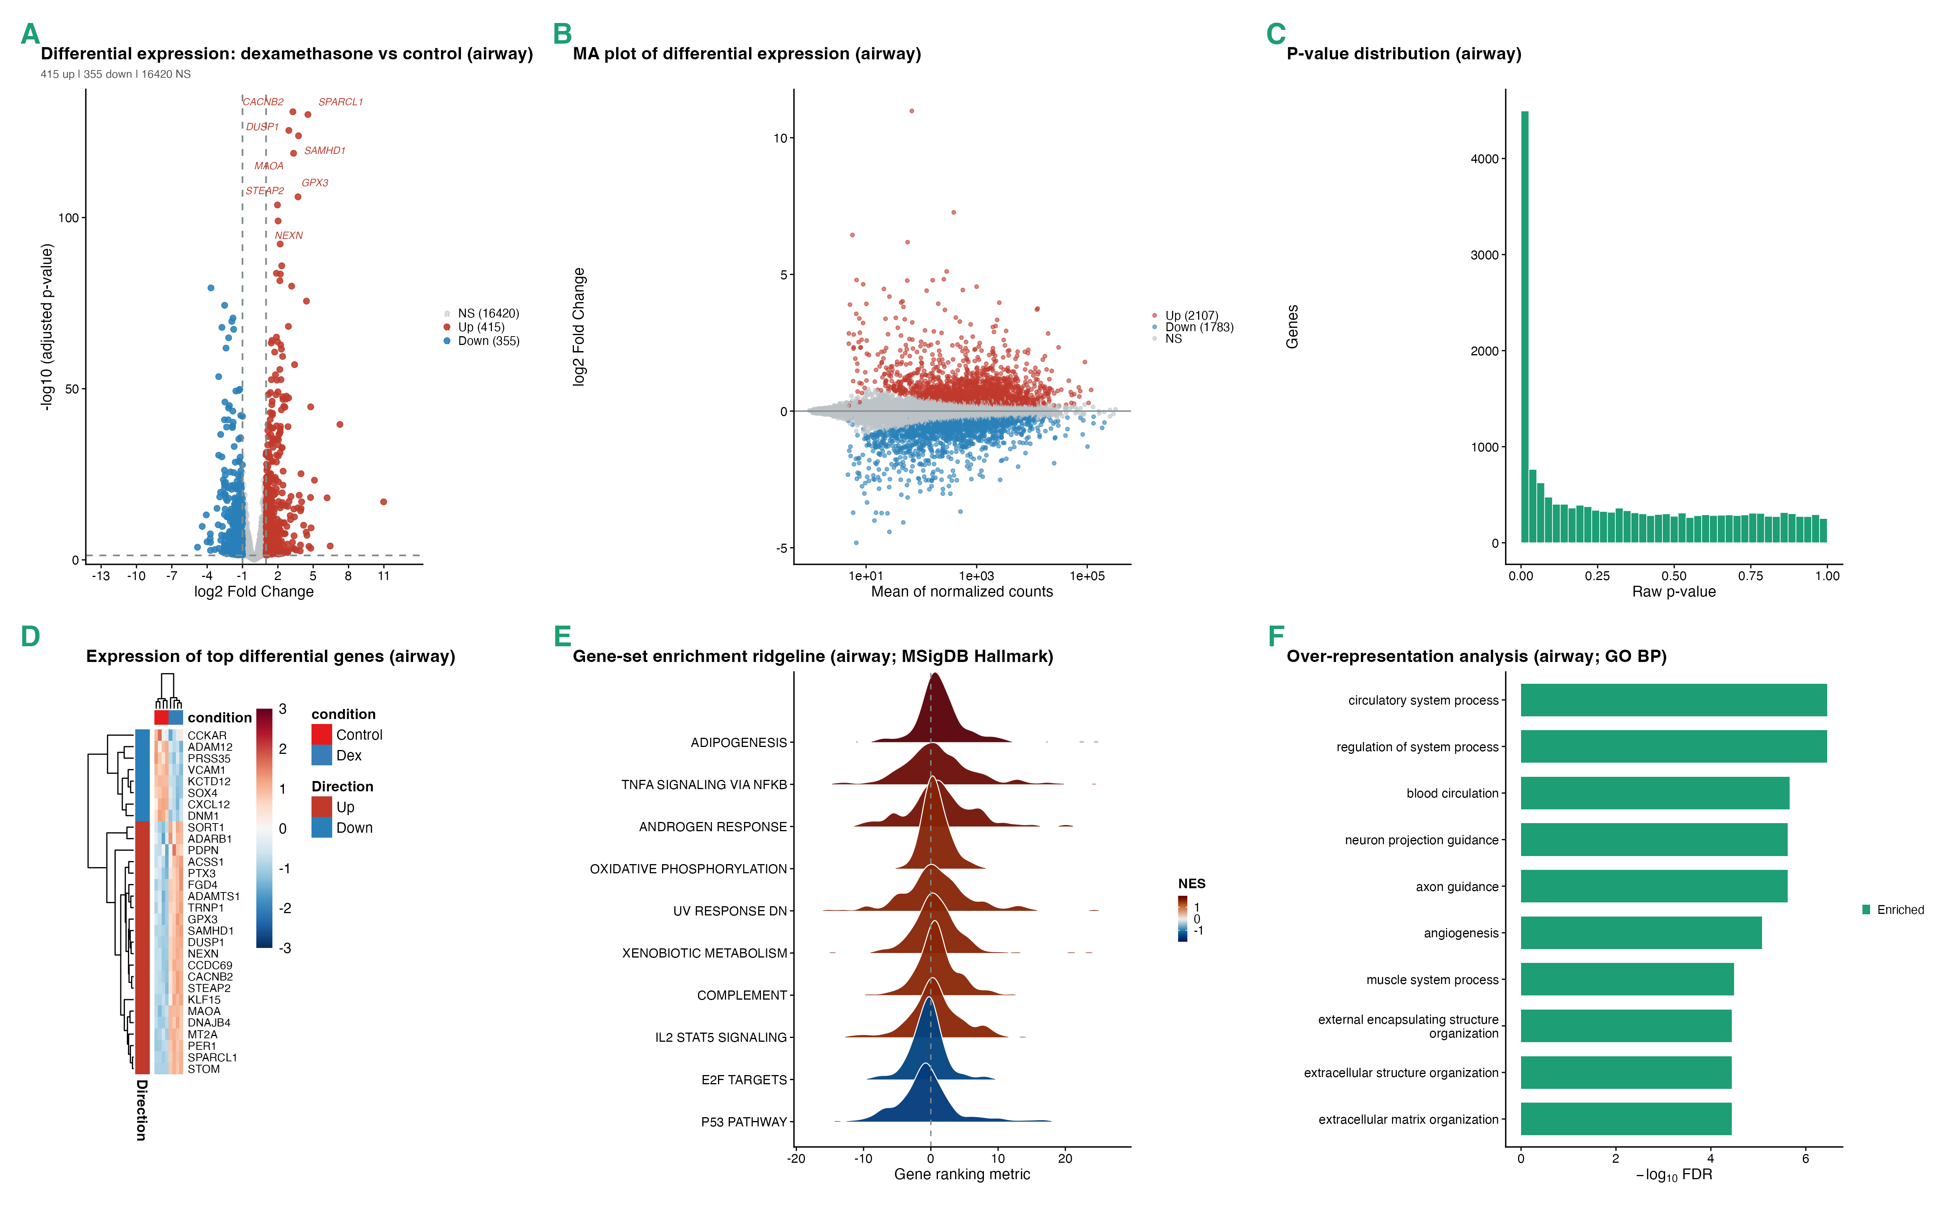
Figure 2. Differential expression and functional enrichment on a known study (airway). (A) Volcano plot of the dexamethasone-versus-control contrast; canonical glucocorticoid-response genes are the top hits. (B) MA plot. (C) P-value distribution. (D) Heatmap of the top differential genes across samples (annotated by condition). (E) Gene-set enrichment ridgeline (MSigDB Hallmark): the ranking-metric distribution of the top enriched sets, coloured by normalised enrichment score. (F) Over-representation analysis against Gene Ontology (biological process).
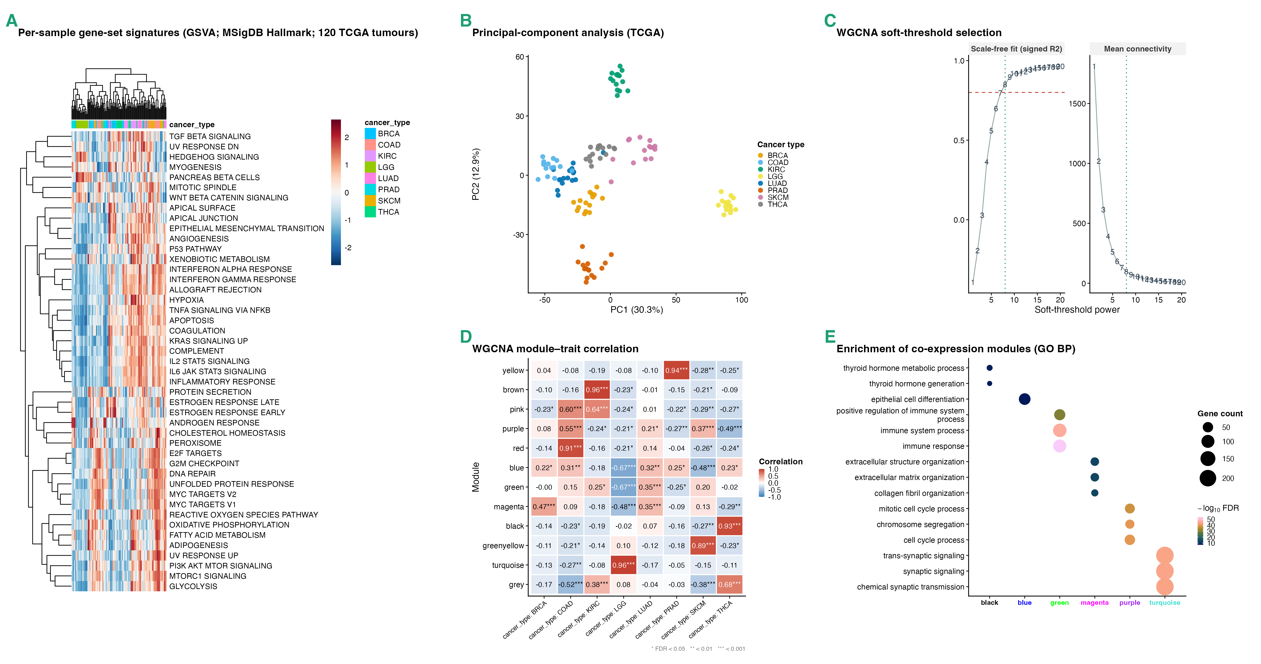
Figure 3. Molecular characterisation of the TCGA pan-cancer cohort. (A) Per-sample GSVA Hallmark signature scores for the 120 tumours (columns annotated by cancer type; both axes hierarchically clustered), the tumours grouping by type. (B) Principal-component analysis coloured by cancer type. (C) WGCNA scale-free soft-threshold selection. (D) WGCNA module–trait correlation between module eigengenes and cancer type. (E) Functional enrichment (GO biological process) of the co-expression modules.
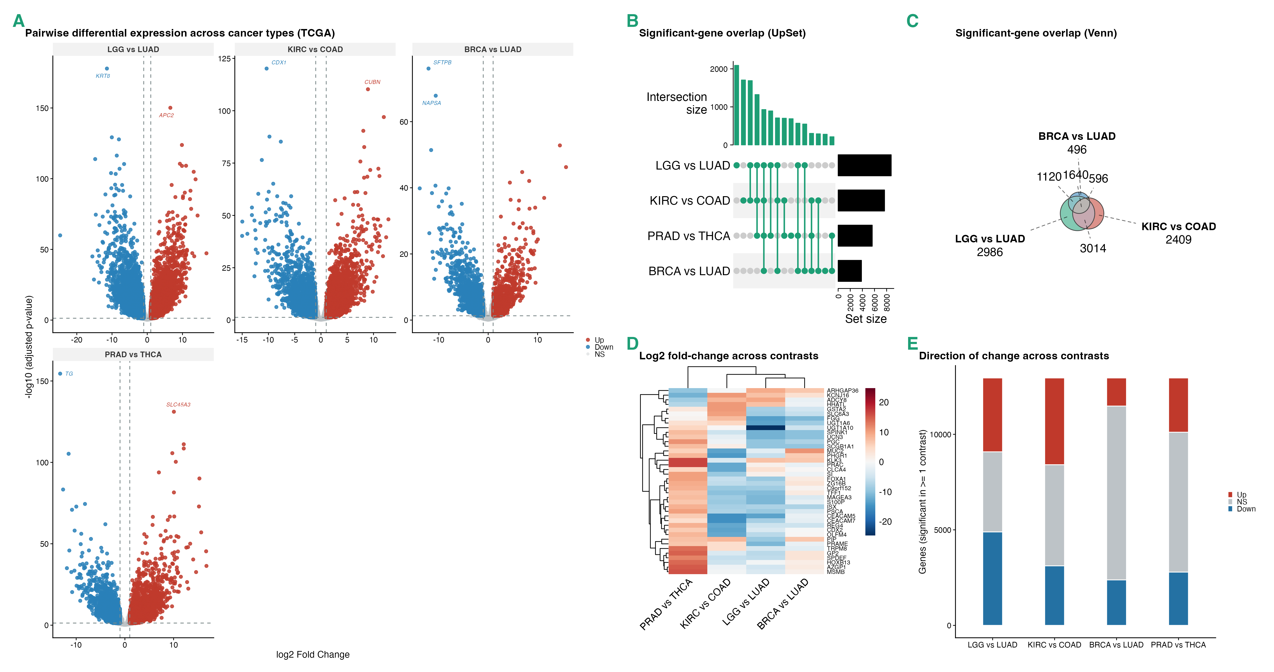
Figure 4. Multi-contrast comparison across cancer types (TCGA). (A) Grid of pairwise volcano plots for representative contrasts. (B) UpSet and (C) Venn views of the overlap between significant-gene sets across contrasts. (D) Log-fold-change heatmap of genes across contrasts. (E) Alluvial diagram of up-/down-/not-significant transitions across contrasts.
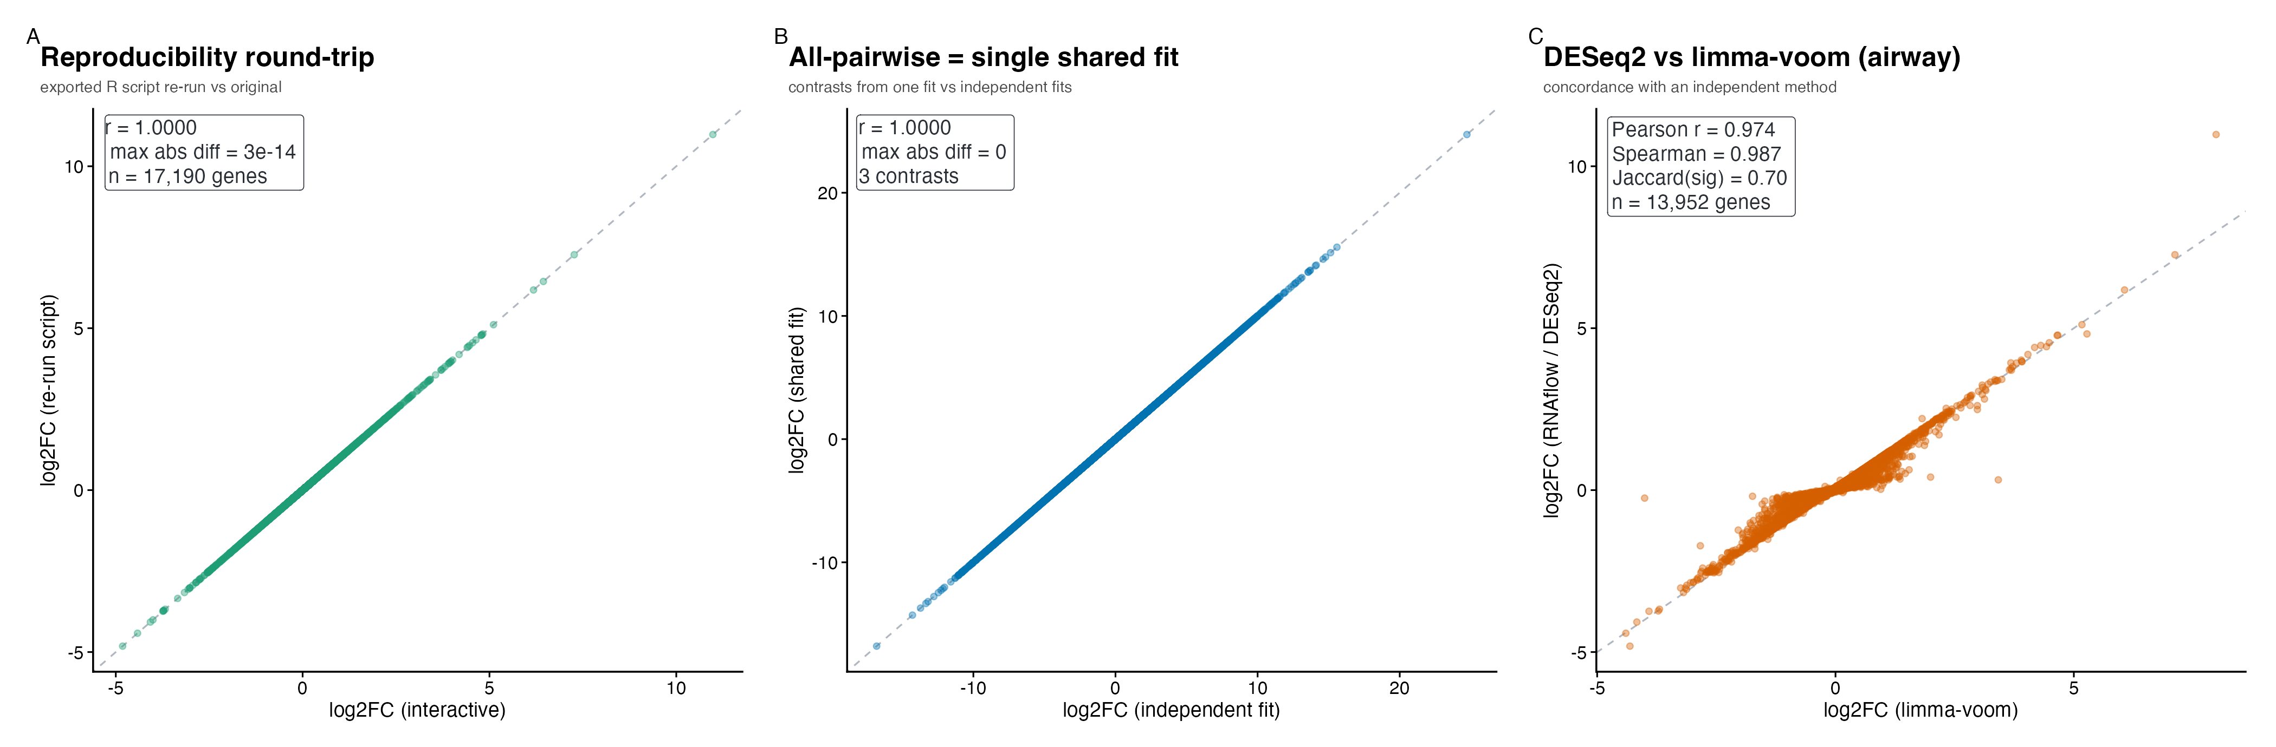
Figure 5. Validation of correctness and reproducibility. (A) Log-fold- changes for the airway analysis re-run from the exported R script versus the original interactive run (identical; r = 1.000). (B) Log-fold-changes for a TCGA contrast extracted from the single all-pairwise fit versus an independent DESeq2 fit (identical; r = 1.000). (C) RNAflow (DESeq2) versus an independent limma-voom analysis of the airway data (Pearson r = 0.97, Spearman rho = 0.99). Dashed line, y = x.

Comparison with existing tools
RNAflow’s contribution is not a new statistical method but an integration: it brings the standard, best-in-class methods for each analysis step into one coherent, reproducible, and properly engineered tool. Table 3 summarises how its scope compares with representative interactive RNA-seq applications, and we discuss each in turn below.
Table 3. Feature comparison with three broad interactive bulk RNA-seq tools of comparable scope. Y = present; ~ = partial or via a related feature; – = not a focus. Compiled from each tool’s primary publication and documentation; feature sets evolve.
Capability | iDEP | DEBrowser | ExpressAnalyst | RNAflow
Differential expression | Y | Y | Y | Y
QC / diagnostics | Y | Y | Y | Y
PCA / dimensionality reduction | Y | Y | Y | Y
Multi-contrast comparison | ~ | Y | ~ | Y
Functional enrichment (GSEA + ORA) | Y | Y | Y | Y
Co-expression networks | Y | – | ~ | Y
TF / pathway activity inference | ~ | – | ~ | Y
Per-sample signatures (GSVA / ssGSEA) | – | – | – | Y
AI-assisted interpretation | – | – | – | Y
Reproducible script / report export | Y | ~ | Y | Y
Tested, reusable R / Bioconductor package | ~ | Y | ~ | Y
Runs locally / offline | ~ | Y | ~ | Y
We compare against three broad, well-established interactive tools whose scope is comparable to RNAflow’s, verified against their primary publications and documentation. iDEP (Ge et al. 2018) is among the most complete: from a count matrix it performs exploratory analysis (hierarchical and k-means clustering, PCA), differential expression, GSEA and GO/KEGG pathway analysis, and co-expression network analysis across 220 species, and its workflow can be re-run from downloadable R code — it is used mainly as a hosted web service (though also available as the idepGolem R package for local installation), with its code organised around the application rather than as a documented, unit-tested analysis API. DEBrowser (Kucukural et al. 2019) is a polished Bioconductor/Shiny tool centred on interactive differential expression (DESeq2, edgeR, limma), with quality-control diagnostics, PCA, heatmaps, multi-condition comparison, batch-effect correction (ComBat/Harman), and GO/GSEA enrichment; it does not target co-expression networks, activity inference, or per-sample signatures. ExpressAnalyst (Ewald et al. 2023) is a broad web platform spanning read quantification, differential expression, functional enrichment, interaction- and regulatory-network analysis, and cross-species meta-analysis, with a companion ExpressAnalystR package and a downloadable R command history for reproducibility; its network emphasis is on interaction networks rather than WGCNA co-expression, and it does not provide per-sample GSVA signatures.
Beyond these broad tools, two excellent focused applications are worth noting but are not directly comparable on a full-workflow feature matrix, because each deliberately covers a single stage: pcaExplorer (Marini and Binder 2019) for principal-component exploration and the functional annotation of components, and GeneTonic (Marini et al. 2021) for the interpretation step, fusing a DESeq2 result and an enrichment result into a linked interface with a reproducible R Markdown report.
Against this backdrop RNAflow is not “better” at any single step (Table 3). Some capabilities are shared: iDEP and ExpressAnalyst also span much of the workflow and export reproducible R code. What distinguishes RNAflow is the combination of three things at once. First, it carries the full downstream workflow on one loaded dataset, including methods rarely integrated into an interactive tool: per-sample gene-set signatures (GSVA / ssGSEA) and AI-assisted interpretation, which none of the compared tools provide, together with regulator and pathway activity inference (decoupleR / PROGENy) and co-expression networks, which the others cover only partially if at all. Second, it makes reproducible export comprehensive, emitting a runnable R script, a Methods paragraph, and a self-contained report together. Third, it is engineered as a tested, reusable R package that runs entirely locally, so its functions can be scripted and unit-tested independently of the interface and no data leave the user’s machine. Where existing tools optimise one or two of breadth, reproducibility, and software engineering, RNAflow aims to hold all three at once for the common case of a single laboratory with a count matrix.

Limitations
The design has clear limitations, which we state plainly. RNAflow analyses bulk RNA-seq only; it is not intended for single-cell or spatial transcriptomics, which have different statistical and visualisation needs. It starts from a count matrix and does not perform read alignment or quantification, which must be carried out upstream with dedicated tools. Its outputs are exploratory and hypothesis-generating: WGCNA modules are most reliable with larger sample sizes and should be treated as hypotheses for small cohorts; enrichment, activity, and signature results carry the usual gene-set and prior-knowledge biases and require independent validation; the all-pairwise mode multiplies the number of tests and should be interpreted with that in mind; and the optional AI interpretation is a drafting aid whose statements can be wrong and must be checked. More broadly, RNAflow is a tool for competent exploratory analysis, not a substitute for expert statistical review of experimental design, batch structure, and model adequacy, which remain the responsibility of the analyst. Finally, because several enrichment and activity resources are fetched from live databases, full offline use is limited to the steps that do not require them.

Future directions
Planned directions include broader organism support beyond human, mouse, and rat; a publicly hosted live demonstration instance; additional visualisation types; and a plugin mechanism so that alternative differential-expression or enrichment back-ends can be added without touching the interface. Because the analysis core is a tested, standalone function layer, such extensions can be developed and validated independently of the application.

Conclusions
RNAflow provides a complete, integrated, and reproducible route from a bulk RNA-seq count matrix to differential expression and multi-layered functional interpretation, packaged as a tested R library with a thin Shiny interface. By treating breadth of analysis, reproducible export, and clean software engineering as primary design goals rather than afterthoughts, it offers the accessibility of an interactive application without sacrificing the transparency of a scripted analysis. We hope it will be useful both as a day-to-day analysis tool for individual laboratories and as a well-structured codebase that others can extend.

Availability and requirements
- Project name: RNAflow
- Project home page: https://github.com/KmBioChemo/RNAflow (documentation: https://KmBioChemo.github.io/RNAflow/)
- Archived version: TODO: Zenodo DOI (minted at release).
- Operating systems: platform-independent (Linux, macOS, Windows); a Docker image is provided.
- Programming language: R (>= 4.4; developed and tested against R 4.5 / Bioconductor 3.22).
- Other requirements: DESeq2, fgsea, clusterProfiler, WGCNA, GSVA, decoupleR, and related Bioconductor packages (installed automatically or via the provided Docker image).
- Licence: MIT.
- Any restrictions to use by non-academics: none.

Declarations
Availability of data and materials. RNAflow and the scripts that generate the bundled demonstration datasets and Figures 2–4 are available at https://github.com/KmBioChemo/RNAflow. The demonstration datasets are derived from public data: the airway dataset (Himes et al. 2014) and the TCGA pan-cancer subset obtained through GSE62944 (Rahman et al. 2015; Weinstein et al. 2013).
Competing interests. The optional AI-interpretation feature queries a third-party large-language-model API using a key that the user supplies; no data are sent unless the user opts in. The author declares no other competing interests. TODO: confirm.
Funding. TODO: funding sources, or “This research received no specific grant from any funding agency.”
Authors’ contributions. TODO: e.g., K.M. conceived, designed, and implemented the software and wrote the manuscript.
Acknowledgements. TODO: acknowledgements, if any. RNAflow builds on the DESeq2, fgsea, clusterProfiler, WGCNA, GSVA, decoupleR, and wider Bioconductor projects, whose authors we thank.

References
Badia-i-Mompel, Pau, Jesús Vélez Santiago, Jana Braunger, et al. 2022. “decoupleR: Ensemble of Computational Methods to Infer Biological Activities from Omics Data.” Bioinformatics Advances 2 (1): vbac016. https://doi.org/10.1093/bioadv/vbac016.
Chang, Winston, Joe Cheng, JJ Allaire, et al. 2024. Shiny: Web Application Framework for r. https://shiny.posit.co/.
Conway, Jake R., Alexander Lex, and Nils Gehlenborg. 2017. “UpSetR: An r Package for the Visualization of Intersecting Sets and Their Properties.” Bioinformatics 33 (18): 2938–40. https://doi.org/10.1093/bioinformatics/btx364.
Dolgalev, Igor. 2022. Msigdbr: MSigDB Gene Sets for Multiple Organisms in a Tidy Data Format. https://igordot.github.io/msigdbr/.
Ewald, Jessica, Guangyan Zhou, Yao Lu, and Jianguo Xia. 2023. “Using ExpressAnalyst for Comprehensive Gene Expression Analysis in Model and Non-Model Organisms.” Current Protocols 3 (11): e922. https://doi.org/10.1002/cpz1.922.
Ge, Steven Xijin, Eun Wo Son, and Runan Yao. 2018. “iDEP: An Integrated Web Application for Differential Expression and Pathway Analysis of RNA-Seq Data.” BMC Bioinformatics 19: 534. https://doi.org/10.1186/s12859-018-2486-6.
Gu, Zuguang, Roland Eils, and Matthias Schlesner. 2016. “Complex Heatmaps Reveal Patterns and Correlations in Multidimensional Genomic Data.” Bioinformatics 32 (18): 2847–49. https://doi.org/10.1093/bioinformatics/btw313.
Hänzelmann, Sonja, Robert Castelo, and Justin Guinney. 2013. “GSVA: Gene Set Variation Analysis for Microarray and RNA-Seq Data.” BMC Bioinformatics 14: 7. https://doi.org/10.1186/1471-2105-14-7.
Himes, Blanca E., Xiaofeng Jiang, Peter Wagner, et al. 2014. “RNA-Seq Transcriptome Profiling Identifies CRISPLD2 as a Glucocorticoid Responsive Gene That Modulates Cytokine Function in Airway Smooth Muscle Cells.” PLoS ONE 9 (6): e99625. https://doi.org/10.1371/journal.pone.0099625.
Korotkevich, Gennady, Vladimir Sukhov, Nikolay Budin, Boris Shpak, Maxim N. Artyomov, and Alexey Sergushichev. 2021. “Fast Gene Set Enrichment Analysis.” bioRxiv, ahead of print. https://doi.org/10.1101/060012.
Kucukural, Alper, Onur Yukselen, Deniz M. Ozata, Melissa J. Moore, and Manuel Garber. 2019. “DEBrowser: Interactive Differential Expression Analysis and Visualization Tool for Count Data.” BMC Genomics 20: 6. https://doi.org/10.1186/s12864-018-5362-x.
Langfelder, Peter, and Steve Horvath. 2008. “WGCNA: An r Package for Weighted Correlation Network Analysis.” BMC Bioinformatics 9: 559. https://doi.org/10.1186/1471-2105-9-559.
Liberzon, Arthur, Chet Birger, Helga Thorvaldsdóttir, Mahmoud Ghandi, Jill P. Mesirov, and Pablo Tamayo. 2015. “The Molecular Signatures Database Hallmark Gene Set Collection.” Cell Systems 1 (6): 417–25. https://doi.org/10.1016/j.cels.2015.12.004.
Love, Michael I., Wolfgang Huber, and Simon Anders. 2014. “Moderated Estimation of Fold Change and Dispersion for RNA-Seq Data with DESeq2.” Genome Biology 15 (12): 550. https://doi.org/10.1186/s13059-014-0550-8.
Marini, Federico, and Harald Binder. 2019. “pcaExplorer: An r/Bioconductor Package for Interacting with RNA-Seq Principal Components.” BMC Bioinformatics 20: 331. https://doi.org/10.1186/s12859-019-2879-1.
Marini, Federico, Annekathrin Ludt, Jan Linke, and Konstantin Strauch. 2021. “GeneTonic: An r/Bioconductor Package for Streamlining the Interpretation of RNA-Seq Data.” BMC Bioinformatics 22: 610. https://doi.org/10.1186/s12859-021-04461-5.
McInnes, Leland, John Healy, and James Melville. 2018. “UMAP: Uniform Manifold Approximation and Projection for Dimension Reduction.” arXiv, ahead of print. https://doi.org/10.48550/arXiv.1802.03426.
Müller-Dott, Sophia, Eirini Tsirvouli, Miguel Vazquez, et al. 2023. “Expanding the Coverage of Regulons from High-Confidence Prior Knowledge for Accurate Estimation of Transcription Factor Activities.” Nucleic Acids Research 51 (20): 10934–49. https://doi.org/10.1093/nar/gkad841.
Rahman, Mahfuza, Lisa M. Jackson, W. Evan Johnson, Dae-Yeol Li, Andrea H. Bild, and Stephen R. Piccolo. 2015. “Alternative Preprocessing of RNA-Sequencing Data in the Cancer Genome Atlas Leads to Improved Analysis Results.” Bioinformatics 31 (22): 3666–72. https://doi.org/10.1093/bioinformatics/btv377.
Schubert, Michael, Bertram Klinger, Martina Klünemann, et al. 2018. “Perturbation-Response Genes Reveal Signaling Footprints in Cancer Gene Expression.” Nature Communications 9: 20. https://doi.org/10.1038/s41467-017-02391-6.
Sievert, Carson. 2020. Interactive Web-Based Data Visualization with r, Plotly, and Shiny. Chapman; Hall/CRC. https://plotly-r.com.
Sievert, Carson, Joe Cheng, and Garrick Aden-Buie. 2024. Bslib: Custom Bootstrap Sass Themes for Shiny and Rmarkdown. https://rstudio.github.io/bslib/.
Subramanian, Aravind, Pablo Tamayo, Vamsi K. Mootha, et al. 2005. “Gene Set Enrichment Analysis: A Knowledge-Based Approach for Interpreting Genome-Wide Expression Profiles.” Proceedings of the National Academy of Sciences 102 (43): 15545–50. https://doi.org/10.1073/pnas.0506580102.
Türei, Dénes, Alberto Valdeolivas, Lejla Gul, et al. 2021. “Integrated Intra- and Intercellular Signaling Knowledge for Multicellular Omics Analysis.” Molecular Systems Biology 17 (3): e9923. https://doi.org/10.15252/msb.20209923.
Weinstein, John N., Eric A. Collisson, Gordon B. Mills, et al. 2013. “The Cancer Genome Atlas Pan-Cancer Analysis Project.” Nature Genetics 45 (10): 1113–20. https://doi.org/10.1038/ng.2764.
Wickham, Hadley. 2016. Ggplot2: Elegant Graphics for Data Analysis. Springer-Verlag New York. https://ggplot2.tidyverse.org.
Wu, Tianzhi, Erqiang Hu, Shuangbin Xu, et al. 2021. “clusterProfiler 4.0: A Universal Enrichment Tool for Interpreting Omics Data.” The Innovation 2 (3): 100141. https://doi.org/10.1016/j.xinn.2021.100141.
Yu, Guangchuang, and Qing-Yu He. 2016. “ReactomePA: An r/Bioconductor Package for Reactome Pathway Analysis and Visualization.” Molecular BioSystems 12 (2): 477–79. https://doi.org/10.1039/C5MB00663E.
Zhu, Anqi, Joseph G. Ibrahim, and Michael I. Love. 2019. “Heavy-Tailed Prior Distributions for Sequence Count Data: Removing the Noise and Preserving Large Differences.” Bioinformatics 35 (12): 2084–92. https://doi.org/10.1093/bioinformatics/bty895.

