Modeling the Evolution of Cooperation using Spatial Game Theory

By Karen MacPherson

May 10, 2011

CSCI-3352

**Abstract**

**Cooperation is common in nature both between members of the same species and between species. However there is no sound basis for the evolution of cooperation without evoking group selection or kin selection which are both very limited. Game theory has been used to explain the rise of altruism in a population and how it can be beneficial to the individual. In the Prisoner’s Dilemma, it is always better to defect instead of cooperate, so the biological models tend to not use this game. However, if there is a spatial characteristic, then the dynamics change. This project is aimed to observe the effect of spatial evolutionary game theory on the evolution and maintenance of cooperation in a population. Both spatial game theory and classical game theory in a finite population is observed. The simulation of spatial game theory works under the assumption that the strategy corresponding to a given site has interactions with the strategies with its close neighbors, and that the strategies change as the neighboring strategies have a higher fitness. The results are qualitatively different from those from the classical evolutionary game theory. The proportion of Defectors in the population in general is lower in the spatial games, and cooperators are dominant for values that in the classical game, the defectors would be dominant. When the orientation is spatial, it’s possible for cooperators to form clusters, which raise their fitness and enable them to spread and invade. This spatial reciprocity gives insight to how cooperation may have evolved in nature.**

**Introduction**

Evolution is based on the survival of the fittest which makes up the core of Darwinian natural selection. Because of this, of course there is combat between organisms for food, territory, and the right to reproduced. In a typical combat, the winner may gain mates, dominance, or other advantages that will increase the probability that that organism’s genes will be passed on. So it would seem intuitive that natural selection would favor an aggressive individual with a deadly arsenal of natural weapons. However, we just don’t observe this phenomenon in nature. It is almost nonexistent that two organisms of the same species will engage in a fight to the death. Instead, they put on displays and usually one individual will retreat before any damage is done.

John Maynard Smith (1973) called this behavior “limited war” as opposed to “total war” which is a fight to the death which is what would seem that natural selection would encourage. Limited war assumed cooperation in a population. The accepted explanation at the time was that total war would cause too much injury, and that this would decrease the fitness of the population as a whole. However, this assumed group selection, which has its own problems and is no longer widely accepted. At the level of a species or a population, the processes of selection are weak (Axelrod 1981). So to account for the existence of cooperation, altruism, and limited war, evolutionary theory incorporated kin theory which takes a gene’s view of evolution. An organism’s kin share many of its genes, and so cooperation leads to their genes getting passed on whether it is through their own reproduction or that of their kin (Axelrod 1981). However, many examples of altruism and cooperation are not between kin, or even between members of the same species.

Noticing this discrepancy, Smith was the first to incorporate game theory into biology in order to try to explain the “nice” behavior of animals that seemed so counter intuitive. Game theory models strategic situations, or games, in which an individual's success in making choices depends on the choices of others. In evolutionary game theory, this is extended to mean that the fitness of individuals is not constant, but depends on the relative proportions of the different phenotypes in the population. Unlike in traditional game theory, which analyzes an interaction between two players based on rationality, evolutionary game theory considers populations of player, consisting of individuals that have fixed strategies determined by their genes. Different individuals interact and receive a payoff depending on the strategy of the other individual. This is often summarized in a payoff matrix (see Figure 1). Their fitness is then the sum of all the payoffs of all of their interactions (Nowak 1992).

The goal of using game theory is often to find a strategy that will be stable under natural selection, an evolutionary stable strategy or ESS. An ESS is a strategy such that, if most of the members of a population adopt it, there is no “mutant” strategy that would give a higher fitness in an invasion (Smith 1973).

The most looked at game in biology is the prisoner’s dilemma. In this game, two people are suspected of committing a joint crime. They are isolated during questioning and can’t talk to each other. If they confess their crime and witness against the other suspect, they go free and the other prisoner receives 10 years in jail. If they both confess, they receive 7 years in jail. If they both stay silent then they only receive one year because nothing can be proved. This scenario can be used in biology by having two strategies in a population, defector and cooperator. Cooperation is necessary for specialization and progress, and is common in nature. But cooperation is always vulnerable to exploitation by defectors. Rationally, in this scenario it is always better to defect no matter what the other person does because the average payoff for defectors is higher than that of cooperators. However, joint cooperation has a better outcome for each player. In this way, natural selection favors selection using these simple strategies.

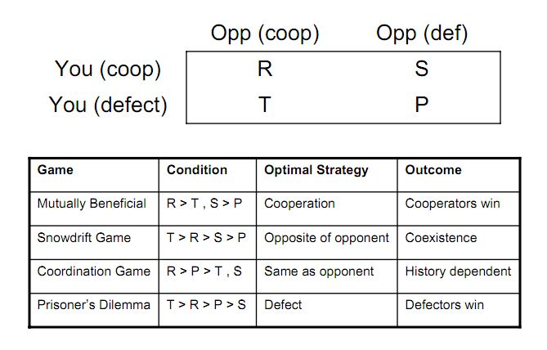

Figure 1. **Summary of different games, and their optimal strategies**. This simulation looks primarily at the Prisoner’s Dilemma, however also looks a bit at the Hawk-dove game, which is an extension of the Snowdrift game, which can lead to coexistence. Which game is being played depends on the relation of the payoffs to each other. This figure is obtained from Gore 2009.

For this reason, alternate strategies are being looked at, as well as alternate games layouts such as the Hawk-dove game and the Snowdrift game (see Figure 1). However, much can still be done with the Prisoner’s Dilemma. Rarely do all individuals in a population interact with other individuals with constant probability. Rather, individuals interact with their immediate neighbors. This is a spatial generalization of game theory. If a grid is assumed, then a cell will correspond to a certain strategy, and will play a game with each of the cell’s immediate neighbors. Reproduction rights then go to the cell with the highest cumulative payoff. This spatial game then has different dynamics and those dynamics will be studied in depth in this simulation.

**Model**

To model the dynamics of game theory in an evolutionary context, simulations were written in the programming language Scala. Classical and spatial orientations were modeled in both a deterministic and stochastic manner with differing configurations that are meant to correspond to observed phenomenon in nature. Finite rather than infinite population sizes were assumed for two main reasons. First, using finites avoids the need for a continuous system and rather can be modeled discretely. Second, no population of a species is observed to be infinite in size, and is not deterministic, rather stochastic in nature. Many important biological effects only arise in a stochastic context, such as neutral drift. Because it is stochastic, the simulation will not stop at an expected equilibrium, and instead continues until one strategy completely dominates and all the other strategies. Eventually the population will consist of individuals of only one strategy, coexistence is not possible. The system will eventually reach one of these states, though it may take a very long time. In nature, this is also true, just very likely that there will still be coexistence for the lifetime of the species.

In a simple evolution simulation dealing with a finite population, the abundance of individuals is given by integers rather than by continuous variables. For this system, both neutral drift and selection was explored before incorporating games. Reproduction followed a Moran process which is sampling with replacement for both death and reproduction. Each time step, there is one death and one birth at random or determined by fitness. If you have x individuals of type A, and 1-x individuals of type B for N individuals, then the frequency that A will be chosen for birth or death would be x/N and for B, (N-x)/N, which depends only on the frequency of each in the population. If selection is added in, then this equation is slightly altered. It was assumed that A has relative fitness r and B has fitness of 1. In this case, A is chosen for reproduction with probability rx/(rx + N –x).

Introducing games into this framework was simple. A and B then became different strategies with a certain payoff matrix. Each time step, A individuals and B individuals randomly interact based on the frequencies of each, resulting in the payoff (P) from the payoff matrix. A variable ω was introduced to represent how strong of an effect the payoff and selection has on reproduction. Then the fitness is given by 1 – ω + ωP. ω close to 0 characterizes weak selection, while ω = 1 means selection is strong and fitness is entirely determined by the expected payoff.

All the above was mostly preliminary theory for the modeling of spatial games. For the spatial games, individuals were arranged on a 2D array called Cells filled with the type Cell, a class that houses data for each individual in the system. This structure keeps track of the strategy of an individual/cell, its next strategy, its summed payoff, and an array of the 8 neighbors surrounding the cell. In each round, the individual will play the game with each of its immediate neighbors to the adjacent and diagonal cells and add up the payoffs from each interaction. At the end of the time step the cell is occupied by either the original owner or one of the neighbors, depending on who had the highest accumulated payoff. All of the players are updated in synchrony by the Update method which takes the max of the neighbors Array and compares it to the individual’s own payoff. This model does not include mutation or any kind of stochasticity except for the initial conditions. These elements are not included so the patterns can be studied and compared to the classic game that doesn’t incorporate spatial structure. For this, the Prisoner’s Dilemma payoff matrix is used to look at the effect of spatiality on the evolution of cooperation:

C D

C 1 0

D b ϵ

In this model, b > 1, and ϵ is a very small positive payoff. For most of the simulations, ϵ is set to 0, in order to model the limit as ϵ approaches 0. This is done because often the cost of a defector interacting with a defector cancels out the benefit of winning, especially because if a 50-50 chance of winning is assumed.

A visual matrix is created to observe the patterns of interacting defectors and cooperators. In this model, a blue cell is a cooperator that was a cooperator in the previous generation, a red cell represents a defector that was a defector in the previous generation, green represents a cooperator that was a defector in the previous generation, and yellow represents a defector that was a cooperator in the previous generation. This way it is easier to see the edges of the changes. And which cells are static and which are dynamic. If the drawn matrix only shows blue and red cells, then there will be no more change in subsequent generation. This model can be used to look at invasion values, and through this, when a strategy is an evolutionary stable strategy.

**Results**

When the interactions between cooperators and defectors are simulation using spatial game theory, there are interesting results. For the following observations, only the value β was altered to observe the patterns in the population resulting from differing payoffs when the defectors meet a cooperator. Figure 2 shows that for β < 1.60, cooperators dominate. When β = 1.10, there is a rather static pattern of small lines of defectors. Where there are single isolated defectors, they oscillate between a single cell and a group of 9. When β = 1.15, the ends of these small lines now oscillate like the single cells. At β = 1.24, the lines of defectors start to be connected and some places still oscillate. Where β = 1.35, there is a pulsating network of defectors. Lines are now oscillating between a thickness of 1 cell and 3 cells. When β = 1.45, it’s odd in that there seems to be a decrease in the number of lines in the defector network. At this value of β the frequency is lower than when β is slightly lower or higher (see figure 3). This may have to do with the frequency of a strategy is not only determined by the payoff/fitness, but also the frequency of the other strategy. It could be that they interact just so at this value to cancel out many of the branching lines of defectors. When β is > 1.60, defectors begin to really thrive, and at β = 1.63 there exists a very dynamic coexistence between the defectors and cooperators where cooperators are around 30%. Clusters of cooperators will always try to expand, then collide, break, and disappear. Then new clusters will form. This is also the β that will allow the most interesting invasion of either strategy (see Figure 4). When β > 1.67, the defectors rule.

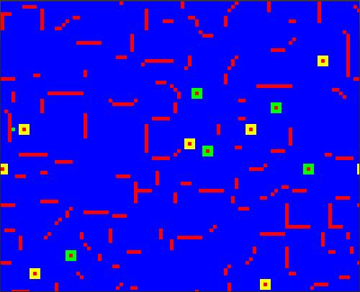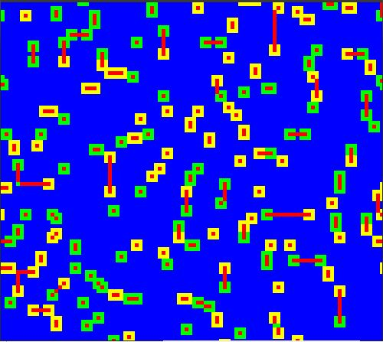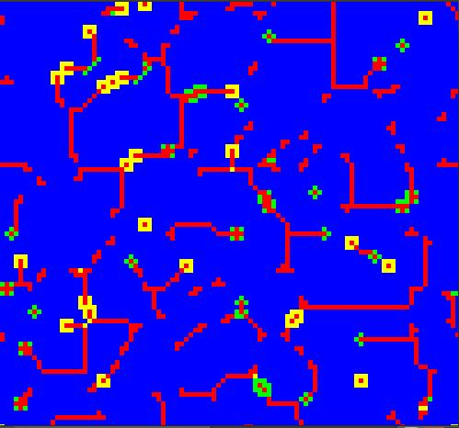

β = 1.10 β = 1.15 β = 1.24

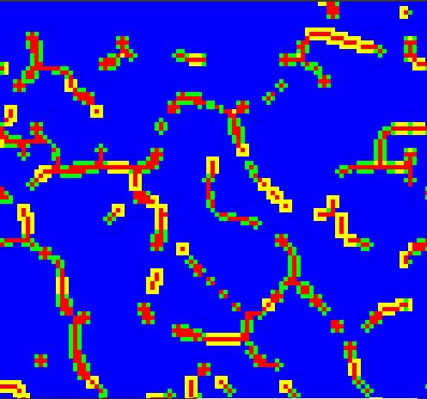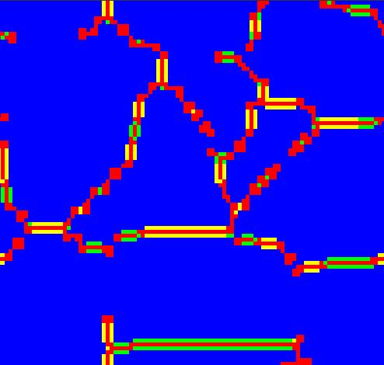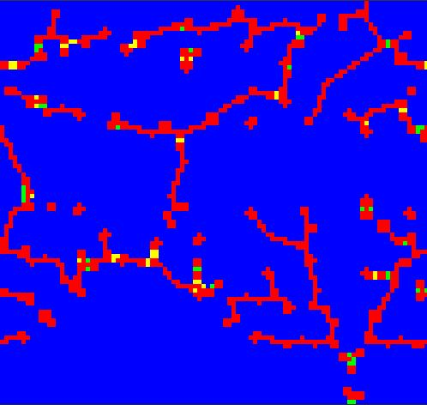

β = 1.35 β = 1.45 β = 1.55

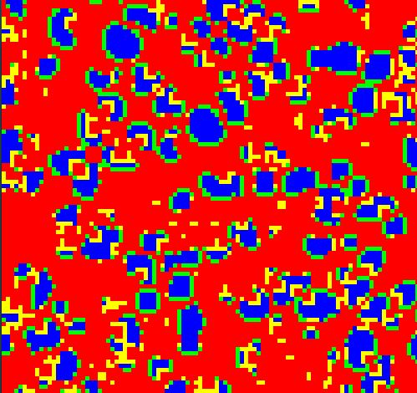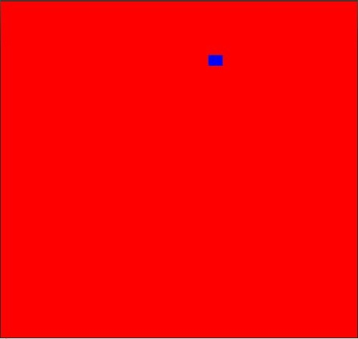

β = 1.63 β = 1.68

Figure 2. **Results of a simulation of the spatial Prisoner’s dilemma with varying β.**  β represents the benefit that a defector receives when interacting with a cooperator. The game was played on a 100x100 matrix with periodic boundaries and no tie breaking. The simulations were run until the frequencies stabilized after the transient period, or until one of the strategies died out. The initial condition was with 50% cooperators. Blue represents a cooperator that was a cooperator the previous round, red is a defector that was a defector the previous round. Yellow is a defector that was a cooperator the previous round, and similarly, green is a cooperator that was a defector the previous round. Cooperators dominate for β < 1.59. At around β = 1.63, there is a stable dynamic coexistence where cooperators form clusters that grow and shrink. This simulation is a reproduction of the example simulation in Nowak, 1992.

The proportion of cooperators in the spatial game is in general higher than the classical implementation of the game. A simulation was conducted of the classical game for a finite number of individuals, and for all β between the interval of 1.0 and 1.70, no cooperators survived. For the deterministic game theory in an infinite population, the frequency of cooperators may instead follow a continuous curve. Instead of this, the proportion of cooperators undergoes what might be called phase transitions. At around β = 1.6 the proportion of cooperators drops very suddenly, then remains constant at round 30%. This is the interval during which there is dynamic coexistence between the cooperators and defectors which is not seen in the classical game. Then at 1.67 the frequency drops again to very close to zero or zero depending on the initial configuration. This can be seen in figure 3. A very similar phenomenon was observed by Killingback and Doebeli in Hawk-Dove spatial games which inspired this simulation. Also note at β = 1.45 the frequency drops slightly. This was also seen in figure 2.

Figure 3. **Proportion of Cooperators as a function β in the Spatial, Classic, and classic with weak selection games**. The spatial simulations followed the same parameters of those in figure 2 and showed phase transition around β = 1.6 and β = 1.68. The classic game was simulated using finite populations and the proportion of cooperators always went to 0.0. When ω was introduced, this lessened the amount of selection based on the payoff of the games. Since the simulations were done with finite populations, the results of 15 runs were averaged and then plotted. It shows a decreasing linear relationship.

The simulations were used to observe the effect of an invading single defector in a population of cooperators. If β > 1, then a single defector will invade the surrounding cells so that there is a cluster of 9 defectors. If β is > 1.65, then this cluster will take over all the cooperators. If 1.6>β >1.4 then the 9 defectors will stay untouched. At a small interval between 1.6 and 1.65, this will create a beautiful symmetrical system of a dynamic coexistence. The defector will only get wiped out if β < 1 which is not very looked at in this simulation. So then in this case, cooperation is an ESS if β < 1.4.

A single cooperator cannot invade a population of defectors, but a group of 9 cooperators can cause a boom of cooperation to burst out under the right conditions. If β < 1.5, then the cooperators will overtake all the defectors. When β is around 1.60-1.65, the cluster will expand along lines but not along diagonals, creating a kaleidoscope pattern (see figure 5). Otherwise the cluster is stable or will disappear.

Figure 4. **The proportions of each strategy as a function of β during invasion.** The graph shows the proportion of defectors when a single cell is invading a population of cooperators and the proportion of cooperators when a group of 9 are invading a population of defectors. These are separate runs, and not obtained from the same simulation. The simulation is deterministic as there is a set initial condition, and is updated synchronously. The simulation was allowed to run until a stable configuration was found.

Invasion by either a single defector or a group of cooperators creates kaleidoscopic images that we can use to observe the behavior of the spread of these phenotypes in a deterministic fashion. These simulations are completely deterministic unlike the other spatial game theory simulations that have random initial configurations. As shown in figure 5, the cooperators tend to expand along the lines and the defectors expand along the diagonals. This is due to the fact that on lines, the cooperator is surrounded by more cooperators which increase its fitness. On the other hand, the defector at the corner is the fittest because it has the most access to cooperators to take advantage on.

**a**. 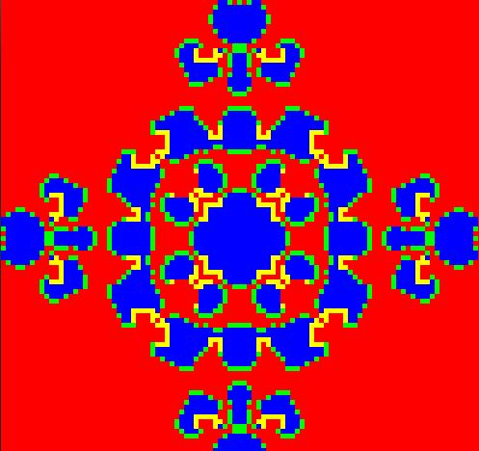 **b**. 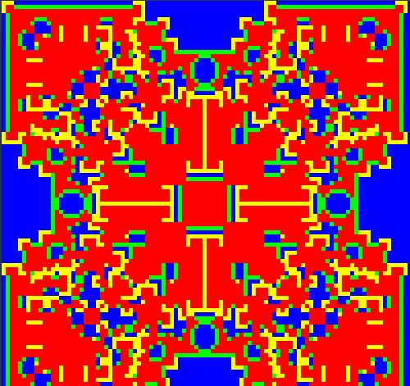

Figure 5. **Patterns created by invasion.** In a., a group of 9 cooperators in a population of defectors was initialized in the center of the matrix. This is a frame at generation 60. In b. a single defector invades a population of cooperators from the center of the matrix. This is a frame at generation 50. Note that the cooperators tend to expand along the lines and the defectors expand along the diagonals. This is due to the fact that on lines, the cooperator is surrounded by more cooperators which increase its fitness. On the other hand, the defector at the corner is the fittest because it has the most access to cooperators to prey on.

Also simulated was a more stochastic model of spatial game theory that may more accurately reflect how groups of cooperators grow in biological systems. In this system, cells are updated asynchronously (for these simulation, 100 random cells were update per time step) but all other conditions are the same. This system will continue until one of the strategies dies out, and will not reach any stable patterns like the other simulation. Certain patterns were observed independent of what the β is for that run. Right after initialization, the defectors wipe out any free standing cooperators, so that only the small initial clusters survive. But these clusters then grow and will often overcome the defectors.

a. 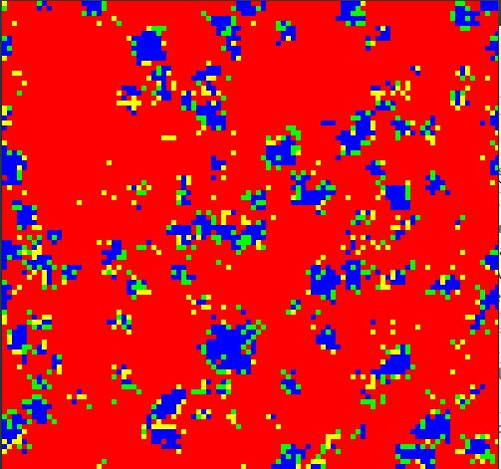 b. 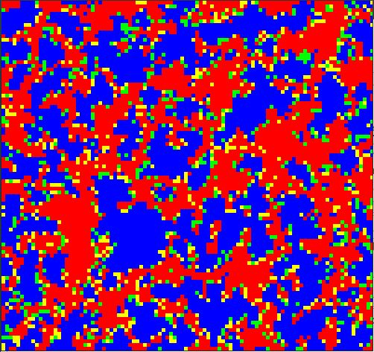

Figure 5. **Dynamics of Cooperator Cluster Growth in a Stochastic System.** The simulations were started with 50% cooperator in random cells. 100 randomly chosen cells were updated at each time step. These are modeled with a β of 1.5. Figure 5a is showing the simulation state at generation 100. 5b shows the simulation state at after 2000 generations. The simulations were started with 50% cooperator in random cells, so after only 100 generations, the proportion dropped greatly, then the clusters of cooperators began to grow.

Figure 6. **Proportion of cooperators as a function of time with varying beta in a stochastic model.** A stochastic asynchronous reproduction model of spatial game theory was modeled with an initial condition of 50% cooperators at random. The simulations were run for 5000 time steps for varying beta values. For all of the runs, and initial drop off was observed, representing the wipe out of all the single cooperators and those in small clusters. Then the large clusters would grow with a rate dependent on beta, or slowly decrease until fixation of a strategy.

The rate at which the clusters of cooperators grow or if they grow again at all is dependent on β (see figure 6). For values of β < 1.5, it is very probable that the cooperators will invade the space completely, and rate of growth is high. For 1.4<β<1.8, the clusters grow at a steady rate for at least the first 5000 time steps, then it is unknown the probabilities that the cooperators will go to fixation. The state may go one for much longer than any species lives, but eventually a strategy will go to fixation. When β > 1.7 the proportion of cooperators does not recover after the initial wipe out and steadily will decrease.

**Discussion**

Many basic general conclusions can be drawn from the data. The most important of which is that spatial configurations in game theory can encourage the evolution and maintenance of cooperation. This spatial orientation favored the evolution of cooperation as opposed to defection because of the effect of spatial reciprocity (Nowak 1992), which is the phenomenon where cooperators support each other in clusters. They don’t just survive, but at certain values of β also expand rapidly. In classical game theory, a cluster of cooperators would never be able to invade defectors. In this way, it can be not only beneficial for the group for the individuals to cooperate, but also increase the fitness of the individuals themselves. This is much closer to natural selection and so is a stronger theory than that of group selection.

It is possible that the theory of spatial reciprocity also can be likened to kin selection and strengthen that theory. Because cooperators tend to form clusters, it is as if they are forming small communities. For some organisms, this would just be the family of the individual, surrounded by a sea of ‘others’ which would be the defectors with which the community. Of course this idea has flaws, such as the assumption that the defectors are not part of a community. This leads to interesting scenarios where two communities that cooperate within the community would defect if they interacted with an outsider. This shows a downfall of evolutionary game theory, as it only takes into account genetic information and not any actual choice like traditional game theory.

For these simulations and this general payoff matrix, the interval from 1.6 to 1.67 was a special interval of β where there was dynamic coexistence between cooperators and defectors. It’s unknown whether this configuration has a greater or smaller average fitness over the entire population, but it creates interesting questions about the interdependency of cooperators and defectors.

Something that was particularly interesting is the how the proportion of cooperators (and defectors) underwent phase transitions at specific threshold β values. It’s unknown why this is, but surely has something to do with the interplay of the frequencies of the two strategies.

This simulation could expand in many directions. The logical next step is to introduce a third strategy. This was actually started, but not included in this paper due to the simulations being off topic. A simulation was run for a hawk-dove-retaliator game. A retaliator is an individual that will cooperate until another individual defects, then it will retaliate. If the retaliator can also take advantage of a cooperator if it realizes with a small probability that they cooperator will not fight back. In this case, the retaliator will always go to fixation.

The simulation should also explore other strategies. There are many very successful strategies in the Prisoner’s Dilemma game such as tit-for-tat, which is a strategy that does whatever the other person did last. However, this strategy would be difficult to implement in an evolutionary frameset, since individuals do not know what another’s last move was. In a spatial system, maybe this would be easier to keep track of.

Evolutionary biology also uses the snowdrift game to model evolution. I would like to do a comparative analysis between this simulation of the prisoner’s dilemma and a simulation of the snowdrift game. The spatial configuration for the prisoner’s dilemma encourages cooperation when the classical game does not, and there are predictions that a spatial snowdrift game would actually inhibit the evolution of cooperation (Hauert 2004), which is counter intuitive. So that would be interesting to analyze.

There is a big gap in evolutionary theory and experimental data for game theory, but empirical data do exist. One such example is an experiment done with yeast (Gore 2009) where one strain can metabolize sucrose but 99% of the product is lost as waste. The other strain is then a cheater that doesn’t have the gene to metabolize sucrose and so lives off of the work of the wild type yeast. This creates a game where the outcome is determined by the efficiency of the wild type metabolism and the cost of metabolism. The original goal was to incorporate this into the simulation, but then it was decided to stay more general.

These models are very simple but also powerful. Game theory is very useful for modeling many types of biological situations including the evolution of cooperation. This model can both support existing theories for the evolution of cooperation as well as give an alternate theory that is based on the fitness of the individual.

**References**

Axelrod, R. & Hamilton, W. D. The evolution of cooperation*. Science* 211, 1390–1396 (1981).

Gore, J., Youk, H. & van Oudenaarden, A. Snowdrift game dynamics and facultative cheating in yeast. *Nature* 459, 253-256 (2009).

Hauert, C. & Doebell, M. Spacial structure often inhibits the evolution of cooperation in the snowdrift game.  *Nature* 428, 643-646 (2004).

Killingback, T. & Doebeli, M. Spatial Evolutionary Game theory: Hawks and Doves Revisited. *Proceedings: Biological Sciences* 263, 1135-1144 (1996).

Nowak, M. A. Evolutionary Dynamics: Exploring the Equations of Life. The Belknap Press of Harvard University Press, 2006.

Nowak, M.A. & May, R.M. Evolutionary Games and Spatial Chaos. *Nature*. 359 (1992).

Smith, J.M. & Price, G.R. The Logic of Animal Conflict. *Nature* 246, 15-18 (1973).