TASK 1: Local Repository Setup
- Create a new project folder.
- Initialize Git in the folder.
- Create a file named index.txt
- Add content to the file.
- Check repository status. 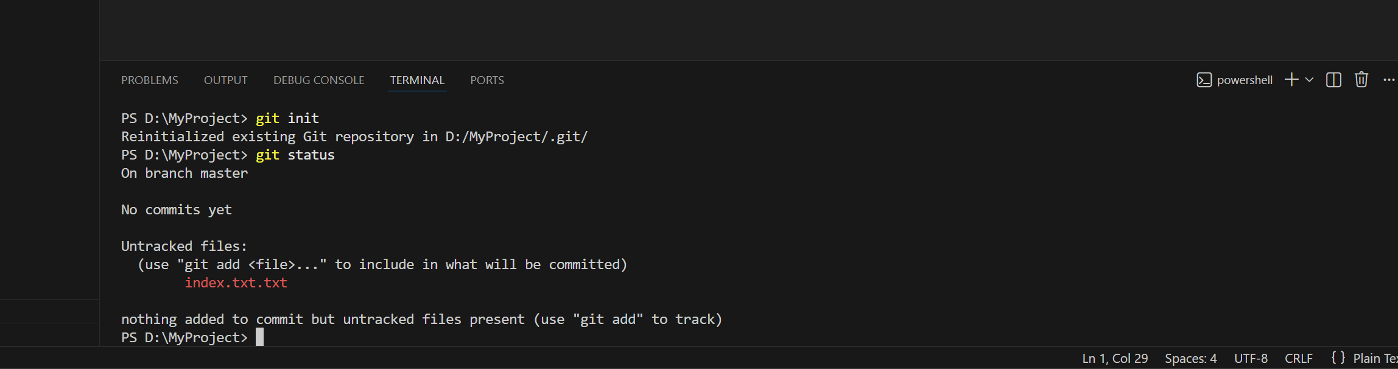
- Stage all changes.
- Commit the changes with an appropriate message.

