TASK 1: Repository Setup
Goal: Initialize Git and create first commit
Steps:
1. Create a folder named git-assignment-yourfullname
2. Navigate into the folder
3. Initialize Git repository
4. Create a file named index.txt
5. Check repository status
6. Stage the file
7. Commit with message:
Initial project setup

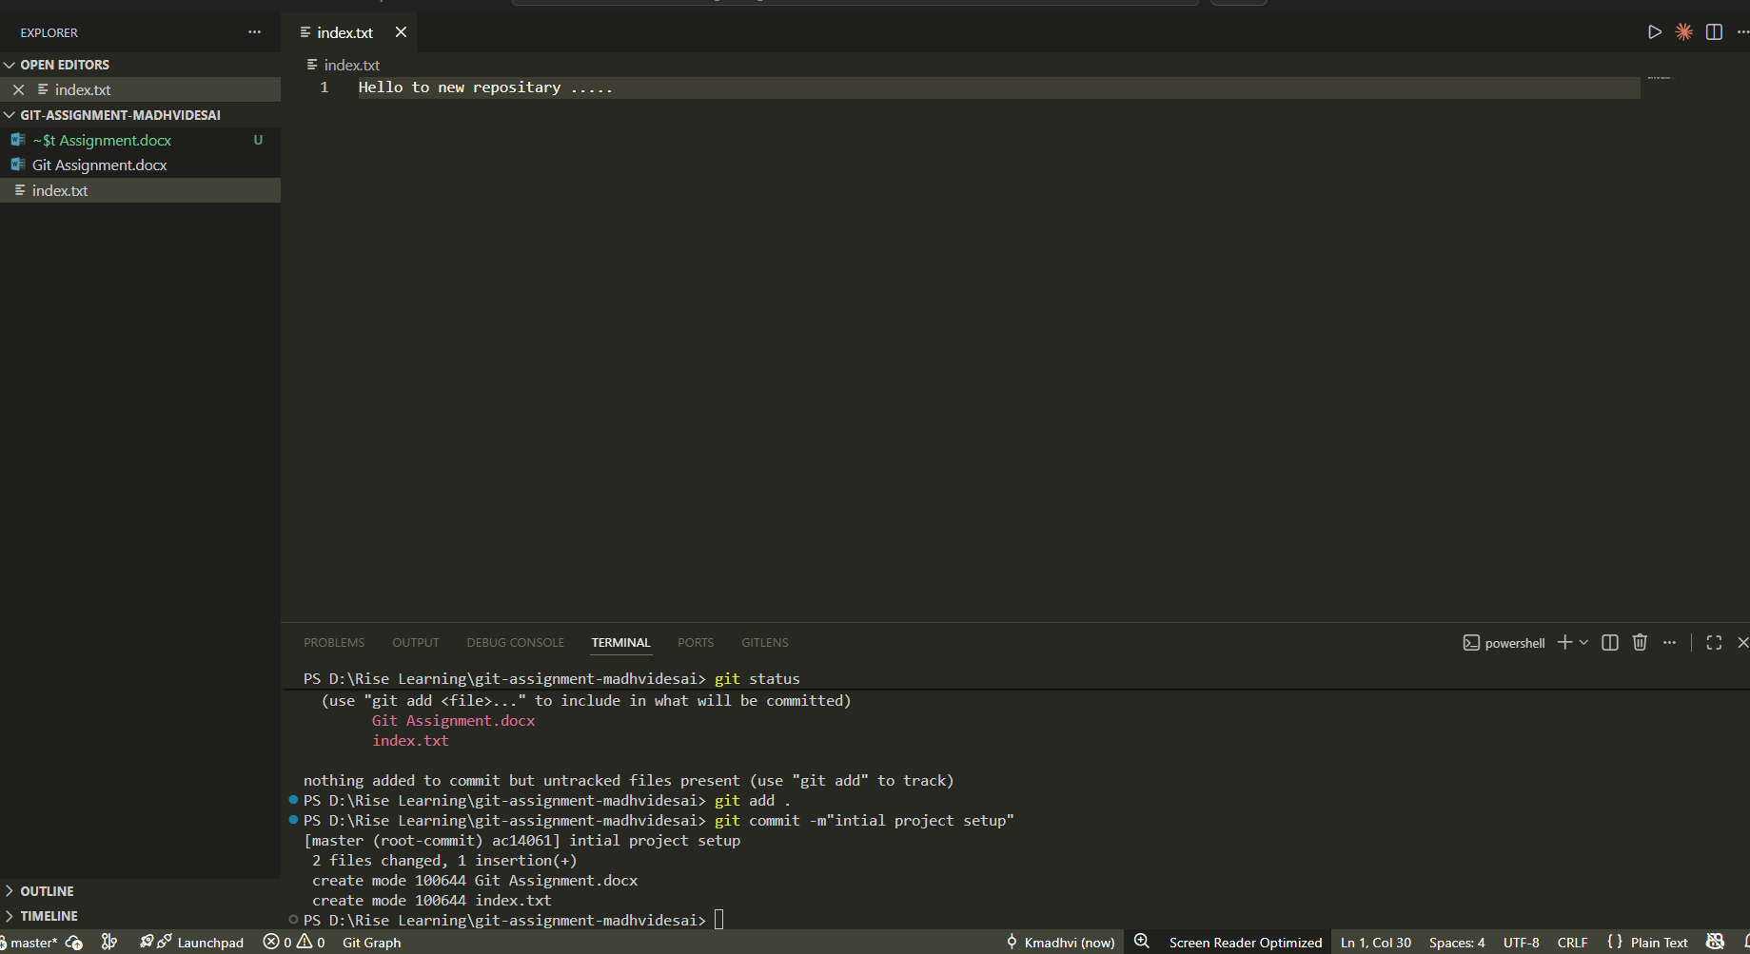

TASK 2: Branch Creation & Work
Goal: Work independently in a branch
Steps:
1. Create a branch named feature-header
2. Switch to feature-header
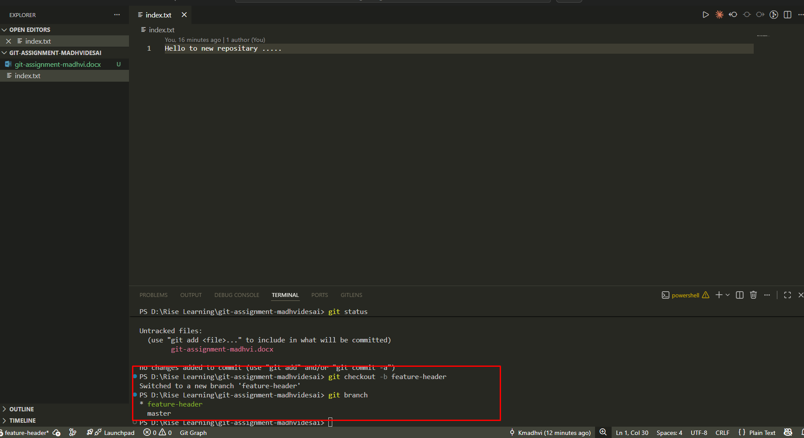
3. Create a file named header.txt
4. Stage the file
5. Commit with message:
Added header section
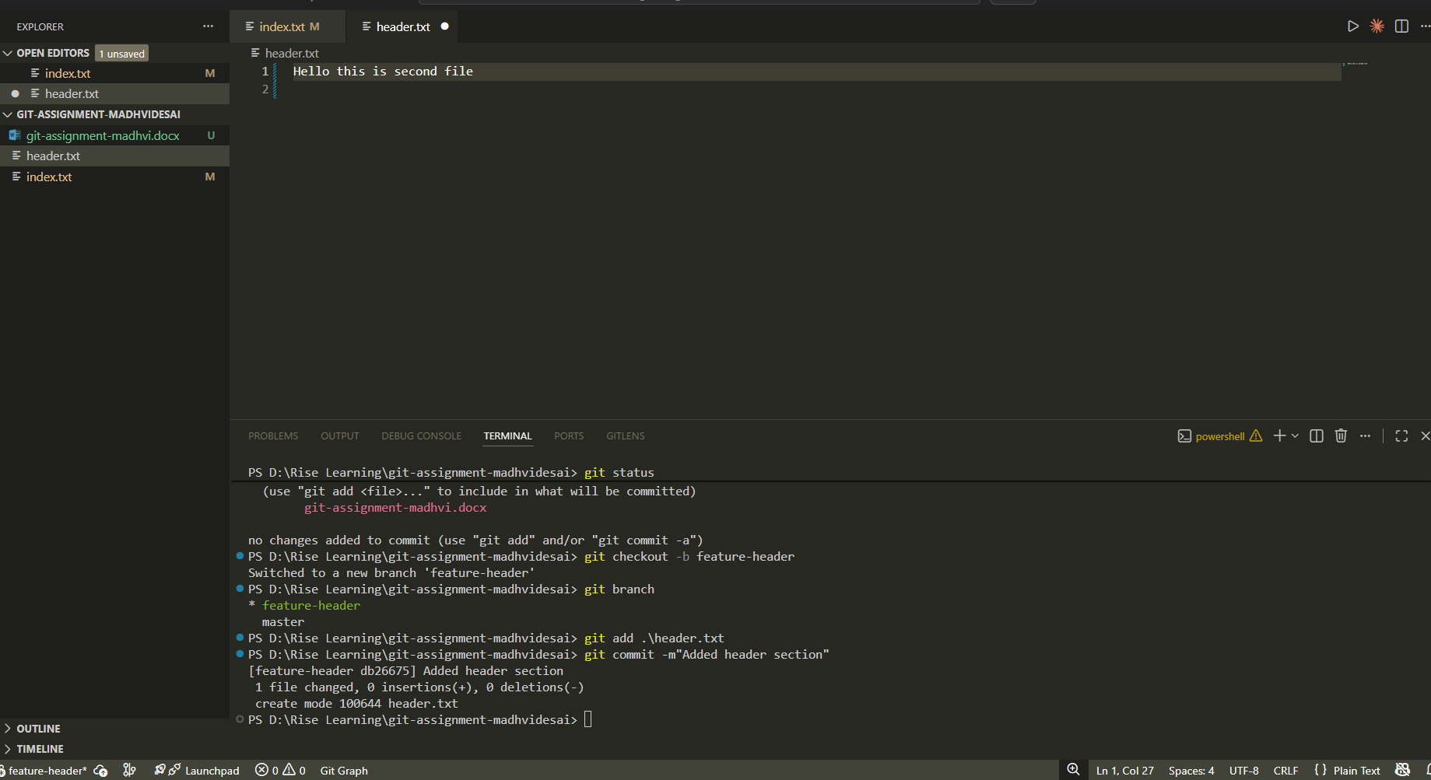

TASK 3: Branch Switching Observation
Goal: Observe branch isolation
Steps:
1. Switch back to master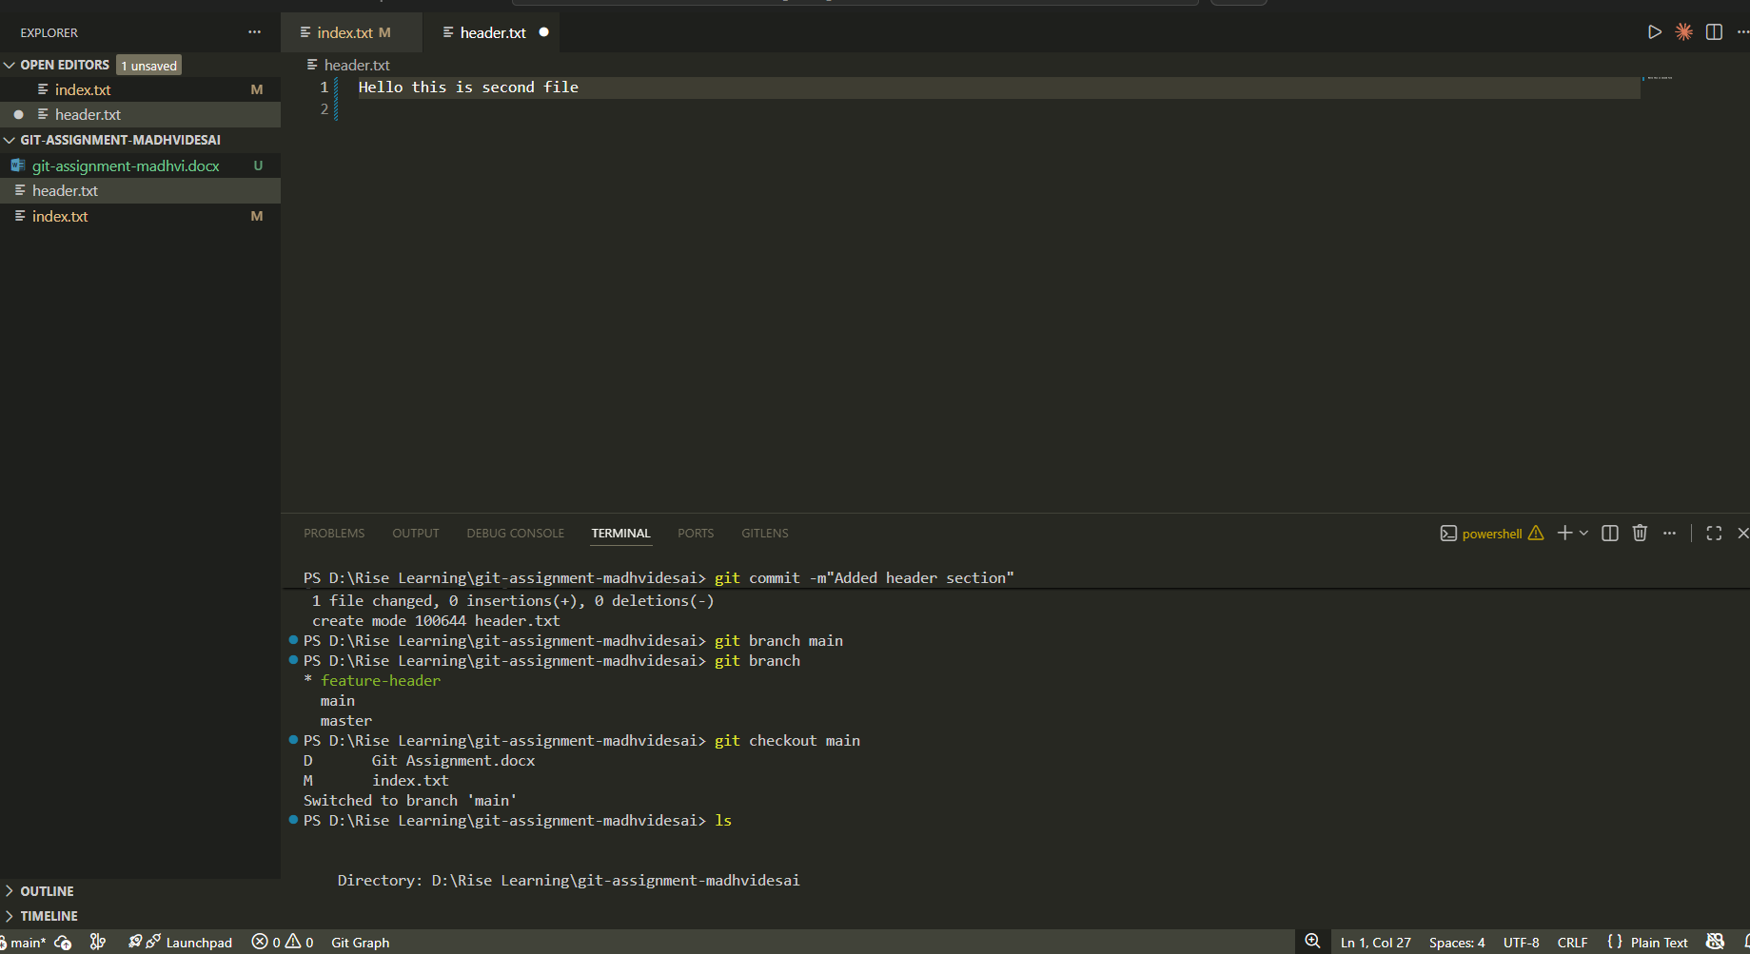
2. List files and observe
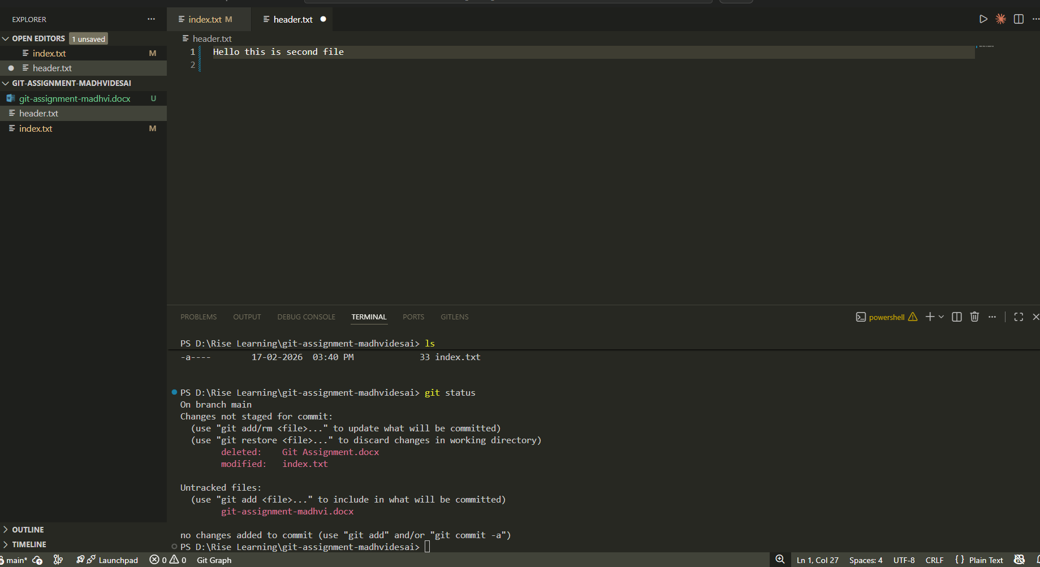
3. Switch again to feature-header
4. List files and observe

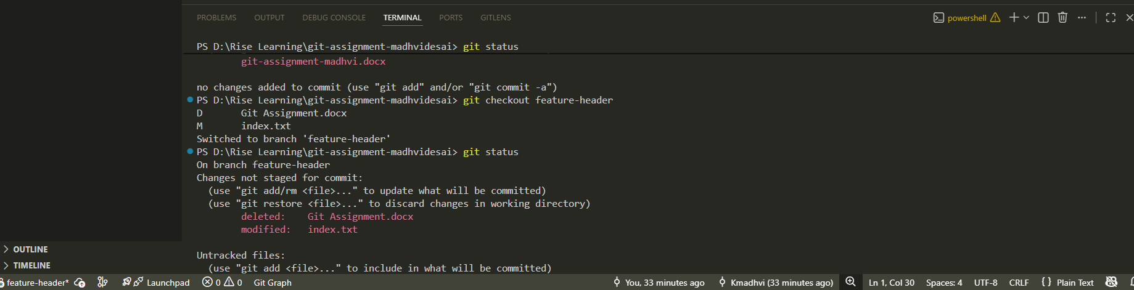

TASK 4: Undo a Mistake
Goal: Safely undo file changes
Steps:

1. In feature-header, modify index.txt
2. Check repository status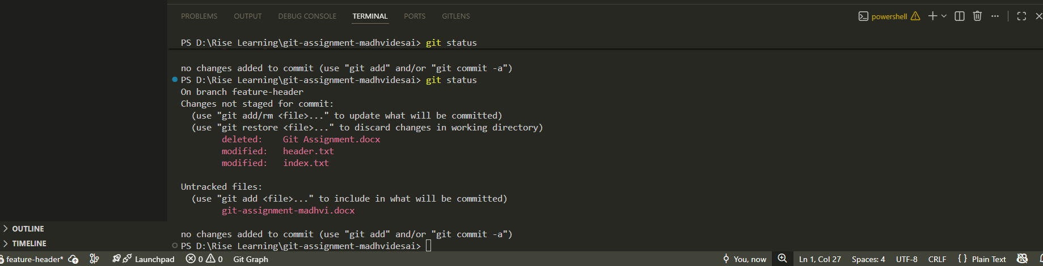
3. Undo the change using Git
4. Verify status again
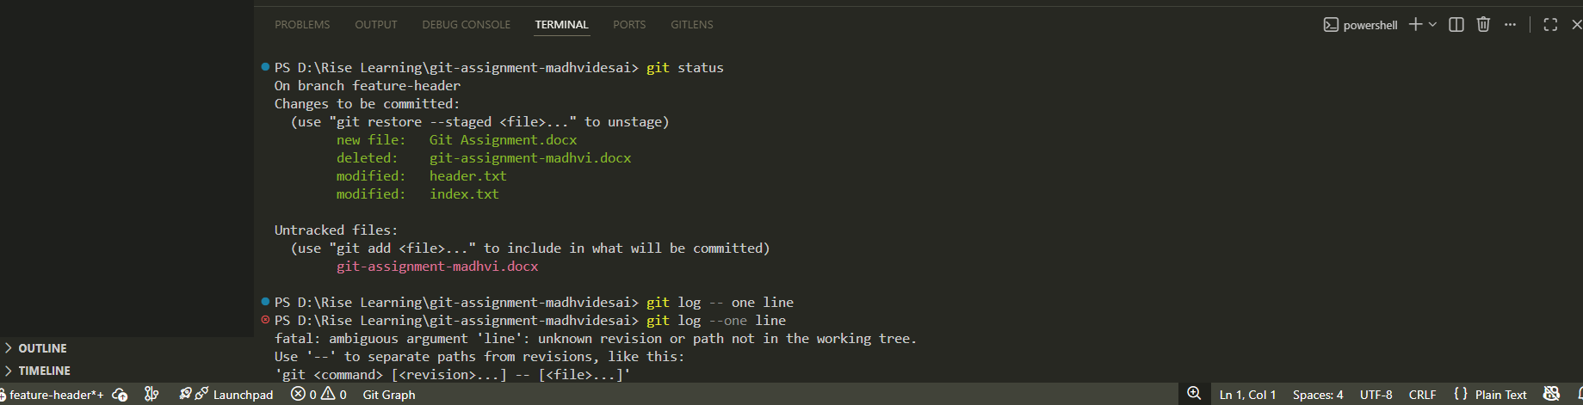

TASK 6: Checkout a Commit (Detached HEAD)
Goal: Understand commit-level navigation
Steps:
- View commit history
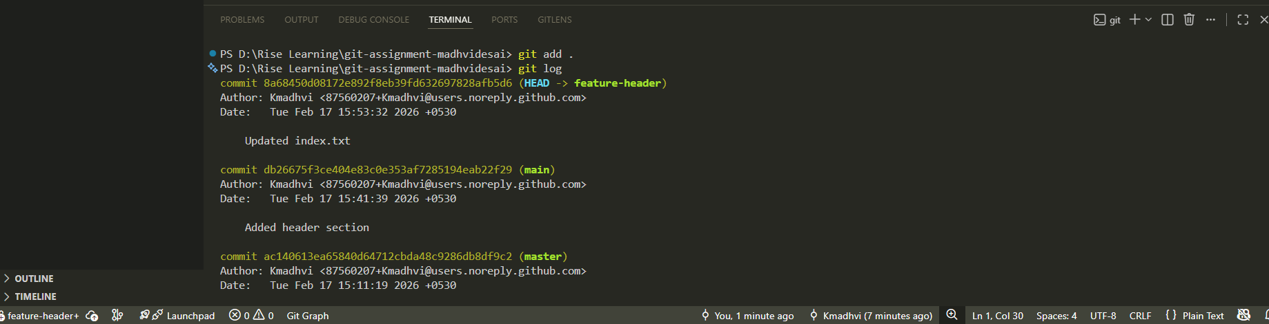
2. Checkout any older commit
3. Check current branch status
4. Switch back safely to master

