Student ID: 103220762

Name: Kanishka Malikkhil

# Setup Screenshot

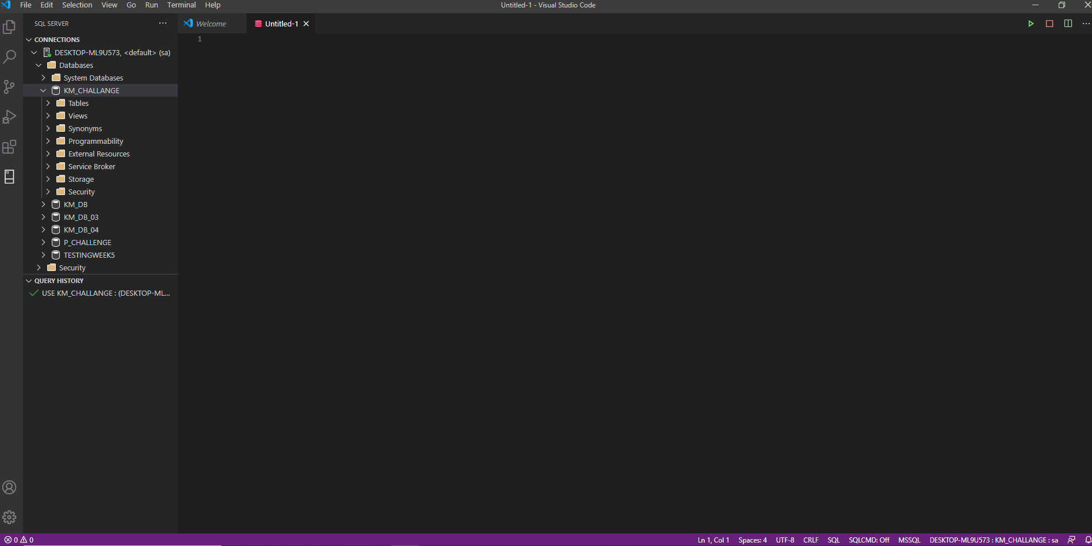

# Task 2 Screenshot

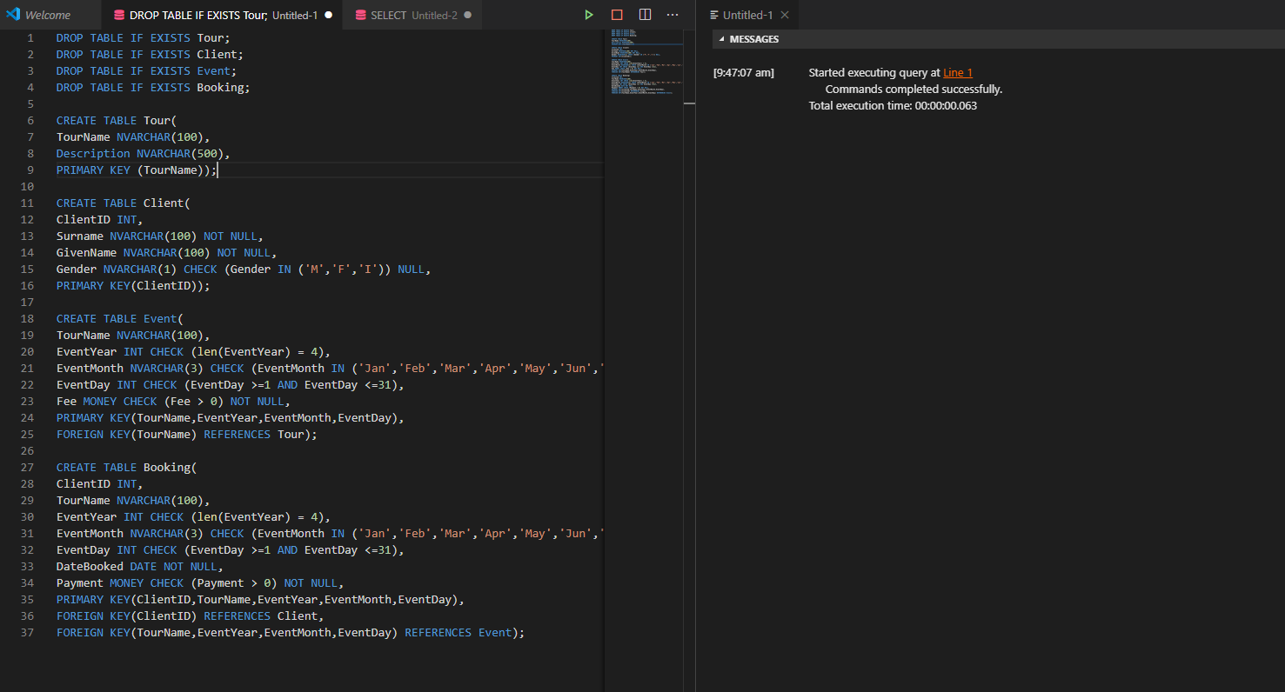

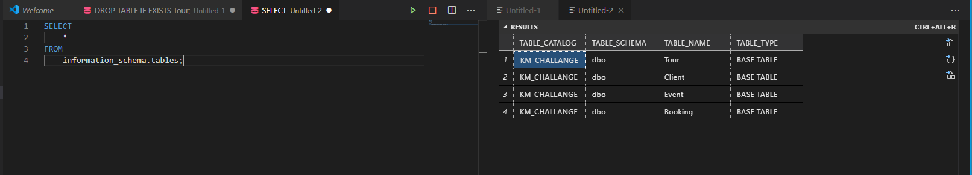

# Task 3 Screenshot

