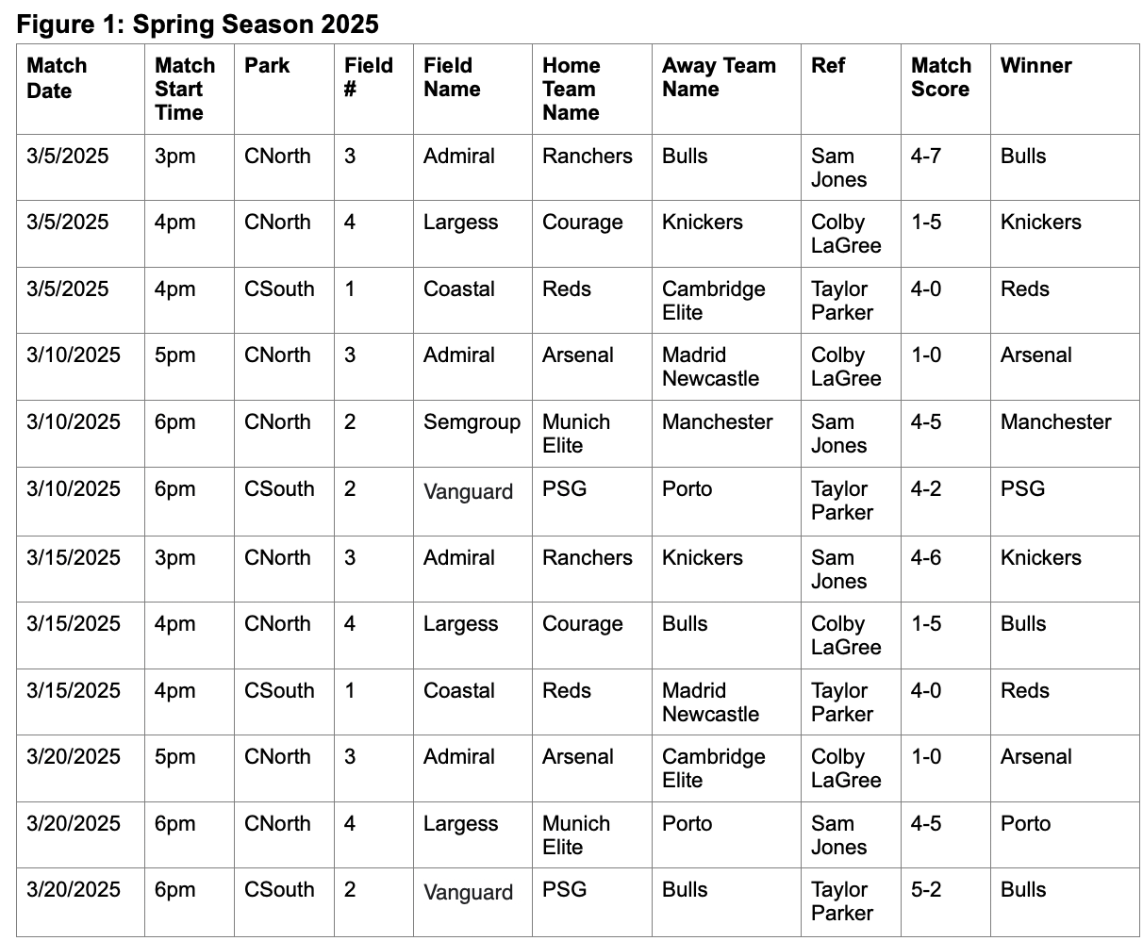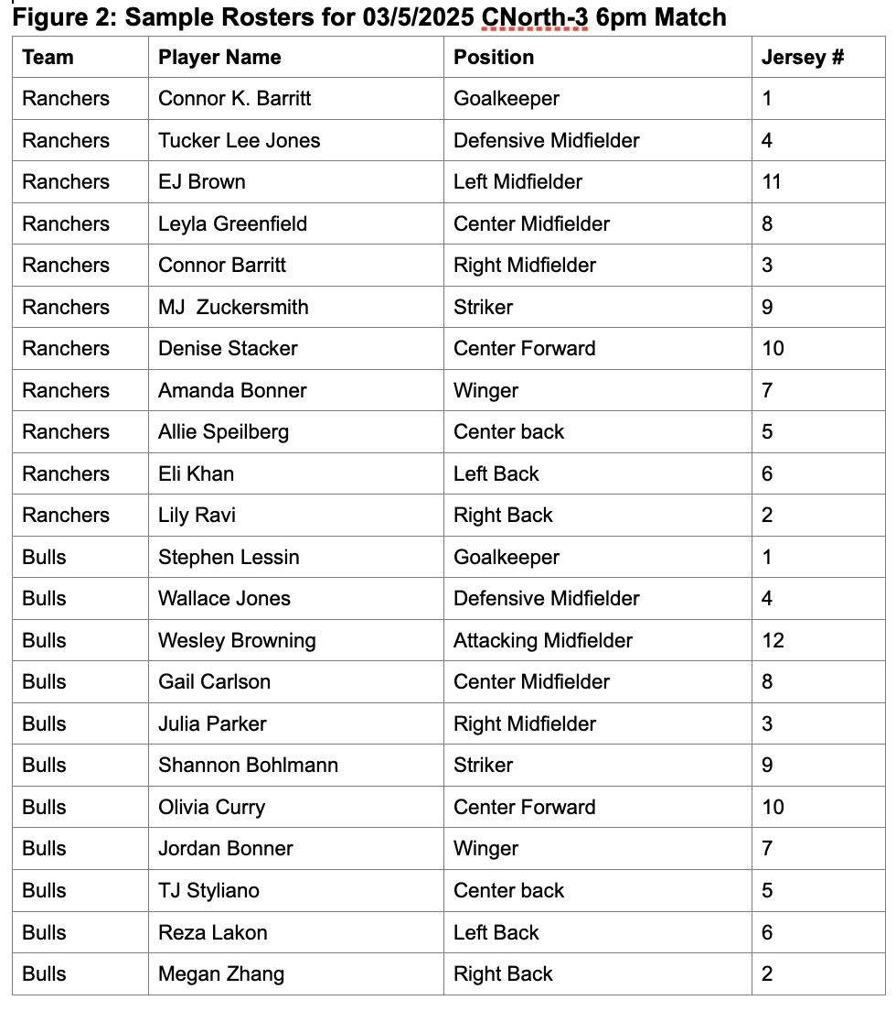

**Instructions:**

**Gather the Business Requirements:**

1. **Using the sample data in Figures 1 and 2 (and your own hypothetical data), look at the data and read the use case carefully. List the business rules in bullet form here. (Note: Get all your questions answered about the project requirements.)**

* Multiple matches can be played at the same time
* Multiple matches can be played on the same day
* Multiple matches can be played on the same park
* Every match has one ref
* Every match requires a home and away team
* Every match has one winner and one loser
* Every team needs 11 or more players
* Exactly 11 players are on the field at once
* Every team has at least one coach (Head Coach)
* Head Coach can only have 1 team
* Assistant Coach an only have 1 team
* Players need to be at least 18 to play
* Each team has 1 captain
* Matches are 90 min with 30 min OT/PKs if tie
* Every player has a unique Jersey for their team only

**Design the solution:**

1. Write out the **relational schema** for all the data. It may be helpful for you to include determinants using functional dependencies for each attribute.

League(coachname,coachage,coachgender,acoachname,acoachage,acoachgenderPlayername,Playerage,Playergender,Playerjersey,Matchscore,playergoals,playerpossessions%,passcounts,passingchains,Matchdates,matchstarttime,park,Field#**,**Fieldname,teamname**,**Hometeamname,awayteamname,ref,winner,position,assists,goals,captain)

Functional Dependencies:

PlayerName>(Playerjersey,PlayerGender,PlayerAge,Position,Teamname)

Coachname>(coachAge,coachGender,Teamname)

Matchdate,Matchstarttime,park,field#>(,Matchscore,ref,hometeamname,awayteamname,winner)

Field,park>(fieldname)

playername,matchdate,matchstarttime,park,field>(assists,playerpossessions%,passcounts,passingchains,goals)

1. **Normalize to 3NF**.
2. Normalize to 1NF. Show your work.

League(coachname,coachage,coachgender,acoachname,acoachage,acoachgender**Playername**,Playerage,Playergender,Playerjersey,Matchscore,playergoals,playerpossessions%,passcounts,passingchains,**Matchdates**,**matchstarttime**,**park**,**Field#,**Fieldname,teamname**,**Hometeamname,awayteamname,ref,winner,position,assists,goals,captain)

1. Normalize to 2NF. Show your work.

League(coachname,coachage,coachgender,acoachname,acoachage,acoachgender,**Playername**,playergoals,playerpossessions%,passcounts,passingchains,**Matchdates**,**matchstarttime**,**park**,**Field#,**,assists,goals,captain)

Player(**Playername,**Playerage,Playergender,Playerjersey,position,teamname)

Match(**Matchdates**,**matchstarttime**,**park**,**Field#,**Matchscore,Hometeamname,awayteamname,ref,winner)

Field(**park**,**Field#,**fieldname)

Normalize to 3NF. Show your work.

Stats(**Playername**,playergoals,playerpossessions%,passcounts,passingchains,**Matchdates**,**matchstarttime**,**park**,**Field#**,assists,goals)

Player(**Playername,**Playerage,Playergender,Playerjersey,Position,teamname)

Match(**Matchdates**,**matchstarttime**,**park**,**Field#,**Matchscore,Hometeamname,awayteamname,ref,winner)

Coach(coachage,**coachname**,coachgender,acoachage,acoachgender,teamname)

Team(coachname,**teamname,**acoachname,captain**)**

Field(**park**,**Field#,**fieldname)

Add two improvements to this design, one of which must be a new feature.

* 1. For example, a new feature could be adding an attribute to track the formation (e.g., 4-3-3 formation) used by each team in each soccer match.

**Adding an attribute to track each player's Playtime. This could be referred to as PT and put in the stats table**

* 1. Another idea is to track whether any yellow or red cards have been issued to any player in the league.

**Adding an attribute to show how many shots on goal each player had in a match. This can be added in stats**

* 1. After your improvements are decided, copy the 3NF answer and paste it here. Then, add your improvements to the design in the relational schema.

Stats(**Playername**,playergoals,playerpossessions%,passcounts,passingchains,**Matchdates**,**matchstarttime**,**park**,**Field#**,,assists,goals,PT,ShotsOnGoal)

Player(**Playername,**Playerage,Playergender,Playerjersey,position,teamname)

Match(**Matchdates**,**matchstarttime**,**park**,**Field#,**Matchscore,Hometeamname,awayteamname,ref,winner)

Coach(coachage,**coachname**,coachgender,acoachage,acoachgender,teamname)

Team(coachname,**teamname,**acoachname,captain**)**

Field(**park**,**Field#,**fieldname)

Relational schema:

League(coachname,coachage,coachgender,acoachname,acoachage,acoachgender**Playername**,Playerage,Playergender,Playerjersey,Matchscore,playergoals,playerpossessions%,passcounts,passingchains,**Matchdates**,**matchstarttime**,**park**,**Field#,**Fieldname,teamname**,**Hometeamname,awayteamname,ref,winner,position,assists,goals,PT,ShotsOnGoal,captain)

1. Assign foreign keys. You could assign surrogate keys at this point instead of composite PKs or names.

Stats(**StatsID,***PlayerID*,playergoals,playerpossessions%,passcounts,passingchains,assists,goals,PT,ShotsOnGoal,*MatchID*)

Player(**PlayerID,**Playername**,**Playerage,Playergender,Playerjersey,position,*teamname*)

Match(**MatchId,**Matchdates,matchstarttime,*park*,*Field#,*Matchscore,Hometeamname,awayteamname,ref,winner)

HCoach(coachage,**coachname**,coachgender,*teamname*)

ACoach(acoachage,acoachgender,**acoachname,***teamname*)

Team(*coachname*,**teamname,***acoachname,*captain**)**

Field(**park**,**Field#,**fieldname)

1. Build an EER for the ***raslYourName*** (e.g., rasl with your first and last name appended) schema in MySQL Workbench to show your final design (model) for the database, including all entities, attributes, and relationships. Be sure to identify the PKs and FKs in the EER so that they will automatically be built in the database tables of the ***rasl*** schema.

**Build the schema and database from the design:**

1. Synchronize the EER to the build.
2. Verify the build.
   1. Verify all tables and their attributes and PK. For example, after synchronization, you should create a ***team*** table that would include attributes such as the *teamID, teamName, headCoach, assistantCoach* (optional), etc. You should also see a ***player*** table that would include attributes such as the *playerID, playerFName, playerMName, playerLastName, playerAge, playerPosition, jerseyNumber, and teamid*.
   2. Verify the FKs representing each relationship in your EER.

**Populate the tables with data:**

1. Add SQL code to insert a constraint on the table with the data in the Player table, such that the age of a player must be greater than or equal 18 (since this is an adult soccer league). Here is an example:

ALTER TABLE player ADD CONSTRAINT age_check CHECK (player_age >=18);

1. Enter the data shown in both figures in the appropriate tables according to your data model design. Additionally, enter (or import) additional hypothetical data for the teams, players, coaches, refs, stats, and matches (at least 5 per table).
   1. Populate each table of the database by typing the data directly into each table or by importing it.
   2. Populate the parent tables first, then the child tables.
   3. (Note: Your data should be different from others – each person should derive their own hypothetical data.)

**Create SQL programs to answer questions of the data:**

1. Create and run the following SQL programs, each with a preceding comment stating the query in English. Save your work in script named rasl along with your first and last name.sql. Add a comment to the top of your script with your name and the current date. Type the use statement and run it. Then, type SQL code for each of the following items. Be sure to validate your results using an alternate method. **Screenshot your code and answer in this document for each question.**

Create the schedule shown in Figure 1

Create the rosters for the first match displayed in Figure 2.

List the youngest and oldest players in the league.

List the stats for all players in the league, aggregated (summed) per player.

Which player has the most assists across all matches in the league in the spring 2025 season and what was that total?

Which team won the most matches in the spring season of 2025 and what was their average points per match?

Which head coach (name) won the most matches in the spring season of 2025 and what is the coach’s team?

Create a query that shows how many days have passed since the last rasl match.

Create a query of your choosing that includes a subquery.

Add another meaningful query of your choosing. For example, you could create a query that answers the following question: What is the name of any player who has scored 3+ goals in a f?

**Submit your project:** Two files are required:

1. This exact .docx file with all query answers and screenshots;
2. Screenshots of the data in each table; and
3. The .sql script.