Emergent Markets and Path-Dependent Optima (Draft)
- Kevin McCabe, Aleksander Psurek

Abstract
In this paper we investigate the formation of locally centralized exchange markets using agent-based simulation with minimal computational and institutional complexity. We find that even with very simple models of agent behavior, centralized market places emerge. Moreover, we measure social welfare outcomes for different institutional and environmental arrangements and find that increasing opportunities to trade, as well as denser environmental conditions, increase social welfare and lead to market centralization. Finally, we investigate the effects of changing social preferences, either permanently or temporarily, and find that preferences for social distancing - analogous to those imposed during the COVID lockdown measures - lead to severely diminished social welfare and lead to permanently depressed social welfare after their subsidence because of path-dependency in local market formation.

I. Introduction
Since at latest the development of cities as centers of industry and exchange in the neolithic period, humans have been gathering at centralized locations to conduct commerce and improve their welfare. As the city is not a unique aspect of any one civilization or geography, it is natural to conclude that this system for facilitating welfare is in some natural way superior to systems without centralized exchange points. Similarly, even within cities, the development of downtowns or commercial centers mirrors the same phenomenon on a smaller scale. While there is a great diversity among the different forms of these particular systems, the overall pattern remains the same - people gather in some centralized place, and they tend to stay there once such a central node has been established.
In this paper, we investigate a set of minimally computationally intensive agent strategies which lead to a development of centralized marketplaces from randomly distributed agent allocations on a spatial grid. We further investigate the centralization and welfare impacts of agents following these strategies and find that agents aggregate onto relatively few points with a simple strategy of choosing not to move if they can continue to trade at their location.
Moreover, we find that introducing agents which have preferences to be socially distant leads to lower welfare outcomes for all agents and in aggregate. We find also that even if such preferences are temporary, the aggregated points which emerge during the period of social distance lead to permanent desegregation and welfare decreases with such simple agent strategies, as a result of market location path-dependence.
Our first result, the emergence of centralized market locations from simple agent strategies and random allocations, mirrors intuitions about the emergence of centralized markets in modern and historical economies. Centralized exchange, in the form of cities, has existed since at least the Neolithic Age (Lampard, 2023). However, while real-world exchange generally follows some pattern of development involving trust and eventually contractual relationships, as for instance in Fafchamps, 1998, which documents such an emergence in African manufacturing, our setting strips away all elements of trust and contracting. Instead the behavior of our agents is a result of simple rules meant to facilitate trade, but it similarly results in path-dependent market formation.
Our result similarly contributes, but is apart from, the set of results and models about city formation from Scott Page in 1998. Specifically, in his paper Page creates models in which agents have preferences relating to the distribution of population of other agents, while being blind to the economic incentives to form centralized nodes. In contrast, our model hinges on agents making decisions based on a narrow set of criteria which compel agents to move or not move based only on the presence of economic incentives in their immediate grid point. Therefore, agents are blind to population information and any incentives outside their own grid position.
Additionally, our result pertaining to the effects of temporary preference changes, be they imposed or genuine, contra but to the conversation around the economic and social effects of measures such as the COVID lockdowns. During the height of the lockdown measures and even while the first batches of vaccines were being distributed, many predicted that the economy and the society would “bounce back” in a “V-shaped” recovery, expecting the overall welfare and societal arrangements to return to pre-pandemic levels (Kammer, 2021; FRED Blog, 2021; Aspachs, 2021). There were, however, some models and papers which predicted different “letter-shaped” recoveries, such as one by Sharma et al. from 2021, which were less saccharine in their predictions, predicting that the economy could be trapped in some bad state.
Similarly, some empirical papers have pointed to significant and persistent gaps in employment and output relative to pre-lockdown levels, such as Schotte al. in 2021. Additionally, some studies have pointed to the fact that such measures have had different effects on different types of workers and sectors of industry, and that many of these changes are likely to be long-lasting (Albanesi, 2021; Jaumotte et al., 2023; Milesi-Ferretti, 2021). While our study does not capture the effects of heterogeneous agents and production or exchange processes, it could be extended to discuss these topics.
The rest of this paper is organized as such: section II discusses the methods of investigation, section III discusses the results, and section IV concludes.

II. Methods
The chief method of investigation in this study is an agent-based simulation of a simplified two-dimensional exchange space within which buyers and sellers participate in exchange and which they can move across. The theoretical formulation for the design of the simulation follows the microeconomic system design first developed in Hurwicz, 1960 and 1973, and elaborated on in Smith, 1982. Specifically, this formulation conceptualizes a microeconomic system as a set of interactions between economic actors called agents through a message space which is curated or curtailed by institutions, all against the backdrop of a wider economic environment. This study focuses mostly on the agents themselves and seeks to limit complexity in all other aspects, as well as within the agents themselves. As such, the following portion of this paper will explain each of the components of the microeconomic system as present within our simulation.
ii.a. Environment
The economic environment contains the institutions and the agents which interact in the microeconomic system and characterizes the broader world which the agents exist in. In this study, constant will be the number of agents and the nature of the market as containing one good. Welfare will also be measured environment-wide, as a percentage of total surplus realized relative to that theoretically possible under a perfectly competitive, unitary market. Our main experiments relate to an environment where there are 20 buyer and 20 seller agents who are uniformly randomly distributed on a 10x10 rigid square grid. Smaller scale tests are performed to show the importance of this spatial arrangement. Agents are allowed to move and trade for 50-100 “weeks”- where each week is a set of 10 periods of moving followed by trading. Welfare calculation for these results are also done at the weekly level.
ii.b. Institutions
There are two institutions in this microeconomic system: a bargaining institution and a travel institution. The bargaining institution allows agents to interact with each other if they are on the same grid point and facilitates trade. Trade takes place over several rounds, with the main results of this paper implanting a rule of 10-round bidding, however results are presented for the importance of this variable. Trade proceeds in a manner of take-it-or-leave-it offers each round, with the institution crossing trades at a random point between viable bids and asks. There is no institutional memory of exchange or contractual relationships created by this exchange, except those instantly completed, so this institution does not create a path-dependence or centralization.
The travel institution allows agents to interact with the grid in an effort to change their position on the grid. While it could contain high level complexities, akin to real-world travel networks, it is very simple allowing agents to move between any directly adjacent grid points, including corners, until they reach the bounding boxes of the environment’s grid. Notably, moving costs the agents nothing, except for the opportunity cost of remaining at their present location. This travel institution, therefore, is not sufficiently complex to lead to any path-dependence or centralization.
ii.c. Agents
The results of this study hinge on the different types of agents that are implemented in the simulation. In an effort to avoid foregone conclusions, this study develops the complexity of agents one step at a time and aims to limit the complexity of agents to the minimum required to replicate the phenomena of market emergence.
ZID: The simplest type of agent implemented is a zero-intelligence budget-constrained type, named ZID. This type of agent has been shown in repeated agent based simulation papers to produce remarkably robust results near-welfare-maximizing results when participating in market exchange mechanisms, as documented by Gode and Sunder in 1993. This type of agent is sufficient for efficient exchange at on a centralized market place, but as it moves entirely randomly on the grid, it is insufficient for creating an overall efficient outcome.
ZIDP: A natural addition of computation to this agent type is the selection of the best presented offer, rather than accepting a random offer, when agents can accept offers from many agents they will prefer to accept the offer with the highest price (bid) or lowest price (ask) depending on their type. This type of trader is termed ZIDP. While this type of trader will lead to an even more efficient result for centralized exchanges than the ZID trader, it too will not lead to market emergence, as it moves randomly.
ZIDA: To incorporate a movement strategy, the ZID agent is augmented with a preference to stay at a grid point if it is able to contract for trades. If it is not able to contract for a trade, it will instead choose to move away. Therefore, agents will move randomly until they find a grid point with a counterpart agent which may be willing to trade with them. This type of agent is sufficient to lead to the development of centralized markets, without the need for complex institutions.
ZIDPA: This agent type incorporates the movement and acceptance of best offers behavior of the ZIDP and ZIDA agent types. While it is slightly more complex than the ZIDA agent, it is more realistic that individuals would accept the best offer they are presented with as it has nearly no cost.
ZIDPR: This agent type behaves identically to the ZIDPA agent type, with the exception that it will move away from any grid point on which there are more than two total agents. Therefore, in an environment consisting of only ZIDPR agents, the maximum occupancy of a grid point would be two.
There are, of course, limitations to the way in which these agents are designed and in their decision making process. While the markets and path-dependence in this context are emergent, the strategies followed by the agents are designed, and in particulate the movement choices of ZIDA and ZIDPR agents depend on lexicographic preferences.
Figure 1 documents the message space through which agents interact with institutions and the environment. This sequence diagram demonstrates the basic process which each simulation ran with this microeconomic system operates.

III. Experiments and Results
We conduct three types of experiments with the microeconomic system described above. We first investigate the effects of having each individual type of agent homogeneously dispersed within the system, and observe the emergent behavior of these agents based on the described strategies. We then investigate the effects of mixing the ZIDAP (most optimal) and ZIDAR (socially-distant) types in different proportions in an effort to investigate potential effects in long-run preference changes for even portions of the population as a result of COVID or similar events. Finally, we investigate the effects of short-term changes in preferences or policy, switching out portions of the ZIDAP population with ZIDAR agents for several weeks after a steady state has been reached with the initial population.
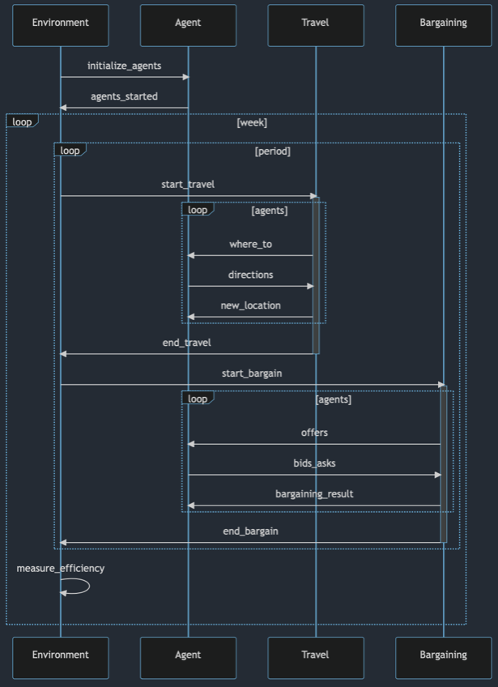
iii.a. Validation of Microeconomic System
Figure 1: Microeconomic System Sequence Diagram
Before conducting experiments in this context, we first validate the microeconomic system variables which will be used for the full-scale experiments. In figure 2, we present the price and quantity of exchanged goods, along with the ordered supply and demand, for an environment which is a 1x1 grid, and thus is fully centralized. These results are generated with just ZID, zero-intelligence, traders, mimicking the results from Gode and Sunder, 1993, with traders converging towards the theoretical price and volume. In figure 3, we demonstrate the effect of the rounds of bargaining permitted, with efficiency reaching a steady state by approximately 10 rounds permitted. These results validate the basic agent bargaining logic and the choice of 10 bargaining rounds.
Figure 2: Price Evolution with Supply and Demand

Similarly, figure 4 investigates the effect of changing the grid size, while only allowing one movement phase. As expected, the efficiency collapses as agents are allocated more sparsely on a larger grid. However, when traders were allowed to move more times by increasing the number of periods, efficiency improved and reached a steady state by around the 50 period mark. Because we want to see an emergent market, these results validate our choice of using a 10x10 grid size and of having many movement and exchange periods.
Figure 3: Efficiency Improves with Additional Rounds of Bargaining

Figure 4: Efficiency Decreases in Short Term with Grid Size

Figure 5: Efficiency Increases with the Number of Periods

iii.b. Comparative Performance of Agent Types
Our first set of experiments is to uniformly randomly place agents of each type on the grid and allow them to move and trade for 50 weeks. In this experiment, we are comparing the efficiency of each trader type to each other, as well as observing the emergence of steady-state points for types which converge to some such point. Figure 6 documents the results of such a comparison. All types except the ZIDP and ZID types reach a steady state outcome, with ZIDPA types consistently outperform all other types in a steady state. Notably, however, this result also holds true for ZIDA types being superior to other types in the steady state. The ZIDPR type also reaches a steady state, but it plateaus at a lower level than do the other ZIDA-derivatives.
Figure 7 plots the emergence of efficiency with the ZIDA type along with the number of grid points which are occupied at a given point in time. As can be seen in this graph, the efficiency increases while the grid points occupied decrease. As the number of agents has not changed, the gird points are more densely occupied and this concentration of agents is facilitating more efficient exchanges. A centralized market has therefore emerged.
Figure 6: Homogenous Agent Type Comparison

Figure 7: Efficiency Increases as the Number of Occupied Points Decreases

iii.c. Mixing-in Socially-Distant Types
Our second set of experiments investigates the result of mixing a proportion of socially-distant, ZIDPR, agents with the most-optimal agents, ZIDPA. This experiment seeks to investigate the effects of heterogeneous types, specifically keeping in mind the different ways individuals may respond to pressures such as infectious diseases or which may have to do with preferences against density. Figure 8 puts this experiment into context by comparing the efficiency results of a 50-50 mixed group with those of homogenous types. Notably, the heterogenous environment produces results much closer that with 100% ZIDPR agents, pointing to the large externalities that social distancing can have on exchange even between other types of agents.
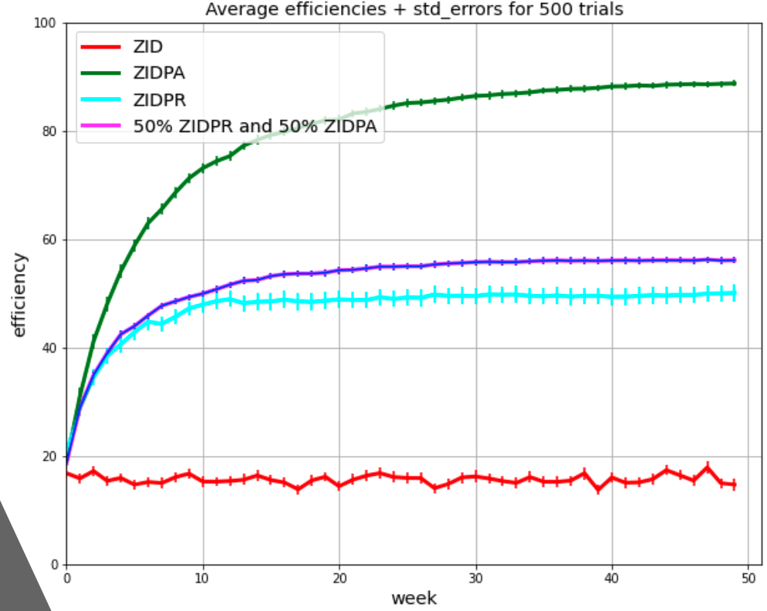
Figure 9 further investigates this phenomenon by plotting the terminal efficiency of environments with an increasing proportion of ZIDPR agents in relation to ZIDPA agents. The slope of the regression line is -2.106, implying that for every additional ZIDPR agent in an environment, the efficiency will decrease by 2.1. The variance, however, is quite large.
Figure 8: Addition of Socially-Distant Types has Outsized Effects

Number of ZIDPR Agents
Terminal Efficiency
Figure 9: Terminal Efficiency Decreases with the Number of Socially-Distant Agents

iii.d. Short-term Preference Changes
Our final set of experiments looks at the effects of changing the composition of agents in a system which has already reached a steady state for a short period of time, four weeks, and then reverting the composition of agents to its original proportions. The agents will therefore not be randomly allocated at the end of the treatment period, but will instead be continuing to occupy the spaces which their predecessors occupied. As can be seen in figure 10, the initial replacement of ZIDPA with ZIDPR agents results in a precipitous drop of efficiency, mimicking the expected and real effect of COVID-era lockdowns. However, once the treatment period is over, the system begins to recover quickly but does not reach its original efficiency. Instead it reaches a steady-state plateau below the efficiency which it was originally at. As can be seen in the figure, even if only 30% of agents are replaced, representing a restrained response, the same qualitative results are obtained, though with less outcome variance.

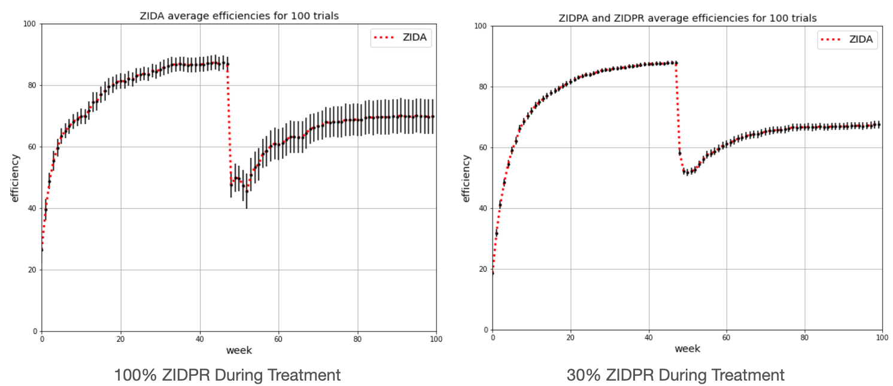
Figure 10: Intervention has Large and Long-lasting Welfare Consequences
IV. Conclusion
Our study demonstrates the potential for markets to emerge spontaneously from an environment with uniformly allocated agents with simple cognition rules and using simple institutions. We demonstrate the efficiency of such markets and compare its efficiency favorably with fully decentralized exchange. Moreover, our model sheds light on the externality effects of social distancing and on the lack of a true v-shaped recovery following the COVID pandemic lockdowns. The path-dependence of markets is an understudied and underappreciated topic, and this paper helps to bring light to these questions.
Further research is required, especially in the area of the institutional aspects of market formation, as well as the questions of escaping this local equilibrium trap. Turning to the literature of institutional development and Schumpeterian destruction appears necessary to fully understand the complexity of real markets and the ways in which they space such local optima.
References
Lampard, E. Edwin (2023). city. Encyclopedia Britannica. https://www.britannica.com/topic/city
Fafchamps, Marcel. (1998). “Market Emergence, Trust, and Reputation,” Working Papers 96016, Stanford University, Department of Economics.
Hammer, Alfred. (2021). “From Vaccines to V-Shaped Recovery in Europe,” IMF Blog, IMF.
FRED Blog. (2021). “A V-shaped recovery,” FRED.
Sharma, Dhruv, Jean-Philippe Bouchaud, Stanislao Gualdi, Marco Tarzia, and Francesco Zamponi. (2021). “V–, U–, L– or W–shaped economic recovery after Covid-19: Insights from an Agent Based Model,” PLoS One, 16(3): e0247823.
Schotte, Simone, Michael Danquah, Robert Darko Osei, and Kunal Sen. (2021). ”The Labour Market Impact of COVID-19 Lockdowns: Evidence from Ghana,” discussion paper series, IZA Institute of Labor Economics, IZA DP No. 14692
Albanesi, Stefania and Jiyeon Kim. (2021). “Effects of the COVID-19 Recession on the US Labor Market: Occupation, Family, and Gender,” journal of Economic Perspectives, Vol. 35, 3
Jaumotte, Florence, Longji Li, Andrea Medici, Myrto Oikonomou, Carlo Pizzinelli, Ippei Shibata, Jiaming Soh, and Marina M. Tavares. (2023). “Digitalization During the COVID-19 Crisis: Implications for Productivity and Labor Markets in Advanced Economies,” Staff Discussion Notes, International Monetary Fund
Milesi-Ferretti, Gian Maria. (2021). “A most unusual recovery: How the US rebound from COVID differs from rest of G7,” UP FRONT, Brookings Institute.
Hurwicz, Leonid. (1960). “Optimality and informational Efficiency in Resource Allocation Processes,” in Kenneth Arrow et al., eds., Mathematical Methods in the Social Sciences, Stanford: Stanford University, 27-46.
Hurwicz, Leonid. (1973). “The Design of Mechanisms for Resource Allocation,” American Economic Review Proceedings, 63, 1-30.
Smith, Vernon L. (1982). “Microeconomic Systems as an Experimental Science,” The American Economic Review, Vol. 72, 5, 923-955.
Gode, Dhananjay K. and Shyam Sunder. (1993). “Allocative Efficiency of Markets with Zero-Intelligence Traders: Market as a Partial Substitute for Individual Rationality,” Journal of Political Economy, Vol. 101, 1, 119-137.

