The effects of Covid on market fragmentation and economic welfare

1. Introduction talking about Covid, social distancing, and market fragmentation. Maybe labor markets make a good example.
2. Describe the decentralized market model. (MES system)
3. Describe agent behavior (travel for meetings and bargaining)
4. Baseline Simulations without Covid and choice of benchmark models
   1. Results. What improves efficiency (Travel strategies)
5. Simulations with social distancing after equilibrium is reached.
   1. Results. A drastic drop in efficiency during the social distancing
   2. Followed by a slow recovery.
   3. Recovery asymptotes below the efficiency before social distancing
6. Simulations on policy variables for restoring efficiency.
7. Discussion of why we are seeing these results.

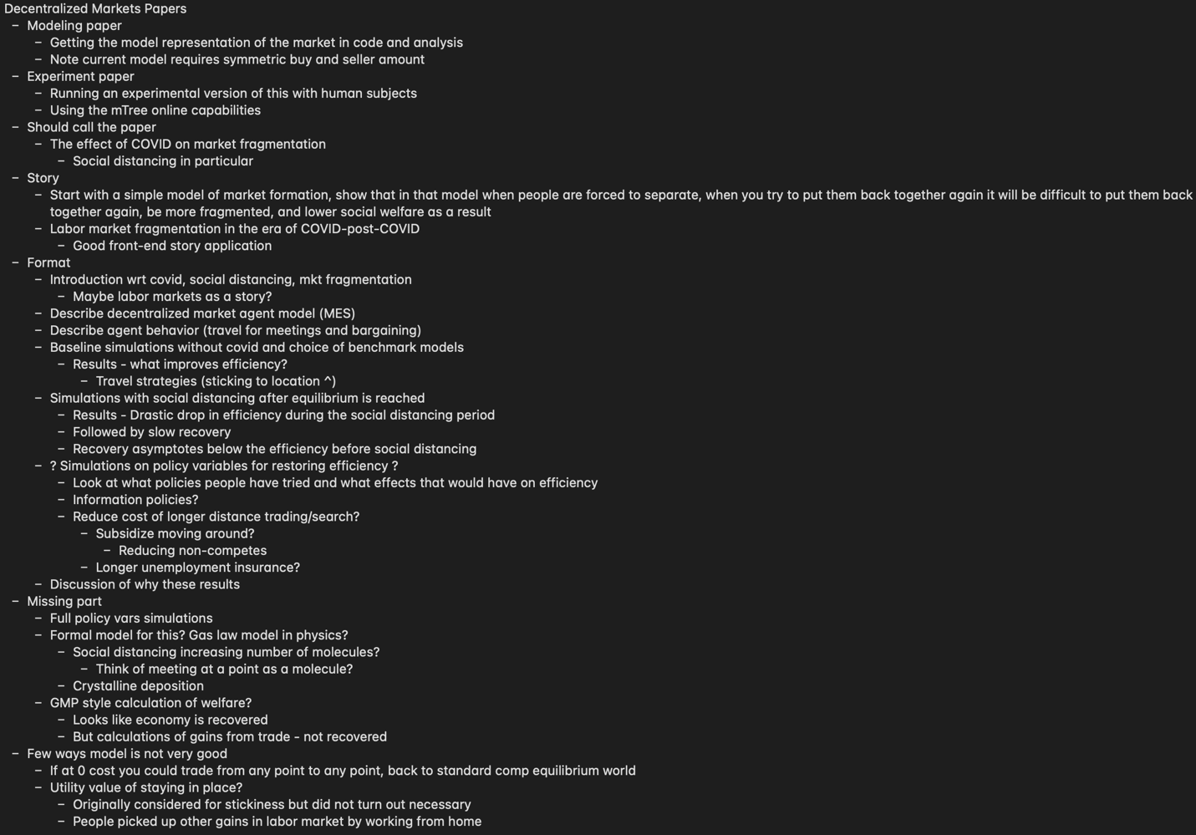

Methods

We investigate the formation of organic market structures as a result of institutional arrangements in a simplified, one-good-and-currency, bargaining economy. We simulate this economy with virtual agents acting as buyers and sellers with heterogeneous cost and value structures trading with each other and moving around on a grid.