No-Error. Full Compliance.

Single Run.

Extending to 500 weeks.

Looking at „Min Agents” – resets the flag to “false” if <2 agents at the same place

Looking at Movement Error.

Not resetting flags if randomly moving.

Yes resetting flags if randomly moving.

Extending the timeframe to 500 weeks.

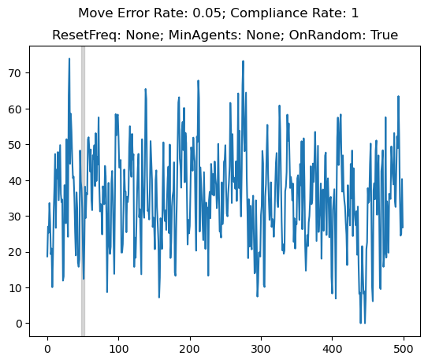

Extending above to 10 trials.

Frequency of Resetting Flag.

For 500 weeks Frequency of Flag Reset

Move if <2 at a point.

With movement error rate, not resetting the flag on random move

