Task 11
Q1. Access Modifiers:
The access modifiers in Java specifies the accessibility or scope of a field, method, constructor, or class. We can change the access level of fields, constructors, methods, and class by applying the access modifier on it.
There are Four Types of Access Modifiers:
1.Default
2.Private.
3.Public.
4.Protected.
 | Default | Private | Public | protected
Class | (i)Key word as default.  (ii)its only access with in Same class.  (iii) also access in same package subclass and non subclass.  iv)cannot access in different package class. | (i)Keyword as private.  (ii)it access only in the class.  (iii).it cannot access different class and package. | (i)keyword as public.  (ii)it will access same class  (iii) access in different class.  (iv) access in different package. | (i)keyword as protected.  (ii)it will access same class  (iii) access in different class.  (iv) access in different package.  (v) it cannot access in different package subclass.
method | we use the default modifier then the class can only be accessed inside the declared package and not anywhere else, Class may or may not be public it makes no difference. | we use the private modifier then the method can only be allowed inside the class. | we use the public modifier then the method is allowed to be used anywhere with only the condition that the class must be available. | we use the protected modifier then the class can be accessed anywhere inside the package and only in child classes outside of the package that too with child reference only.
variable | do not use any access modifier it is treated as default where this allows us to access within a class, within a subclass, and also non-sun class within a package but when the package differs now be it a subclass or non-class we are not able to access. | A member of a class is specified as private, then that member can only be accessed by other members of its class. | When a member of a class is modified by public, then that member can be accessed by any other code. | Its used in same class.different class, and different subclasses.

Q2.
Exception | Error
Exceptions, are used to handle errors that can be recovered from within the program. Exceptions are represented by the Exception class and its subclasses.  It have 2 types :  i)Runtime exception  ii)compiletime exception  Exception can handled by try… catch. Try with multiple catch.try catch and finally.  And also handled with throw and throws keyword its throws the exception in super class. | Errors are usually caused by serious problems that are outside the control of the program, such as running out of memory or a system crash. Errors are represented by the Error class and its subclasses. Some common examples of errors in Java include:  - OutOfMemoryError: Thrown when the Java Virtual Machine (JVM) runs out of memory.  - StackOverflowError: Thrown when the call stack overflows due to too many method invocations.  - NoClassDefFoundError: Thrown when a required class cannot be found.

Q3
Checked Exception | Unchecked Exception
The Exception will occur in compile time it is called compile time exception. | The exception will occur runtime its also called runtime exception.
Some checked exceptions are:  i)Filenotfound Exception  ii) I/o Exception.  iii)Sql exception.  iv)Class not found Exception | i)Arithmetic exception.  ii)nullpointer exception.  iii)input mismatch exception.  iv)Array index out of bond exception.  v)String index out of bond exception.

Q4.
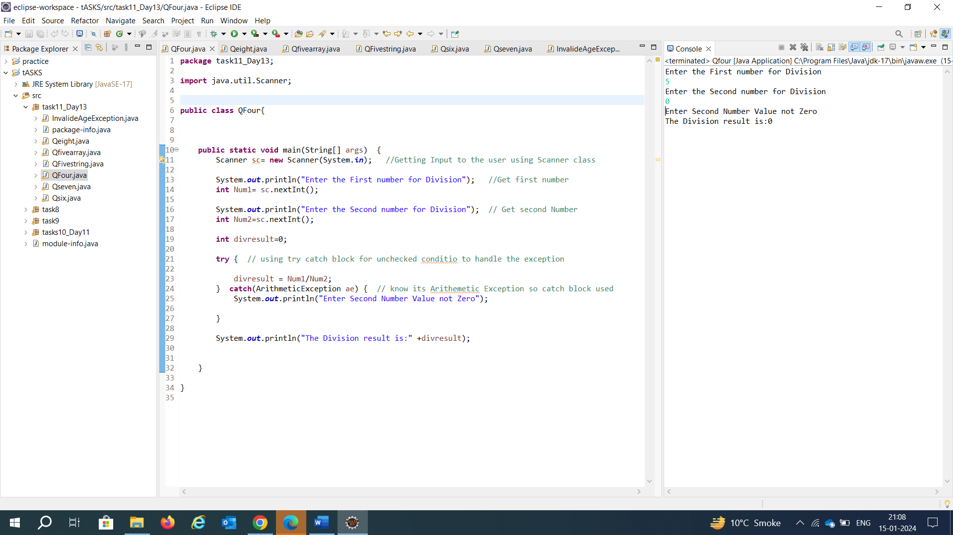

Q5 ArrayIndexoutofbond Exception:

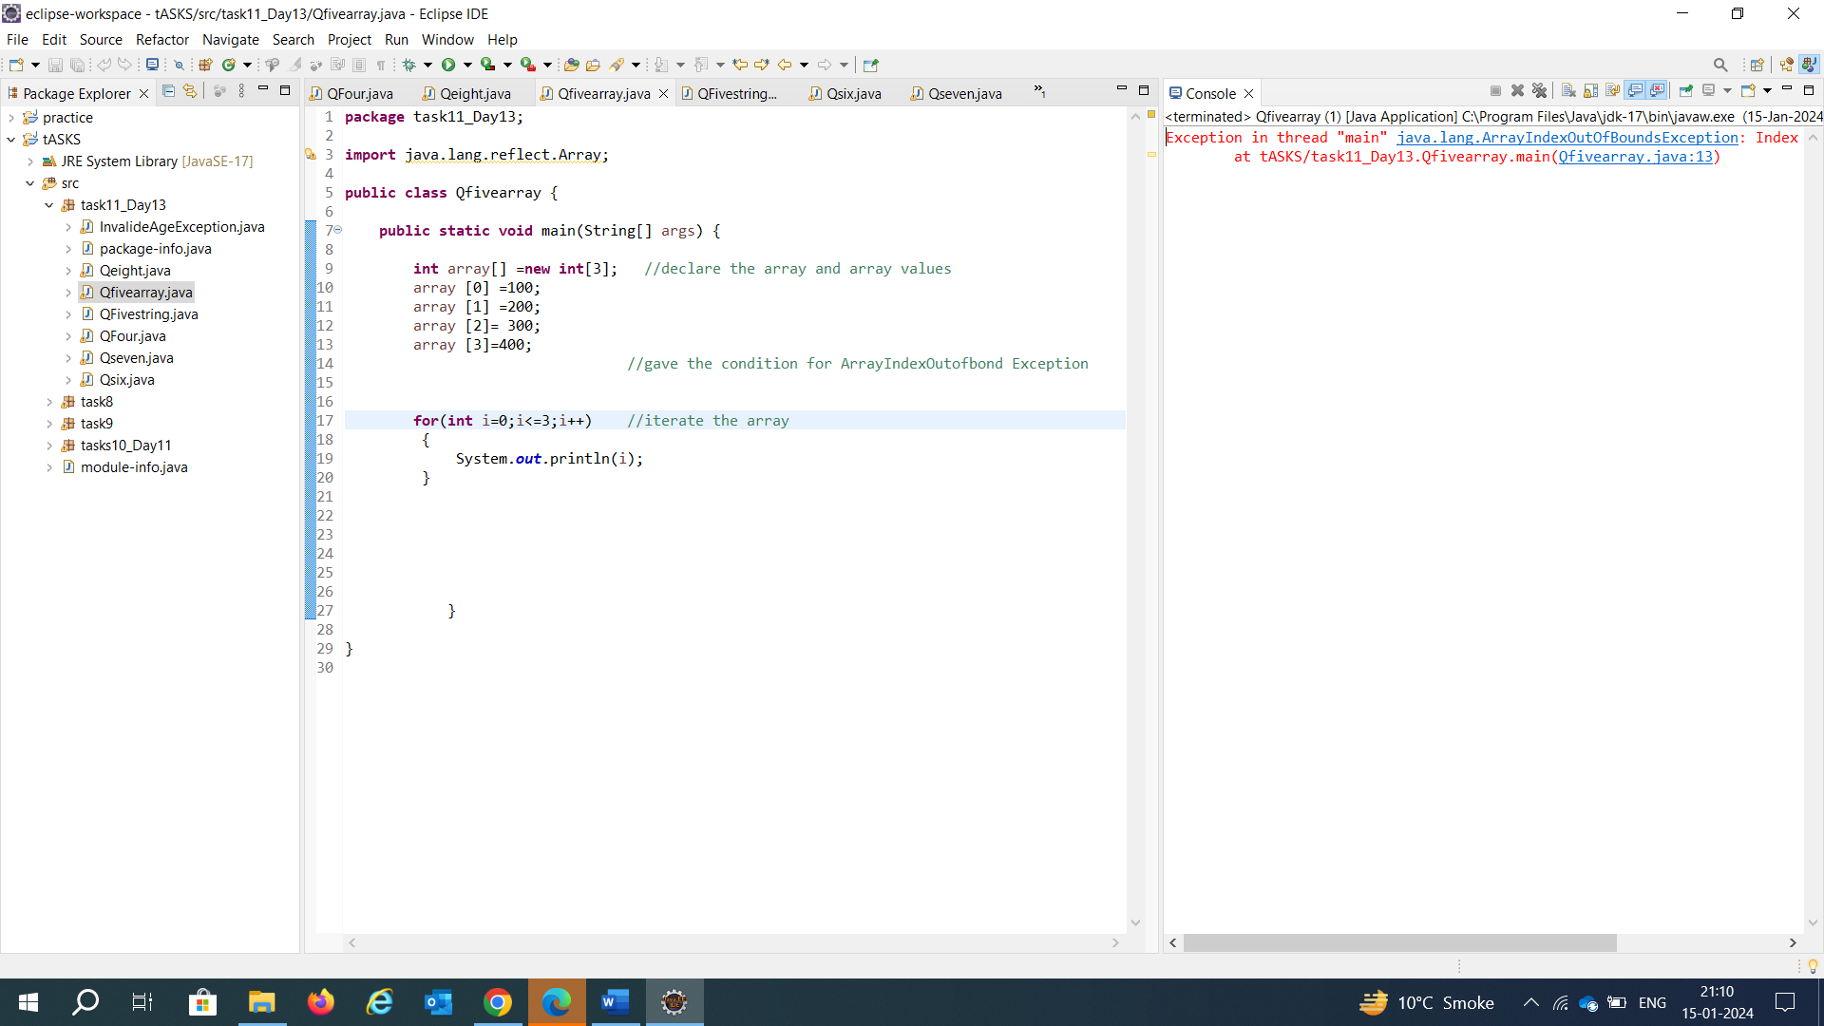

StringIndexoutofbond Exception:
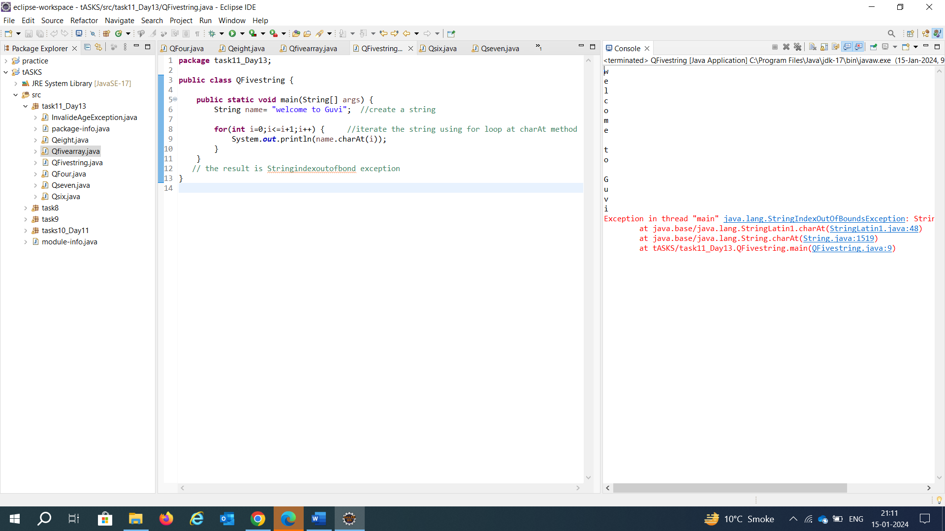

Q6.check the password:

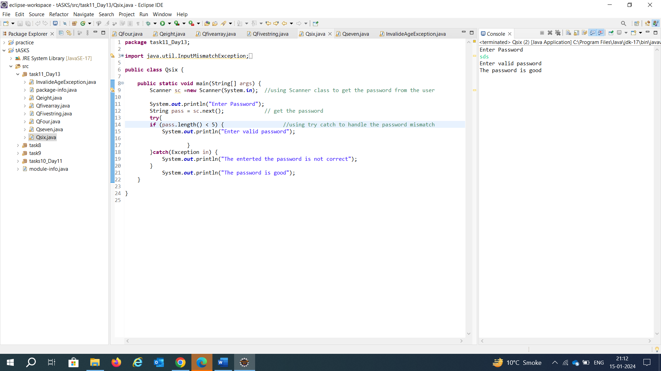

Q7.customised Exception:

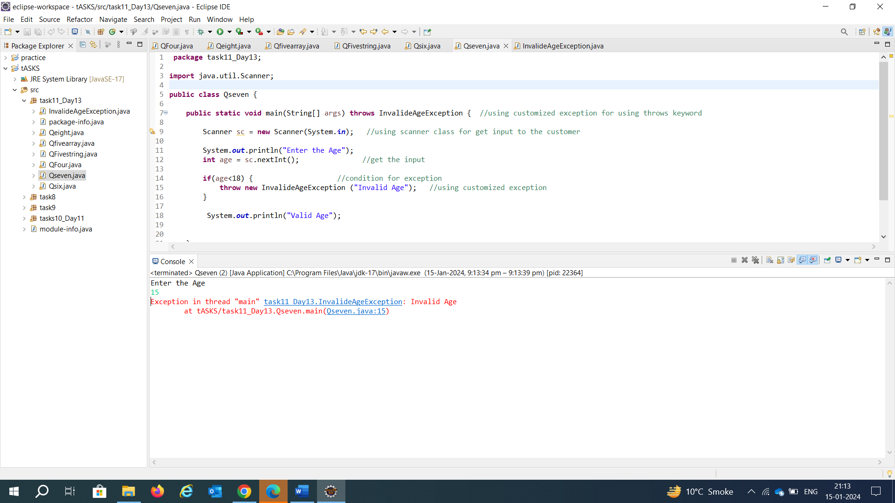

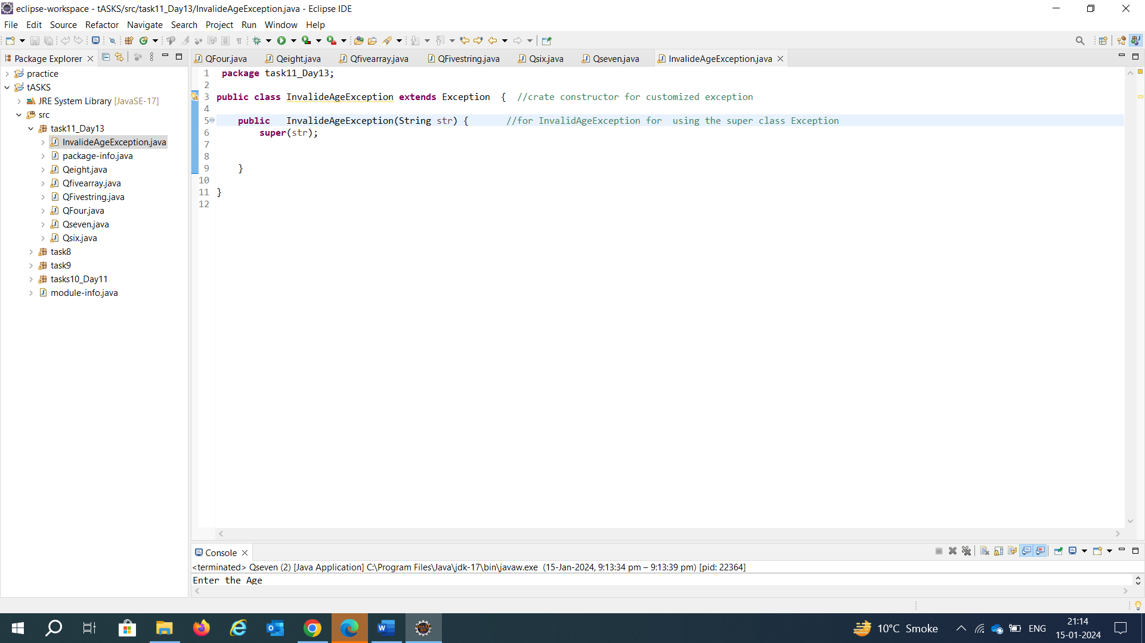

Q8.File not found Exception:

