Task 20

Q1.

Launch the driver, load the url

Switch the frame

Pick the date to next month ie March 2024

Pick the date 22

And print the date in console.

Script:

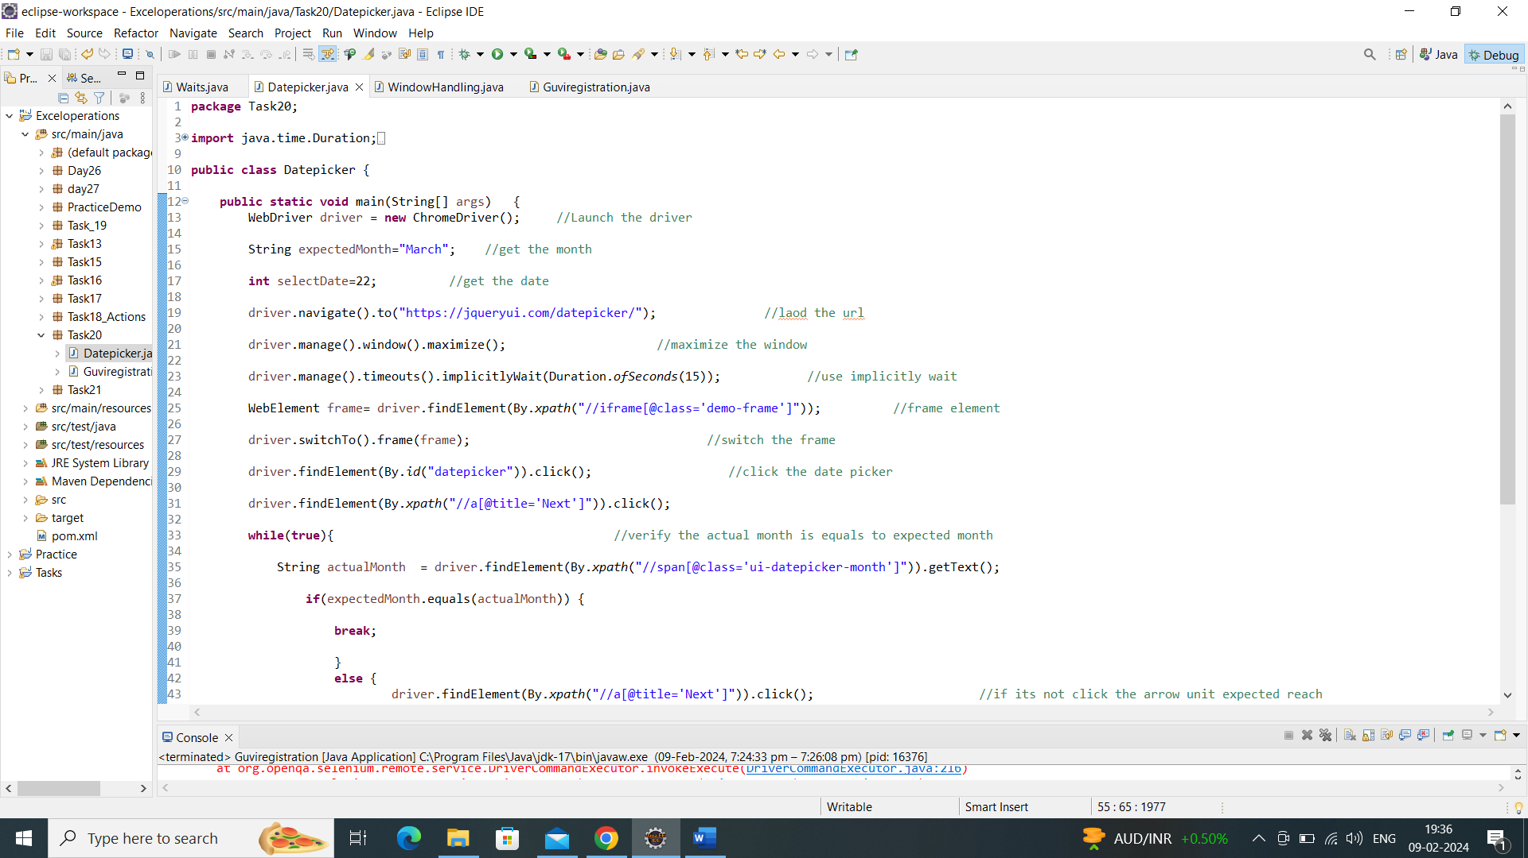

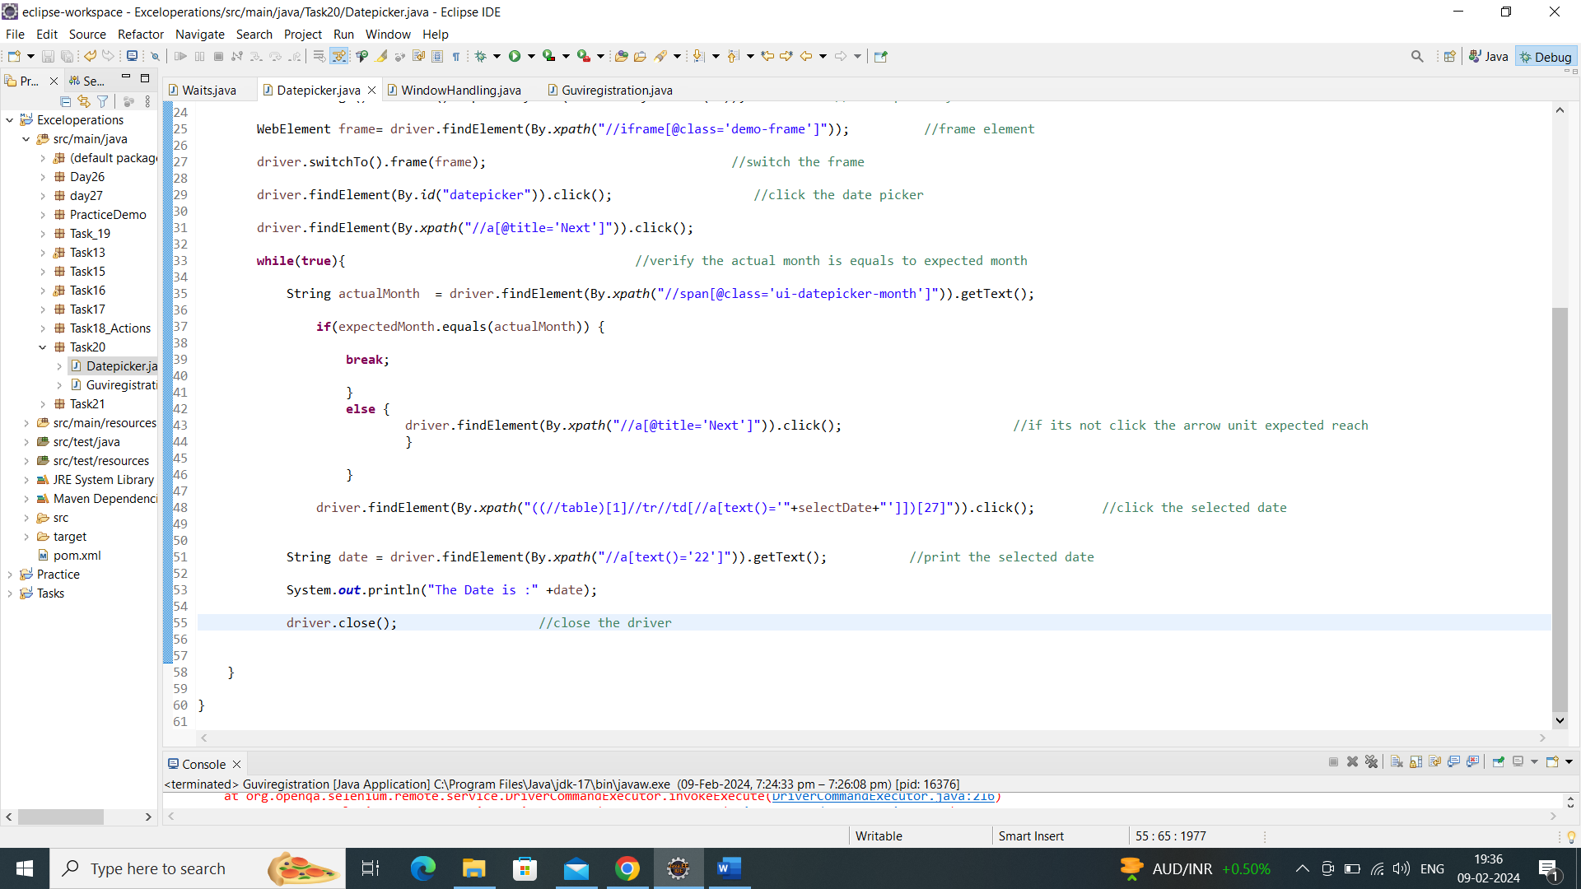

Output:

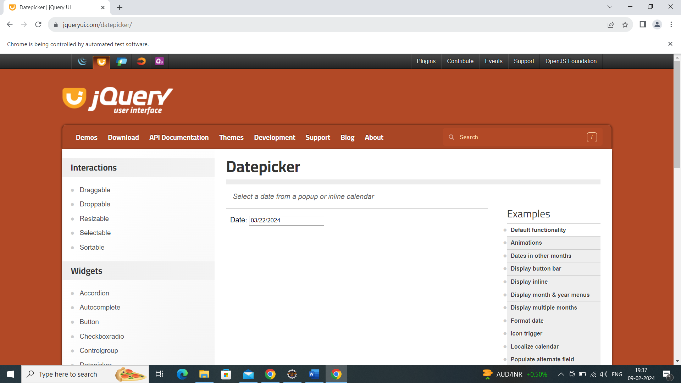

Console output:

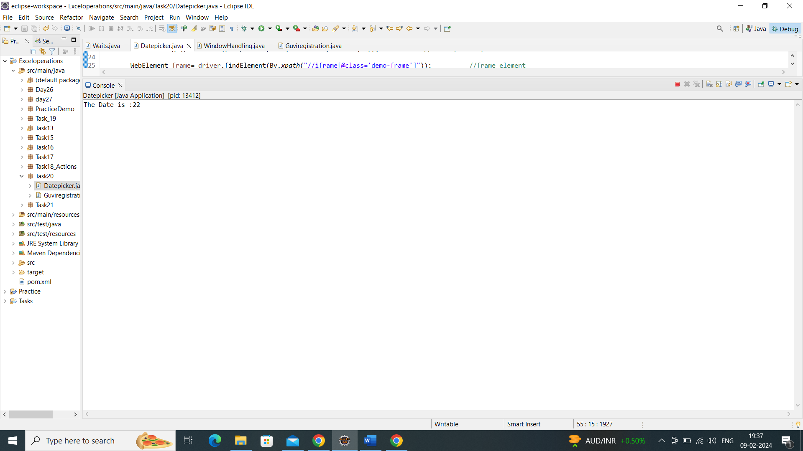

Q2.

Launch the [www.guvi.in](http://www.guvi.in)

Signup the guvi page with the necessary information

After signup navigate to the homepage

Login the guvipage with the credentials

And verify that page.

Script:

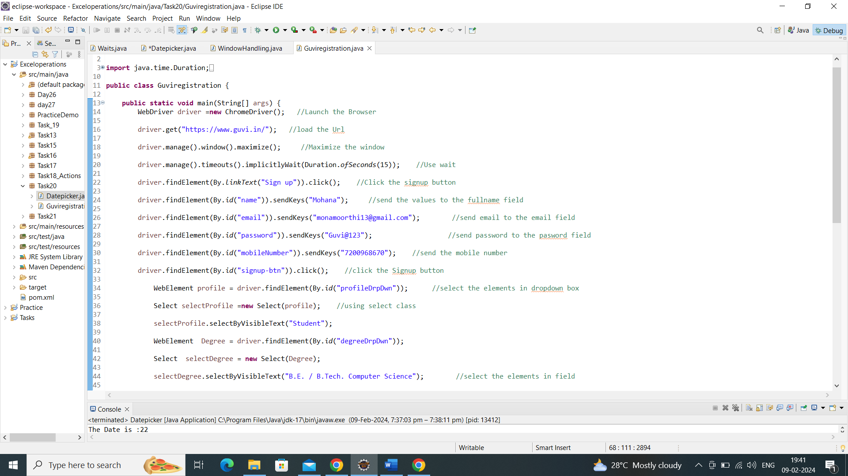

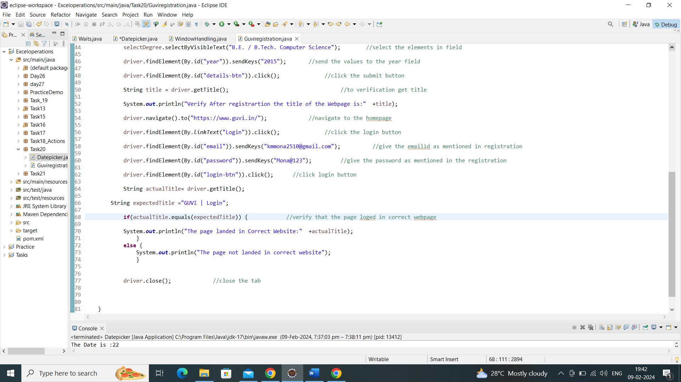

Output:

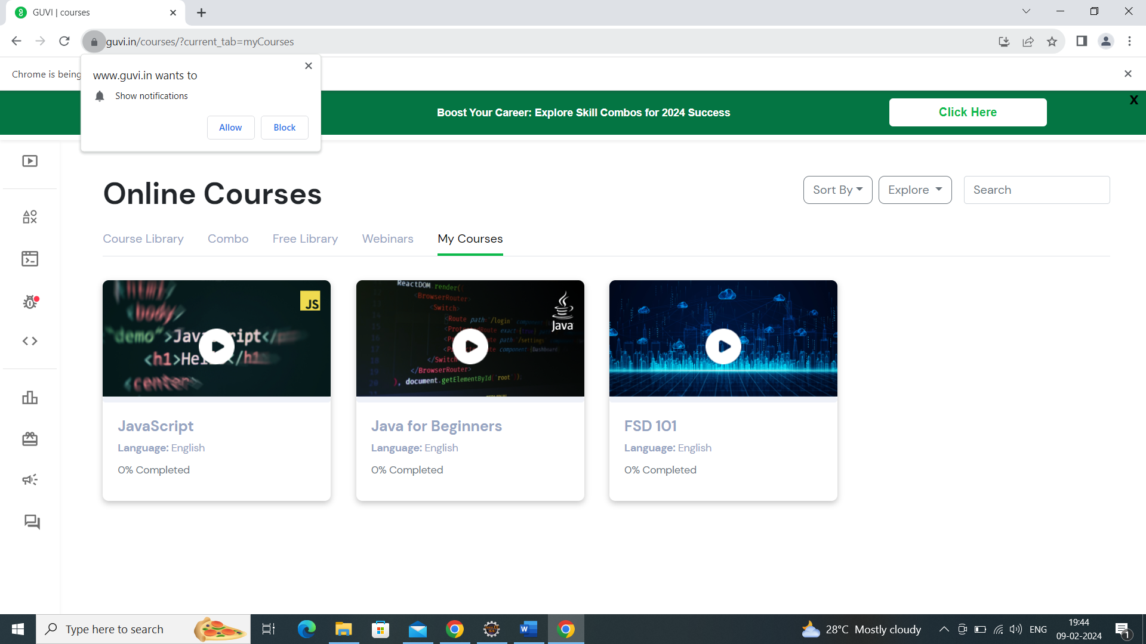

Console output:

