SOC Detection and
Threat Hunting Lab
  - Splunk project evidence report
Moses Kanagaraj

Project overview
I built a personal Splunk lab to explore Windows security telemetry, investigate suspicious activity, and turn searches into saved alerts and visualizations. My work included an RDP password-guessing exercise, network discovery, PowerShell event analysis, an antivirus test-file exercise, a MITRE ATT&CK lookup, and a monitoring dashboard.
The completed artifacts demonstrate searchable Windows events, a failed-login threshold search, five enabled alert definitions, a retrievable five-row lookup, and a populated dashboard. End-to-end alert firing, antivirus remediation, and detection accuracy remain separate validation tasks.

Demonstrated deliverables
Deliverable | Visible evidence | Status
Windows event searches | Failed-logon aggregation, PowerShell records, Defender-related Application records | Demonstrated
Detection configuration | Five enabled saved alerts; full SPL captured for Multiple Failed Logins | Configured
ATT&CK lookup | CSV authored, uploaded, and retrieved as five rows | Demonstrated
Monitoring dashboard | Technique, host, account, and source-address visualizations | Demonstrated
Triggered alerts and response | Saved-alert counters show 0; no response record accompanies the screenshots | Not demonstrated

My contribution and technical scope
I used Hydra and Nmap in the lab, searched Windows events with SPL, configured detection objects, created and uploaded a CSV lookup, and assembled dashboard panels. The visible product is Splunk Enterprise with Search & Reporting; this report does not claim a Splunk Enterprise Security or SOAR deployment.
Evidence identifiers E01-E12 refer to the original screenshots. Their pixels are preserved; images are scaled only for page layout. Key findings and queries are transcribed alongside them so the report remains readable without relying on small interface text.

Lab environment and network discovery
Component | What is established
Test workstation | Source notes identify Debian; terminal screenshots show Hydra v9.5 and Nmap 7.95.
Windows target | Hydra and Nmap target 192.168.56.101. Nmap identifies an Oracle VirtualBox virtual NIC.
Event host and source | Splunk events show DESKTOP-PS5ONHR; failed-login results show source 192.168.56.102. The source workstation IP assignment is not captured.
Splunk and log collection | Splunk Web appears at localhost:8000 and lookup paths show a Windows installation. PowerShell and Application events are searchable; the collection/forwarding configuration is not captured.

Logical workflow
Lab activity produces Windows telemetry that I inspect in Splunk searches. Search logic feeds the detection workflow, while the lookup and dashboard organize the results for review. The screenshots establish these components, but do not define a distributed topology, forwarder configuration, or network isolation mode.
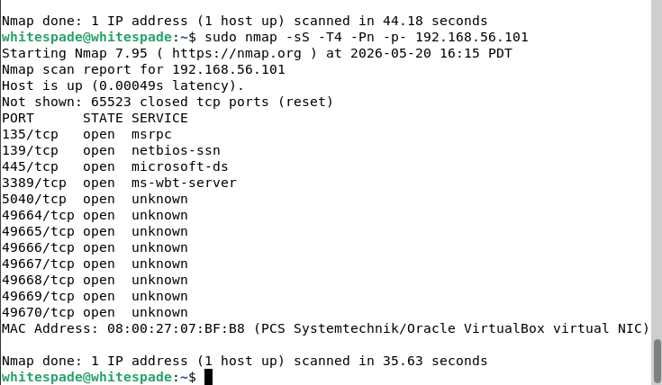
E03 Nmap scan of the Windows lab target, including open RDP port 3389/TCP.
sudo nmap -sS -T4 -Pn -p- 192.168.56.101
Observed: The target is up, with 3389/TCP open alongside 135, 139, 445, 5040, and 49664-49670. This provides service-discovery evidence relevant to T1046, Network Service Discovery [7]. Open RDP alone does not prove authentication succeeded or a remote session was established.

Failed logon investigation
Objective: Investigate repeated authentication failures associated with the RDP password-guessing exercise. Windows Security Event 4625 records a failed logon; it is evidence to investigate, not proof of account compromise [1].
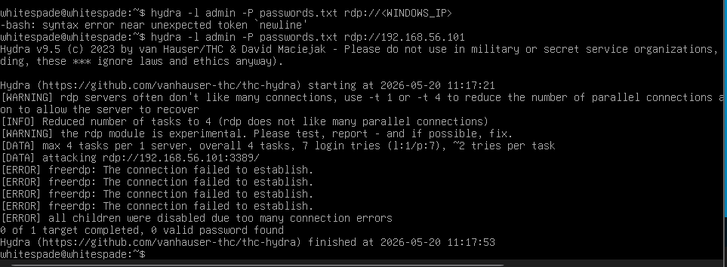
E01 Hydra execution against 192.168.56.101 ends with connection errors and no valid password found.
The initial placeholder command caused a shell syntax error. The subsequent run targeted the lab address, reported seven login tries, and stopped after connection failures. It does not establish a successful brute-force attack or completion of all password attempts.
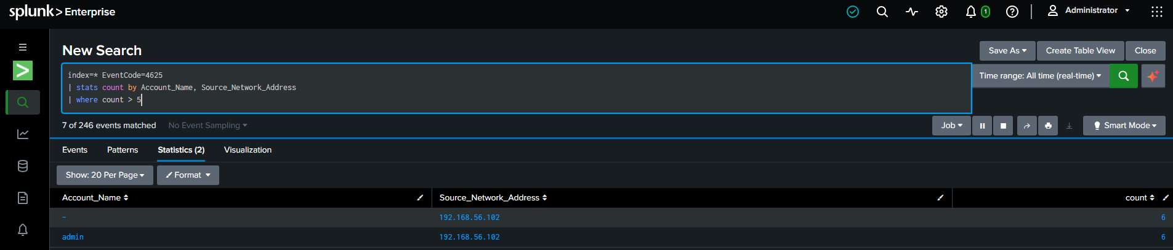
E02 Failed-logon aggregation returns two account/source rows above the configured threshold.

Captured SPL
index=* EventCode=4625
| stats count by Account_Name, Source_Network_Address
| where count > 5
The result table shows account values "-" and "admin", both paired with 192.168.56.102 and count 6. The query selects groups with six or more records over the selected search interval. The screen also displays "7 of 246 events matched"; raw records and field extraction must be reviewed before reconciling these counts or treating their sum as unique attempts.
Assessment: Repeated failed-logon activity is visible. Attribution to the exact captured Hydra run requires aligned timestamps, host identity, logon type, failure codes, and event-record identifiers. No successful logon or compromised credential is established. T1110, Brute Force, is an appropriate exercise-level label [5].

PowerShell event investigation
Objective: Determine whether PowerShell activity is visible in Splunk and identify command-line indicators requiring investigation. The source notes describe this exercise as remote-desktop PowerShell abuse; the screenshot establishes PowerShell telemetry, while the RDP session linkage remains unverified.
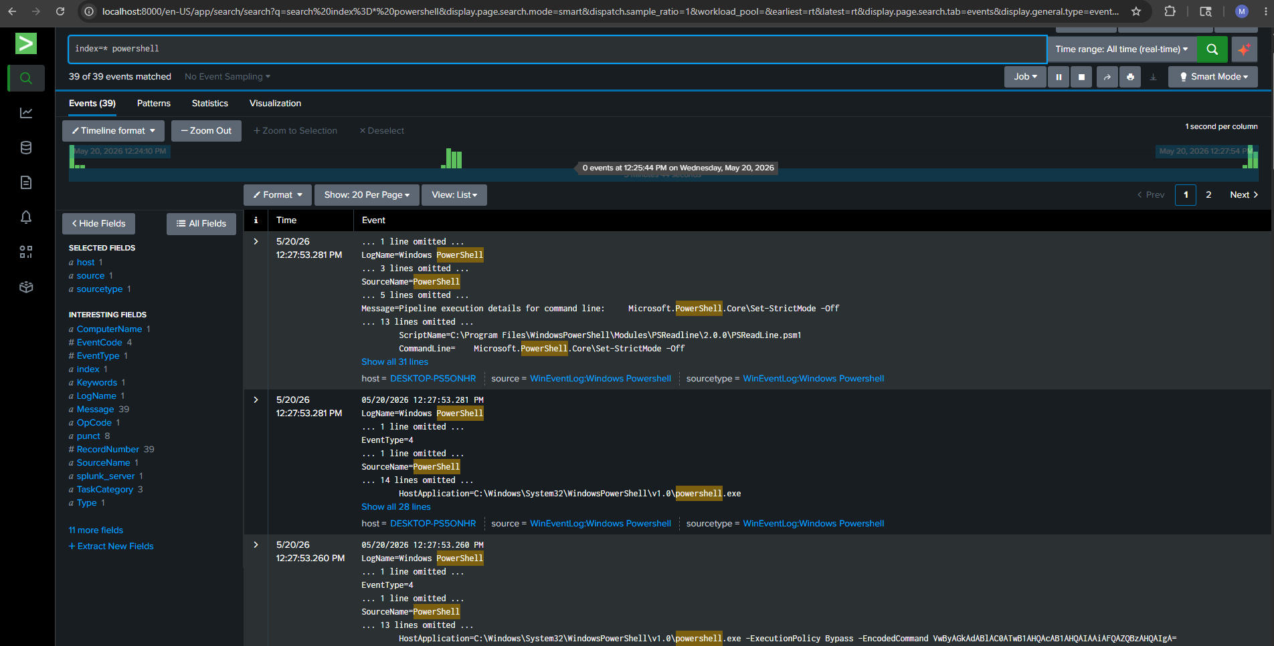
E04 PowerShell search returns 39 events and exposes command-line context from the Windows event host.

Captured SPL and observations
index=* powershell
- The search displays 39 matching events from host DESKTOP-PS5ONHR, with source and sourcetype WinEventLog:Windows PowerShell.
- Visible records include EventCode 800 and a HostApplication entry containing powershell.exe, -ExecutionPolicy Bypass, and -EncodedCommand.
- Other visible content includes Set-StrictMode -Off in a PSReadLine module path. Context matters: a broad keyword search can return routine activity alongside suspicious command lines.

Interpretation and next evidence
The command-line indicator supports review under T1059.001, PowerShell [6]. Encoding and execution-policy flags are investigation signals, not a complete maliciousness verdict. The screenshot does not establish the encoded command's full behavior, parent process, initiating account, or successful payload execution.
A complete case would preserve the raw event, decode the command as data for inspection, identify the parent process and user session, and correlate it with the relevant logon and any subsequent network or file activity. Those steps are the next validation work, rather than claimed completed results.

Antivirus test and Defender visibility
Objective: Explore an antivirus test-file workflow and inspect related Windows telemetry. The EICAR file is designed for antivirus testing without using real malware [2]. This exercise should be described as an EICAR test, rather than a live malware attack.
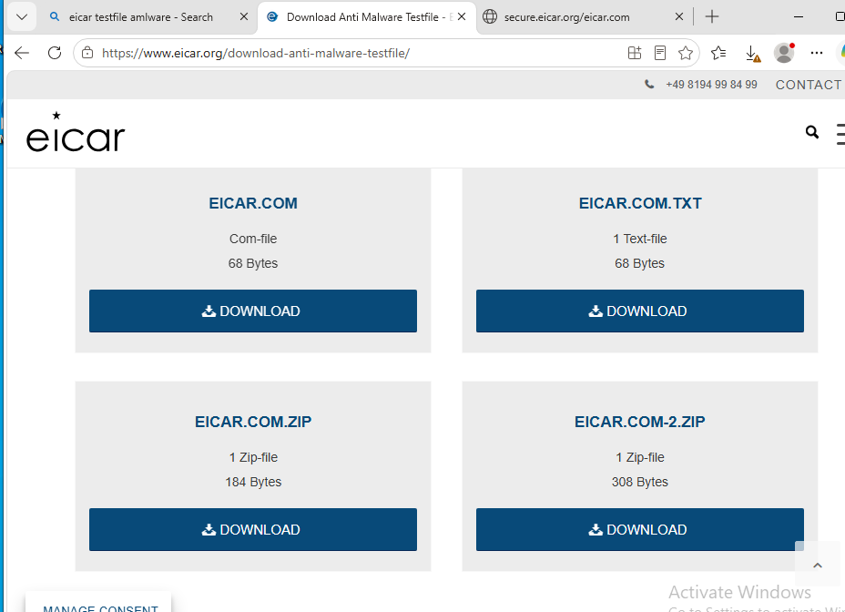
E05 EICAR download page used for the antivirus test-file exercise.
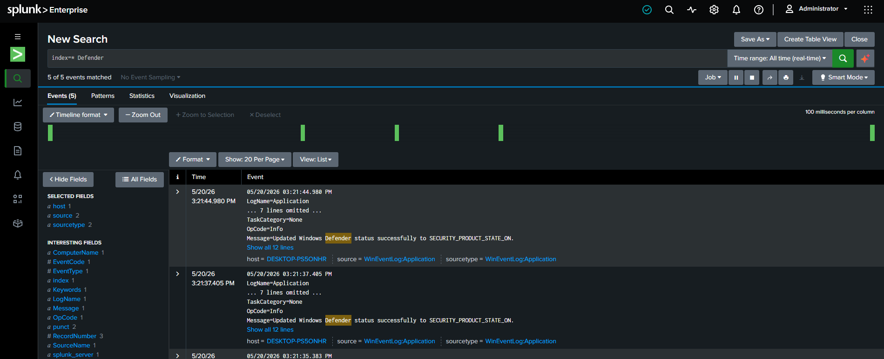
E06 A broad Defender search returns five events; the visible entries report product status updates.
index=* Defender
Observed: The displayed Application-log records state that Windows Defender status was updated to SECURITY_PRODUCT_STATE_ON. They confirm Defender-related event visibility, but do not show an EICAR threat name, detection, quarantine, or successful remediation.
To validate the antivirus outcome, capture the relevant Defender Operational events and protection-history result. Event 1116 records a detection; Event 1117 records an action, whose details and result must be inspected before claiming removal [3].

Failed login alert configuration
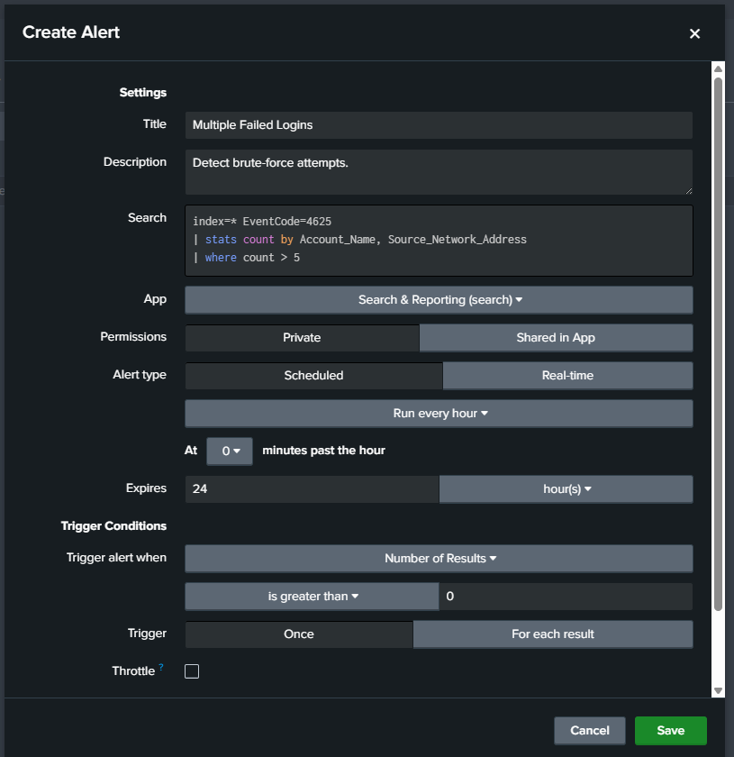
E07 Configuration dialog for the Multiple Failed Logins alert. E08 confirms a saved alert with this name.
Setting | Visible value or interpretation
Detection threshold | count > 5 per Account_Name and Source_Network_Address.
Run cadence | Run every hour, at 0 minutes past the hour.
Trigger condition | Number of Results is greater than 0.
Expiration and throttling | Expires after 24 hours; throttle checkbox is unchecked.
Search scope | index=*; search lookback is not visible in this dialog.

The aggregation threshold and alert trigger condition have different roles: the SPL produces rows that exceed five failures, and the trigger checks whether any qualifying rows exist. An hourly run cadence does not by itself establish a one-hour search window.
Validation needed: Confirm the actual earliest/latest time settings, field extraction, notification action, and triggered-alert record. Restrict the search to the intended index and test benign failures before using it outside the lab.

Saved detection inventory
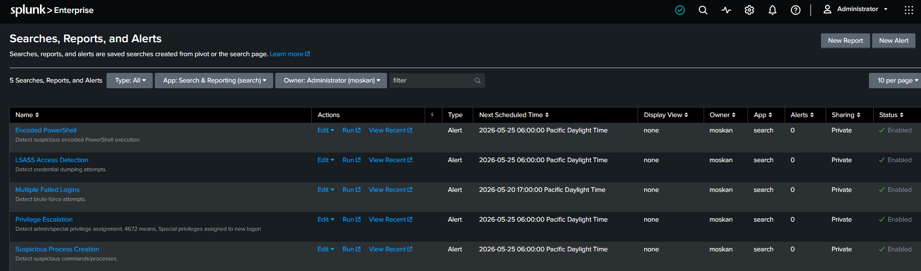
E08 Five alert definitions are enabled in Search & Reporting; the Alerts column displays 0 for every row.
Saved alert name | Intent shown | Evidence boundary
Multiple Failed Logins | Repeated authentication failures | Full SPL and matching search rows are visible in E02/E07.
Encoded PowerShell | Suspicious encoded execution | Saved object visible; full rule SPL and fired-alert result are not captured.
LSASS Access Detection | Credential-dumping attempts | Saved object visible; no supporting process-access event or rule SPL shown.
Privilege Escalation | Admin/special privilege assignment; description references 4672 | Rule name is preserved. Event 4672 alone does not prove escalation.
Suspicious Process Creation | Suspicious commands/processes | Saved object visible; full rule SPL and validation result are not captured.

All five rows are private, enabled Alert objects owned by moskan in the search app. The visible next-run timestamps are May 20 or May 25, 2026; they are scheduling metadata, not incident timestamps or proof of completed execution.

Detection judgment
The inventory demonstrates that I created saved detection objects. The zero counters do not establish a positive alert test. For each rule, the next evidence should show its SPL, time window, test event, triggered result, and analyst disposition.
For the rule named Privilege Escalation, Event 4672 describes special privileges assigned at logon [10]. Review the account, session, expected administrative role, and correlated activity before interpreting it as privilege escalation.

MITRE lookup creation and upload
I created a CSV to associate technique identifiers with readable names, then uploaded it into Splunk. These steps demonstrate lookup-file management; they do not establish that every listed behavior occurred or that alerts were enriched automatically.
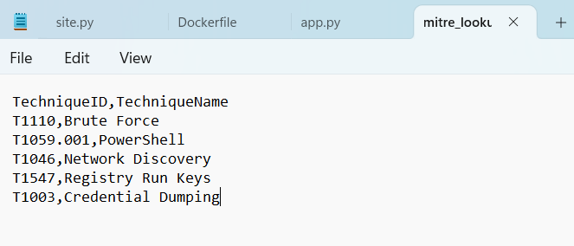
E09 Original five-row MITRE ATT&CK lookup content
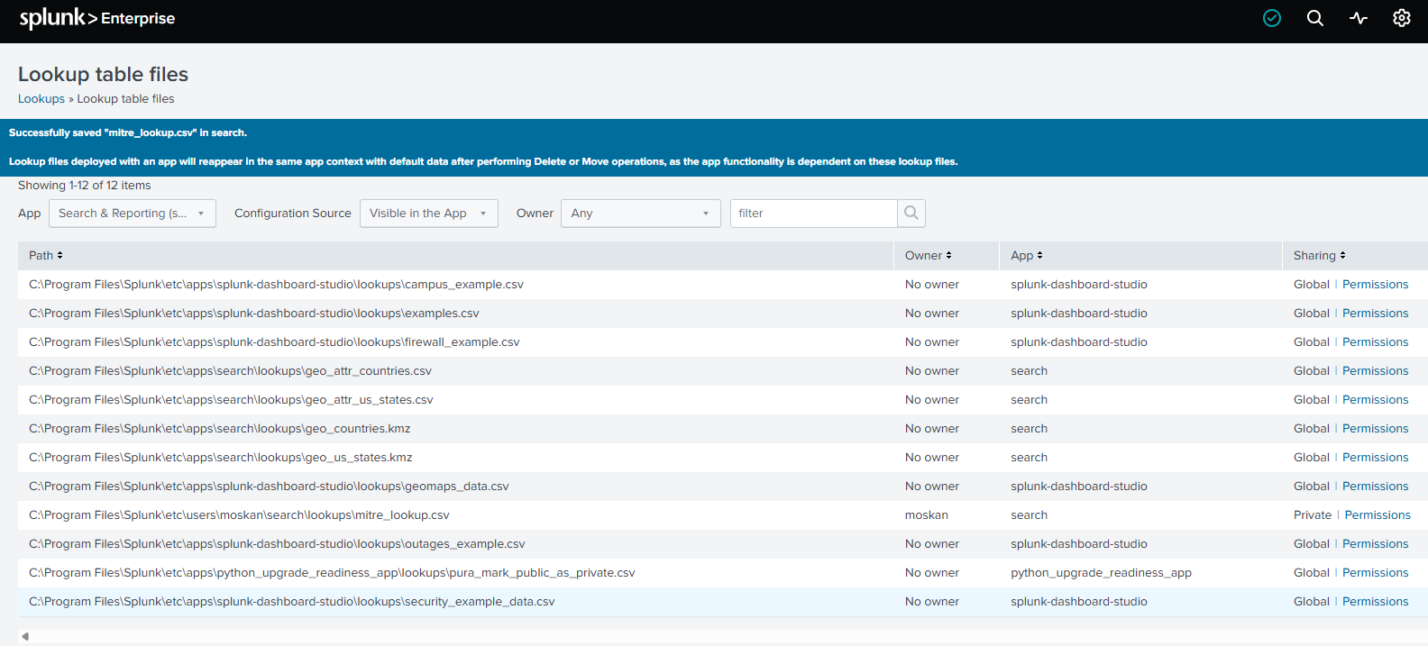
E10 Splunk confirms that mitre_lookup.csv was saved in the search app.

Upload result
The success banner identifies mitre_lookup.csv. The visible file row places it under the user-specific search lookup directory, with owner moskan and Private sharing. The page lists 12 lookup files in total, including bundled examples; only the five-row custom file is claimed as my artifact.
C:\Program Files\Splunk\etc\users\moskan\search\lookups\mitre_lookup.csv
The original lookup uses several shortened labels and a parent/sub-technique mismatch. The next page provides reviewed mappings for documentation; it does not imply that the captured CSV or running lab was changed.

Lookup verification and mapping review
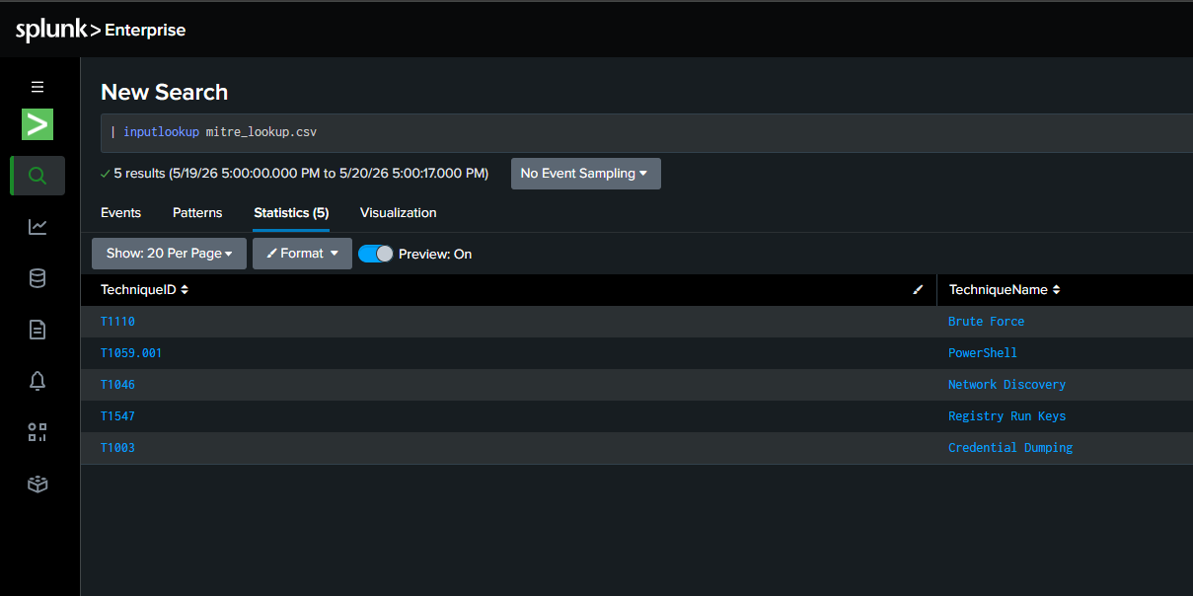
E11 inputlookup retrieves five technique rows. These are lookup records, not fired alerts.
| inputlookup mitre_lookup.csv
The five returned rows confirm that Splunk can read the uploaded CSV. The inputlookup command reads lookup-table contents [4]; this result does not show event enrichment or alert execution.
Captured mapping | Reviewed label or mapping | Evidence status
T1110 / Brute Force | T1110 / Brute Force [5] | Password-guessing exercise and failed-logon search.
T1059.001 / PowerShell | T1059.001 / PowerShell [6] | PowerShell telemetry visible.
T1046 / Network Discovery | T1046 / Network Service Discovery [7] | Nmap service discovery visible.
T1547 / Registry Run Keys | T1547.001 / Registry Run Keys / Startup Folder [8] | Specific intended label requires sub-technique ID; no run-key activity shown.
T1003 / Credential Dumping | T1003 / OS Credential Dumping [9] | Lookup label and LSASS rule exist; dumping activity is not demonstrated.

A technique name in a CSV or dashboard is a classification label. Validation requires the underlying event, matching logic, and the relationship between the observed behavior and the ATT&CK definition.

Cybersecurity monitoring dashboard
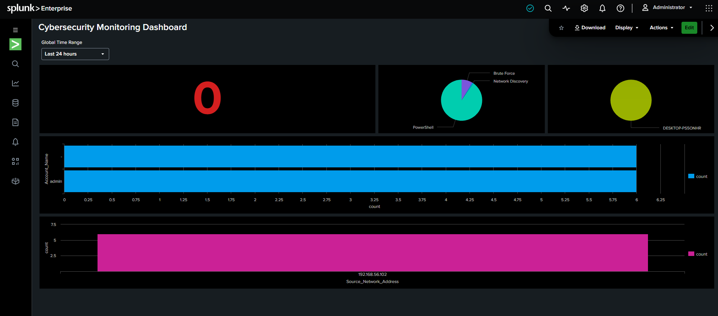
E12 Dashboard with a Last 24 hours selector and populated technique, host, account, and source-address panels.
Visible panel | What can be read from the screenshot
Single value | Red 0 with no visible panel title; the metric cannot be identified.
Technique chart | PowerShell, Brute Force, and Network Discovery labels; exact counts are not shown.
Host chart | DESKTOP-PS5ONHR appears as the host label.
Account chart | "-" and "admin" each display a bar reaching 6.
Source-address chart | 192.168.56.102 displays a bar reaching 6.

What this demonstrates
I assembled a monitoring view that brings several event dimensions into one dashboard. The screenshot demonstrates dashboard construction and populated visualizations. Its panel searches and source definition are not included, so the values cannot be independently reconciled with raw events or interpreted as fired-alert totals.

Improvements to validate next
- Give each panel a title, unit, and clear definition; label the red single-value metric.
- Export the dashboard definition and SPL, then verify that every panel respects the global time selector.
- Investigate the "-" account bucket and reconcile per-account and per-source counts before presenting unique-attempt totals.
- Confirm the method used to assign ATT&CK categories and provide drilldowns to the underlying evidence.

Threat hunting and investigation workflow
The captured searches support exploratory investigation. A completed hypothesis-led hunt, false-positive assessment, and response record are not yet demonstrated. The workflow below is the proposed next validation exercise, not a claim that these actions have already been performed.

Proposed hunt hypothesis
Repeated failures from one source against a Windows account may be followed by a successful logon and suspicious PowerShell execution on the same host. Investigate that relationship with timestamps and session identifiers rather than assuming the screenshots form a single attack chain.
Step | Evidence or decision to record
1 Validate | Check the detection logic, source channel, time window, and whether records represent the intended test.
2 Identify entities | Record the account, source address, destination, host, and logon/session identifiers.
3 Collect evidence | Preserve raw logon and PowerShell events, alert SPL, relevant endpoint records, and search results.
4 Build a timeline | Align event time zones and establish the order of failures, any success, and subsequent execution.
5 Classify activity | Decide whether activity is expected lab behavior, suspicious, malicious, or unresolved; state why.
6 Determine scope | Check other accounts, hosts, source addresses, and related activity within a documented interval.
7 Consider containment | Document whether any approved lab containment is needed; do not claim an action that was not performed.
8 Escalate if needed | Record the threshold for further review and the evidence supporting escalation.
9 Document findings | Capture queries, timestamps, source records, interpretation, and alternative explanations.
10 Close or hand off | State the disposition, remaining uncertainty, and validation criteria for closure.

Success criteria
A reproducible positive test produces the expected search result and alert record. A benign comparison explains whether the rule creates noise. The case connects each conclusion to saved evidence and records any response decision separately from detection.

Results and validation backlog

Completed work
The lab demonstrates hands-on SPL searching, Windows-event investigation, saved-alert configuration, CSV lookup management, ATT&CK classification work, and dashboard construction. The clearest quantitative artifacts are five enabled alerts and five retrievable lookup rows. These are configuration counts, not detection rates.
Priority | Next evidence to capture | Why it matters
1 | Raw events and timestamps for the failed-logon and PowerShell exercises; host/IP assignments | Links activity to the correct test and resolves ambiguous counts.
1 | All five saved-search definitions, including SPL, schedules, search windows, and actions | Makes each rule reviewable and reproducible.
1 | One positive and one benign test per rule, plus triggered-alert details | Demonstrates firing behavior and provides a starting point for tuning.
1 | Defender threat/action event and protection-history record for the EICAR exercise | Separates antivirus detection/remediation from general product-status logs.
2 | Windows audit/log collection settings and Splunk inputs configuration | Documents how telemetry reaches Splunk; avoids assuming a forwarder design.
2 | Dashboard definition, panel queries, and reviewed lookup CSV | Allows values and technique mappings to be checked against source events.

Lessons from reviewing the evidence
- A command invocation, a search match, a saved rule, and a fired alert are different stages of validation.
- Thresholds depend on both the aggregation fields and time window; missing or multivalue fields can change interpretation.
- A useful investigation distinguishes suspicious indicators from confirmed execution or compromise.
- ATT&CK labels and dashboard counts need traceable underlying logic.

Portfolio description
Built a Splunk lab to investigate Windows failed-logon and PowerShell activity, configured five saved alerts, created a five-row MITRE ATT&CK lookup, and developed a monitoring dashboard. Documented test evidence, detection logic, and remaining validation work, including an EICAR antivirus test exercise.

Evidence register and technical references
Evidence | Original image | Report section
E01 | image1.png | Hydra execution and connection errors
E02 | image2.png | Failed-logon SPL and result rows
E03 | image3.png | Nmap service-discovery output
E04 | image4.png | PowerShell event search
E05 | image5.png | EICAR test-file page
E06 | image6.png | Defender-related Application records
E07 | image7.png | Failed-login alert configuration
E08 | image8.png | Five saved alert definitions
E09 | image9.png | Original ATT&CK CSV content
E10 | image10.png | Lookup upload confirmation
E11 | image11.png | Lookup retrieval
E12 | image12.png | Monitoring dashboard

Technical references
[1] Microsoft Learn - Event 4625 failed logon
[2] EICAR - Anti Malware Testfile
[3] Microsoft Learn - Defender Antivirus events
[4] Splunk - inputlookup command
[5] MITRE ATT&CK - T1110 Brute Force
[6] MITRE ATT&CK - T1059.001 PowerShell
[7] MITRE ATT&CK - T1046 Network Service Discovery
[8] MITRE ATT&CK - T1547.001 Registry Run Keys / Startup Folder
[9] MITRE ATT&CK - T1003 OS Credential Dumping
[10] Microsoft Learn - Event 4672 special privileges at logon

