**A Kubernetes pod** is a group of containers that are deployed together on the same host

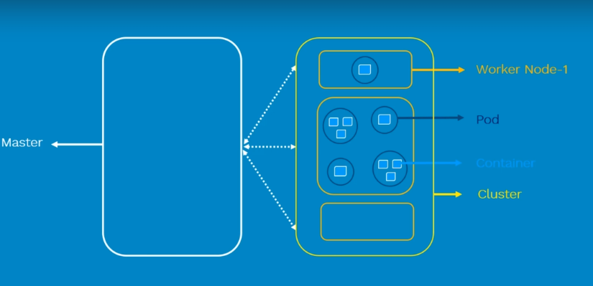

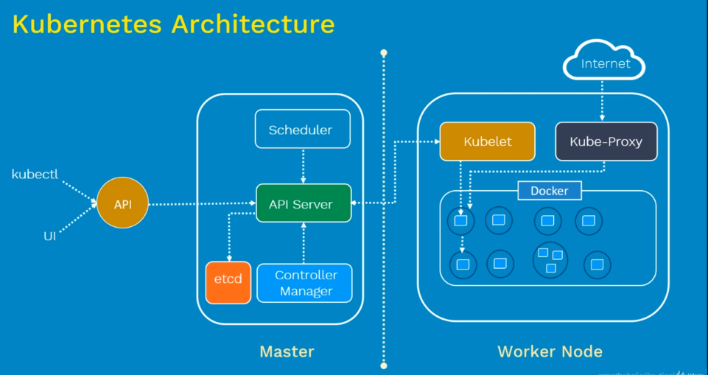

A scheduler watches for newly created Pods that have no Node assigned. For every Pod that the scheduler discovers, the scheduler becomes responsible for finding the best Node for that Pod to run on.