About us page

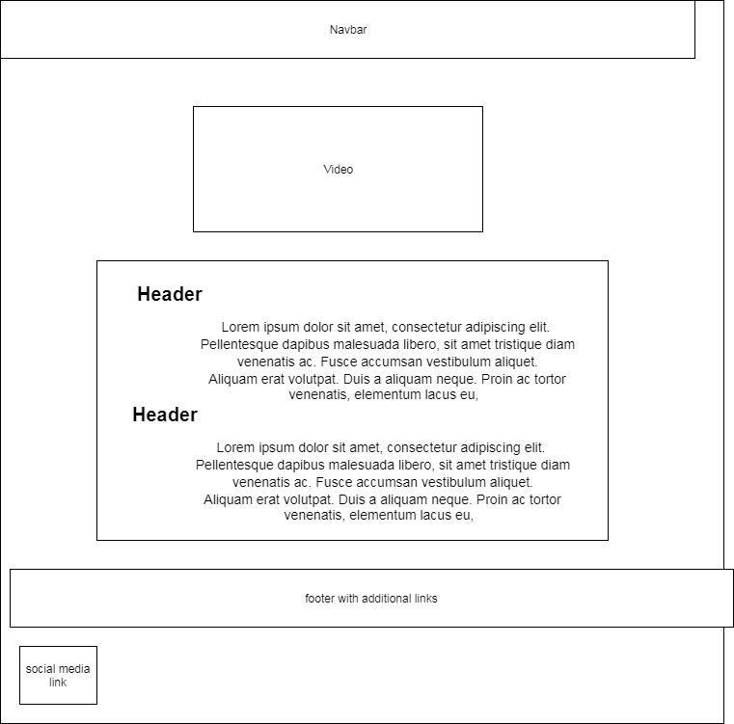

GDPR

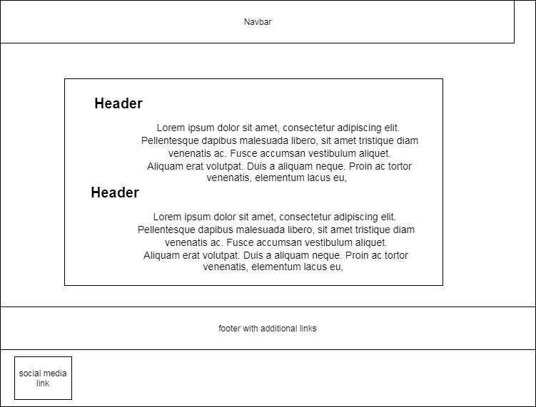

Contact us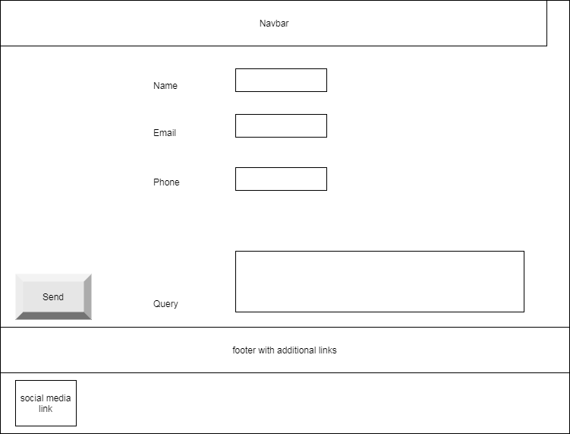

Attractions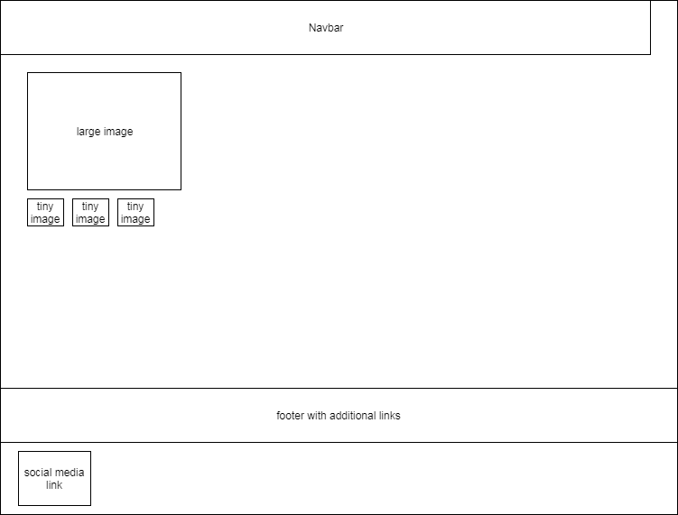

Home Page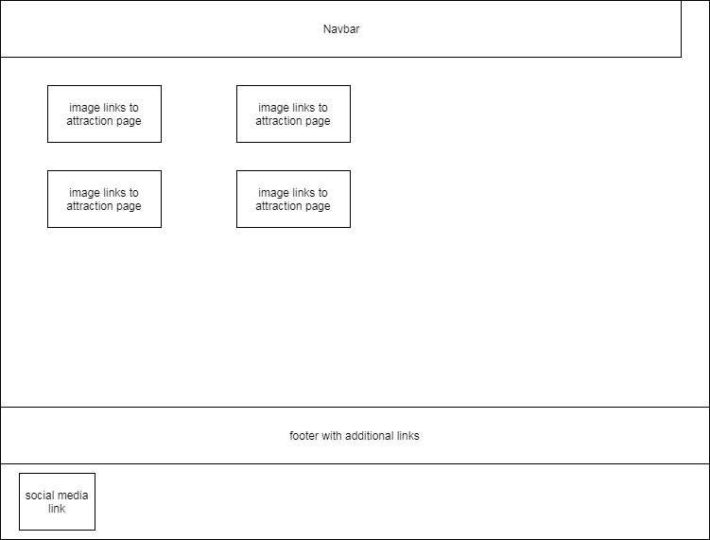

Navigation Diagram

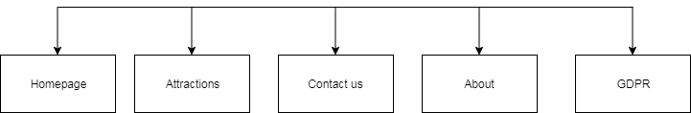

CSS format

Font family- TimesNewRoman

Font style – normal

Font size – 16px

Font weight: 700

The logo:

Background color: RGB(128,128,128)

Color: (0,0,255)

Font-family – Dancing Script(Google fonts)

Font-size: 3em