discussion_1_answer_key

Question 2
# A tibble: 20 × 2
Plant.Size prop.survive
<int> <dbl>
1 1 0
2 2 0.111
3 3 0.167
4 4 0.143
5 5 0.429
6 6 0.571
7 7 0.75
8 8 0.818
9 9 0.75
10 10 0.882
11 11 0.8
12 12 0.625
13 13 0.75
14 14 0.4
15 15 0.6
16 16 0.364
17 17 0.286
18 18 0.0833
19 19 0.0769
20 20 0
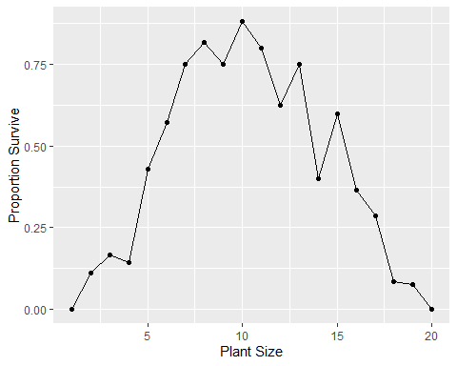

Question 3
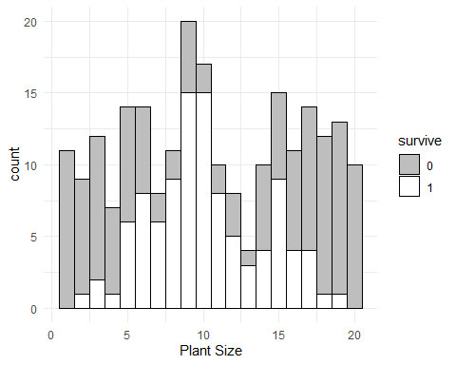

Question 4
[1] -0.46

question 5
# A tibble: 10 × 2
dist2 prop.survive
<dbl> <dbl>
1 0.25 0.852
2 2.25 0.714
3 6.25 0.8
4 12.2 0.556
5 20.2 0.586
6 30.2 0.4
7 42.2 0.238
8 56.2 0.125
9 72.2 0.0909
10 90.2 0
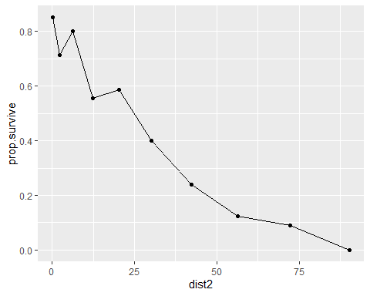

Question 6
Fitness is highest toward the center of the distribution, i.e. extreme values of plant height are being selected against. This is called stabilizing selection (don’t need to know that here, we will talk about it in the future).

