discussion_2_key

Question 1:
You are studying a population of flowers that have 3 alleles at the flower color locus: A1, A2, and A3. You sample 1000 plants and genotype them at the locus. The genotype counts are: 290 A1A1, 100 A2A2, 70 A3A3, 410 A1A2, 100 A1A3, 230 A2A3. Is this flower color locus in Hardy-Weinberg equilibrium?

Question 2:
You are studying the evolution of a lethal recessive allele in a population of anoles. The homozygous recessive genotype is completely lethal, the heterozygote and dominant homozygote are fine. You find that the allele has a frequency in the population of 0.01.

2.1
What is the ratio of heterozygotes to homozygotes in this population?
$$2pq:q^{2}=198:1$$

2.2
How do you expect selection to change this ratio? What does this mean for selections ability to remove deleterious recessives?
As selection removes the deleterious allele, relatively more of them will occur in heterozygotes than homozygotes meaning that they are invisible to selection. So selection cannot remove a deleterious recessive allele.
It is often useful to code genetic data numerically. We often do this by counting the number of alleles in a genotype. For example, if we are studying a locus with two alleles—A1 and A2—we can count the number of A2 alleles. In the A1A1 genotype, there are no A2 alleles so it is coded as 0, likewise A1A2 and A2A2 are coded as 1 and 2 respectively. For the remaining questions, genotypes will be coded in this manner in the data (i.e. representing the count of A2 alleles)

Question 3:
Analyze the data in the question 3 sheet of the Google sheet. The sheet represents an experiment where we transplanted 100 monkeyflowers of known genotype at a flower color locus. We came back and measured whether or not they survived (coded as 1 for survive and 0 for died).

3.1 What is the change in the frequency of the A1 allele if it’s starting frequency is 0.8?
# A tibble: 3 × 3
genotype survival relative_fit
<int> <dbl> <dbl>
1 0 0.56 0.778
2 1 0.68 0.944
3 2 0.72 1
[1] -0.03252336

3.2 What is the change in the frequency of the A1 allele if it’s starting frequency is 0.2?
[1] -0.00776385

3.3 Draw the adaptive topography for this fitness regime.
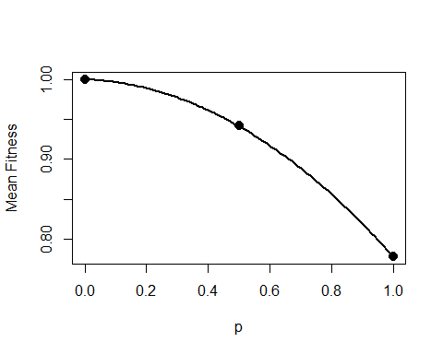

Question 4:
We have done the same experiment as question 3, but measured survival in a new environment. The data is under the question 4 tab in the Google sheet.

4.1 What is the change in the frequency of the A1 allele if it’s starting frequency is 0.8?
# A tibble: 3 × 3
genotype survival relative_fit
<int> <dbl> <dbl>
1 0 0.54 0.6
2 1 0.9 1
3 2 0.76 0.844
[1] -0.06263283

4.2 What is the change in the frequency of the A1 allele if it’s starting frequency is 0.2?
[1] 0.00810713

4.3 Draw the adaptive topography for this fitness regime.
First calculate $\hat{p}=\frac{w_{22}−w_{12}}{w_{11}+w_{22}−2w_{12}}$
(p_hat = (.844 - 1)/(.844 + .6 - 2))
[1] 0.2805755
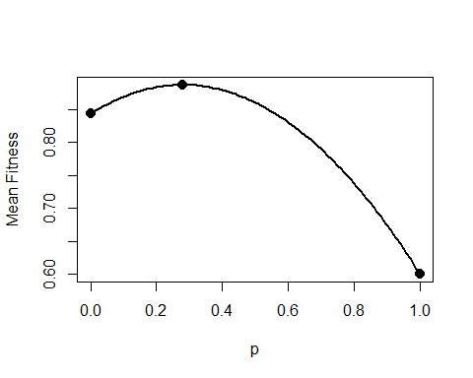

Question 5:
We have done the same experiment as questions 3 and 4, but measured survival in a yet a new environment. The data is under the question 5 tab in the Google sheet.

5.1 What is the change in the frequency of the A1 allele if it’s starting frequency is 0.8?
# A tibble: 3 × 3
genotype survival relative_fit
<int> <dbl> <dbl>
1 0 0.92 1
2 1 0.52 0.565
3 2 0.74 0.804
[1] 0.05631214

5.2 What is the change in the frequency of the A1 allele if it’s starting frequency is 0.2?
[1] -0.02267189

5.3 Draw the adaptive topography for this fitness regime.
Calculate $\hat{p}$.
(p_hat = (.804 - .565)/(1 + .804 - 2*.565))
[1] 0.3545994
