discussion_3_key

Question 1
# A tibble: 3 × 3
genotype prop.survive rel.fit
<int> <dbl> <dbl>
1 0 0.6 0.75
2 1 0.5 0.625
3 2 0.8 1
Equilibrium points 0,1 and 0.75.
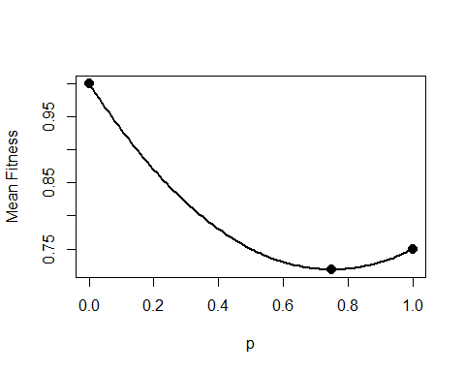

Question 2
# A tibble: 3 × 3
genotype prop.survive rel.fit
<int> <dbl> <dbl>
1 0 0.8 1
2 1 0.8 1
3 2 0.5 0.625
$\hat{q}=\sqrt{\frac{μ}{s}}$. s = 0.375. $\hat{q}=0.016$

Question 3
# A tibble: 2 × 2
population p
<chr> <dbl>
1 new_york 0.287
2 virginia 0.587
$p_{t}=\frac{.287+.587}{2}=.437$
$H_{t}=2\left(.437\right)\left(.563\right)=.492$
$H_{s}=\frac{2\left(.287\right)\left(.713\right)+2\left(.587\right)\left(.413\right)}{2}=.447$
$F_{ST}=\frac{.492−.447}{.492}=0.091$

Question 4
4.1: $H_{g+t}=.5{\left(1−\frac{1}{2000}\right)}^{10}=.498$
4.2: $N_{e}=\frac{4\left(250\right)\left(500\right)}{250+500}=666.67$; $H_{g+t}=.5{\left(1−\frac{1}{2\left(666.67\right)}\right)}^{10}=.496$

Question 5
5.1:
.5*(1-1/40)^(c(5,10,15))
[1] 0.4405478 0.3881648 0.3420103
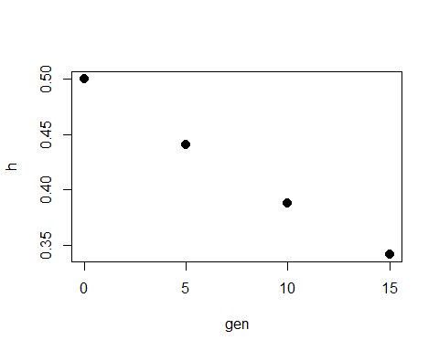
5.2:
You can either solve for Ne, or plug in numbers and get it through trial and error.
~11-11.5

Question 6
# A tibble: 3 × 3
genotype prop.survive rel.fit
<int> <dbl> <dbl>
1 0 0.6 0.667
2 1 0.8 0.889
3 2 0.9 1
Make p the frequency of the A2 allele:
(1-.03)*.8 + .03*0
[1] 0.776
Fitness before:
.8^2*1 + 2*.8*.2*.889 + .2^2*.667
[1] 0.95116
Fitness after:
.776^2*1 + 2*.776*.224*.889 + .224^2*.667
[1] 0.9447025

