Patterns and Contexts of Reported Road Collisions in Great Britain: A Visual Investigation of STATS19 Data
DSM050-Final Assessment - Sep 2026
Nino Nenchev
Student number - 250744244
Abstract
This study uses visual analysis of STATS19 collision records to examine how the frequency and severity of reported road collisions in Great Britain vary over time and geographically, across road and environmental contexts.
[3,368 words]

Introduction and Background
Road collisions are an important transport and public-safety issue in Great Britain. Although road casualty numbers have generally decreased over the longer term, recent changes are smaller and patterns vary considerably by collision severity and road environment (Department for Transport, 2025a). For example, most casualties in 2024 occurred on urban roads, while fatalities were more strongly represented on rural roads. This suggests that collision frequency alone does not fully describe the severity of the road-safety problem.
Previous studies also show that road characteristics can be associated with collision severity. Using British collision data, Mason-Jones et al. (2022) found that higher posted speed limits were associated with increased odds of serious or fatal cyclist injury. At a more local level, Sarkar et al. (2018) found that street and road-network characteristics were also related to casualty severity in Greater London.

Topic and Objectives
This study uses the STATS19 collision records from 2021–2025 to visually examine the frequency and severity of reported road collisions in Great Britain. The analysis considers changes over time, road and environmental conditions, temporal patterns and geographic concentration. This study is aimed at Road -safety policy makers, local transport authorities and transport planners.
The primary objective is to identify where collision frequency and severity show similar or different patterns and identify any patterns that may be useful for road-safety monitoring and planning. It is important to bear in mind that the data used in this study is purely observational and cannot be used to measure or establish of causal effect or exposure-adjusted risk.
Five research questions examine complementary temporal, environmental and geographic dimensions of the same STATS19 dataset:
- RQ1 - How have the number and severity of reported road collisions in Great Britain changed over the five-year study period?
- RQ2 - How does collision severity vary across different road environments, including speed limit, road type and urban or rural location?
- RQ3 - How does collision severity vary under different lighting, weather and road-surface conditions?
- RQ4 - What temporal patterns are visible in serious and fatal collisions by hour of day, day of week and month?
- RQ5 - Where are serious and fatal collisions geographically concentrated, and how does their spatial distribution compare with reported collisions overall?

Data preparation

Data source and overview
The analysis uses the Department for Transport STATS19 collision dataset (Department for Transport, 2025b), which covers the most recent five-years available, and records personal-injury road collisions reported to the police in Great Britain. Each observation represents one reported collision, allowing the collision file to be analysed without combining the separate casualty and vehicle files.
The raw dataset contains 513,801 records and 44 variables. The available fields include collision severity, date and time, number of vehicles and casualties, speed limit, road type, junction characteristics, lighting, weather and road-surface conditions, urban/rural classification and geographic coordinates.
Initial inspection identified no fully duplicated rows. Standard pandas missing-value checks showed only 53 records with missing geographic coordinates, although STATS19 also uses coded values for unknown or unreported categories. These coded values therefore required separate inspection and were selectively excluded from certain analysis where the lack of their interpretation would have Interfered with the analysis. In general, these partial exclusions were a minute subset of the data, but a detailed list is available and discussed in Section 5 Limitations and Future work.

Data Preparation Workflow
The data preparation process was carried out in 3 main stages – Pruning, Type casting and Category encoding. Feature engineering was not performed on the overall dataset but was selectively done as part of the analysis subsets for each research question.
Pruning was used to reduce the analysis dataset from the full 44 variables to just those of interest to the specific research questions. This was done primarily to reduce computational load for later manipulations and visualisation. Table 1 summarises the selected variables.
Table 1 Key variables selected for the analysis (shortlisted from 44)
Variable | Type | Role in analysis | Relevant RQ(s)
collision_severity | Ordinal categorical | Main outcome: slight, serious, fatal | RQ1–RQ5
date | Temporal | Annual, monthly and weekday patterns | RQ1, RQ4
time | Temporal | Hour-of-day patterns | RQ4
collision_year | Temporal/discrete | Five-year trend comparison | RQ1
speed_limit | Numerical/ discrete | Road-environment comparison | RQ2
road_type | Nominal categorical | Road-environment comparison | RQ2
urban_or_rural_area | Nominal categorical | Urban/rural comparison | RQ2
light_conditions | Nominal categorical | Environment context | RQ3
weather_conditions | Nominal categorical | Environment context | RQ3
road_surface_conditions | Nominal categorical | Environment context | RQ3
number_of_vehicles | Numerical/count | Descriptive characteristic | Supporting
number_of_casualties | Numerical/count | Collision-impact context | Supporting
longitude, latitude | Spatial/numerical | Geographic positioning | RQ5

The initial CSV read coerced most values into numeric or object variable types, so Type casting was used to coerce variables to the correct type for plotting and manipulation later. This primarily consisted of forcing nominal and ordinal variables into ‘category’ type, setting unique collision_index and collision_ref_no into strings, date-time formatting and feature creation for Month and Day categories.
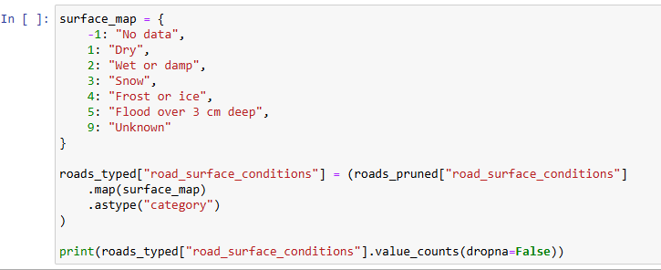
Finally, the Department for Transport STATS19 documentation (2025b) was used to assign the correct human readable labels to each encoded category. See Figure 1 for example. The full category lists are visible on the figures and the analysis section later in this report.
Figure 1 Example of Category encoding - surface road conditions
Crucially STATS19 underwent a change in reporting in scope of several existing variables in 2024, which is within the date-range examined in this analysis. To account for this, the documentation around the changes - Department for Transport (2025c) – was examined along with any potentially affected variables. Of the shortlisted variables in Table 1 only road_surface_conditions was affected. A closer inspection however revealed the older codes 6 and 7 (Oil/Diesel and Mud respectively) were not present in the data which suggests the data has already been harmonised with the post 2024 scope.
An overview of the final prepared data is available in Appendices - Table 3.

Analysis and results
Initial Exploratory Data Analysis (EDA) was carried out to test the feasibility of answering RQs visually and to derive initial impressions of trends. This employed basic data reviews, descriptive statistics and exploratory visualisations, which were later refined into the explanatory figures in this chapter. The final figures prioritise direct comparison, consistent scales and reduced visual clutter, following general principles of effective scientific visualisation (Kelleher & Wagener, 2011).

RQ1 - How have the number and severity of reported road collisions in Great Britain changed over the five-year study period?
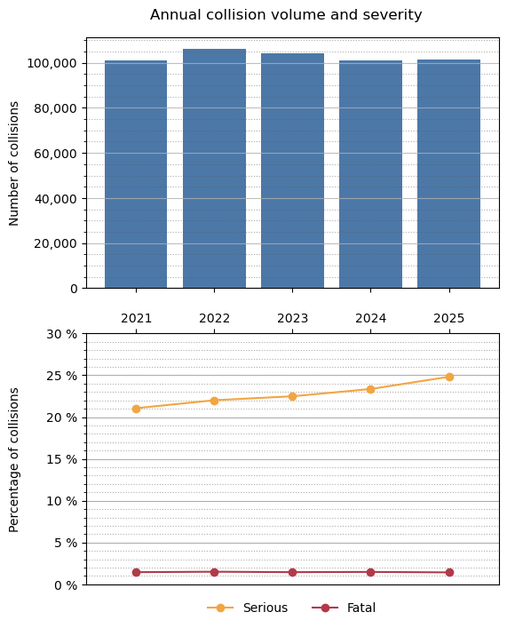
Figure 2 RQ1 - Annual collision volume and severity makeup
The data displayed in Figure 2 shows that there has been a continual decrease in total collisions since 2022. Despite this the proportion of severe ones has been steadily increasing from around 21.1% in 2021 to 24.8% in 2025. Meanwhile Fatal collisions have maintained a relatively steady rate of 1.43-1.51% throughout the 5-year period.

A compound bar-and-line design was chosen for this visualisation because annual collision volume and severity percentage use different units and magnitude, while the shared year axis allows their trends to be compared directly.

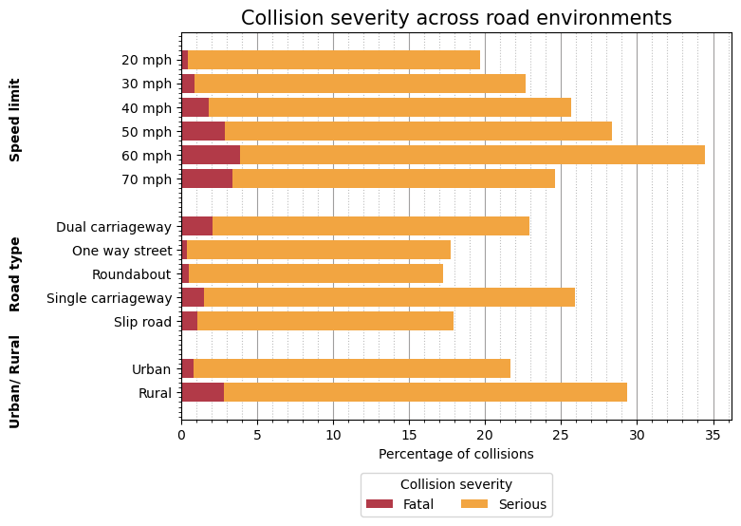
RQ2 - How does collision severity vary across different road environments, including speed limit, road type and urban or rural location?
Figure 3 RQ2- Severe and Fatal collision rate at different road environments
Horizontal stacked bars allow the three road-environment variables to share the same percentage scale, while separating Fatal and Serious contributions without introducing an additional axis. This makes it easier to compare both individual and compound severity measures within and between categories.
All 3 examined road environment variables show certain categories are more strongly associated with increased severity of recorded collisions. Understandably one of the strongest indicators is speed limits. One notable exception however is at roads limited to 70 mph. While fatal collision percentage remains high at this condition (3.37%) severe collision rate drops by 9.4 percentage points from 30.65% at 60mph to 21.25% at 70mph, which manifests in the lower severe + fatal collision rate shown in Figure 3.
One plausible explanation, which cannot be tested with the present analysis, is that many 70mph roads are typically dual carriage ways and motorways which are designed for higher speed travel with traffic separation and fewer junctions. This may partly explain the lower association with serious and fatal collisions. The general association between higher-speed environments and severity is also consistent with Mason-Jones et al. (2022).
Single carriageways account for by far the most collisions and have the highest serious/fatal share at 25.94%. Dual carriageways are next at 22.89%, while roundabouts are lowest at 17.21%.
Rural collisions are only 1/3 of records, but 29.36% of them were serious or fatal versus the comparatively lower proportion of 21.69% in Urban collisions. Fatal collisions specifically are 2.83% rural versus 0.80% urban — more than three times the proportion. This is consistent with national DfT statistics, where fatalities are disproportionately represented on rural roads relative to traffic exposure (Department for Transport, 2025a).

RQ3 - How does collision severity vary under different lighting, weather and road-surface conditions?
The Higher count of possible categories in these variables necessitated the use of colour and spacing distinguish the three environmental dimensions. While the common horizontal scale was retained to support direct comparison.
Overall lighting produces the clearest environmental severity gradient, while weather shows some differences, road-surface differences are comparatively modest as ca be seen in Figure 4 above.
Serious/fatal share progresses from 23.19% in daylight to 25.11% in darkness with lights lit, 29.14% with lights unlit, and 34.95% where there is no lighting. Fatal proportion alone rises from 1.21% in daylight to 4.81% in darkness with no lighting.
In terms of weather 3 categories stand out – High winds combined with either fine weather or rain and fog/mist. All three conditions have over 26% rates of severe or fatal collisions. Weather effects should nevertheless be interpreted cautiously. Edwards (1998), using England and Wales collision data, also found that severity varied across weather conditions, including lower severity during rain and geographically variable effects for fog.
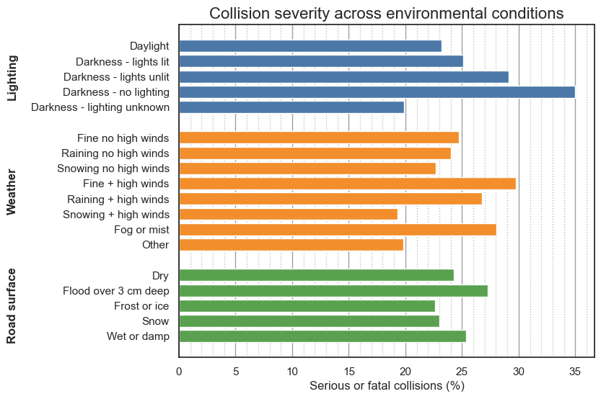
Wet and flood >3cm road conditions are associated with slight increase in severity rate. Although flooded collisions have higher fatality rate, they represent less than 0.2% of the overall dataset and are more easily influenced by outliers and skew. Wet/damp is 25.36% versus is only marginally higher than dry at 24.29%. Snow and frost/ice are somewhat lower
Figure 4 RQ3 - Severe or Fatal collision rate at different environmental conditions

RQ4 - What temporal patterns are visible in serious and fatal collisions by hour of day, day of week and month?
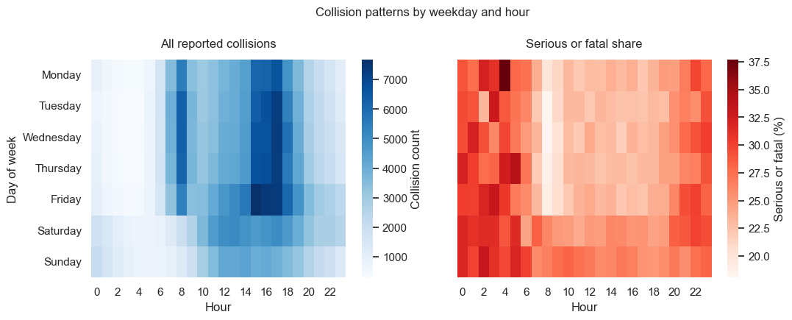
Heatmaps aggregate the ordered hour/day dimensions without overplotting and allow collision frequency and Serious/Fatal share to be compared side by side. Monthly volume and severity are shown with a bar-line chart using a shared month axis and secondary y-axis because the measures use different units.
Figure 5 Heatmaps of reported colissions by day and hour across 2021-2025. Left - Total collissions ; Right - Serious or Fatal colissions as a % of all reported on that day and hour
The temporal heatmap in Figure 5 clearly shows a concentration of recorded collision volumes on weekdays at peak morning/evening commuting periods and a weekend pattern shifted toward a mid-day and late-night. Looking at the severity plot on the right reveals a different pattern altogether. Despite fewer collisions occurring at night, their severity rate is substantially higher than daytime. This possibly links to previous observations around lighting conditions, although a collinearity study is not carried out.
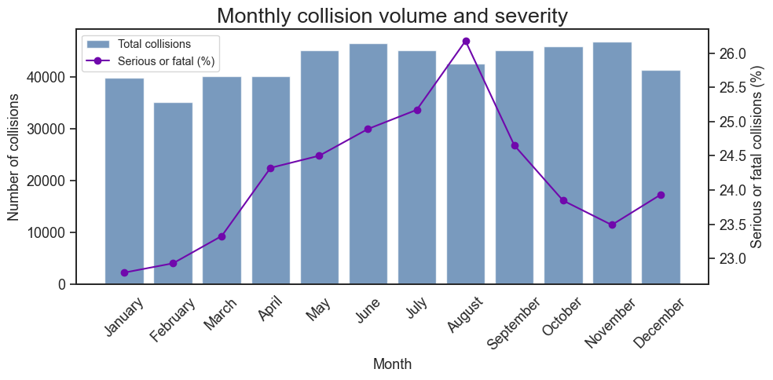
Monthly variation, by contrast, is comparatively modest as shown in Figure 6. While total monthly variation collisions recorded in the 5 year period is at a minimum in February and peak in June and November, the severity rate pattern is much more distinct. Serious and Fatal collisions tend to increase in proportion and volume in summer with a sharp peak in August. In that month serious or fatal collisions account for 26.18% of records, over 1 and 1.53 percentage points higher than the in the previous and following month respectively.
Figure 6 Monthly collision records across 2021-2025. Bars represent total collision reports; line plot on the secondary axis represents % of serious or fatal collisions.

RQ5 - Where are serious and fatal collisions geographically concentrated, and how does their spatial distribution compare with reported collisions overall?

Geospatial plotting is done over a Great Britain boundary obtained from the ONS Open Geography Portal (Office for National Statistics, 2026). Hexagonal aggregation was used instead of plotting more than 500,000 individual points to reduce overplotting and reveal spatial concentration. Both maps use the same grid resolution and geographic extent. Separate sequential colour scales reflect the different variables and count/rate distributions. The collision data concentration in London in particular is so high it necessitated capping the colour scales at the 95th percentile in order for other patterns to emerge.

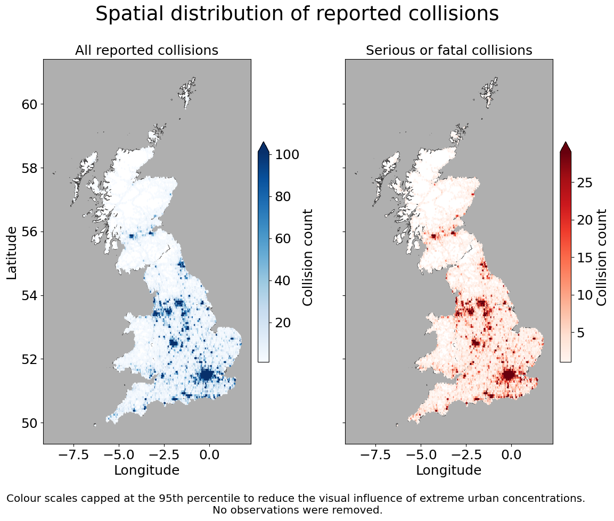
Perhaps unsurprisingly both total reported and increased severity collisions occurred in or nearby major Urban centres. A particularly high concentration of such centres can be observed in the Midlands.
Figure 7 Spatial plots of collision locations and severity. Left- total collisions; Right- serious or fatal collisions.

Limitations and Future work
The STATS19 dataset covers personal-injury collisions on public roads that were reported to the police and recorded through STATS19 (Department for Transport, 2025b). It is not a census of every road incident in Great Britain. So, there may be a substantial amount of unrecorded likely low severity accidents.
The study period also crosses the transition to the 2024 STATS19 specification. Although inspection suggested that the retained road-surface categories had already been harmonised in the downloaded dataset, changes in collection and implementation across police forces remain a potential comparability limitation (Department for Transport, 2025c).
The analysis compares proportions within reported collisions. The dataset does not contain exposure denominators such as traffic volume, vehicle-km travelled, pedestrian exposure, etc. Thus, it does not measure true road-user risk and cannot deem particular conditions as “more dangerous”. For example, collision clusters around London and major cities reflect where more people and traffic are present, not geographic risk. In contrast, official DfT reporting also presents casualty rates relative to traffic exposure, such as casualties per billion vehicle miles (Department for Transport, 2025a).
The data used for this and analysis is only observational, so any associations between severity and temporal, spatial and environmental factors cannot establish causation. Furthermore categories such as weather conditions are descriptive and broad without precise measures of windspeed precipitation rates at the time of accident etc. Likewise posted speed limit is not actual travelling speed.
Furthermore, covariance is not explored in this study, so the interaction between environmental conditions, road type, traffic levels, time of day and other factors may covary with and contribute to each-other’s severity outcomes shown above.
The dataset is not balanced between categories in most of the reviewed variables. Some weather/surface categories are very small. Thus, rare categories like snow/flood can show high or low percentages of severe or fatal collisions based on relatively few actual records.
Some reports coded as missing or unknown were excluded from some parts of the analysis. Generally these are only a small part of the dataset and were only excluded from the specifically relevant question where the lack of interpretability would have caused problems - see summary in Table 2 below.
Table 2 Report exclusions per research question based on unknown/missing encoding
Analysis subset | Missing / excluded | % of total | reason
RQ1 – Annual | 0 | 0.000% | No exclusion
RQ2 – Speed limit | 3 | 0.001% | Valid speed-limit groups only used in final visual
RQ2 – Road type | 13,060 | 2.542% | Unknown road type excluded
RQ2 – Urban/rural | 58 | 0.011% | No data and Unallocated excluded
RQ3 – Weather | 14,578 | 2.837% | Unknown and No data excluded
RQ3 – Lighting | 34 | 0.007% | No data excluded
RQ3 – Road surface | 10,248 | 1.994% | Unknown and No data excluded
RQ4 – Temporal | 0 | 0.000% | No exclusion
RQ5 – Geographic | 53 | 0.010% | Missing longitude or latitude

Future work can add traffic-flow or vehicle-km exposure to estimate risk rather than just collision composition, include covariance across road/environment/time variables instead of examining the data one factor at a time. While predictive model testing with feature selection can suggest focus areas to prioritise when reviewing safety standards and road designs.
A more detailed and localised investigation can incorporate local-authority boundaries for normalised regional comparisons. Finer resolution maps of specific areas can display urban hotspots at more precise locations for local authorities to prioritise.

Conclusions
The analysis identified several distinct patterns in reported collision frequency and severity across time, road environment and geography. The RQ1 analysis showed that total collision reduction did not come with identical improvement patterns across severity categories. While overall and slight collision counts declined after the peak in 2022, serious collisions have steadily increased over the later period. Fatal proportion remained comparatively stable across the 5 years.
The descriptive associations and road environment review in RQ2 found that severity composition differs substantially across road environments. Serious/Fatal rates generally increase in higher speed-limit areas, but this pattern is not monotonic because roads sections limited to 70 mph had lower severity rates than 60 mph. Single carriageways have both high collision volume and the highest Serious/Fatal share among road types analysed. While rural collisions make up less of the overall collision count, they have a clearly higher Serious/Fatal proportion than Urban collisions.
Looking at environmental conditions in RQ3 - overall lighting produces the clearest environmental severity gradient, while weather shows some differences, road-surface differences are comparatively modest. Serious/Fatal and Fatal shares substantially higher in darkness without lighting than in daylight. Rare environmental categories, however, need cautious interpretation because of small sample sizes.
The temporal pattern analysis in RQ4 revealed overall collision counts concentrate around weekday commuting periods, while weekend pattern shifts toward later-night and midnight periods. Importantly Serious/Fatal share does not exactly follow total collision count. Although slight monthly variation exists in total collision reports, there is a substantial escalation of severity in summer with Serious and Fatal Rates peaking in August.
Unfortunately, the geographic visualisation in RQ5 did not show much nuance in findings as it mainly emphasised the concentration of collision reports in Urban areas. A more localised approach or population / traffic normalisation could yield further observations.
Overall reported collision frequency and collision severity do not follow the same spatial, temporal or road-environment patterns. All analysed factors show some level of differentiation between severity rates, although exact correlation or causation was not established.

Engagement with AI
The author used AI was for search and dataset scoping, part of the data-wrangling code, some visualization code debugging, and literature search — not for generating analysis, interpretation, or written conclusions. For more detailed information on the specific uses please refer to Table 4 in Appendix 9.1 - AI usage Log.
The greatest contribution of AI was when it caught a data migration issue I wouldn’t have checked myself. Specifically the STATS19 data recording standards change in 2024 and migration, which shaped how I framed RQ1/RQ3. It helped me check the coded missing values and noted the coding discontinuity across police forces.
One example of AI output that needed correction was when I asked it to review my EDA observation notes for exaggerated or unevidenced claims. Initially AI flagged a claim about the 70mph/road-type as unnecessary and suggested I simplify the statement to increase severity with speed limit. I however did not agree with this as 70mph roads are fundamentally different in structure and design which could explain the lower rates and was an important observation to make.
Although I used AI to speed up the categorical variable encoding, all suggested code was run against the actual dataframe and manually Verified against official DfT documentation. No AI-generated figure or data was used at any point.
While AI was helpful for wide search, the actual dataset choice, research questions, exclusion decisions, visual design choices, and all interpretive claims were mine. AI contributions were treated as drafts requiring my verification, not finished outputs.
Overall AI improved efficiency and rigor of the technical/wrangling process, but did not substitute for independent analytical judgement, which remained the deciding factor throughout.

References
Department for Transport. (2025a). Reported road casualties Great Britain, annual report: 2024. GOV.UK. https://www.gov.uk/government/statistics/reported-road-casualties-great-britain-annual-report-2024
Department for Transport. (2025b). Road safety open data. GOV.UK. https://www.gov.uk/government/statistical-data-sets/road-safety-open-data
Department for Transport. (2025c). STATS19 collection and use: Initial impacts of transition to the 2024 specification. GOV.UK. https://www.gov.uk/government/publications/stats19-collection-and-use-impacts-of-the-2024-specification/stats19-collection-and-use-initial-impacts-of-transition-to-the-2024-specification
Edwards, J. B. (1998). The relationship between road accident severity and recorded weather. Journal of Safety Research, 29(4), 249–262. https://www.sciencedirect.com/science/article/abs/pii/S0022437598000516?via%3Dihub
Kelleher, C., & Wagener, T. (2011). Ten guidelines for effective data visualization in scientific publications. Environmental Modelling & Software, 26(6), 822–827. https://doi.org/10.1016/j.envsoft.2010.12.006
Mason-Jones, A. J., Turrell, S., Gomez, G. Z., Tait, C., & Lovelace, R. (2022). Severe and fatal cycling crash injury in Britain: Time to make urban cycling safer. Journal of Urban Health, 99, 334–343. https://link.springer.com/article/10.1007/s11524-022-00617-7
Office for National Statistics. (2026). Countries (December 2025) boundaries for United Kingdom. Open Geography Portal. https://geoportal.statistics.gov.uk/
Sarkar, C., Webster, C., & Kumari, S. (2018). Street morphology and severity of road casualties: A 5-year study of Greater London. International Journal of Sustainable Transportation, 12(7), 510–525. https://doi.org/10.1080/15568318.2017.1402972

Appendices
Table 3 End of general data preparation - Typed and Category Coded data overview
 | dtype | unique_values
collision_index | string | 513801
collision_ref_no | string | 510837
collision_year | int64 | 5
date | datetime64[ns] | 1826
time | object | 1440
collision_severity | int64 | 3
number_of_vehicles | int64 | 19
number_of_casualties | int64 | 26
speed_limit | int64 | 7
road_type | category | 6
urban_or_rural_area | category | 4
light_conditions | category | 6
weather_conditions | category | 10
road_surface_conditions | category | 7
longitude | float64 | 437863
latitude | float64 | 412451
severity | category | 3
collision_datetime | datetime64[ns] | 389260
hour | int32 | 24
month_name | category | 12
day_of_week | category | 7

AI usage Log
The Author used Claude (Anthropic) Sonnet 5 to assist with parts of this assignment in the following way.
Table 4 AI useage Log
Date | Stage / Task | Prompt (summarised)
31.08.26 | Dataset scoping | Requested exploration and ranking of authoritative public datasets relevant to UK, Vietnam, Southeast Asia and Bulgaria (topics like storms, food safety, transport, road safety, economics). Rank sources by analytical richness, originality, feasibility , and visualisation potential especially. Avoid heavily processed Kaggle sources.
31.08.26 | Dataset feasibility check | I provided initial STATS19 inspection results, like row count, missing-value count, severity breakdown duplicate check etc. Then I asked whether these feasibility checks were sufficient and what final checks were potentially missing before committing to the research questions I created.
31.08.26 | Report structuring | Requested ideas for key points to raise in the Introduction and Research Topic sections given my five research questions.
01.09.26 | Data wrangling | Requested decoding of STATS19 categorical variables (road_type, urban_or_rural_area, light_conditions, weather_conditions, road_surface_conditions) into pandas categorical types, datetime conversion from DD/MM/YYYY/HH:MM fields, and flagging of issues from the 2024 STATS19 specification change.
03-05.09.26 | Visualization debugging | Requested fixes for chart layout issues across several figures: vertical legend placement, spacing between stacked subplots, minor gridlines on a bar chart, spacing between heatmap panels with colourbars, spacing for rotated category labels on a horizontal bar chart, and axes background colouring on a geospatial hexbin plot.
05.09.26 | Geospatial data sourcing | Requested a GeoPandas-compatible open-source boundary outline for Great Britain (England, Scotland, Wales) with reproducible download code for use if the file is not available locally.
04.09.26 | Analytical review | Requested review of written analysis observations for exaggerated or unevidenced claims.
06.09.26 | Literature search | Requested identification of 5–8 literature sources to contextualise STATS19 findings, prioritising UK/GB studies, with explicit mapping of each source to specific research questions and distinction between associational and causal/exposure-adjusted claims.
07.09.26 | Report shortening | Help me cut 150 words out of this report.

