VeriFace Architecture Guide
Technical design, data flow, ML pipeline, security, and scalability

Purpose: This guide explains the internal architecture of VeriFace and how the mobile app satisfies offline biometric authentication, low model footprint, fast processing, secure local proof, and sync-ready scalability.

1. High-Level Architecture
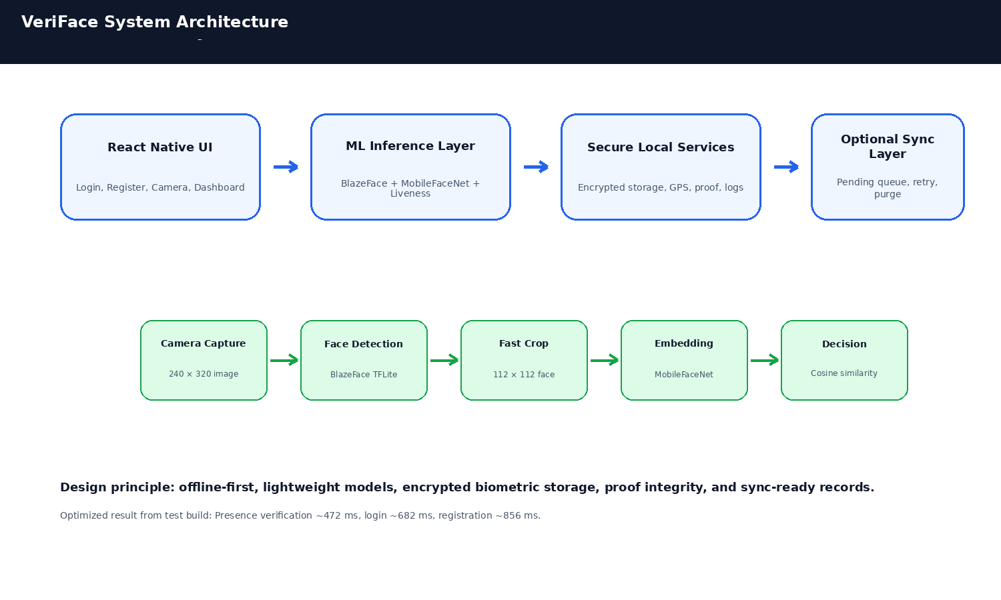
Item | Details
UI Layer | React Native screens for login, registration, presence verification, camera capture, dashboard, proof verification.
ML Layer | BlazeFace face detection, MobileFaceNet embeddings, head-turn presence verification, optional FaceMesh blink verification.
Service Layer | Encrypted storage, GPS attendance, activity logs, proof generation, proof export, sync-ready records.
Storage Layer | react-native-keychain for sensitive data and local storage for non-sensitive records.
Optional Sync Layer | Queues offline records and syncs when network/backend is available.

2. Optimized Face Authentication Pipeline
- Low-resolution front camera capture around 240 x 320.
- JPEG image is decoded and resized only to the minimum useful size.
- BlazeFace detects the face box using TFLite.
- Fast manual crop + resize converts the detected face to 112 x 112.
- MobileFaceNet generates a compact numerical embedding.
- Cosine similarity compares the live embedding with the encrypted stored embedding.
- Authentication succeeds when the score crosses the threshold.

3. Performance Architecture
Item | Details
Capture size | 240 x 320 or similar low resolution
MAX_IMAGE_WIDTH | 320
Face validation | ~518 ms
Embedding | ~159 ms
Total login | ~682 ms
Presence verification | ~472 ms
Registration | ~856 ms

4. Model Footprint Strategy
Item | Details
blazeface.tflite | Face detection, approximately 400 KB
mobilefacenet.tflite | Face embedding generation, approximately 5 MB
face_landmark.tflite | Optional blink verification model; include only if performance target remains satisfied
Target footprint | Around 20 MB or less for AI models

5. Presence Verification Architecture
Item | Details
Primary mode | Head-turn challenge-response verification
Why this mode | Very lightweight, no extra model required, suitable for sub-second target
Optional mode | Blink verification using FaceMesh landmarks
Risk reduction | Helps reduce simple printed-photo and screen replay attempts

6. Secure Proof Lifecycle
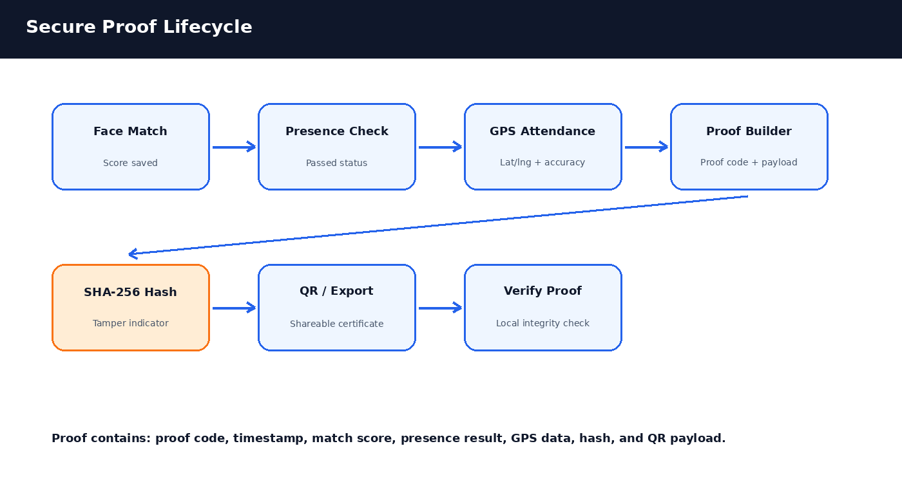
Item | Details
Proof code | Unique local proof identifier
Timestamp | Generated at time
Match score | Latest face authentication confidence
Presence result | Passed/not available and challenge metadata
GPS metadata | Latitude, longitude, accuracy, map URL
SHA-256 hash | Tamper detection
QR payload | Portable proof summary
Export | JSON proof and text certificate

7. Storage and Security Design
Item | Details
Biometric embedding | Stored securely using react-native-keychain
Last match score | Stored securely
Presence result | Stored securely
Proof data | Stored securely
Attendance records | Stored locally with GPS metadata; can be encrypted in production
Images | Captured photos are temporary and not retained as identity records

8. Offline-to-Online Sync and Purge Design
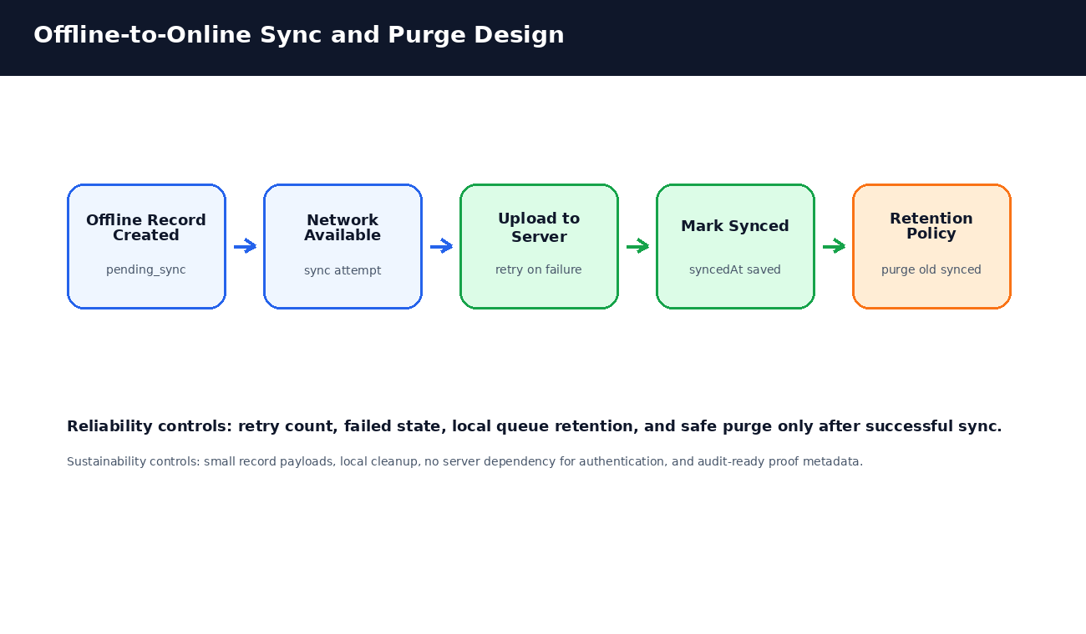
Item | Details
pending_sync | Record created offline and waiting for upload
syncing | Upload attempt in progress
synced | Backend has acknowledged the record
failed | Upload failed; retry count is increased
purged | Old synced records are removed based on retention policy

Scalability note: The current app is offline-first. A backend can be added later without changing the local authentication flow. Only proof/attendance metadata needs to sync; authentication can remain local.

9. Suggested Data Contracts
AttendanceRecord {
id: string;
time: string;
status: "verified";
method: "face-auth";
latitude: number;
longitude: number;
accuracy: number;
mapUrl: string;
syncStatus?: "pending_sync" | "synced" | "failed";
retryCount?: number;
}
SecureProof {
proofCode: string;
generatedAt: string;
method: "offline-face-auth";
matchScore: number | null;
livenessPassed: boolean;
latitude: number | null;
longitude: number | null;
hash: string;
}

10. Source Code Structure
src/
├── components/CameraView.tsx
├── ml/
│ ├── blazeFace.ts
│ ├── faceAuth.ts
│ ├── faceValidator.ts
│ ├── mobileFaceNet.ts
│ ├── modelWarmup.ts
│ ├── preprocess.ts
│ └── liveness/
│ ├── headPose.ts
│ ├── livenessAuth.ts
│ ├── faceMesh.ts
│ └── blinkDetector.ts
├── screens/
│ ├── LoginScreen.tsx
│ ├── RegisterScreen.tsx
│ ├── LivenessCheckScreen.tsx
│ ├── FaceCaptureScreen.tsx
│ ├── DashboardScreen.tsx
│ └── ProofVerificationScreen.tsx
├── services/
│ ├── secureStorage.ts
│ ├── faceStorage.ts
│ ├── attendanceService.ts
│ ├── proofService.ts
│ ├── proofExportService.ts
│ ├── securityMetrics.ts
│ ├── livenessService.ts
│ └── activityLog.ts
└── navigation/AppNavigator.tsx

11. Integration Guide
- Add required TFLite models to assets/models.
- Ensure metro.config.js includes tflite in assetExts.
- Install native dependencies and rebuild Android.
- Add camera and location permissions to AndroidManifest.xml.
- Warm up models in App.tsx using modelWarmup.ts.
- Use head-turn liveness for strict sub-second builds.
- Keep FaceMesh blink optional unless tested on target devices.
- Use Reset Registered Face after changing encrypted storage or preprocessing.

