VeriFace Demo Script
Live demonstration guide for evaluation committee

Demo objective: Show that VeriFace performs offline face registration, presence verification, face login, GPS attendance, secure proof generation, proof verification, and export within a lightweight mobile app.

1. Demo Setup Checklist
- Android emulator/device is connected and camera permission is allowed.
- GPS/location permission is allowed for attendance.
- Models exist in assets/models: blazeface.tflite and mobilefacenet.tflite.
- Metro is running on port 8088.
- Registered face can be reset from the app for a clean demo.
- Network can be turned off to demonstrate offline behavior.
Item | Details
Metro command | npx react-native start --reset-cache --port 8088
Android run command | npx react-native run-android --port 8088
Clean build | cd android; .\gradlew clean; cd ..
Reset fallback | Use app button: Reset Registered Face

2. Recommended Live Demo Flow
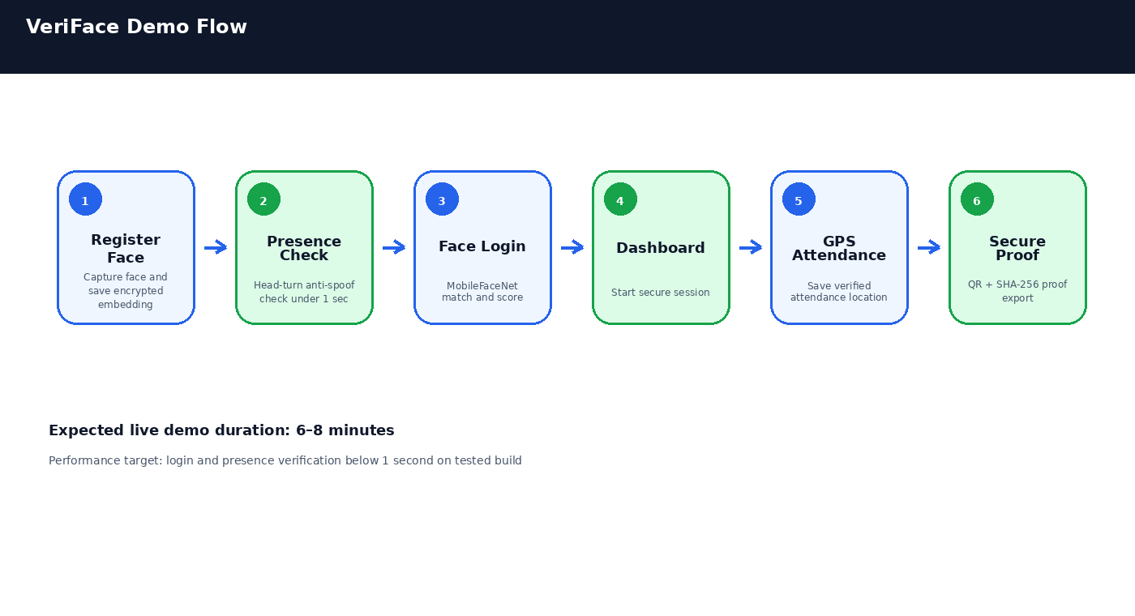

3. Exact Demonstration Steps
Step 1: Reset demo state
Tap Reset Registered Face if an old enrollment exists. This ensures the evaluation starts from a clean state.
Step 2: Register face
Tap New Registration. Keep face centered. Capture once. Expected message: Face registered successfully.
Step 3: Login with presence verification
Tap Login Existing User. Follow instruction: Turn face slightly left/right. Capture. Expected message: Presence Verification Passed.
Step 4: Face login
Capture centered face. Expected: Login successful with match score.
Step 5: Dashboard protected session
Tap Start Protected Session. Secure actions become available.
Step 6: GPS attendance
Tap Attendance. Confirm GPS data is captured and displayed.
Step 7: Secure proof
Tap Proof. Confirm proof code, QR, hash, score, presence result, and GPS metadata.
Step 8: Export and verify
Export JSON/certificate or verify proof code/hash locally.

4. Expected Performance Evidence
Item | Details
Presence verification | ~472 ms on tested optimized build
Face validation | ~518 ms
MobileFaceNet embedding | ~159 ms
Total login | ~682 ms
Registration | ~856 ms
Model warmup | ~1.5–1.8 seconds at app startup

Important talking point: Model warmup happens once at app startup. The actual login and presence flow is optimized for sub-second operation by using low-resolution capture and fast manual crop/resize.

5. Evaluation Criteria Mapping
Item | Details
Offline functionality | Authentication, presence verification, attendance, proof generation, and proof verification work locally.
Lightweight model footprint | Uses small TFLite models: BlazeFace and MobileFaceNet; FaceMesh is optional.
Processing speed | Optimized login measured at ~682 ms and presence at ~472 ms.
Security | Encrypted embedding storage, SHA-256 proof hash, QR proof, and local verification.
Scalability | Records are designed for pending_sync, retry, synced, and purge lifecycle.
Sustainability | Low resource usage, small model footprint, no high-end GPU requirement.
Documentation | README, requirements, demo script, architecture guide, and presentation artifacts.

6. Fallback Plan
- If camera permission fails, open Android app settings and allow camera.
- If GPS fails, explain attendance module requires location permission and show existing saved record.
- If proof QR is slow, use proof code and SHA-256 hash text as primary evidence.
- If login fails due to lighting, re-register in current lighting and retry.
- If Metro bundle is stale, run taskkill /F /IM node.exe and restart Metro with --reset-cache.

7. Closing Statement
VeriFace demonstrates a practical offline-first biometric workflow: secure enrollment, presence verification, fast local recognition, GPS attendance, tamper-aware proof, and future-ready synchronization. The prototype is optimized for lightweight deployment and midrange mobile devices.

