Research

**Adaptive Optics in Microscopy.** We are interested in applying Adaptive Optics to problems in fluorescence microscopy. AO is a technology used to correct for aberrations in optical waves that are created when light travels through a medium with a varying refractive index. In astronomy AO is needed to correct for aberrations that arise from minute refractive index variations in the atmosphere that blur the images of stars and planets as the light travels through the atmosphere to a ground-based telescope. An example of AO in astronomy is shown to the right. Images of Neptune from the Keck telescope are shown without and with AO.

Figure . Neptune imaged by the Keck telescope without (left) and with (right) Adaptive Optics. (https://www.osti.gov/servlets/purl/792749)

**Superresolution Microscopy.** Structured Illumination Microscopy is a technique for increasing the resolution of fluorescence microscopy by a factor of two in each dimension. This is achieved by creating Moiré fringes in the sample which shift high frequency sample information – unresolvable by the microscope – to lower frequencies that the microscope can image.

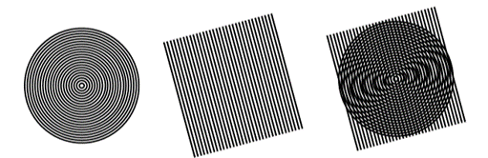

Figure . Moiré Fringes are formed between a circular and linear pattern.

Figure . Actin in α-TN4 lens epithelial cell imaged with AO-SIM. Lin et al., Nat. Comm. 2021.

**Light Sheet Microscopy.** We are using Light Sheet Microscopy to image the central nervous system of zebrafish to study the role of GABAergic signaling in neural development. We have imaged seizure-like events in zebrafish with different mutations and exposed to seizure-inducing chemicals. We are currently applying Adaptive Optics to Light Sheet Microscopy and developing new LSM techniques.

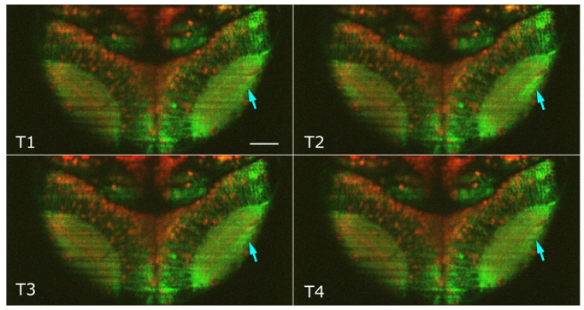

Figure . A seizure event occurs in the right optic tectum of a zebrafish treated with PTZ.

**Incoherent Holography.** We are developing incoherent digital holography as a method for imaging single molecules. The hologram encodes the axial position of the molecule and the molecule can be localized in three-dimensions over a large axial range.

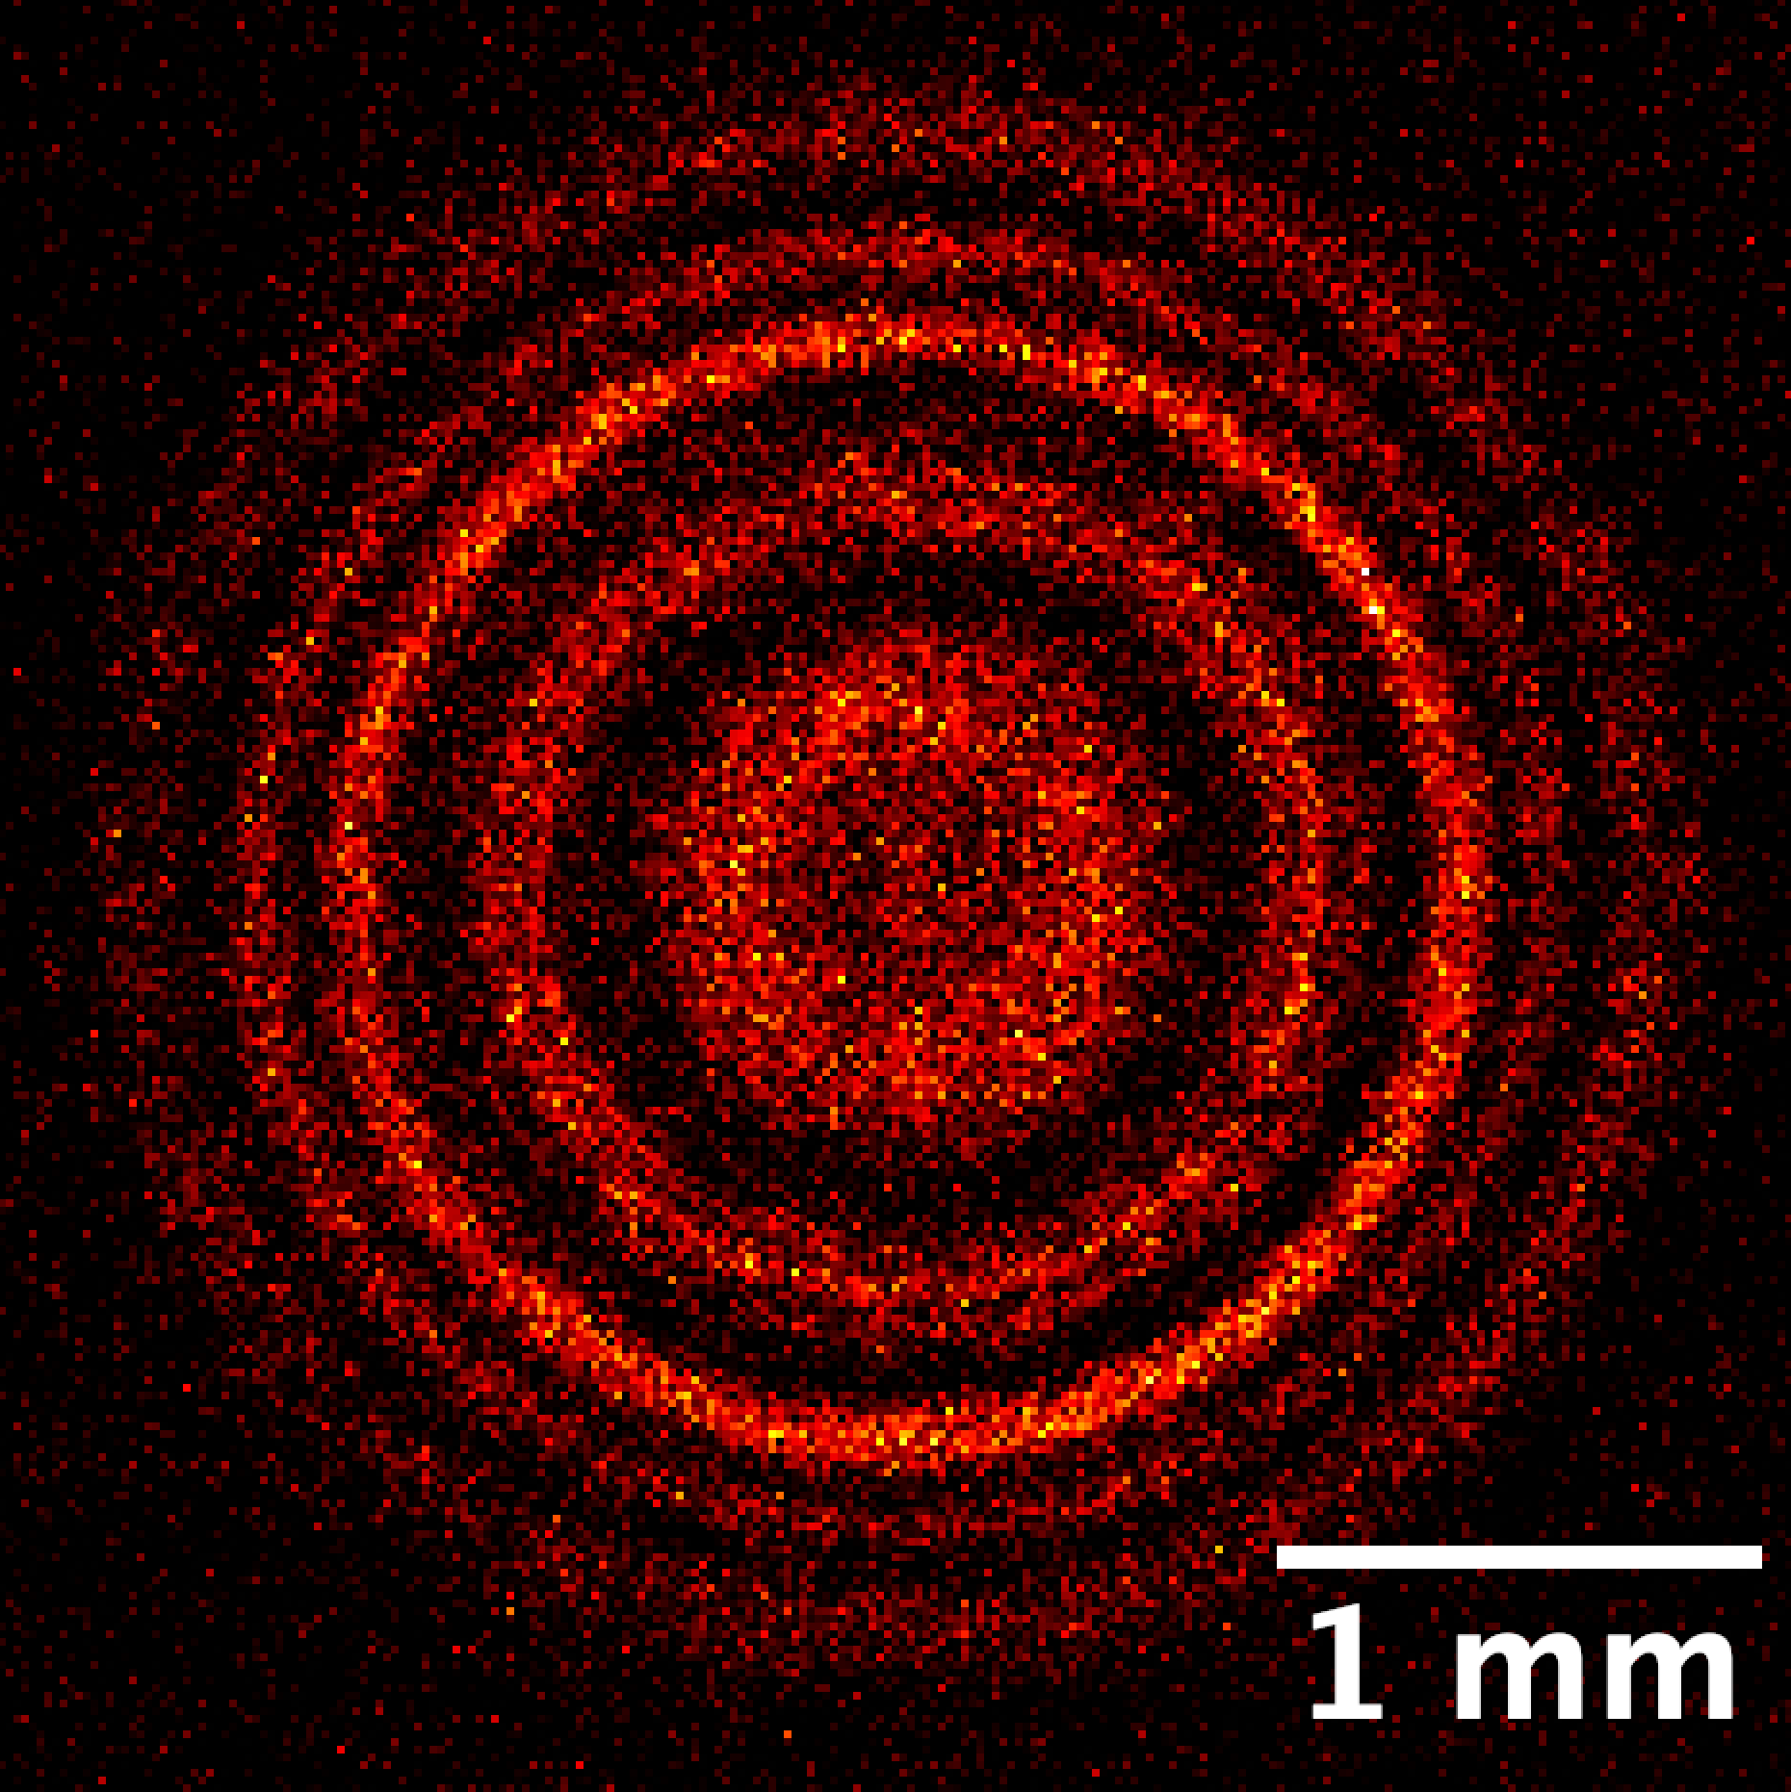

Figure . Hologram of a 200 nm fluorescent bead.

Teaching

ENGR 8570 Topics in Advanced Optical Microscopy

Course Description: A variety of topics in advanced optical microscopy, including the mathematical formalism behind modern three-dimensional microscopy techniques, such as confocal and multiphoton imaging, will be covered. A range of microscopy techniques, including Raman spectroscopy, phase contrast techniques, and Second- Harmonic Generation Microscopy will be examined. Background material in statistical optics and nonlinear optics will be introduced.

ELEE 8530 Advanced Optics and Photonics

Course Description: Advanced topics in optics and photonics. Topics covered include nonlinear-optics, optical response of materials and optical fiber, and electro-optic effects in photonic devices. Applications of photonic technologies in signal processing and emerging applications will be discussed.

ELEE 8240 Instrumentation Programming

Course Description: Students will learn to write custom computer programs that interface with laboratory instruments. The course will cover advanced topics such as interfacing with dynamic link libraries and using queues and state space models to control program execution. The course is intended for graduate students who will be performing experimental work.