***University of Maryland University College***

**ITEC 630 - 9045**

**Summer 2017**

**Final Exam**

Monday, August 04, 2017

**The Final is due by 11:59 PM Sunday, August 13, 2017**

This is an open-book individual exam comprised of **five (5) questions.**

Please follow the following guidelines:

1. **Put your name in the exam**.
2. You should submit your exam to your assignment folder in LEO in a MS-Word or PDF file.
3. Please scan your file(s) against viruses before submitting.
4. **Please keep the full text of the question as part of your answering sheet.**
5. Be as clear and objective as you can in all questions and be sure you are answering what is being asked.
6. **Justify all your numerical answers and answer all the questions using your own words. Show all your work, including how you found your answer** (this is very important and essential to have your answer graded appropriately!)**.**

**Make sure that you read, acknowledge, and follow the following rules**

Rules:

* The exam is to be taken in **accordance with the UMUC Honor Code** – e.g., do not collaborate or seek help from anyone else.
* This is an open-book exam but you are only allowed to use your textbook and information posted in our classroom. Please do not use any other sources that are not listed in our classroom. *For example, you can refer to our class lecture notes and all links posted in the lecture notes* ***but you should not search the Web for information to solve exam questions****.*
* You should not discuss exam questions with other students or anyone else.If you have any questions about the exam, please send me an e-mail**.**

**Acknowledge:**

**I, Kyle Neuman acknowledge the above rules.**

*(Your name)*

###### Question 1 of 5: (10 points)

You are a project manager at L & D Inc., specializing in information technology and network engineering. One of your junior systems analyst came to you for advice on a technology to capture user information requirements. He described to you that he had talked with his client several times in the past week to define user information requirements. Each time he thought he had captured user information requirements, they’ve already changed. Finally, he thinks his clients do not even know what they want for their system.

1. Give your junior systems analyst advice on a technology that he could use to capture user information requirements. **(3 points)**
2. Explain to him how this technology can help him to better define users’ information requirements. **(7 points)**

*** For this question, please limit your response to a maximum of one page.

**Clarification:**

Students should understand the word "technology" as being defined in several dictionaries as a scientific method, technique, theory, or practice to solve a practical problem. I included some definitions of the word "technology" from several dictionaries that you might refer to answer your question below:

1. The application of science, especially to industrial or commercial objectives.
2. The scientific method and material used to achieve a commercial or industrial objective.
3. The application of practical sciences to industry or commerce.
4. The methods, theory, and practices governing such application a highly developed technology.
5. The use of scientific knowledge to solve practical problems, especially in industry & commerce.
6. The specific methods, materials, and devices used to solve practical problems.

###### Question 2 of 5: (15 points)

Mandy Bradford, who is the store manager of ACME Department Stores, wants to be able to receive clear feedback on the systems used to manage the stores.

Design a display that shows an acceptable way to tell Mandy that input to her system was accepted. Make sure that all three types of the following feedback messages are covered:

1. Action successful. **(5 points)**

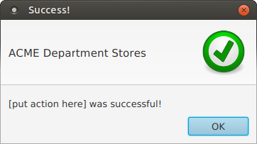

1. An error in the user entry. **(5 points)**

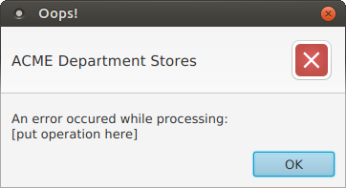

1. Please wait messages, indicating that a response time of more than 5 to 10 seconds will elapse. **(5 points)**

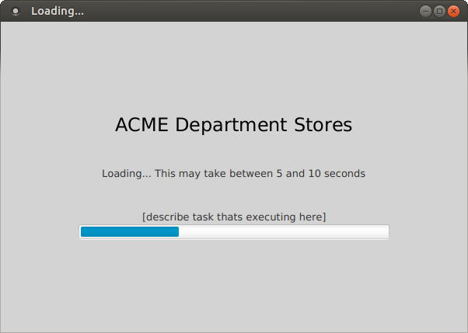

**Question 3 of 5: (25 points)**

A summary of business activities of a “Course Registration System” for enrolling courses for students and for enrolled class lists for faculty members at an online university is as follows:

An academic department provides information on offered courses. Students request enrollment in offered courses and the system sends to each student an enrollment schedule. Faculty members receive enrolled class lists when the registration period is complete.

1. Draw a context-level data flow diagram for the “Course Registration System” **(10 points)**

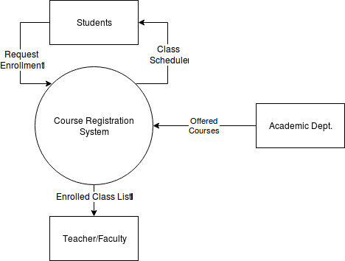

1. Explode the above context-level diagram by drawing the logical data flow diagram level 0 showing all the major processes **(15 points)**

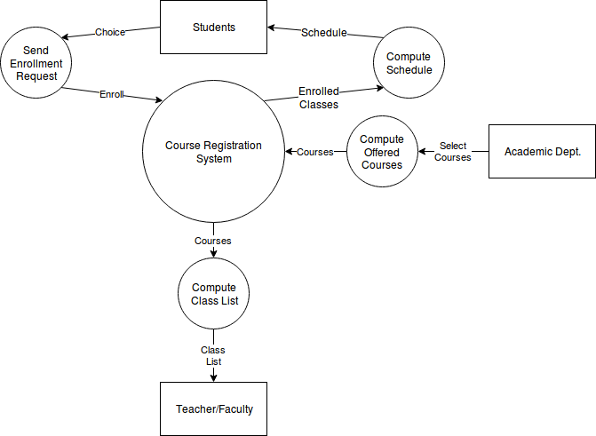

###### Question 4 of 5: (30 points)

A local art charity is hosting several charity events and you are tasked to design an entity-relationship diagram (ERD) for the situation described as follows:

* Many volunteers can participate in many different art charity events and one person, called the art charity events coordinator, assumes the role of overseeing these art charity events.

You must complete the following:

1. Draw the ERD **(10 points)**
2. Handle many-to-many relationships, if any, in the ERD using knowledge learned in the Week 7 lectures **(10 points)**
3. Identify primary keys for each entity in the ERD **(10 points)**

**Question 5 of 5: (20 points)**

Consider the following agent sales report in which:

1. Each agent covers only one state but each state may be assigned to many agents
2. Each agent may have many customers
3. Each customer has only one store but each store may service many customers
4. There is a one-to-one correspondence between “Customer ID” and “Customer Name” and between “Store ID” and “Store Location”

**AGENT-SALES-REPORT**

|  |  |  |  |  |  |  |  |
| --- | --- | --- | --- | --- | --- | --- | --- |
| **Agent ID** | **Agent Name** | **Agent Covered State** | **Customer ID** | **Customer Name** | **Store ID** | **Store Location** | **Sales Amount** |
| A123110 | Alex Johnson | Georgia | C111253 | John Russell | 119 | Atlanta | 37500 |
| A123110 | Alex Johnson | Georgia | C111312 | Kent Wilson | 153 | Macon | 12500 |
| A320115 | Marc Thomas | Florida | C211233 | Fred Greggory | 465 | Orlando | 7500 |
| A999150 | June Jones | New York | C998750 | William Kent | 912 | Albany | 5700 |
| A999150 | June Jones | New York | C998811 | Brian Kilgore | 938 | Manhattan | 58500 |
| A425130 | Clara Barton | Indiana | C325119 | Bryan Manning | 326 | Bloomington | 7000 |
| A888175 | Brian Wilson | Maine | C017617 | Edward Rush | 008 | Portland | 45750 |

Perform the normalization process to convert the above un-normalized table to:

1. First normal form (1NF)
2. Second normal form (2NF)
3. Third normal form (3NF)

Please show all your work. Show each step along the way and identify primary keys, if any, in each table in each step.