Graph

1 What is the graph

1.1 Graph Definition
- show the relationship of many to many
- contain:
- a group of terminal points: use the V(Vertex)stand for the collection of vertex
- a group of edges: using the E(Edge) to stand for the collection of terminal edges

edge:edge is the two vertex connection. For example: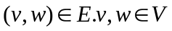
No direction edge is use(v,w) to stand for a path v and w can reach each other. Direction edge is use<v,w> to stand for a path from v to w. We don’t think repeat edge and self path.

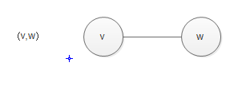
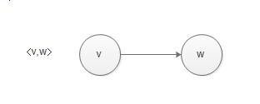

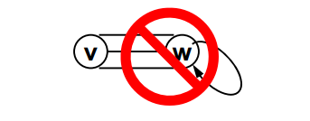
The number in the edge is the weight of the edge. For example,we can use those number stand for the distance between the two vertexes.
We call the graph with weight as the network.

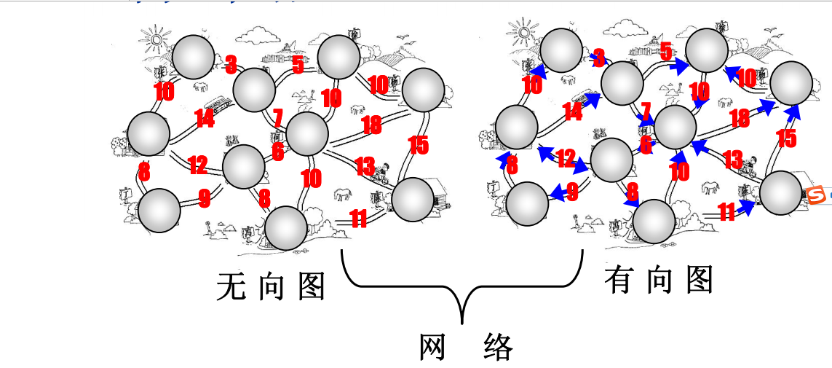

2 Define Abstract Data Type and Operate

2.1 Date Type Name
图：Graph

2.2 The Collection of the Data Type
G(V,E) is not null,contains limited points’ collection and limited edges’ collection.

2.3 The Collection of Operate
Operation Collections：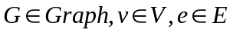
a):
/*build a empty graph then return*/
❑ Graph Create();

b):
/*insert a new vertex into the graph
*/
❑ Graph InsertVertex(Graph G, Vertex v);

c):
/*
insert a new edge into the graph
*/
❑ Graph InsertEdge(Graph G, Edge e);

d):
/* from the vertex v start, depth first search graph*/
❑ void DFS(Graph G, Vertex v);

e)
/*from the vertex start,breadth first search graph*/
❑ void BFS(Graph G, Vertex v);
/*get min path from vertex v to other vertex*/
❑ void ShortestPath(Graph G, Vertex v, int Dist[]);

/*calculate the min created tree*/
❑ void MST(Graph G);
......

3 How to show a graph using program

3.1 Adjacent Matrix
G[n][n]:There are N vertex from 0 to N-1 stored in the matrix

1 if<vi,vj> is the edge in the graph
G[i][i]=
0 if <vi,vj> is not edge in the graph

For example:
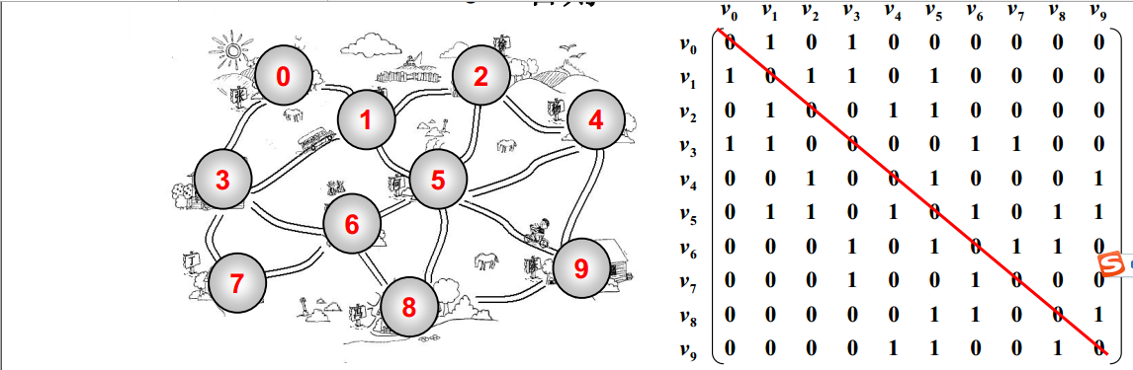

We find the matrix is symmetrical,So we only store halt of those data.
So we can use a one-dimensional array to stand for the above two-dimensional.
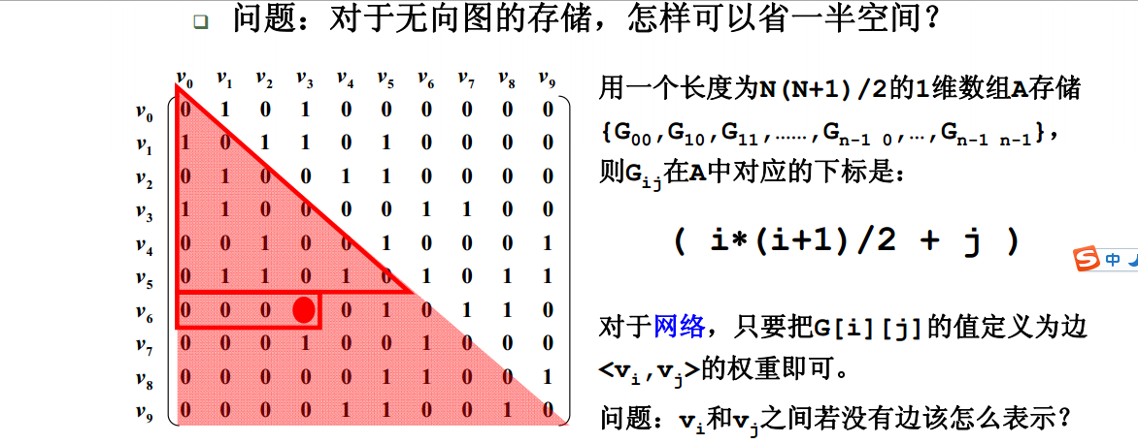
The one-dimensional length is n*(n+1)/2,The G(i,j) in the one-dimensional index is (i*(i+1)/2+ j ). If the graph is network,we just modify the 1 to the weight value.

3.1.1 The Advantages of Adjacent Matrix


3.1.2 The Disadvantages of Adjacent Matrix


3.1.3 Sparse Matrix
In sparse matrix,the 0 element is too many.

3.2 Adjacent Table
We set a point to every vertex and let them to point the vertexes that they are adjacent. From following picture,we find we need N head point and 2*E(edge) node
For example:

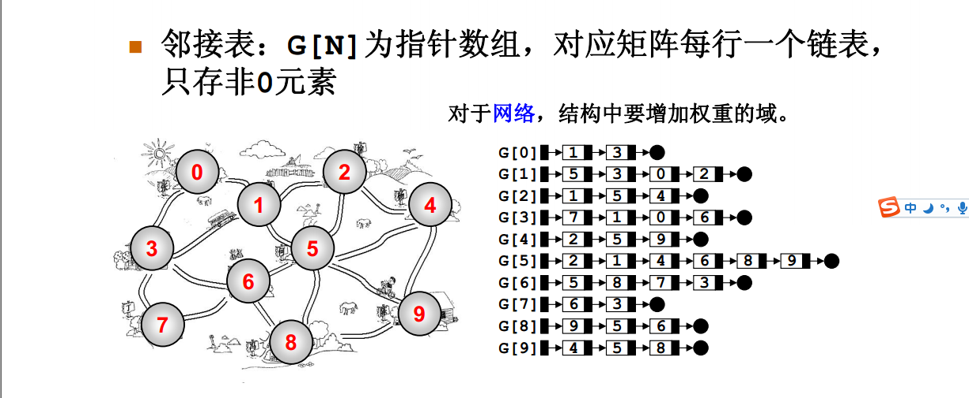

Think this method is really reduce space?
From above picture,in no direction graph ,we store the node twice.4-->9 and 9-->4.It waste the space.But if the graph is very spare,we use the adjacent table is very reduce the space.But is the graph is not spare graph,the adjacent will waste many space.

3.2.1 The Advantage and the Disadvantage of Adjacent Table



3.2.2 Orthogonal List
We know we only get indegree(入度) from the adjacent table.If will want get outdegree(出度), we need construct reverse adjacent table. Is a link list can provide the tow advantage. We can try orthogonal list. Let’s see following picture.
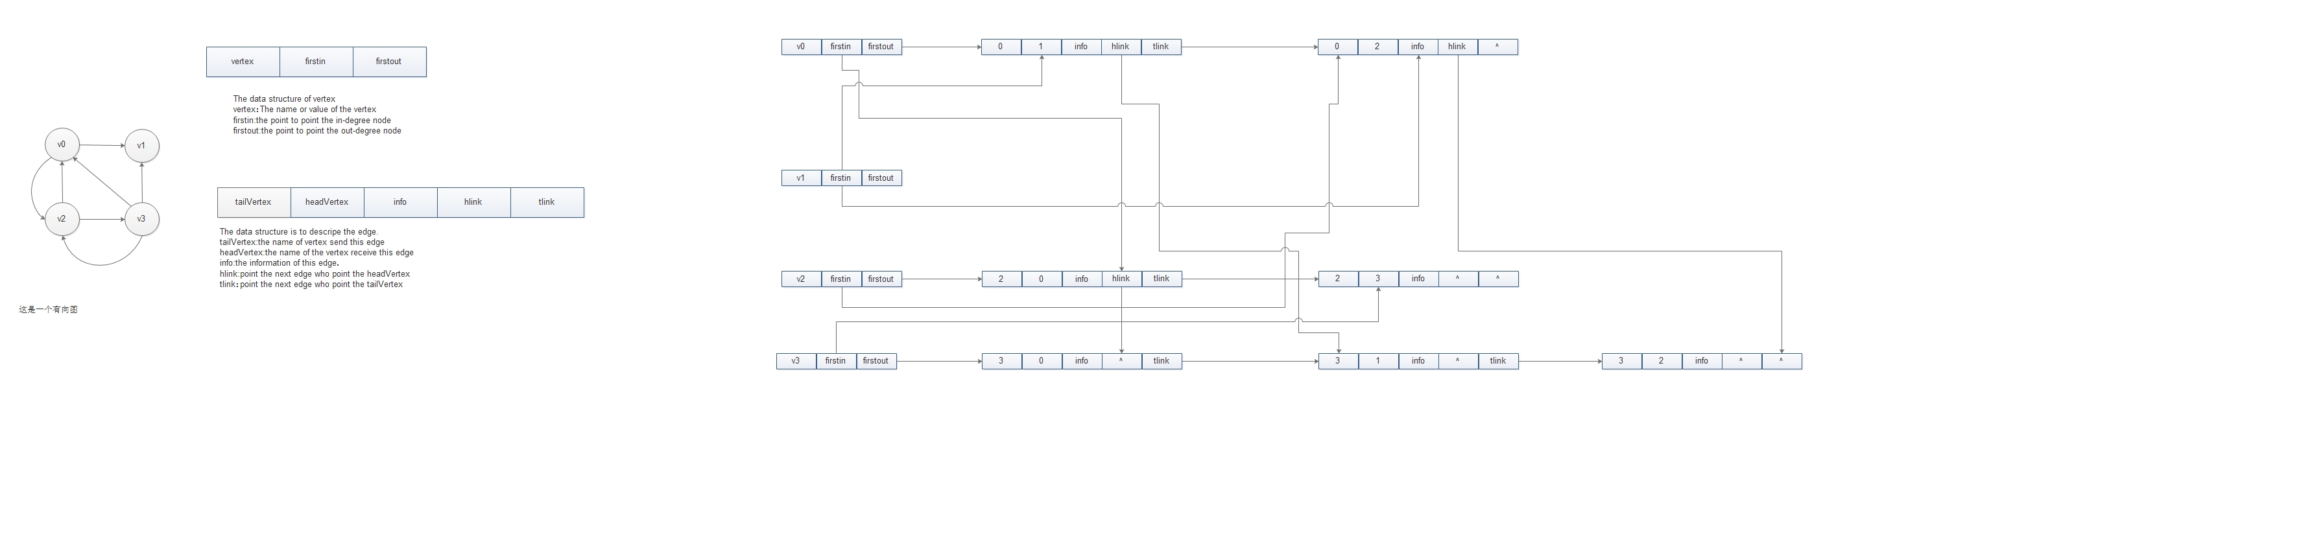

3.3 What method we will chose?
From the above two ways,we can know: adjacent matrix store N vertex need N*(N+1)/2 space The adjacent table store N vertex need N + 2*E(edge)space.
If N*(N+1)/2 >= N+2*E

4 Insert Data to Graph

4.1 the code you can see

5 The Search of Graph

5.1 Depth First Search(DFS)
we will introduce it by following picture:
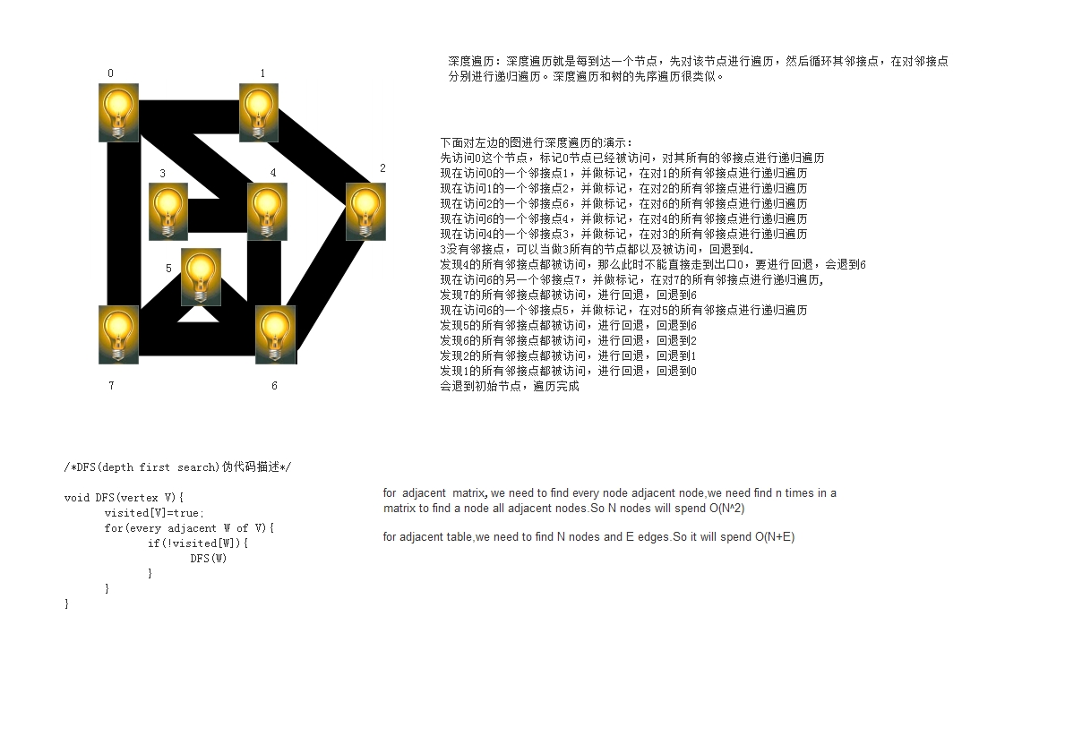

5.2 Breadth First Search(BFS)

BFS is similar with the tree level search.We using follow picture to display it’s principle.
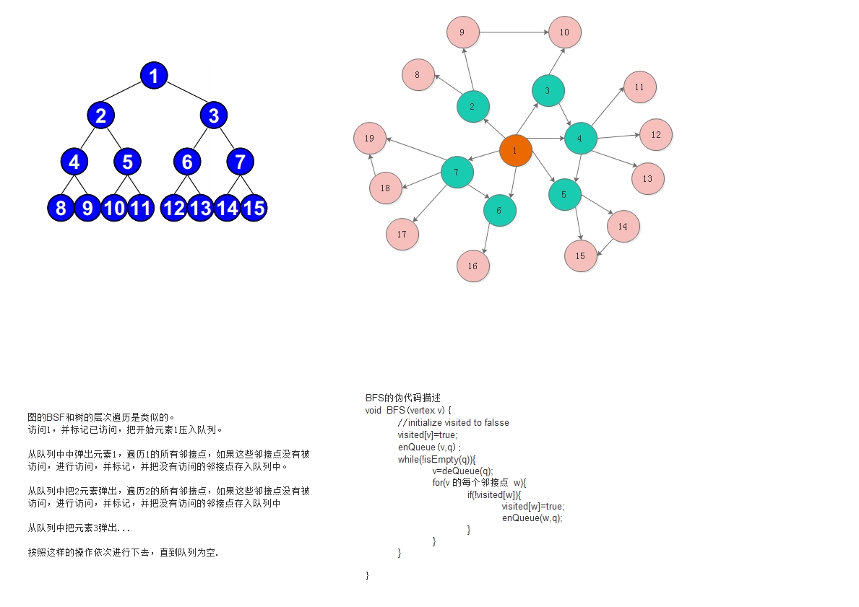

6 Special Graph

6.1
we maybe meet some graphs, that are don’t connect to all nodes.
If we use BFS or DFS to search,we we find some node will be be searched. How to solve this problem.
The following we will use Chinese to describe.

首先我们要引入一些概念：
连通：如果从V到W存在一条(无向)路径，则V和W是连通的。
路径：V到W的路径是一系列的顶点{V,v1,v2,v3....W},其中任意相邻的顶点都有图的边。路径的长度是路径中边数之和(如果有权重则是所有的权重之和)，如果V到W之间所有的顶点都不同，则称为简单路径。
回路：起点等于终点的路径
连通图：图中任意两点均连通。

6.2 图不连通怎么办
连通分量:无向图的极大连通子图
极大顶点数：再加一个顶点图就不连通了。
极大边数：包含子图中所有顶点相连的所有边
下面使用一个图片来说明

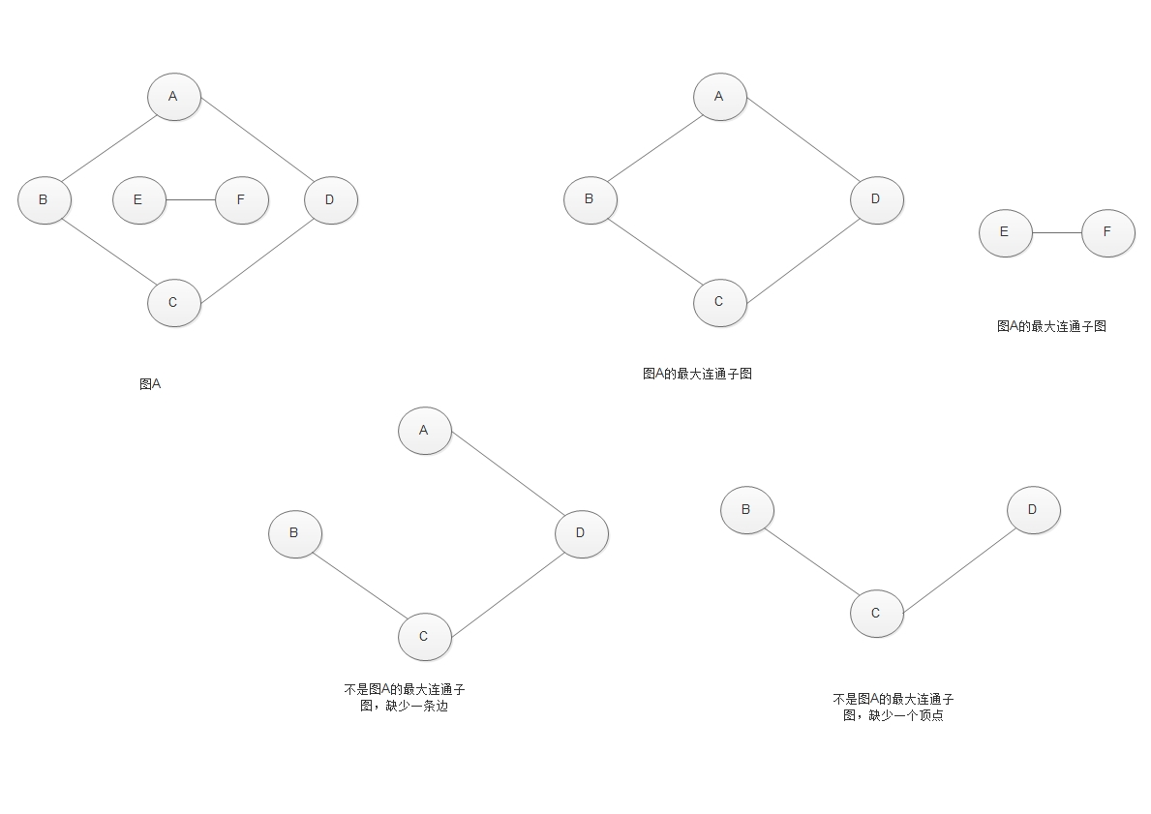

■ 强连通：有向图中顶点V和W之间存在双向路径，则称V和W是强连通的
■ 强连通图：有向图中任意两顶点均强连通
■ 强连通分量：有向图的极大强连通子图

6.3 不连通的图如何进行BFS和DFS
对于不连通的图，对BFS来说，之前我们需要遍历每个节点的邻接点，但是如果出现不连通的图，我们需要把遍历每个节点的邻接点改为遍历每个节点的极大连通子图。对于DFS，我们需要在遍历每个节点的邻接点时改为遍历每个节点的极大连通子图即可。

