*Jamison Peconi*

*Copyright © 2016 Checkmate*

*Checkmate Law*

User Guide

Table of Contents

**Introduction to the Checkmate Law application 3**

1. **Creating a new report 4**
2. **Filling out a report 6**

**Choosing a checklist in report 7**

**Adding notes to a list item 8**

**Completing a report 9**

1. **Processing saved reports 10**

**Email Report 11**

1. **Guidelines 12**

**Grounds for arrest 13**

**Firearms Guidelines 14**

1. **About 15**

**Checkmate Law**

User Guide

Welcome to the Checkmate Law mobile application. This is a comprehensive guide to navigating and using the application. At any point of the application you want to be returned to this screen, touch the checkmate logo at the top of the screen.

Upon first launching the application you will be brought to application home screen. This will be the landing screen which contains the main menu. This will be your starting point for navigating the application.

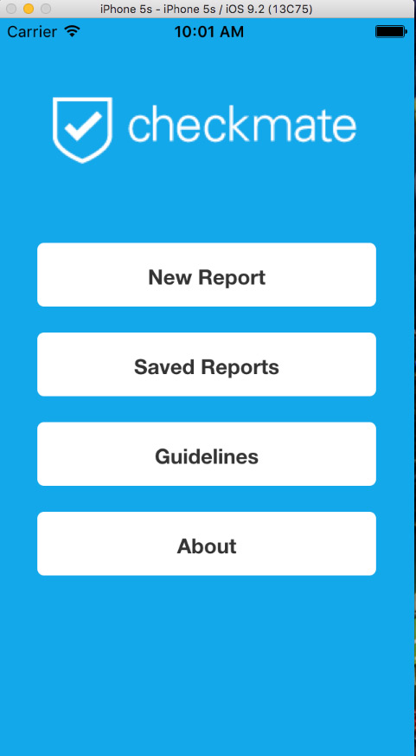

*Application Home Screen*

1. Creating a New Report

Touch the New Report Button on the main screen. This will bring you to the page in *Figure 1.2.*

Figure 1.1 Figure 1.2 – Report Selection

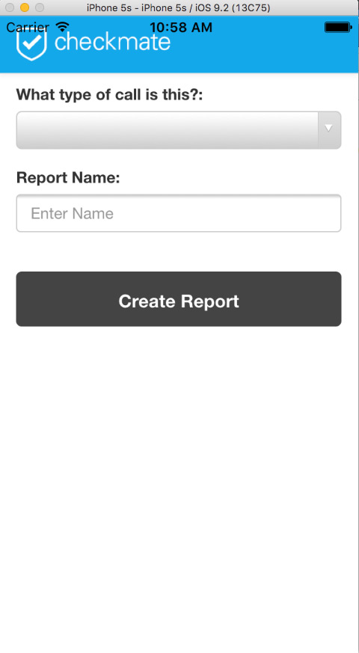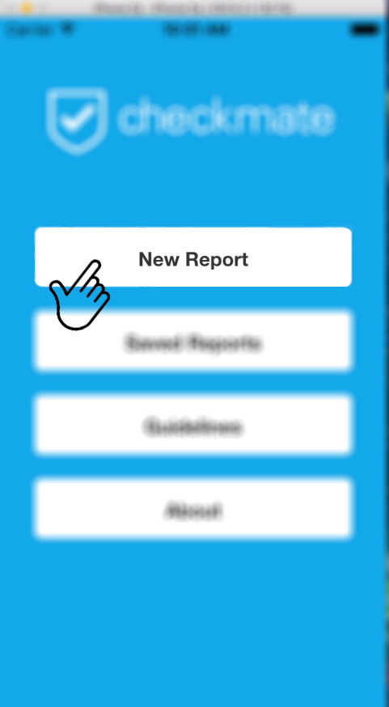

*Touch the New Report button to create report Report Selection Screen*

From this screen you will select the type of report you would like to create and give the report a name. Touch the dropdown menu bar and select one of the report types from the list. *Figure 1.3*

Figure 1.3

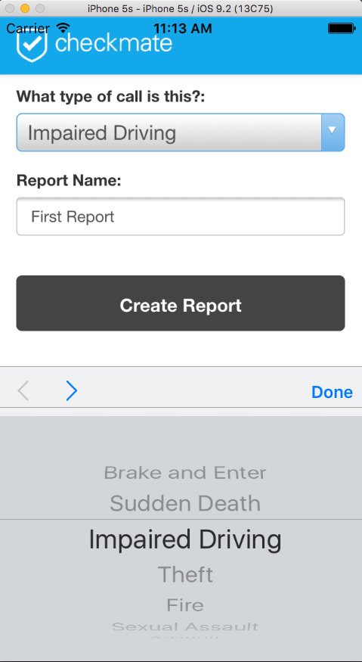

*Selecting the report and naming it*

Fill in the name of the report and touch the Create Report button.

1. Filling out a report

After creating the report, you will be brought to the initial checklist menu screen for the report you have selected. *Figure 2.1*.

*Figure 2.* *1*

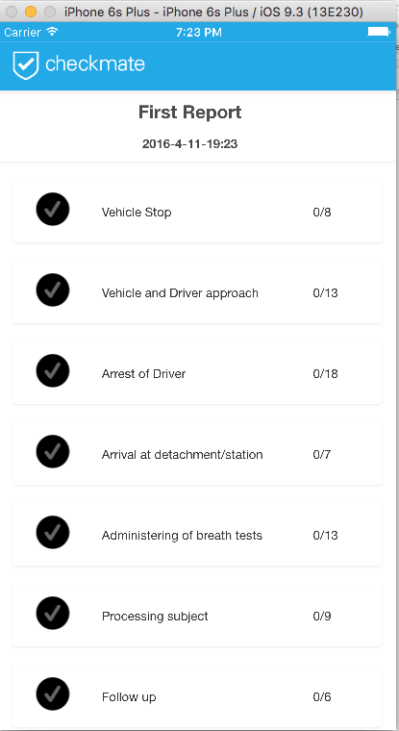

*Initial report checklist*

The checklists are generated in the order in which they should be performed. You can see in *Figure 2.1* each individual category of the checklist has a count of the number of items. (*Ex. 0/8 for Vehicle Stop).* This represents the number of items completed from within each list item.

Select an item from the list and you will be taken to another screen with a list of tasks to be completed for each step of the procedure. *Figure 2.2.* For this example, I will be selecting the Vehicle Stop which is the first item in the list.

*Figure 2.2*

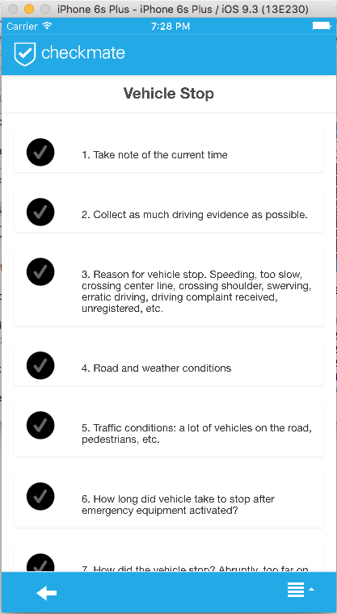

*The Vehicle Stop*

From this screen you can see the current list you have selected. Vehicle Stop.

From this screen you will start to complete the tasks from the list. Upon completion of each task you will touch the checkmark which will light up to show you that the step has been completed. Each task also has a Not Applicable button, if for some reason the item doesn’t apply to the given situation. By clicking this the application will still count the task as completed and will light up the check a different color.

Within each item in the list, you also have the ability to take a photo using the devices built in camera, and record a voice memo using the built in microphone. It will also give you a place to write a note or comment that you might want to record. *Figure 2.3.*

*Figure 2.3*

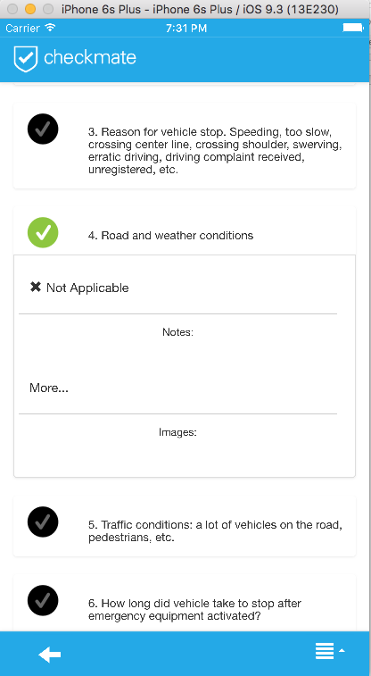

You can see where the item above has been checked off, along with the item that was just completed. In the Road and Weather conditions item, you can see above the space where your notes will be added. If you scroll down you will also find the button to take a photo or record a voice memo.

Upon completion of all the items in the list, you must scroll to the bottom of the screen and click to the back button to return to the previous page.

After returning to the main page, if all the tasks were complete within one of the list items the checkmark will light up. *Figure 2.4*

*Figure 2.4*

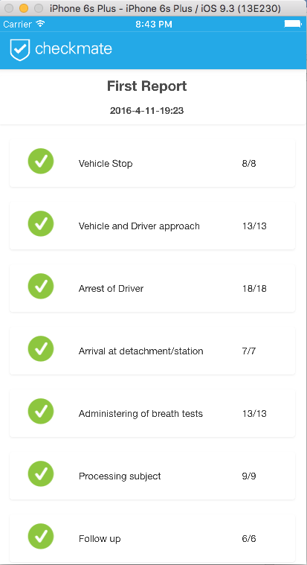

Completed Checklist

After all the items in the checklist are completed, the user must touch the checkmate logo at the top of the screen. This will take you back to the main menu. From there you will be able to further process the report.

Note: The report is automatically saved throughout the entire process. When any item is changed, added or deleted.

1. Processing Saved Reports

Now that you have completed your first report, you want to be able to go back and access this report to either edit, delete or forward to another person or place. When you return back to the main menu, you want to select the Saved Reports option. *Figure 3.1.*

*Figure 3.1*

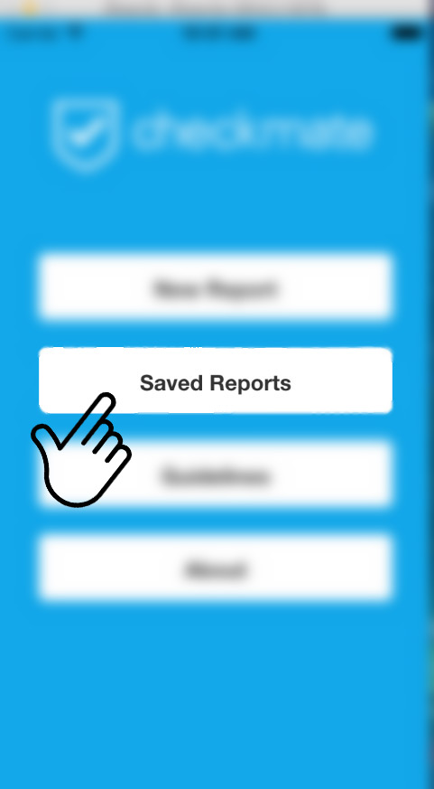

Clicking this will take you to a list of all the reports that are saved on the device. Select the name of the report that you would like from the list. Once you select the report you would like to work with, you will be brought to another menu where you will have the option to

* **View/Edit** - which will bring you back to filling out the checklists.
* **Delete** - which will delete the report from the device.
* **Email -** which will automatically open the email function on your phone.

*Figure3.2*

*Figure 3.2*

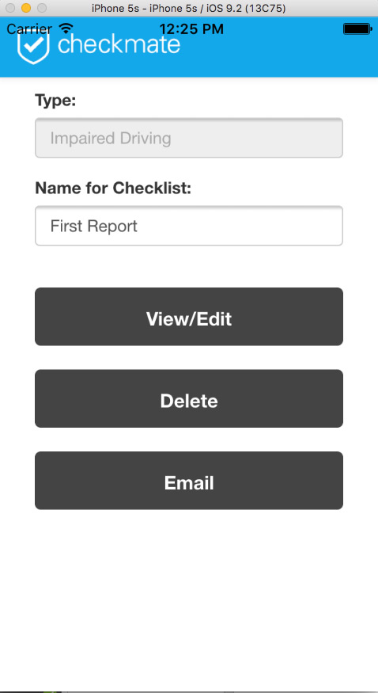

When you select the Email feature, this will open up a new message and automatically attach all the files associated with this report to it. It will generate a PDF of all the items that are checked from the checklist, along with any comments that correspond to each item. It will also include all the voice recordings, and photos that were taken. The photos and voice recordings are named with the list item that they belong to so it will be easy for the user to identify which memos or photos belong to which list item.

1. Guidelines

From the main menu we have also included guidelines that can be used to aid an officer in making decisions on whether to arrest a suspect or not. There is also a very detailed list of rules and regulations which apply to firearms. From the main menu select the guidelines button. *Figure 4.1*

*Figure 4.1*

*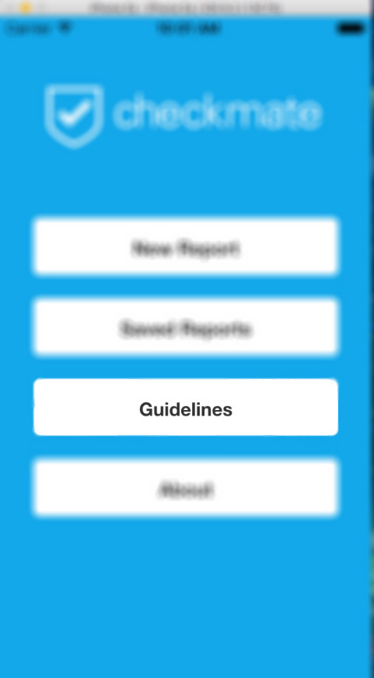.*

When you click the guidelines button from the main menu, you will be brought to another screen which will give you two options. *Figure 4.2*

*Figure 4.2*

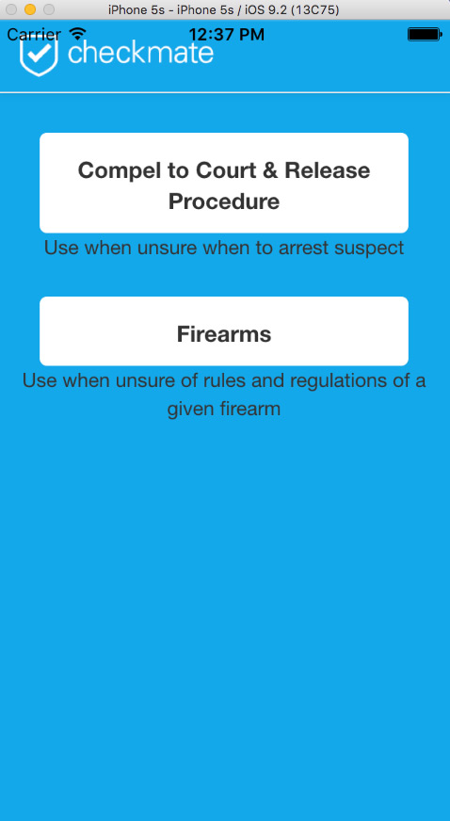

*Guidelines Menu*

If you are unsure whether or not you have grounds to make an arrest, by selecting the first option “Compel to Court & Release Procedure” it will give you through a questions which you answer by selecting one of the options on screen. At the end of the questions it will either say, no grounds to arrest or make the arrest. *Figure4.3*

*Figure 4.3*

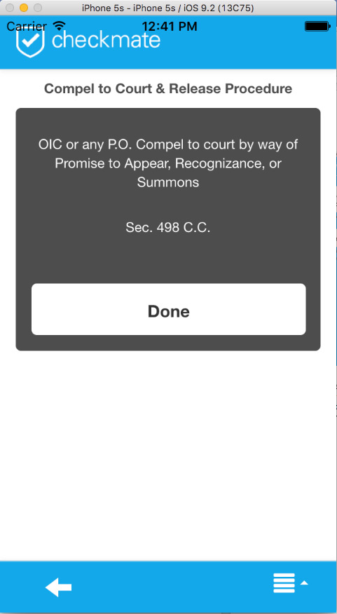

By selecting the Firearms option from the menu, you will be provided with a list of different rules and regulations which respond to firearms. *Figure 4.4*

*Figure 4.4*

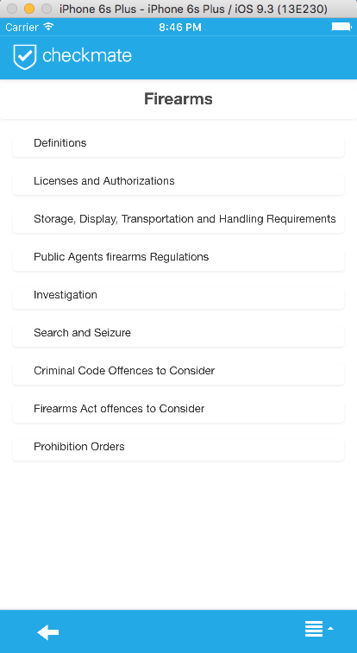

*Firearms Rules and Regulations*

Click through the different categories to obtain the information required.

1. About

This option from the main menu provides information about the Checkmate Law application. From this screen you can find out the current version number along with licensing and copyright information.