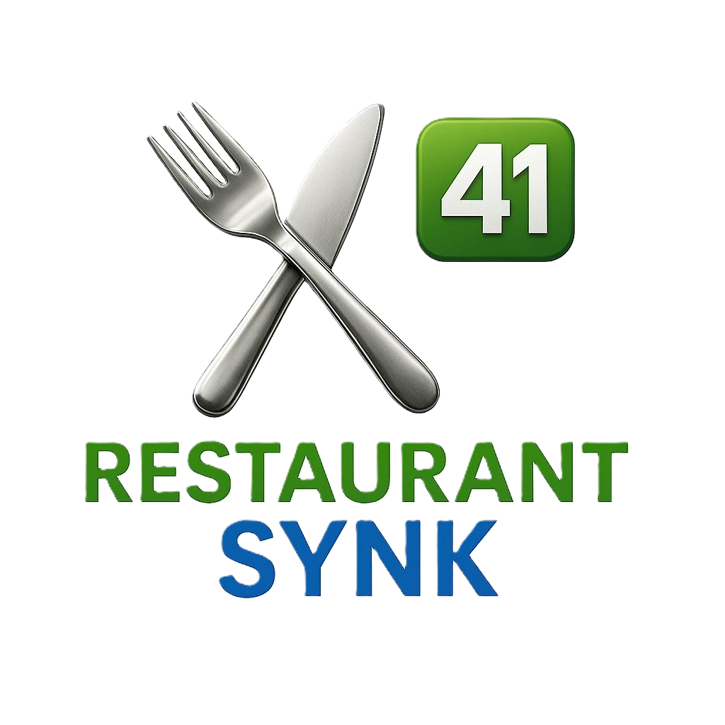
RESTAURANTSYNK POS UNBUNDLED
The Operator's Guide to Ownership, Margin Protection, and Flexibility
A practical white paper for restaurant owners and operators evaluating bundled POS systems, payment processing lock-in, and AI-driven operational control.
Processor freedom  Choose and negotiate your own processor | Lower monthly costs  Pay only for the tools you actually use | Owned infrastructure  Keep your stack, data, and workflows in your accounts
RestaurantSynk by Sigma41

Introduction: Why More Software Is Not the Answer
Restaurants need more control, not more software. Today, almost every operational task has a corresponding app, subscription, or vendor add-on attached to it. Many operators are paying for ten or more systems, often totaling $1,000 to $2,000 each month.
That creates a technology trap. Software costs increase while control over the business shrinks. RestaurantSynk is the alternative. We help operators own their POS, control their data, and stop giving away margin.
The Problem: The Hidden Cost of Bundled POS Systems
Most modern POS systems are sold as bundles. Software, payments, reporting, and back-office functionality are tied together into one closed environment. It feels simple at first. Over time, it limits flexibility and quietly erodes margin.
Processor Lock-In
When the POS controls payments, the operator loses leverage. There is little room to negotiate rates, and switching providers usually means replacing more of the system than necessary.
Forced Feature Upgrades
Operators are often pushed into higher tiers, contracts, or bundled modules that include features they do not need. Monthly costs rise while operational value stays flat.
Data Silos
Reporting, costing, and back-office tools live inside someone else's system. Exporting, analyzing, or connecting the data across the business becomes harder than it should be.
The result is simple: restaurants pay more while controlling less.
The RestaurantSynk Solution: The AI Operational Layer
RestaurantSynk takes a different approach. Instead of locking operators into a single platform, we help them build a system they own.
We create a custom AI-powered management stack that lives in the client's accounts, not ours. This becomes an AI operational layer that can replace the current setup or sit on top of it and make it smarter.
How Ownership Changes the Economics
Choose your processor: operators can work with interchange-plus providers, negotiate rates directly, and switch processors later without rebuilding the POS.
Lower ongoing costs: after setup, most operators spend under $300 per month on the AI and cloud tools they actually use.
Build permanent infrastructure: menu data, workflows, reporting, and operational logic become business assets instead of rented access.
Protecting Margins With Intelligence
Margin protection comes from better decisions, not more reports. RestaurantSynk uses AI to turn operational data into clear, useful signals.
Predictive Labor Forecasting
Sales history, weather, and local trends can be used to recommend staffing levels that reduce overtime and improve labor-to-sales ratios.
Menu and Plate Costing
Every menu item can be broken down to the ingredient level so true plate costs are visible in real time and low-margin items are easier to address.
Smart Inventory and Prep
Daily prep targets and reorder suggestions can be based on actual usage, which helps reduce waste and prevent stockouts.
The Directional Math
For a restaurant doing $150,000 per month, a 1 percent to 2 percent margin improvement equals roughly $1,500 to $3,000 saved each month without increasing sales.
A Practical Starting Point: The Tech Stack Review
The first step is not replacement. It is clarity. RestaurantSynk begins with a short operational intelligence review to identify overlap, reporting gaps, labor visibility, and food cost variance.
What We Look For
Technology overlap: where tools duplicate work, where spreadsheets still fill critical gaps, and where subscriptions should be consolidated.
Labor visibility: whether the operation can see labor-to-sales ratios in real time or only after the fact.
Food cost variance: how often food costs are calculated and where waste is likely occurring.
The Pilot: Proving the ROI
After the review, RestaurantSynk launches a 60-day pilot without disrupting the operation or forcing system changes. Intelligence is layered on top of existing tools to improve margin visibility, identify waste, and generate clear recommendations.
Most locations should expect measurable impact from better labor control, reduced waste, and smarter purchasing.
Bottom Line: Your POS. Your Data. Your Rules.
RestaurantSynk is about control. No forced contracts. No vendor dependence. No guessing where the margin is going.
The operator owns the system, controls the data, and makes decisions with clarity.
Typical directional ROI
$3,000 to $8,000 per month in improved margin performance per location during a successful pilot.
Ready to Take Back Control?
Schedule a consultation: https://calendly.com/kitchen-restaurantsynk/30min
Questions: kitchen@restaurantsynk.com
Website: restaurantsynk.com

