CSC8502 – ORI LAZAR – B9061712

Youtube Link: https://www.youtube.com/watch?v=IS9GLXPMrL8&feature=youtu.be

# Standard Features Implemented

1: **A landscape that changes over time, and uses multiple textures in the fragment shader**, it rises out of a flat surface. Also there are multiple other changing parts in the scene, such as the growing trees, and flying saucers. Below are screenshots of the initial setup of the scene.

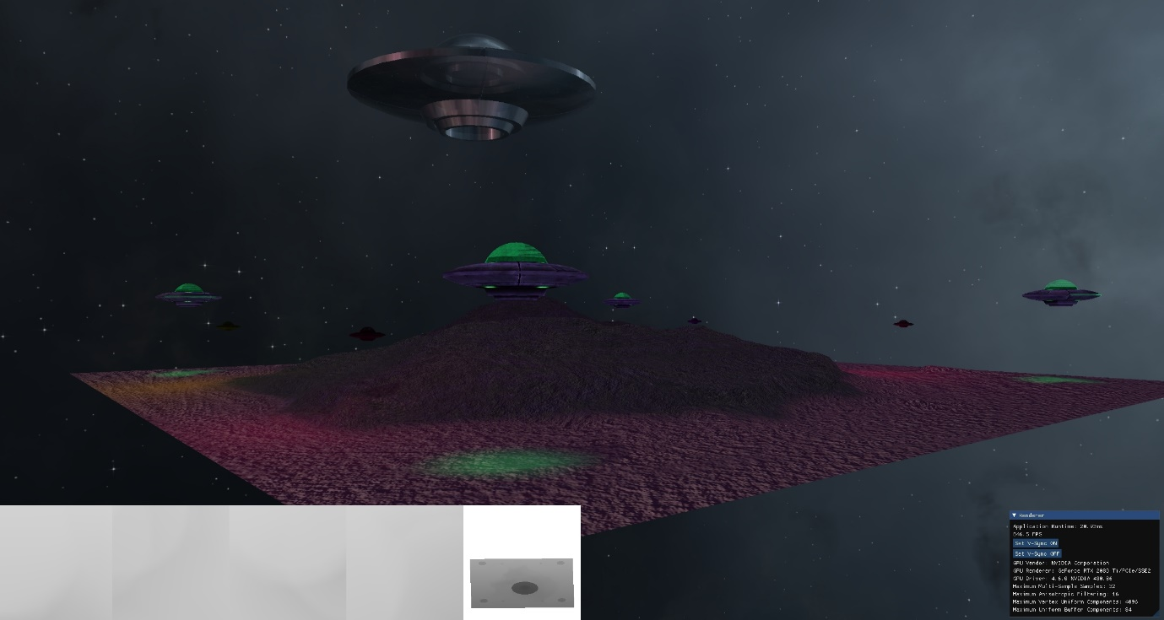

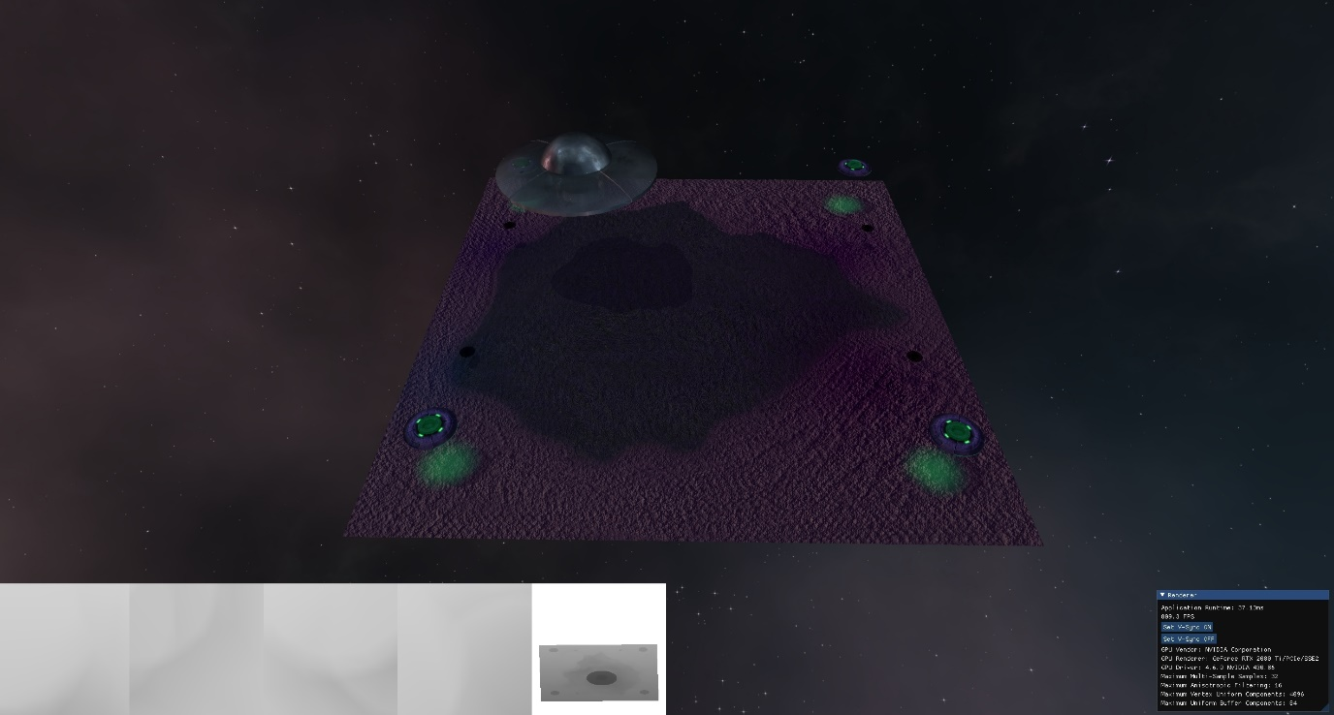

2: The **scene is lit** using a directional light (forming the flying spaceships shadows), this is setup as the galaxy’s ambiance, which results in the blue/purple colour of the scene. I utilise the blinn-phong lighting model, and calculate separate components for **ambient, diffuse and specular**, as well as attenuation for the spot and point lights.

3: All lights in the scene apart from the point lights perform **real-time shadowing**, with the included calculations for pcf (percentage-closer filtering) and multi-sampling smoothing. I have implemented omnidirectional shadow capabilities in the engine but did not have time to implement them in this scene. Which is why those function calls are commented out in the shader.

4: The camera moves automatically through the scene for 125 seconds, with the **ending of the scene animation** **being indicated by the geometry explosion of a spaceship**, as can be seen in the following image. 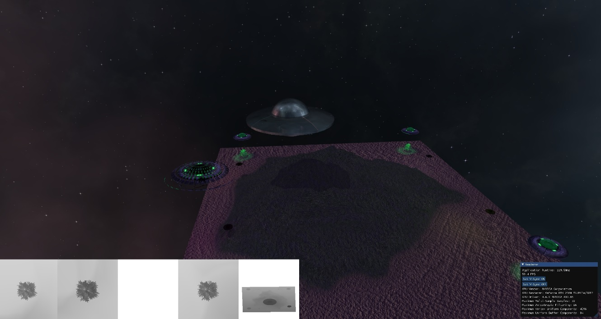

4: The large mothership performs **environment mapping** by reflecting the skybox, and the point lights perform environment mapping by refracting the skybox. 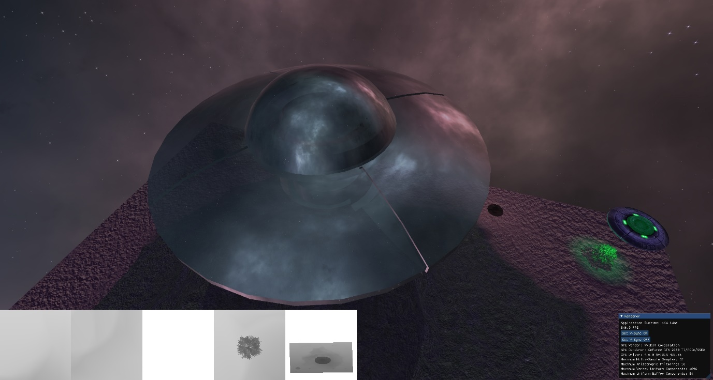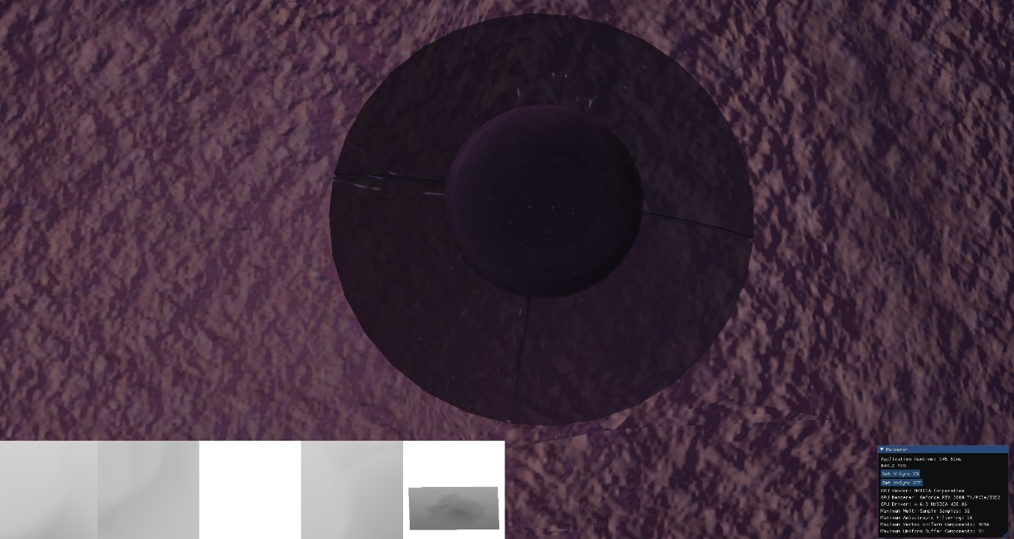

5: The scene is sorted using a **scene graph with frustum culling** both for optimization and transparency reasons.

# Advanced Features

Post Processing: **In order to go back to non-post-processed view, press the 0 key.**

The following post processing techniques can be toggled through the following keys:

**Color Inversion** – 1 key

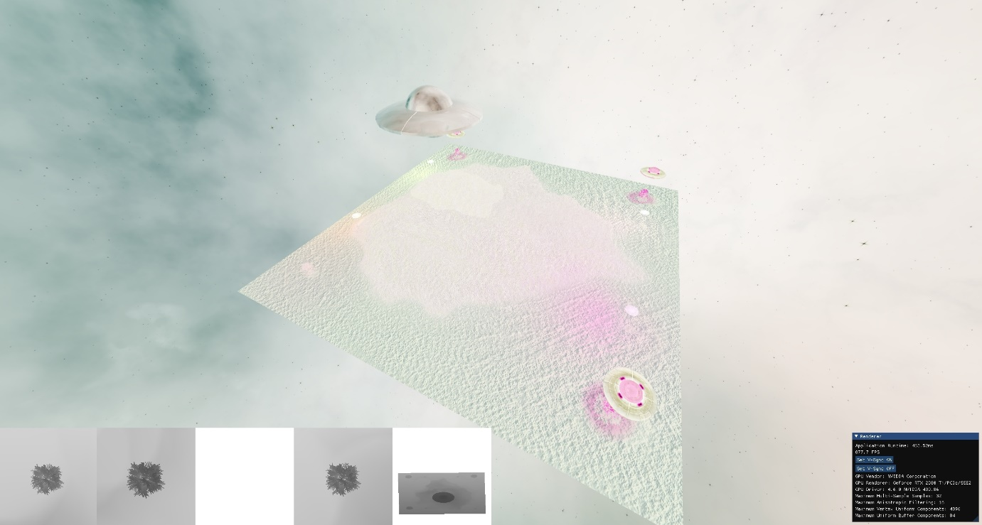 **Grayscale** – 2 Key

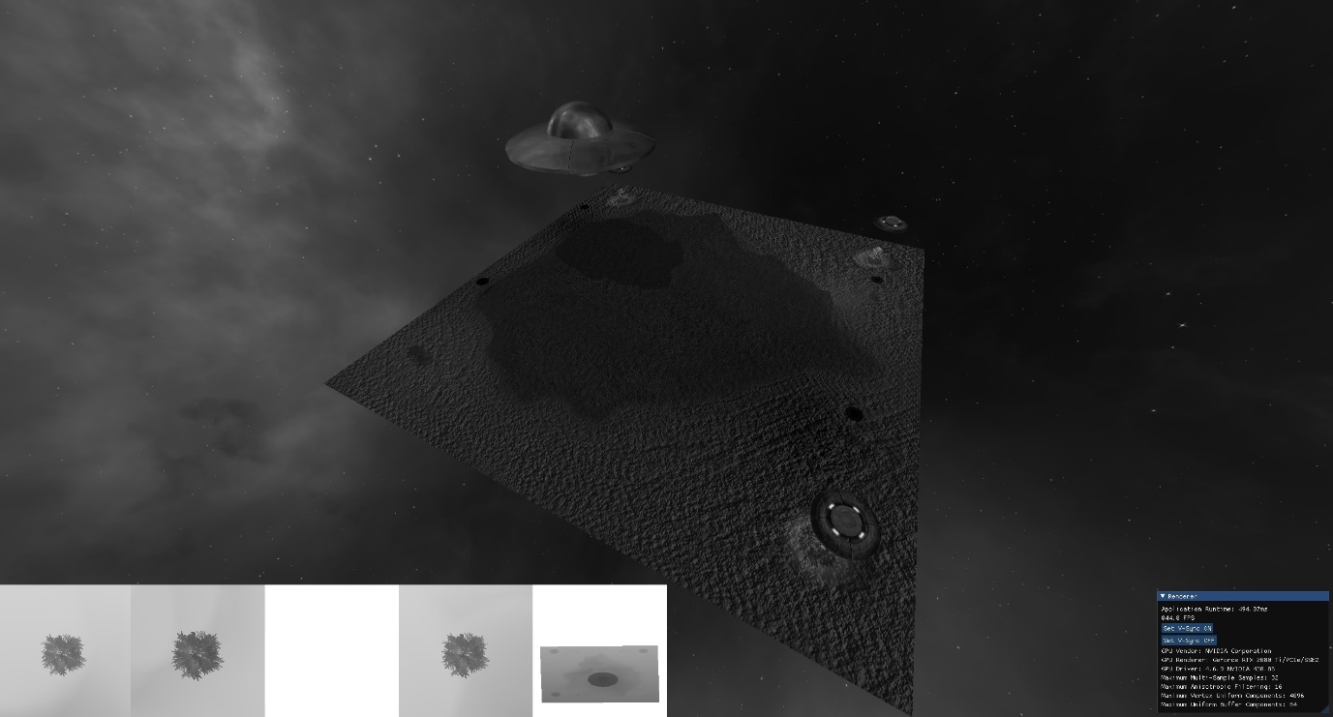

**Color sharpening** – 3 key

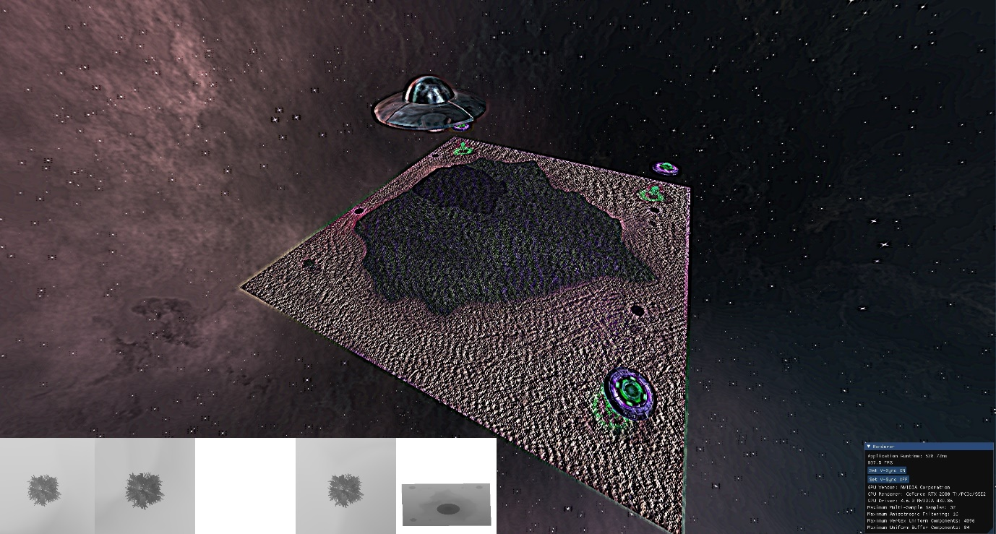

**Blurring** – 4 key

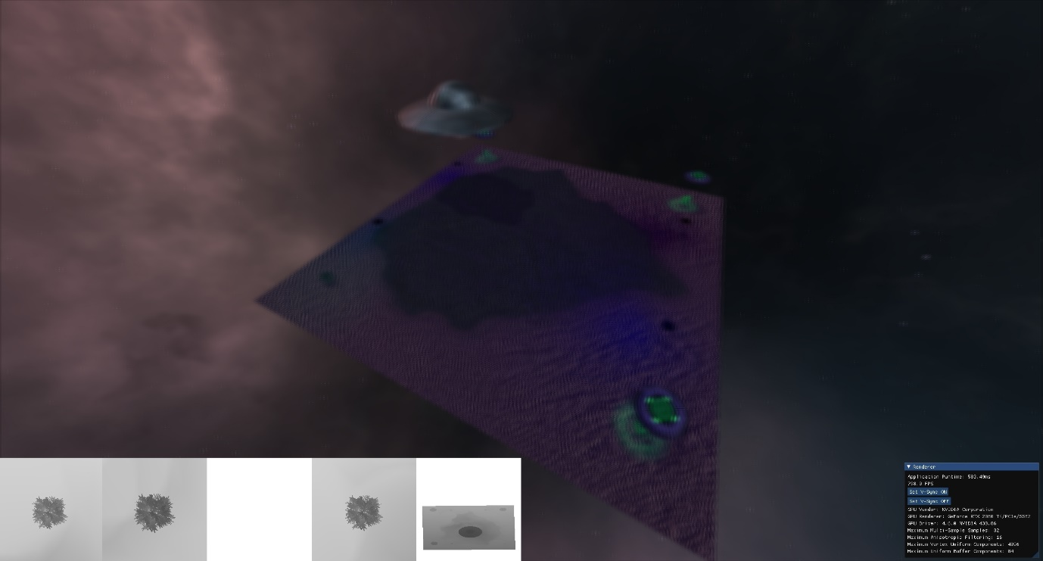

**Edge detection** – 5 key

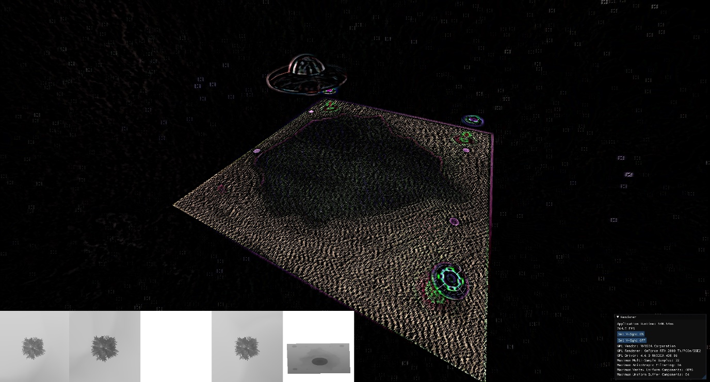

**Multiple Lighting Calculations and multiple shadow maps:** Point Lights, Spotlights (multiple shadowmaps, 1 for each spotlight), Directional Light (orthographic shadowmap, as can be seen on the far most right of the debug panel)

Below is an image of the **multiple point lights and spot lights**, as you can see, the point lights change their color over time, and the spot lights produce additional shadows onto the trees below them (using **multiple shadow maps**), it can be seen in the **debug view on the bottom left** (multiple scenes on screen simultaneously) what the normalized shadow maps are outputting.

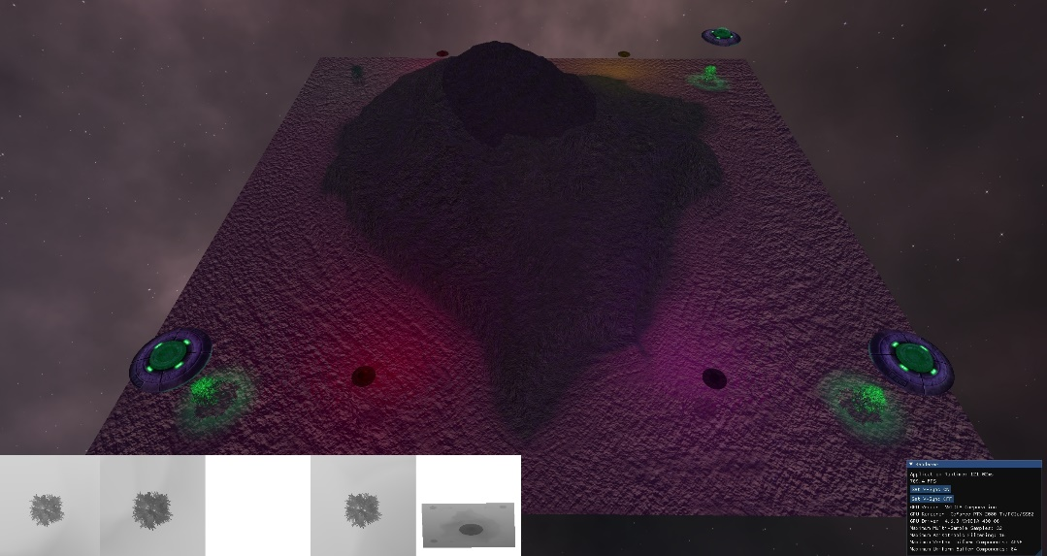

Below are two images of the tree growing over time, and the shadow from the spot light changing respectively.

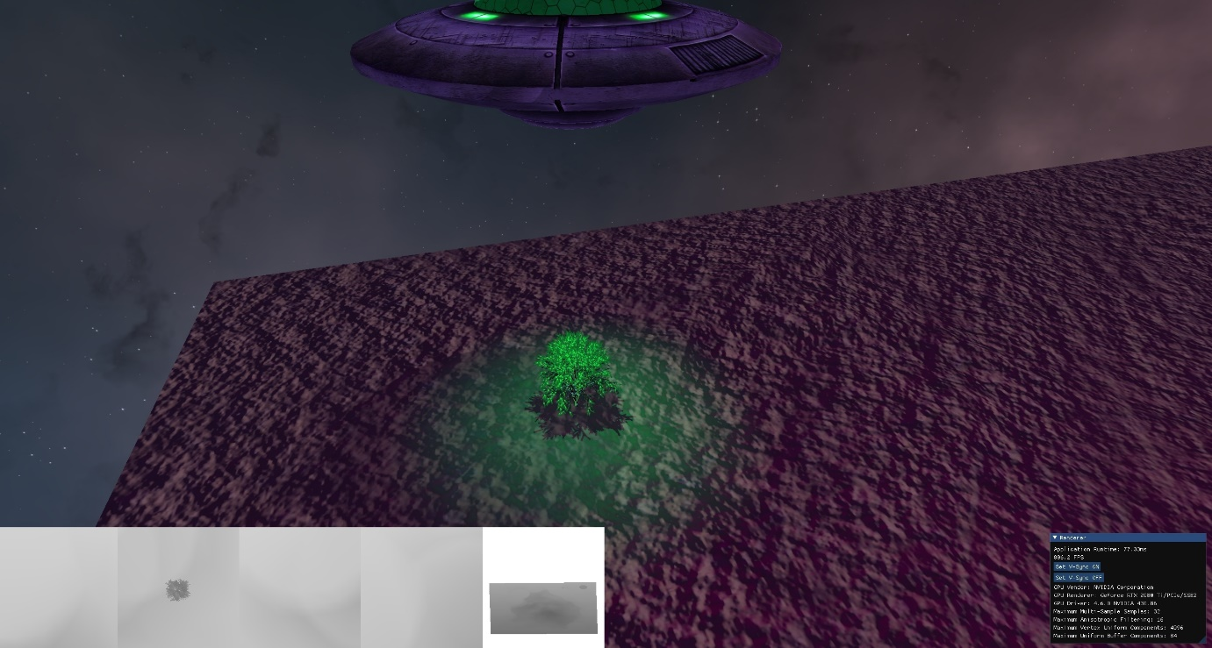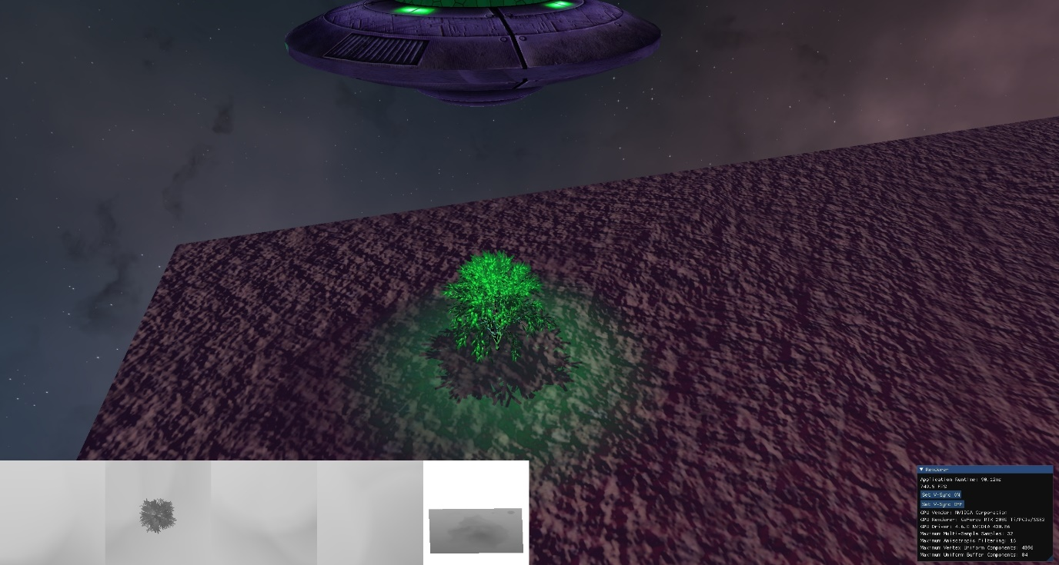

Below is a zoomed in image of the shadow viewports, as you can see the depth of the shadow maps are normalized and were thus very useful in debugging shadows in these scenes.

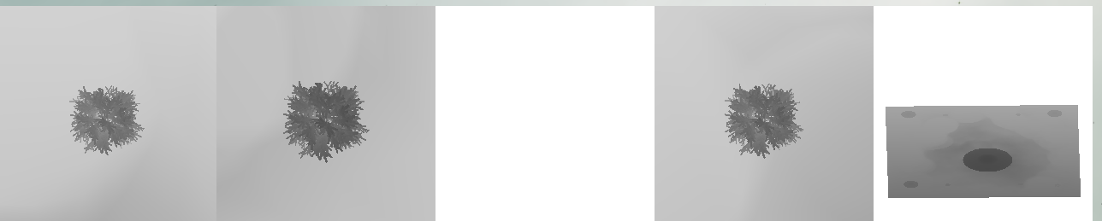

# Camera Keys

**Escape** – Exits the camera track and allows free movement

**F1** – Starts the camera track, note however that the camera track is best viewed from the start of the program, as the animation sequence of the objects was developed to work within the initial startup boundaries of the program (i.e the timing is best seen from the start).

In order to **move around freely** after pressing escape, **you must hold the right click on the mouse**, and use the **WASD keys** as well as the **Q and E keys** to **move up or down**. You can use **the scroll wheel** of the mouse to **zoom in and out**.