**MSSV** : 21068021

**Họ và Tên** : Phan Nguyễn Khôi Nguyên

**Ca TH** : Thứ 7 tiết 10-12

**BÀI LÀM**

**Hình chụp bài làm :**

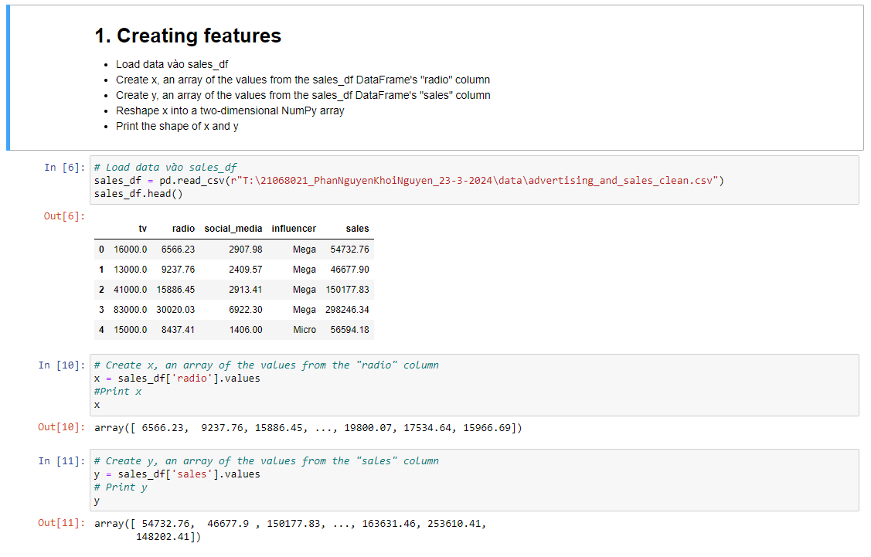

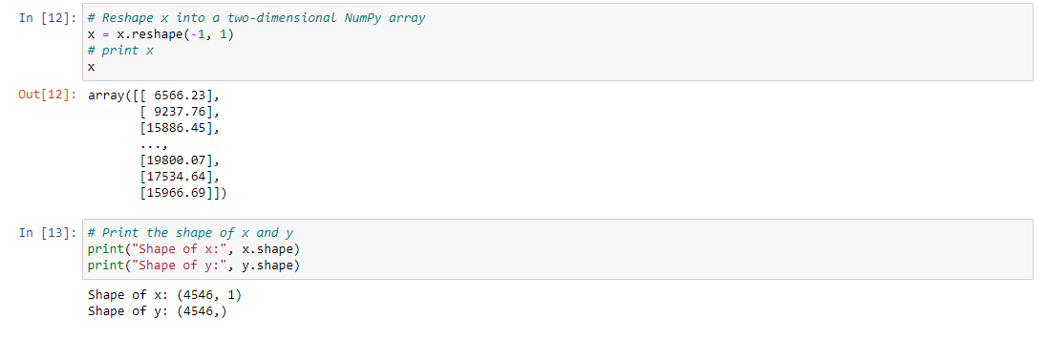

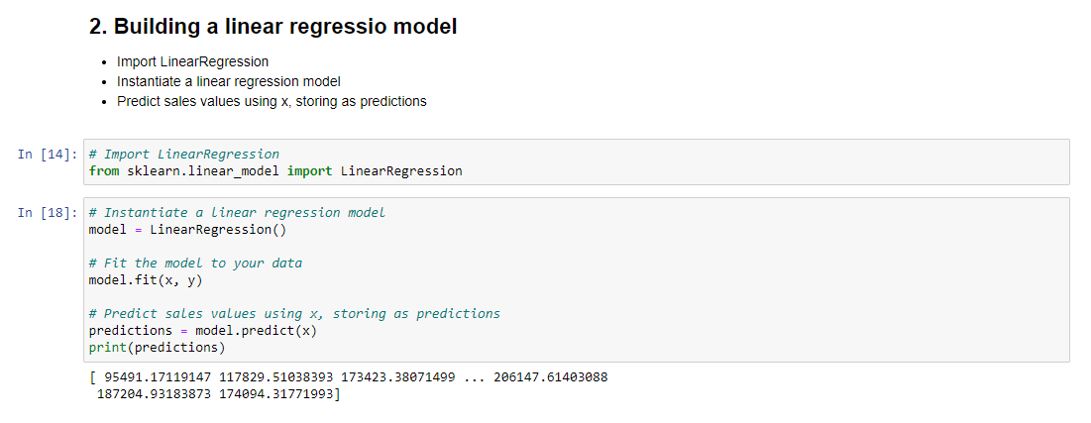

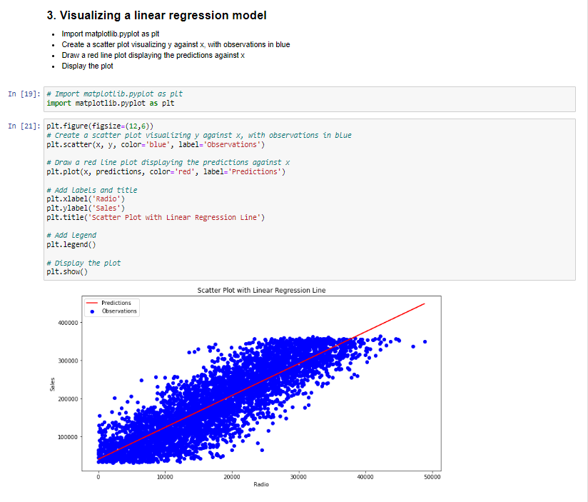

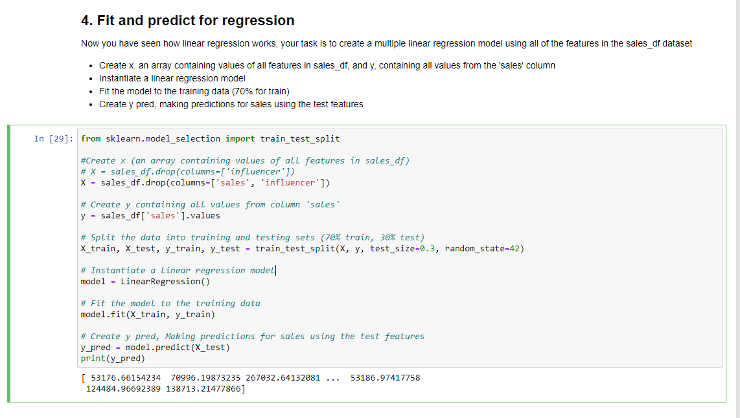

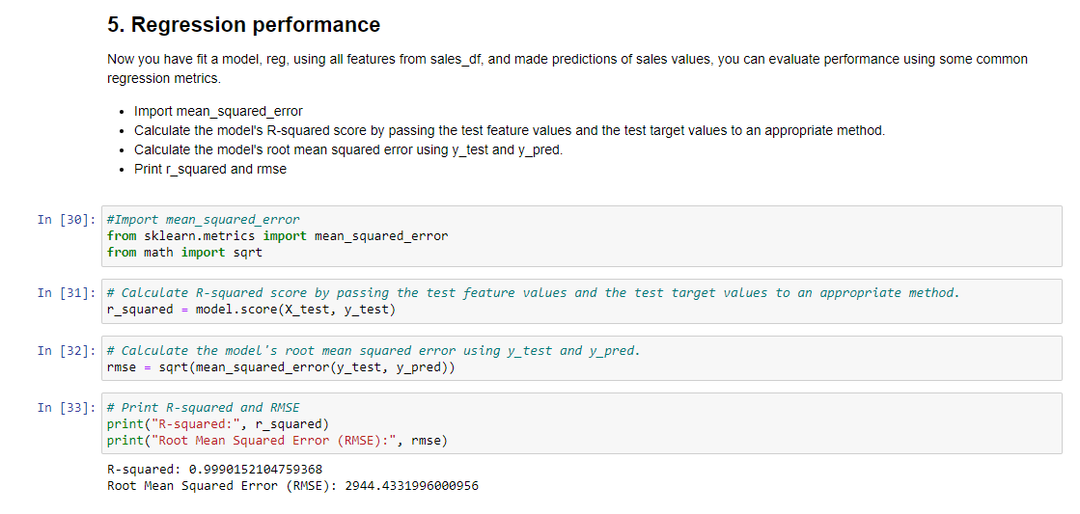

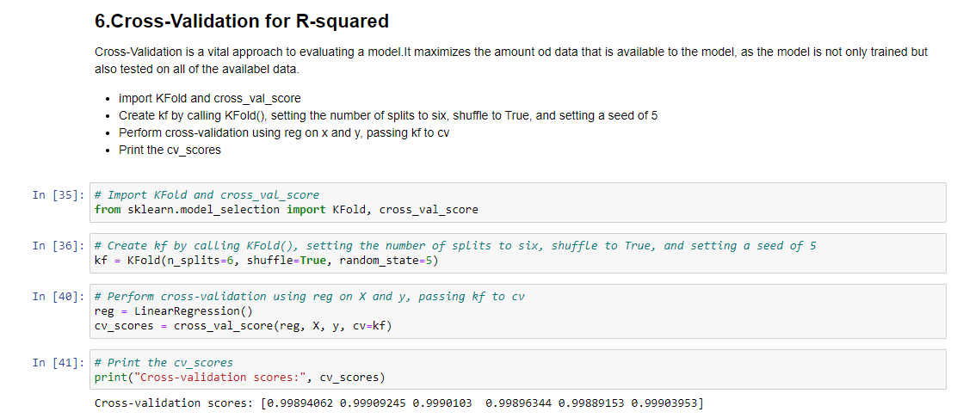

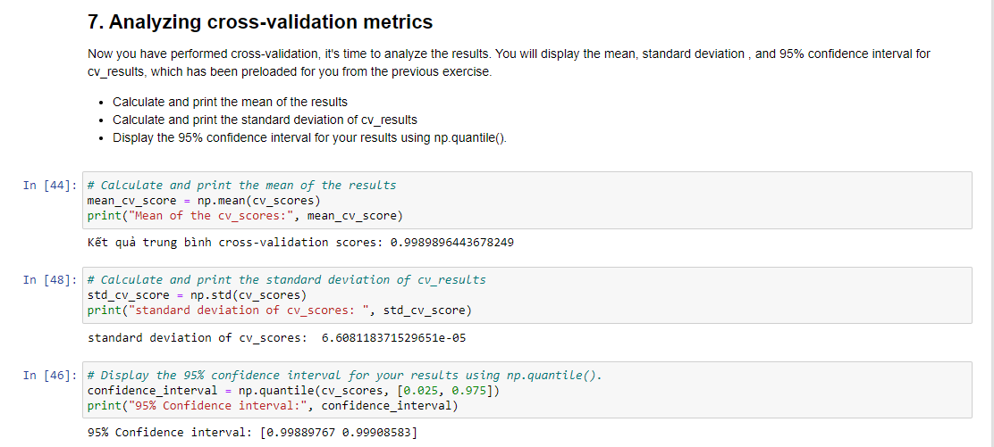

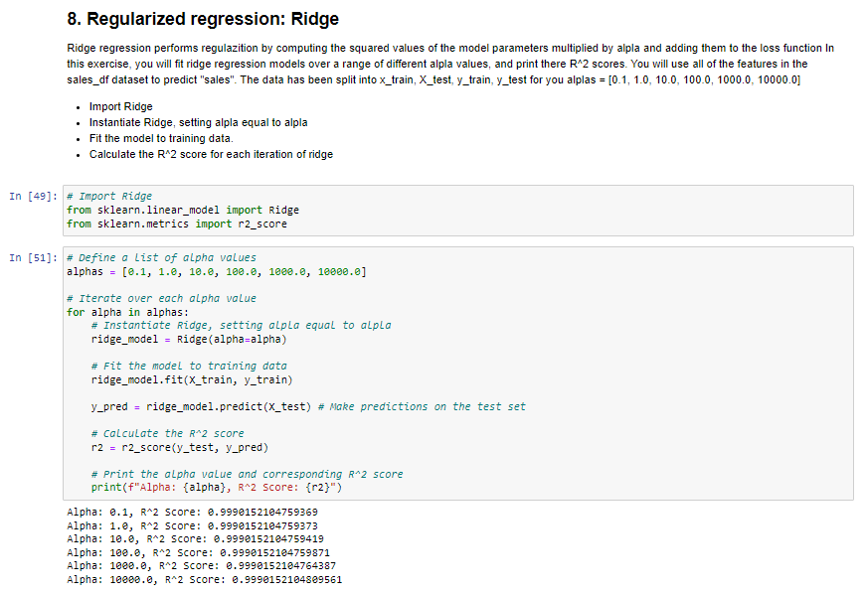

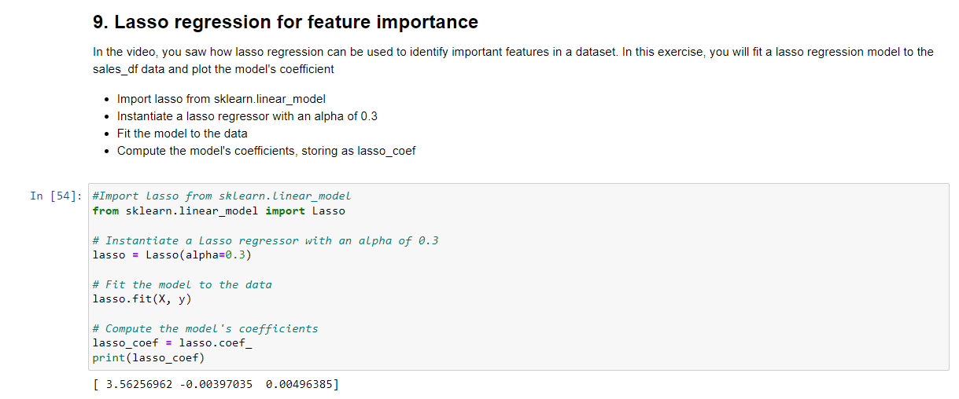

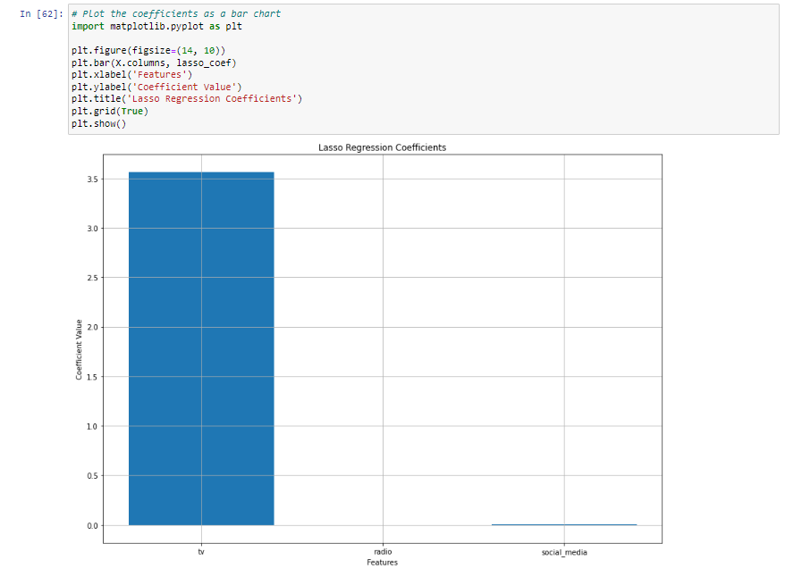

**Code bài làm:**

**Bài 1:**

|  |
| --- |
| # Load data vào sales_df  sales_df = pd.read_csv(r"T:\21068021_PhanNguyenKhoiNguyen_23-3-2024\data\advertising_and_sales_clean.csv")  sales_df.head()  # Create x, an array of the values from the "radio" column  x = sales_df['radio'].values  #Print x  X  # Create y, an array of the values from the "sales" column  y = sales_df['sales'].values  # Print y  Y  # Reshape x into a two-dimensional NumPy array  x = x.reshape(-1, 1)  # print x  X  # Print the shape of x and y  print("Shape of x:", x.shape)  print("Shape of y:", y.shape) |

**Bài 2:**

|  |
| --- |
| # Import LinearRegression  from sklearn.linear_model import LinearRegression  # Instantiate a linear regression model  model = LinearRegression()  # Fit the model to your data  model.fit(x, y)  # Predict sales values using x, storing as predictions  predictions = model.predict(x)  print(predictions) |

**Bài 3:**

|  |
| --- |
| # Import matplotlib.pyplot as plt  import matplotlib.pyplot as plt  plt.figure(figsize=(12,6))  # Create a scatter plot visualizing y against x, with observations in blue  plt.scatter(x, y, color='blue', label='Observations')  # Draw a red line plot displaying the predictions against x  plt.plot(x, predictions, color='red', label='Predictions')  plt.xlabel('Radio')  plt.ylabel('Sales')  plt.title('Scatter Plot with Linear Regression Line')  plt.legend()  # Display the plot  plt.show() |

**Bài 4:**

|  |
| --- |
| from sklearn.model_selection import train_test_split  #Create x (an array containing values of all features in sales_df)  # X = sales_df.drop(columns=['influencer'])  X = sales_df.drop(columns=['sales', 'influencer'])  # Create y containing all values from column 'sales'  y = sales_df['sales'].values  # Split the data into training and testing sets (70% train, 30% test)  X_train, X_test, y_train, y_test = train_test_split(X, y, test_size=0.3, random_state=42)  # Instantiate a linear regression model  model = LinearRegression()  # Fit the model to the training data  model.fit(X_train, y_train)  # Create y pred, Making predictions for sales using the test features  y_pred = model.predict(X_test)  print(y_pred) |

**Bài 5:**

|  |
| --- |
| #Import mean_squared_error  from sklearn.metrics import mean_squared_error  from math import sqrt  # Calculate R-squared score by passing the test feature values and the test target values to an appropriate method.  r_squared = model.score(X_test, y_test)  # Calculate the model's root mean squared error using y_test and y_pred.  rmse = sqrt(mean_squared_error(y_test, y_pred))  # Print R-squared and RMSE  print("R-squared:", r_squared)  print("Root Mean Squared Error (RMSE):", rmse) |

**Bài 6:**

|  |
| --- |
| # Import KFold and cross_val_score  from sklearn.model_selection import KFold, cross_val_score  # Create kf by calling KFold(), setting the number of splits to six, shuffle to True, and setting a seed of 5  kf = KFold(n_splits=6, shuffle=True, random_state=5)  # Perform cross-validation using reg on X and y, passing kf to cv  reg = LinearRegression()  cv_scores = cross_val_score(reg, X, y, cv=kf)  # Print the cv_scores  print("Cross-validation scores:", cv_scores) |

**Bài 7:**

|  |
| --- |
| # Calculate and print the mean of the results  mean_cv_score = np.mean(cv_scores)  print("Mean of the cv_scores:", mean_cv_score)  # Calculate and print the standard deviation of cv_results  std_cv_score = np.std(cv_scores)  print("Standard deviation of cv_scores: ", std_cv_score)  # Display the 95% confidence interval for your results using np.quantile().  confidence_interval = np.quantile(cv_scores, [0.025, 0.975])  print("95% Confidence interval:", confidence_interval) |

**Bài 8:**

|  |
| --- |
| # Import Ridge  from sklearn.linear_model import Ridge  from sklearn.metrics import r2_score  # Define a list of alpha values  alphas = [0.1, 1.0, 10.0, 100.0, 1000.0, 10000.0]  # Iterate over each alpha value  for alpha in alphas:  # Instantiate Ridge, setting alpla equal to alpla  ridge_model = Ridge(alpha=alpha)    # Fit the model to training data  ridge_model.fit(X_train, y_train)  y_pred = ridge_model.predict(X_test) # Make predictions on the test set    # Calculate the R^2 score  r2 = r2_score(y_test, y_pred)    # Print the alpha value and corresponding R^2 score  print(f"Alpha: {alpha}, R^2 Score: {r2}") |

**Bài 9:**

|  |
| --- |
| #Import lasso from sklearn.linear_model  from sklearn.linear_model import Lasso  # Instantiate a Lasso regressor with an alpha of 0.3  lasso = Lasso(alpha=0.3)  # Fit the model to the data  lasso.fit(X, y)  # Compute the model's coefficients  lasso_coef = lasso.coef_  print(lasso_coef)  # Plot the coefficients as a bar chart  import matplotlib.pyplot as plt  plt.figure(figsize=(14, 10))  plt.bar(X.columns, lasso_coef)  plt.xlabel('Features')  plt.ylabel('Coefficient Value')  plt.title('Lasso Regression Coefficients')  plt.grid(True)  plt.show() |