Homework 1

The gradient descent process was terminated by the number of iterations. I used 100000, 200000, and 500000 iterations. When 100000 iterations were used, the value for b was 49.71549965667737. When 200000 was used the value for b was 53.68318555572463. For 500000 the value for b was 54.8675311535231. When these iterations were tested the learning rate was kept constant at 0.000001. When the learning rate is changed it greatly affects the graph. If the learning rate is too high or too low the graph can end with an undefined line that runs up and down or a regression line that ends very early.

Figure 1 100000 iterations lr 0.000001

Figure 2 200000 iterations lr 0.000001

Figure 3 500000 iterations lr 0.000001

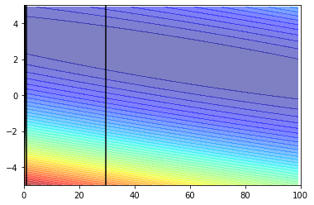

Figure 4 100000 iterations lr 0.00001

Figure 5 100000 iterations learning rate 0.0000001



Figure 6 iterations 100000 lr 0.000025