NOTE: For this test, you will be adding content to your **existing** RecordStoreSolution project.

Be sure you have saved a copy of the first test on GitHub and/or on your flash drive and/or on your desktop, **but work with the original**.

For this test, you will want to use one or more of the following resources:

1. [Tutorial: Implement CRUD Functionality with the Entity Framework in ASP.NET MVC](https://docs.microsoft.com/en-us/aspnet/mvc/overview/getting-started/getting-started-with-ef-using-mvc/implementing-basic-crud-functionality-with-the-entity-framework-in-asp-net-mvc-application#update-httppost-edit-method)
2. [Tutorial: Add sorting, filtering, and paging with the Entity Framework in an ASP.NET MVC application](https://docs.microsoft.com/en-us/aspnet/mvc/overview/getting-started/getting-started-with-ef-using-mvc/sorting-filtering-and-paging-with-the-entity-framework-in-an-asp-net-mvc-application)
3. Your Textbook, i.e.: [Pro ASP.NET MVC 5](http://enos.itcollege.ee/~ijogi/Nooks/Pro%20ASP.NET%20MVC%205/Pro%20ASP.NET%20MVC%205.9781430265290.pdf)
4. If/as necessary, fix any mistakes from the last test. – **0 points**

**NOTE: For #0 above, I will look at this when grading this test. If you had anything wrong in the first test, please fix it!**

1. Using Tutorial Listing a) above (the **Create a Details Page** section near the beginning of the tutorial), modify the details.cshtml of your Artist view to show all albums by the associated Artist (see below), followed by a count of how many albums Mynyl Vynyl has by that artist. HINT: For the last part of this question, I looked at URL: <https://stackoverflow.com/questions/6601715/how-to-declare-a-local-variable-in-razor> for *guidance.* You can add the code to do this in the View file and you do **not** need a query to do this. **– 25 points total**

**Shown below is a screen shot from my application, showing the details and the album count for the Artist Metallica.**

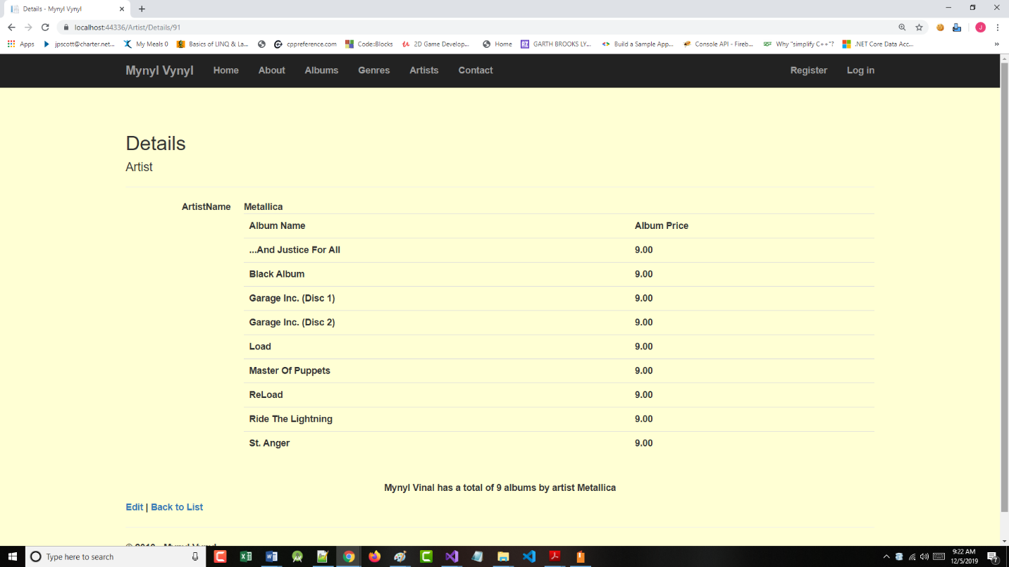

1. Using Tutorial Listing b) above (the **Add Column Sort Links** section near the beginning of the tutorial), add a column sort link to the Album Name field of the AlbumController. I believe that the price for each album is $9.00, so sorting on that field is “senseless”. Allow sorting in ascending or descending directions. **– 25 points**

**Shown below is a partial screen shot from my application, showing the Artist Name in descending order.**

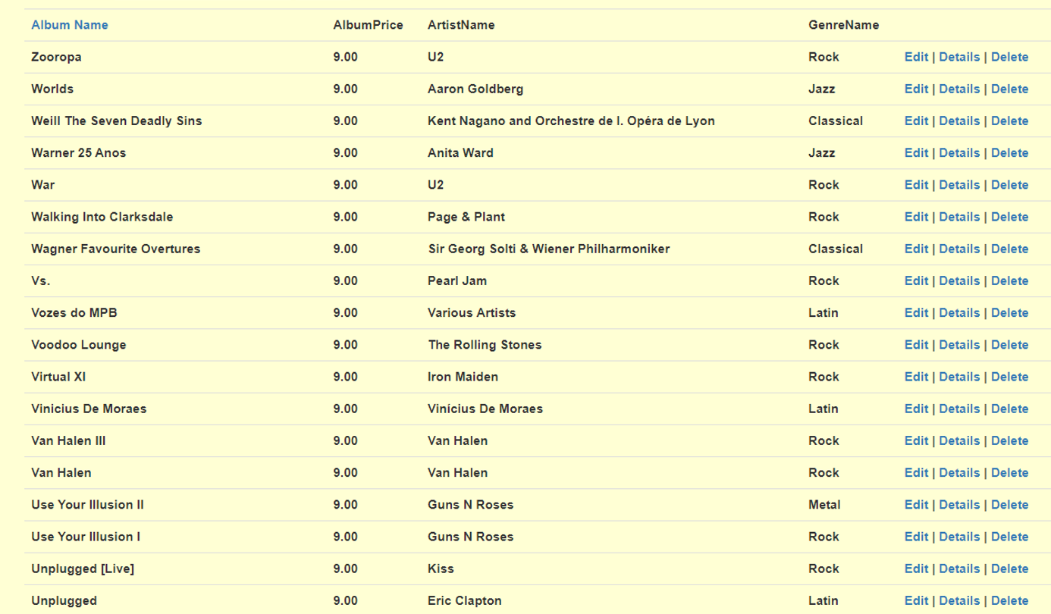

1. Using Tutorial Listing b) above (the Add a Search Box section), add a search box to the albums page to allow the user to search by genre. – **25 points**

**Shown below is a screen shot from my application, showing a search by Jazz Genre.**

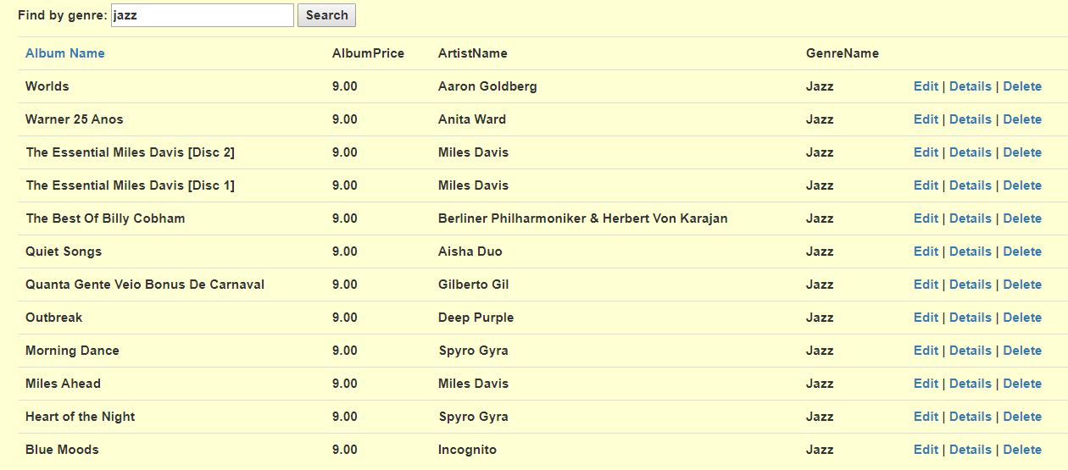

1. Using the **Adding Pagination** section on Pages 178 – 190 of your text (recommended) or Tutorial Listing the **Add Paging** section) above as a guide, add paging to the Album index view. Use Bootstrap to make this look professional. There should be a minimum of 3 albums and a maximum of 5 albums per page. See below, and sorry for the “old” example – **25 points**

NOTE: The following link may help here as well:

[Paging, Searching And Sorting In ASP.NET MVC 5](https://www.c-sharpcorner.com/UploadFile/4b0136/perform-paging-searching-sorting-in-Asp-Net-mvc-5/)

