

Program No
Roll No
Topic | Sorting
Title of Program | Bubble, Selection, Insertion, Shell, Radix
Objective

Source Code: 1) Bubble sort

/*
Name : Yash Ishan Gohil
Roll NO: 1313
Unit: Sorting
Program:Bubble Sort
*/

#include<iostream>

using namespace std;

int main()
{

int a[20], n;
int i,j,temp;

cout<<"****Bubble sort****"<<endl<<endl;

//get the size of array
cout<<"Enter the size of array : ";
cin>>n;

cout<<"Enter the values in the array : "<< endl;
for(i=0; i<n; i++)
{
cin>>a[i];
}//end of for i

//Bubble sort
for(i=0; i<n; i++)
{
for(j = i+1; j<n; j++)
{
if(a[i] > a[j])
{
temp =a[i];
a[i] =a[j];
a[j] = temp;
}//End of if
} //end j

}//end for i

//display the sorted array
cout<< endl;
cout<<"Sorted array : "<<endl;
for(i= 0; i<n; i++)
{
cout<<a[i]<<endl;
}
}//end main

Output:
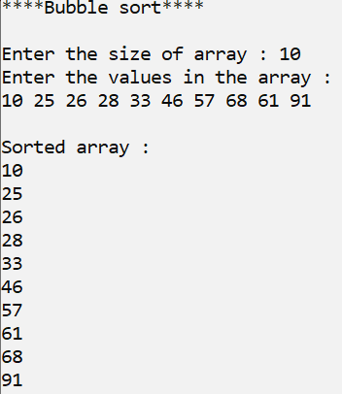

Source Code: 2) Selection Sort

/* Name: Yash Ishan Gohil
Roll No: 1313
Unit 1: Sorting
Program: selection Sort */

#include<iostream>
using namespace std;
int main()
{
int n, arr[20];
int i, j, min, tmp, loc;

cout<<"*** Selection Sort***"<< endl<< endl;

cout<< "Enter the size of array: ";
cin>> n;

cout<< "Enter the elements of the array: "<<endl;
for(i=0 ; i<n ; i++)
{
cin>> arr[i];
}

//Selection Sort
for(i=0 ; i<n ; i++)
{
min = arr[i];
loc = i;

for(j=i+1; j<n; j++)
{
if(arr[j] < min)
{

min + arr[j];
loc = j;

}

}//end of loop j
//found the smallest value and its loc at min and loc
//swap

tmp = arr[i];
arr[i] = arr[loc];
arr[loc] = tmp;
}//end of loop i

//Display
cout<<"Sorted Array: ";
for(i=0 ; i<n ; i++)
{
cout<<arr[i]<<" ";
}

}//end of main

Output:

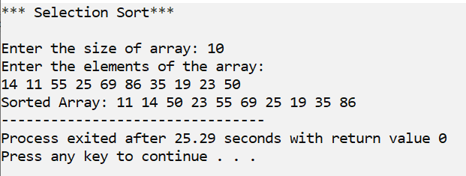

Source Code: 3) Insertion Sort

/* Name: Yash Ishan Gohil
Roll No: 1313
Unit 1: Sorting
Program: Insertion Sort */

#include<iostream>
using namespace std;
int main()
{
int n, arr[20];
int i, temp, loc;

cout << "*** Insertion Sort***\n\n";

cin>> n;

cout<< "Enter the elements of the array:" << endl;

for(i=0 ; i<n ; i++)
{
cin >> arr[i];
}

//Insertion sort
for(i=1 ; i<n ; i++)
{
temp = arr[i];
loc = i-1;

while(temp<arr[loc] && loc>=0)
{
arr[loc+1] = arr[loc];
loc = loc-1;
}

arr[loc+1] = temp;
}

cout << endl << endl << "Sorted array: ";
for(i=0 ; i<n ; i++)
{
cout << arr[i] << " ";
}

}//end of main

Output:

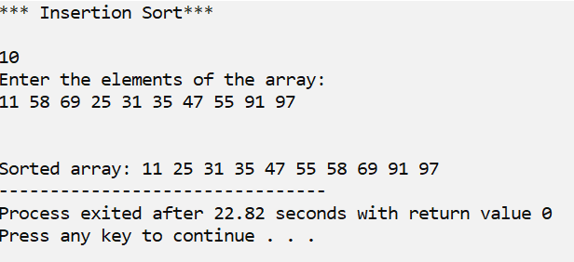

Source Code: 4) Shell Sort

/* Name : Yash Ishan Gohil
Roll No : 1323
UNIT 1 : Sorting
PROGRAM : Shell Sorting
*/
#include<iostream>
#include<math.h>
using namespace std;

int main()
{
int n, arr[20], i;
int gap,loc, extractData;
cout<< " *** Shell Sort *** " <<endl << endl;

cout<< "Enter the elements of the array: "<<endl;
cin >> n;

cout<<"Enter the elements of the array :"<<endl;
for(i=0; i<n; i++)
{
cin>>arr[i];

}
gap = floor(n/2);

while(gap>0)
{
for(i=0; i<n-gap; i++)
{
extractData = arr[i+gap];
loc = i + gap;

while((loc-gap)>=0 && extractData < arr[loc-gap])
{
arr[loc] = arr[loc-gap];
loc = loc-gap;
}
arr[loc]= extractData;
}//end of for i
gap = floor(gap/2);
}//end of While

cout<<endl<<endl<<"Sorted array :";
for(i=0; i<n; i++)
{
cout<<arr[i]<<" ";
}
}// end of for main

Output:

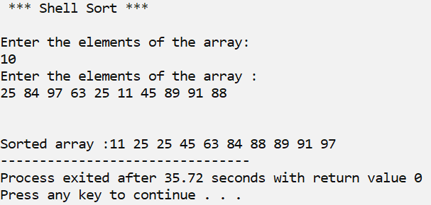

Source Code: 5) Radix Sort

/* Name : Yash Ishan Gohil
Roll No : 1323
UNIT 1 : Sorting
PROGRAM : Radix Sorting
*/
#include<iostream>

using namespace std;

int main()
{
int i,n,arr[20];
int passes=0;
int max;
int bucket[10][20], b_count[10];
int j,k,r,x;

int gap,loc, extractData;
cout<< " *** Radix Sort *** " <<endl << endl;

cout<< "Enter the elements of the array: "<<endl;
cin >> n;

cout<<"Enter the elements of the array :"<<endl;
for(i=0; i<n; i++)
{
cin>>arr[i];

}
//Identify max number in the array
max= arr[0];
for (i=0; i<n; i++)
{
if(arr[i] > max)
{
max= arr[i];
}
}

// count the number of digits in max - define the # of passes
while(max > 0 )
{
passes++;
max=max/10;
}

//radix sort
int divisor =1;
for(x=1 ; x<=passes ; x++)
{
//initialize the b_count
for(k=0; k<10; k++)
{
b_count[k] = 0;
}

//2.chek digit and place in bin, upadate b_count
for(i=0; i<n; i++)
{
r= (arr[i]/divisor) % 10;
bucket[r][b_count[r]]= arr[i];
b_count[r]++;
}

//3. collect the bins
i=0;
for(k=0; k<10; k++)
{
for(j=0; j<b_count[k]; j++)
{
arr[i] = bucket[k][j];
i++;
}//end of for j

}//end of for k

divisor = divisor*10;
}//end of for x

cout<<endl<<endl<<"Sorted array :";
for(i=0; i<n; i++)
{
cout<<arr[i]<<" ";
}
}

Output:

