    Program No | 5,6
Roll No | 1313
Topic | Searching
Title of Program | Linear Search and Binary Search
Objective
Source Code: 1) Linear Search

/* Name: Yash Ishan Gohil
Roll no: 1313
unit 2: Searching
Program: Linear/ Sequential Search */

#include<iostream>

using namespace std;

int main()
{
int n, arr[20], key;
int i, flag=0;

cout << "*** Linear Search ***" << endl <<endl;

cout <<"enter the size of the array: ";
cin>>n;

cout <<"enter the elements: " <<endl;
for(i=0; i<n; i++)
{
cin >> arr[i];
}

cout << "enter the target value: ";
cin >> key;

for(i=0; i<n; i++)
{
if(arr[i] == key)
{
flag =1;
break;
}
}//end of for i
if(flag == 1)
{
cout << "target value "<<key<<"is found at index "<<i;

}
else
{
cout << "target value is not found";
}
} //end of main
Output: I) Successful

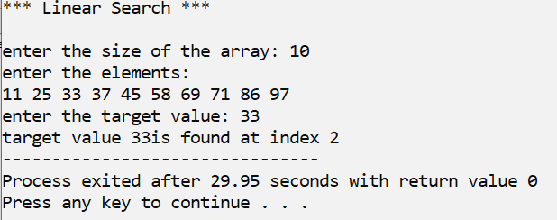
  - Unsuccessful

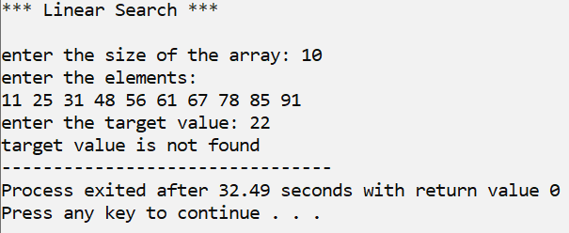

Source Code: 2) Binary Search

/* Name: Yash Ishan Gohil
Roll NO: 1313
Unit 2 : Searching
Program : Binary Search*/

#include<iostream>

using namespace std;

int main()
{
int n, arr[20], key;
int i;
int first, last, mid, flag=0;

cout<< "*** Binary Search ***" << endl << endl ;

cout <<"Enter the size of array :";
cin>> n;

cout<< "Enter the elements: " << endl;

for(i=0 ; i<n ; i++ )

{
cin >> arr[i];
}

cout << "Enter the key :";
cin >> key;

first = 0;
last = n-1;

while(first <= last)
{
mid = (first+last)/2;

if(key < arr[mid])
{
last = mid-1;
}
else if (key > arr[mid])
{
first = mid+1;
}
else // Key is found
{
flag=1;
break;
}
}//end of while

if(flag==1)
{
cout << "Key" << key << " is found at index " << mid;

}
else
{
cout << "Key" << key << "is not found ";
}
}

Output: I) Successful

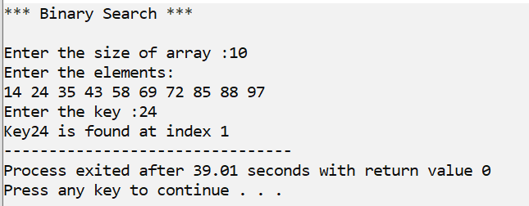
  - Unsucessful

