Program No | 8
Roll No | 1308
Unit | 2
Title | Hashing
Program | Modulo Division with Linear Probe

Source Code:
/*
Name: Manish Chilwal
Roll No.: 1308
Unit 2 : Hashing
Program: Modulo Division with Linear Probe
*/

#include<iostream>
#include<conio.h>

#define MAX 10
#define EMPTY -1

using namespace std;

/* 1. Node Template */

/* 2. Template of Hash Table */
class Hash
{
int h[MAX];

public:
Hash()
{
int i;

for(i=0;i<MAX;i++)
{
h[i] = EMPTY;
}
}
void Insert(int key);
void Display();
void Search(int skey);
};
/* 3. Funcion */
void Hash::Insert(int key)
{
int addr = key % MAX; //Modulo Division calculation-HASH FUNCTION
int oaddr = addr;

if(h[addr] == EMPTY) // addr is available
{
h[addr] = key;
cout << key << " is inserted at address " << addr << endl;
}
else // Collision!
{
do
{
addr=(addr+1)%MAX;
if(addr == oaddr)
{
cout << "Hash Table Full";
return;
}
}
while(h[addr] != EMPTY);

h[addr] = key;
cout << key << " is inserted at address " << addr << endl;
}
}

void Hash::Display()
{
int i;
for(i = 0;i<MAX;i++)
{
cout << "h[" << i << "] = " << h[i] << endl;
}
}

void Hash::Search(int skey)
{
int saddr = skey % MAX; // HASH FUNCTION
int oaddr = saddr; // ORIGINAL ADDRESS
if(h[saddr] == skey)
{
cout << "Value " << skey << " is found at " << saddr;
}
else
{
do
{
saddr = (saddr + 1)%MAX;
if(saddr == oaddr)
{
break;
}
}
while(h[saddr] != skey);

if(h[saddr] == skey)
{
cout << "Value " << skey << " is found at " << saddr;
}
else
{
cout << "Value " << skey << " is not found";
}
}

}
/* 4. Menu */
int main()
{
int ch, num;
Hash h;
while(1)
{
system("cls");
cout << "*** Hashing using Modulo Division & Linear Probe ***" << endl << endl;

cout << "1. Insert a value in the Hash Table" << endl;
cout << "2. Display the Hash Table" << endl;
cout << "3. Search the Hash Table" << endl;
cout << "4. Exit " << endl;

cout << "Enter a choice: ";
cin >> ch;

switch(ch)
{
case 1:
cout << "Enter a value: ";
cin >> num;
h.Insert(num);

getch();
break;
case 2:
h.Display();

getch();
break;
case 3:
cout << "Enter a value: ";
cin >> num;
h.Search(num);

getch();
break;
case 4:
exit(1);
default:
cout << "Please Enter a valid choice ;)";

getch();
break;
}//end of switch
}//end of while
}//end of main
Output:
Insert value:
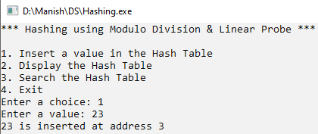
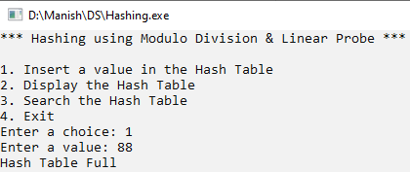
Display HashTable:
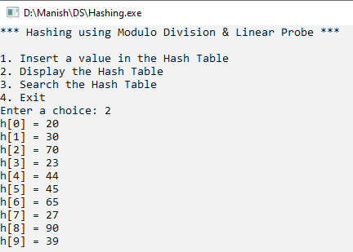
Search:
Successful:
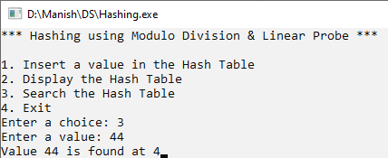
Unsuccessful:
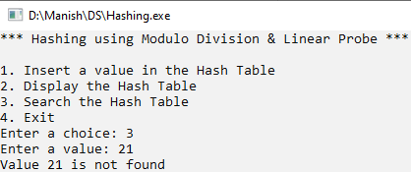

Program No | 8
Roll No | 1308
Unit | 2
Title | Hashing
Program | Digit Extraction with Linear Probe

Source Code:
/*
Name: Manish Chilwal
Roll No.: 1308
Unit 2 : Hashing
Program: Digit Extraction with Linear Probe
*/

#include<iostream>
#include<conio.h>

#define MAX 10
#define EMPTY -1

using namespace std;

/* 1. Node Template */

/* 2. Template of Hash Table */
class Hash
{
int h[MAX];

public:
Hash()
{
int i;

for(i=0;i<MAX;i++)
{
h[i] = EMPTY;
}
}
void Insert(int key);
void Display();
void Search(int skey);
};
/* 3. Funcion */
void Hash::Insert(int key)
{
int a[6];
int i,r,max=key,d=0;
while(max>0)
{
d++;
max /=10;

}
if(d > 6)
{
cout << "Enter a key less then 6 digit in size: ";
return;
}
int nkey = key;
for(i = 5;i>=0;i--)
{
r = nkey % 10;
nkey = nkey/10;
a[i] = r;
}

int addr = a[4]; //Digit Extraction calculation-HASH FUNCTION
int oaddr = addr;

if(h[addr] == EMPTY) // addr is available
{
h[addr] = key;
cout << key << " is inserted at address " << addr << endl;
}
else // Collision!
{
do
{
addr=(addr+1)%MAX;
if(addr == oaddr)
{
cout << "Hash Table Full";
return;
}
}
while(h[addr] != EMPTY);

h[addr] = key;
cout << key << " is inserted at address " << addr << endl;
}
}

void Hash::Display()
{
int i;
for(i = 0;i<MAX;i++)
{
cout << "h[" << i << "] = " << h[i] << endl;
}
}

void Hash::Search(int skey)
{

int a[6];
int i,r;
int nkey = skey;
for(i = 5;i>=0;i--)
{
r = nkey % 10;
nkey = nkey/10;
a[i] = r;
}
int saddr = a[4]; // HASH FUNCTION
int oaddr = saddr; // ORIGINAL ADDRESS
if(h[saddr] == skey)
{
cout << "Value " << skey << " is found at " << saddr;
}
else
{
do
{
saddr = (saddr + 1)%MAX;
if(saddr == oaddr)
{
break;
}
}
while(h[saddr] != skey);

if(h[saddr] == skey)
{
cout << "Value " << skey << " is found at " << saddr;
}
else
{
cout << "Value " << skey << " is not found";
}
}

}
/* 4. Menu */
int main()
{
int ch, num;
Hash h;
while(1)
{
system("cls");
cout << "*** Hashing using Digiit extraction & Linear Probe ***" << endl << endl;

cout << "1. Insert a value in the Hash Table" << endl;
cout << "2. Display the Hash Table" << endl;
cout << "3. Search the Hash Table" << endl;
cout << "4. Exit " << endl;

cout << "Enter a choice: ";
cin >> ch;

switch(ch)
{
case 1:
cout << "Enter a value: ";
cin >> num;
h.Insert(num);

getch();
break;
case 2:
h.Display();

getch();
break;
case 3:
cout << "Enter a value: ";
cin >> num;
h.Search(num);

getch();
break;
case 4:
exit(1);
default:
cout << "Please Enter a valid choice ;)";

getch();
break;
}//end of switch
}//end of while
}//end of main
Output:
Insert value:
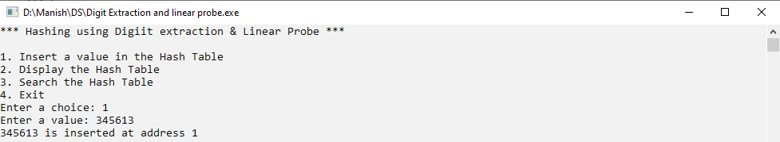
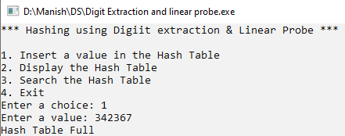
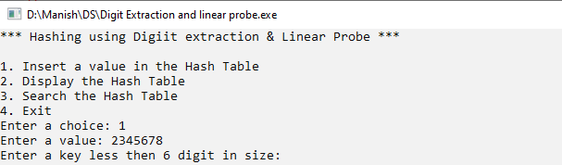
Display HashTable:
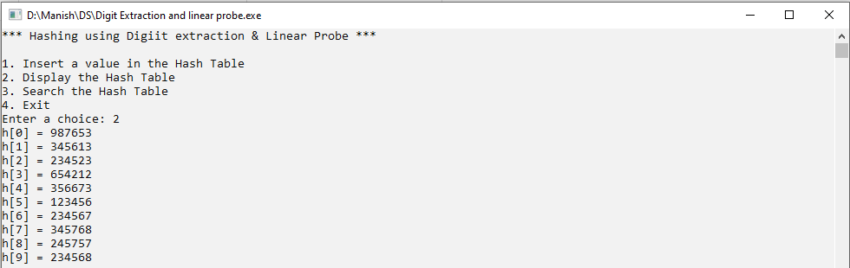
Search:
Successful:
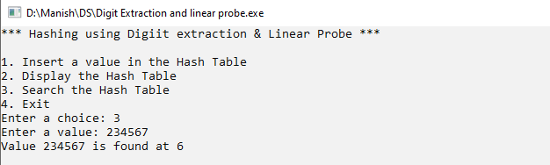
Unsuccessful:
