**Experiments with CNN activations**

In these experiments we run the Brain Bench tests against the activations of Convolutional Neural Networks instead of the Semantic word vectors. We basically study the activations of various convolutional layers and output layers of CNN and run the two vs two tests against vector output of these layers. The images for the activations are basically .jpg images

1. **ResNet50.**
2. **Data science FMRI and MEG**

A pre-trained ResNet50 Convolutional Neural Network implementation in Keras along with its trained ImageNet Weights were used for the initial study. This CNN model has 50 layers and has about 25,636,712 trainable parameters. The diagram for the last few layers are given Table 1. The output of the 49th layer after all the convolutional, batch normalization and max pooling steps is the flattened to produce a vector of 2048 dimensions. This CNN vector contains all the information from the 49 layers of CNN and is fed into the last dense layer (1000 neurons) to make the predictions for the 1000 classes in the image net. However, we use the CNN vector from the 49th layer for our analysis and performing the two vs two test against the Data science FMRI and MEG.

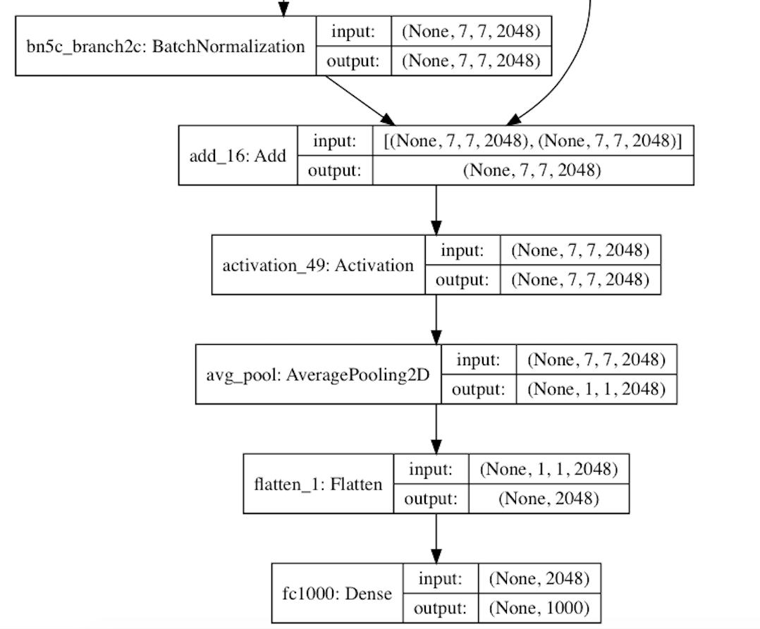

Table 1: Last few layers of ResNet.

Results

|  |  |  |  |  |
| --- | --- | --- | --- | --- |
| CNN Layer | FMRI_OLD | MEG_OLD | FMRI_NEW | MEG_NEW |
| Layer49: Flatten_1 function | 0.573132 | 0.619021 | 0.796798 | 0.812869 |
| Layer50: Dense layer | 0.594350 | 0.580289 | 0.748964 | 0.733522 |

Let’s visualize the vectors from the layers 49 and layer 50.

Fig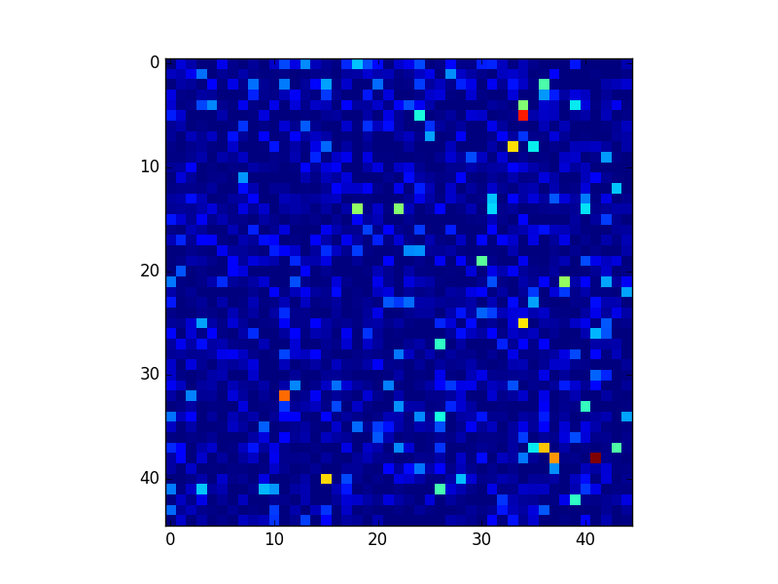

Fig1: Layer 49 (Flatten) Visualizations

We also repeated the experiments with some of the Convolutional layers of the network. Let’s visualize what some of these layers see through the below figures.



Fig2: The activation map for Convolutional layer 1 of ResNet50. An image of an airplane was used to produce this activation.

The first Convolutional layer produces an output in the dimensions of (1, 112, 112, 64) which is then flattened to produce a single vector of dimension 802816. Then a two vs two test was performed on this vector output of first convolutional layer.

|  |  |  |  |  |
| --- | --- | --- | --- | --- |
| CNN Layer | FMRI_OLD | MEG_OLD | FMRI_NEW | MEG_NEW |
| Layer1: Conv1 | 0.541620 | 0.556246 | 0.624670 | 0.616824 |

It may be more feasible to do a PCA to reduce the dimensions of the vector before performing two vs two test.

Brain Images of people viewing them….