PUNE VIDYARTHI GRIHA'S COLLEGE OF ENGINEERING, TECHNOLOGY & MANAGEMENT, PUNE
Department of Artificial Intelligence & Data Science
2025 – 26
Final Proposal for
The Project
On
AI-Based Medical Representative Visit Prioritization and Route Optimization System
Group Number: 19
Domain: Artificial Intelligence & Data Science / Machine Learning / Optimization
Roll No. | Name | Role / Task Assigned | Sign
3071 | Bhakti Jayantilal Gundecha | Team Leader | ________
1020 | Parth Lokhande | Team Member | ________
3056 | Udaykiran Bitla | Team Member | ________

Sponsorship Details (if any)
Name of Company: ________________________________
External Guide Name: _____________________________ Signature: ________________
Email ID: ______________________________________________

Name of the Faculty | Role | Signature
Prof. M. U. Buchade | Internal Guide | ________

Type of Project: Web-Based AI Application
External Mentor: ________________________
TE students associated with: No

PUNE VIDYARTHI GRIHA'S COLLEGE OF ENGINEERING, TECHNOLOGY & MANAGEMENT, PUNE
Department of Artificial Intelligence & Data Science
2025 – 26
Application
To,
The Project Coordinator,
Department of AI & DS,
PVG's COET, Pune.
Subject: Submission of Project Synopsis.

Respected Sir/Ma'am,
We, the undersigned students of BE AI & DS with Group ID: 19, are submitting our project synopsis titled “AI-Based Medical Representative Visit Prioritization and Route Optimization System.” We are bound by the decision taken by the department regarding our selected project title and are submitting the final synopsis for the selected project. Henceforth we will not change the project group or the selected project title/topic due to any reason.
Thank you.
Bhakti Gundecha (3071)
Parth Lokhande (1020)
Udaykiran Bitla (3056)

1. Synopsis

1. AI-Based Medical Representative Visit Prioritization and Route Optimization System

1.1 Project Options
- AI-Based Medical Representative Visit Prioritization and Route Optimization System
- AI- Powered Warehouse Management digital twin for SME
- Explainable and Adaptive AI-Based Intrusion Detection Framework for Cloud and Edge Networks
Selected Project
AI-Based Medical Representative Visit Prioritization and Route Optimization System
Option 1 is retained as the final title because it clearly communicates both the AI (visit-prioritization) component and the optimization (routing) component of the system.

1.2 Problem Definition
Medical Representatives (MRs) are required to visit multiple doctors within a limited working day. The planning of these visits involves several factors such as doctor priority, doctor availability, appointment time windows, visit duration, geographical location, travel time, and the MR's working hours.
In many practical situations, visit planning depends on manual schedules, spreadsheets, past experience, or fixed routes. Such approaches can result in inefficient travel, missed or delayed appointments, poor prioritization of important visits, and limited visibility for managers into field activity.
Prior research has already shown that pharmaceutical sales representatives face the problem of deciding which doctors to visit and in what order, including situations involving doctor time windows and uncertain waiting times. This confirms that the problem is a genuine, well-studied operational challenge rather than a purely academic scenario.
There is, therefore, a need for a data-driven system that can assist in prioritizing doctor visits and generating an efficient daily route while satisfying appointment and working-hour constraints.
Problem Statement
To develop an AI-assisted system that predicts the priority of planned Medical Representative doctor visits and generates an optimized daily visit sequence by considering doctor availability, visit duration, geographical distance, and working-hour constraints.

1.3 Abstract
This project develops an AI-assisted web application that automates Medical Representative visit prioritization and daily route planning.
Medical Representatives (MRs) must plan and manage multiple doctor visits within limited working hours, where doctor priority, availability, visit duration and geographical distance make manual planning inefficient, error-prone and difficult to scale as the number of doctors grows. The proposed system addresses this by combining Machine Learning with route-optimization techniques from the Artificial Intelligence and Operations Research domains. Historical doctor, appointment and visit-related data is processed to predict a priority score for each planned doctor visit using a Random Forest model. This predicted priority, together with doctor availability, visit duration, MR working hours and location constraints, is supplied to Google OR-Tools, which solves a Vehicle Routing Problem with Time Windows (VRPTW) to generate a feasible and efficient visit sequence.
Existing approaches — including manual/spreadsheet-based planning and general-purpose CRM or field-force platforms — typically treat prioritization and routing as separate, disconnected activities, and rarely expose an experimentable pipeline suitable for academic evaluation. Our contribution is to integrate predictive visit-priority scoring with constraint-aware route optimization inside a single, role-based web platform, and to evaluate the pipeline end-to-end using ML, route, and application-level metrics.
The resulting system generates an optimized sequence of doctor visits and provides role-based dashboards for Medical Representatives and managers — the MR views a prioritized, optimized daily plan, while the manager gains visibility into team-wide visit completion, route efficiency and performance analytics. Beyond the classroom, the same approach is directly applicable to pharmaceutical field-force operations and, more broadly, to any resource-constrained field-visit planning problem (technical service, field sales, community health outreach) where priority and routing must be reasoned about together.
By replacing purely experience-based planning with a combination of historical data, machine learning, operational constraints and optimization, the project aims to reduce unnecessary travel, improve visit scheduling, prioritize important visits, and provide better managerial visibility — making Medical Representative planning measurably more data-driven and efficient.

1.4 Goals and Objectives
Goal
The primary goal of the project is to develop a web-based, AI-assisted decision-support system that helps Medical Representatives prioritize doctor visits and generate efficient daily visit routes while satisfying appointment and operational constraints.
Objectives
- Doctor and MR Data Management — build and maintain a database of doctor profiles, locations, availability, appointment history, MR information, visit history, visit duration and priority-related features.
- Visit Priority Prediction — develop an ML model (Random Forest) that calculates a priority score for each planned doctor visit using historical and operational features such as visit frequency, days since last visit, and appointment availability.
- Appointment Constraint Management — incorporate doctor availability, appointment time windows, MR working hours, visit duration, break periods and maximum working duration into the planning process.
- Route Optimization — use Google OR-Tools to solve a Vehicle Routing Problem with Time Windows (VRPTW) that generates a feasible, efficient visit sequence considering travel distance, travel time and visit priority.
- Role-Based Web Dashboard — provide separate interfaces for MRs (daily schedule, prioritized doctors, optimized sequence, visit-status updates) and managers (team schedules, completed/pending visits, route and efficiency metrics, analytics).
- Performance Evaluation — evaluate the system using ML metrics (precision, recall, F1-score, accuracy), route metrics (distance, travel time, visits completed, late appointments, improvement over baseline) and application metrics (API response time, appointment-creation success, dashboard functionality, role-based access).

1.5 Scope of the Project
Current Scope
- Single-city / limited-territory MR planning
- Doctor and MR data management
- Historical visit-data preprocessing
- AI-based visit-priority prediction
- Doctor appointment time-window management
- Daily route optimization
- MR dashboard and Manager dashboard
- Visit-status tracking and performance analytics
- Cloud deployment of the prototype
Future Scope
- Multi-MR optimization across an entire field team
- Multi-region / multi-city planning
- Real-time GPS integration for dynamic location tracking
- Dynamic rescheduling when appointments are cancelled or urgent visits are added
- Native mobile application (Android/iOS) for field representatives
- CRM integration with enterprise field-force systems
- Comparison of Random Forest with XGBoost, LightGBM, Gradient Boosting and Neural Networks
- Dynamic/adaptive optimization incorporating real-time traffic and changing availability

1.6 Keywords
ACM Computing Classification System (CCS) Concepts
- Computing methodologies → Machine learning → Machine learning approaches → Classification and regression trees
- Applied computing → Operations research → Transportation
- Information systems → Decision support systems
- Mathematics of computing → Discrete mathematics → Graph theory → Network optimization
- Software and its engineering → Software organization and properties → Software system structures → Client-server architectures

Keywords
Medical Representative, Machine Learning, Visit Prioritization, Route Optimization, Vehicle Routing Problem with Time Windows (VRPTW), Random Forest, Google OR-Tools, Appointment Scheduling, Field-Force Management, Decision Support System, Artificial Intelligence.

2. Software and Hardware Requirements

2.1 Software Requirements
Category | Technology
Programming Language | Python
Frontend | React.js
Backend | FastAPI
Database | MySQL
Machine Learning | Scikit-learn
Data Processing | Pandas, NumPy
Optimization | Google OR-Tools
API | REST API
Visualization | Plotly / Chart.js
IDE | Visual Studio Code
Version Control | Git & GitHub
Testing | Pytest / Postman
Deployment | Cloud platform

2.2 Hardware Requirements
Component | Minimum Specification
Processor | Intel Core i5 / AMD Ryzen 5 or equivalent
RAM | 8 GB minimum (16 GB recommended)
Storage | 256 GB SSD or higher
Internet | Stable internet connection
Operating System | Windows 10/11 or Linux
Browser | Chrome / Edge / Firefox

The project does not require specialized hardware, since both the ML model and the route optimizer can be trained and executed on a standard development machine.

3. Introduction

3.1 Background
Medical Representatives play an important role in pharmaceutical field operations by maintaining professional interactions with doctors and healthcare organizations. Their work involves frequent travel between geographically distributed locations and requires planning visits according to doctor availability, appointment schedules and organizational priorities.
As the number of doctors and appointments grows, manual scheduling becomes increasingly difficult to manage well. This creates an opportunity to apply Artificial Intelligence, Machine Learning and Operations Research to improve field-visit planning — the central motivation for this project.

3.2 Literature Survey
A total of fifteen research papers were surveyed, spanning three complementary areas: pharmaceutical sales-force / physician-targeting research, vehicle-routing and field-service-scheduling research, and AI-based healthcare-appointment scheduling research. Each paper is summarised below in terms of its key finding, its limitation with respect to our problem, and how our project builds on or differs from it.
No. | Paper | Key Point from Research | Limitation / Gap | Our Effort to Overcome It
1 | Yi, Anandalingam & Sorrell (2003) — An expert system to physician-detailing planning | Uses data mining/neural networks and nonlinear programming to allocate pharmaceutical sales-force resources to physicians. | Focuses on physician-detailing/resource allocation rather than complete daily route generation and web-based field management. | We use ML for visit priority, then connect it to route optimization and a web application.
2 | Yi (2008) — An expert system to derive carryover effect for pharmaceutical sales detailing optimization | Uses neural networks + nonlinear programming to identify physician responsiveness and optimize detailing frequency. | Focuses on promotional carryover and sales effectiveness rather than geographical route planning. | We focus on operational visit priority + location + time constraints + routing.
3 | Yi (2011) — Knowledge-based approach to improving detailing plan in multiple product situations using PDE weights | Combines expert knowledge, neural networks and nonlinear programming to improve the physician-detailing sequence. | Mainly optimizes the content/order of product detailing, not the MR's physical daily route. | We separate visit priority from physical route sequencing, allowing both to work together.
4 | Zhang, Ohlmann & Thomas (2014) — A priori orienteering with time windows and stochastic wait times at customers | Directly models pharmaceutical representatives deciding which doctors to visit and in what order, considering time windows and uncertain waiting. | A strong optimization model, but it does not provide an integrated ML + web-dashboard architecture. | We add an ML priority layer, role-based application and manager analytics before route optimization.
5 | Keskin et al. (2020) — Multi-period orienteering with uncertain adoption likelihood and waiting at customers | Models repeated sales visits, uncertain customer adoption probability and waiting times via a two-stage heuristic. | Computational optimization focuses on sales/adoption probability rather than an accessible operational web system. | We use a simpler, explainable priority score + OR-Tools approach suitable for a final-year deployable system.
6 | Rhee & Yi (2020) — Physician's interest to meet the sales rep and sample need | Studies factors affecting a physician's willingness to meet a sales representative and predicts individual targeting outcomes. | Focuses on meeting interest/sampling rather than geographical scheduling and route optimization. | We can use similar appointment/interest-related features as inputs to our visit-priority model, while adding routing.
7 | Bouatouche & Belkadi (2025) — A hybrid firefly algorithm for the sales representative planning problem | Addresses pharmaceutical sales-representative route planning with a hybrid Firefly + Local Search algorithm, considering coordinates, service time, time windows and route duration. | Primarily an optimization algorithm/benchmark study; does not integrate ML-based priority prediction with a complete web application. | We use Random Forest → priority → OR-Tools → dashboard, giving a more application-oriented architecture.
8 | Liu et al. (2023) — A Systematic Literature Review of Vehicle Routing Problems with Time Windows | Reviews 64 VRPTW studies; most use approximate/metaheuristic approaches, with problems commonly multi-objective and multi-constrained. | General logistics domain, not specific to medical representatives. | We adapt VRPTW specifically to MR working hours, doctor availability, visit duration and priority.
9 | Paraskevopoulos et al. (2017) — Resource constrained routing and scheduling: Review and research prospects | Surveys routing/scheduling where resources have qualifications and service requirements, covering technicians, healthcare workers and field services. | A broad resource-routing framework rather than an MR-specific workflow. | We simplify the resource model around one MR + multiple doctors + appointment constraints.
10 | Frits & Bertok (2021) — Routing and scheduling field service operation by P-graph | Handles multiple geographically distributed tasks, priorities, staff availability and routing via a two-level optimization model. | Focuses on technical field-service workers and a specialized P-graph methodology. | We use a more accessible architecture: FastAPI + ML + OR-Tools + React.
11 | Zhang & Van Woensel (2023) — Dynamic Vehicle Routing with Random Requests: A Literature Review | Reviews 115 papers on dynamic routing and unexpected requests, discussing dynamic/stochastic decision-making. | General vehicle-routing domain, not MR-specific. | Dynamic rescheduling is included as a future enhancement for cancelled/new doctor appointments.
12 | Cordeau, Iori & Vezzali (2024) — An updated survey of attended home delivery and service problems | Reviews real-world attended service routing problems, including time windows and integrated demand/routing decisions. | Focuses on home delivery/service rather than pharmaceutical sales. | We transfer the attended-service/time-window concept to doctor visits.
13 | Shala, Fleckenstein & Klein (2026) — A model-based survey on operational planning of technician-based after-sales field services | A recent survey covering routing/scheduling constraints, objectives and stochastic-dynamic field-service problems. | Technician/service domain, not MR/doctor visits. | Our system uses the same field-work principles but introduces doctor-priority prediction and MR-specific constraints.
14 | Ala & Chen (2022) — Appointment Scheduling Problem in Complexity Systems of Healthcare Services: A Comprehensive Review | Reviews 150+ healthcare appointment-scheduling papers, including mathematical optimization, simulation, Markov models and AI. | Mainly patient/healthcare appointment scheduling, not pharmaceutical field representatives. | We apply appointment constraints to MR–doctor visits and connect them with route optimization.
15 | Artificial intelligence for patient scheduling in the real-world health care setting: A metanarrative review (2023) | Reviews real-world AI/ML applications for healthcare scheduling; identifies evidence around workload, utilization and scheduling efficiency. | Focuses on patient scheduling rather than field-force routing. | We use ML specifically for visit-priority prediction, then use optimization for the physical route.

Summary
From the literature survey, the problem has already been studied from several distinct perspectives. Pharmaceutical sales-force research has addressed physician targeting and representative route planning; VRPTW research has addressed time-window and travel constraints; and healthcare-scheduling research has explored AI-based appointment scheduling. However, these components are generally studied as separate problems. Our effort is to integrate them into one pipeline, where machine learning predicts visit priority, appointment constraints define feasibility, Google OR-Tools generates the optimized route, and a web application presents the final plan to the MR and the manager.

3.3 Research Gap
Existing research has investigated different parts of the problem in isolation:
- Physician targeting and pharmaceutical sales-force allocation
- Sales-representative routing
- Time-window routing (VRPTW)
- Appointment scheduling
- Dynamic vehicle routing
For example, pharmaceutical research has used neural networks and optimization for physician-detailing planning, while Zhang et al. directly studied pharmaceutical representative routing with time windows and stochastic waiting. Similarly, VRPTW is a mature optimization area, with recent literature showing that real-world routing problems commonly involve multiple constraints and objectives.
Identified Gap
The proposed project focuses on integrating visit-priority prediction, appointment constraints, route optimization and operational dashboards into a single, domain-specific web application for Medical Representative planning — a combination that the surveyed literature does not address as one system.

3.4 System Architecture
The system follows a seven-layer architecture that carries a visit request from raw historical data through machine-learning prediction, constraint handling, and route optimization, to the final web application used by MRs and managers.
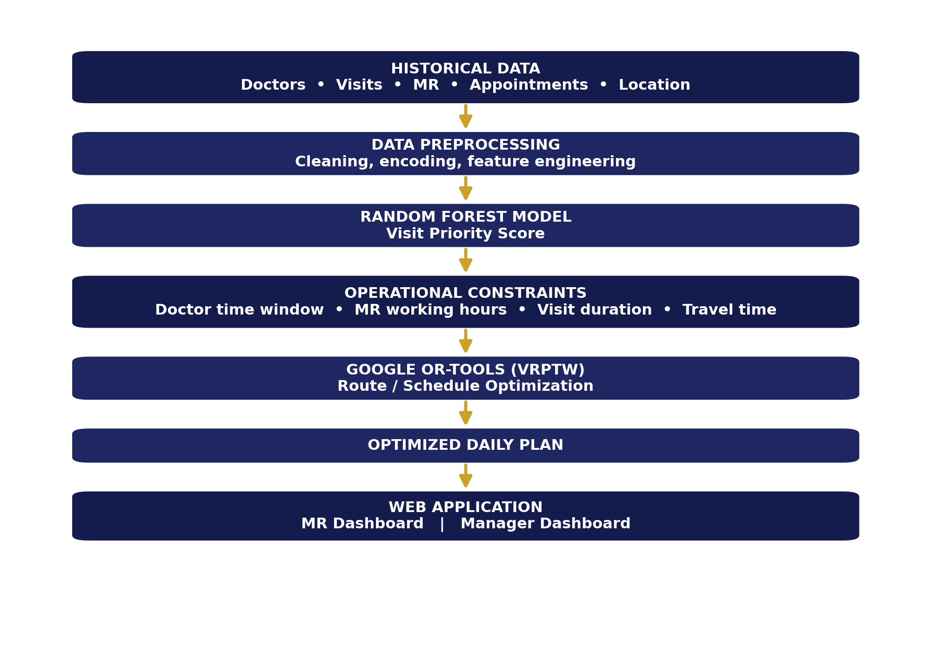
Layer Description
- Layer 1 — Users: Medical Representative, Manager, Doctor/Appointment interface.
- Layer 2 — Frontend (React.js): login, doctor selection, appointment creation, daily schedule, route visualization, manager dashboard.
- Layer 3 — Backend (FastAPI): authentication, business logic, appointment management, ML-prediction requests, optimization requests, database communication.
- Layer 4 — Database (MySQL): users, doctors, MRs, appointments, visit history, locations, visit outcomes.
- Layer 5 — AI Engine (Random Forest): produces the doctor visit-priority score.
- Layer 6 — Optimization Engine (Google OR-Tools): solves the VRPTW routing/scheduling problem.
- Layer 7 — Analytics: route efficiency, visit completion, priority distribution, travel distance, appointment performance.
This separation of concerns keeps the AI component (“How important is this visit?”) distinct from the optimization component (“Given all important visits and constraints, what is the best feasible sequence?”), giving the project a clear and defensible technical identity.

3.5 Proposed Work of Project Topic
Module 1 — User Authentication and Role Management
Role-based login for two roles. The MR can view assigned doctors, request/create appointments, view the daily plan, view the optimized route, and update visit status. The Manager can add/manage doctors, manage MRs, view schedules, monitor visits, view analytics and compare route efficiency.
Module 2 — Doctor Management
The manager maintains doctor name, specialization, address, latitude/longitude, availability, preferred visit time, visit duration and historical visit information.
Module 3 — Appointment Management
The system records the doctor, MR, appointment date, start time, end time, expected duration and appointment status, and flags obvious scheduling conflicts.
Module 4 — Data Preprocessing
Historical data is processed using Pandas, NumPy and Scikit-learn: data cleaning, missing-value handling, encoding of categorical features, feature selection, feature scaling where required, and a train/test split for model training.
Module 5 — AI Visit-Priority Prediction
This is the project's primary AI component. Historical and operational visit features are fed to a Random Forest classifier/regressor (the exact formulation depends on the final dataset and target definition), producing a Visit Priority Score for each planned doctor visit — for example, Doctor A → 0.91 → High Priority, Doctor B → 0.74 → High Priority, Doctor C → 0.48 → Medium Priority, Doctor D → 0.21 → Low Priority. These illustrative scores will be replaced by values produced by the trained model.
Module 6 — Route Optimization
Priority scores are combined with operational constraints — doctor location, doctor time window, MR working hours, visit duration, travel time and maximum route duration — and passed to Google OR-Tools, which generates a feasible, efficient visit sequence (for example: MR Start → Doctor C → Doctor A → Doctor D → Doctor B → MR End). The exact sequence depends on the dataset and optimization inputs used.
Module 7 — MR Dashboard
Displays today's plan as a prioritized, time-ordered list of doctors with status, along with the recommended route and estimated travel information.
Module 8 — Manager Dashboard
Displays total planned visits, completed visits, pending visits, high-priority visits, MR-wise performance, route distance, travel time, appointment delays, and historical trends.

4. Present Work Related to the Project Topic

4.1 Current Market Survey
Commercial field-force/CRM systems already provide parts of this functionality, so the market survey below is deliberately honest about existing tools rather than claiming no such software exists.
Veeva CRM
Veeva CRM is a pharmaceutical/life-sciences-focused platform that supports call planning, schedule management, map-based activity planning and route visualization. Its limitation, relevant to our academic project, is that it is a large enterprise platform, whereas our project aims to build a focused academic prototype demonstrating ML-based visit prioritization integrated with route optimization. Our approach is to develop a smaller, transparent system where the complete AI → optimization pipeline can be demonstrated and evaluated end-to-end.
General CRM / Field-Service Platforms
Commercial CRM systems typically provide customer management, sales-activity tracking, scheduling, reporting, maps and field-force management, but their internal algorithms and business rules are usually not accessible for academic experimentation. Our approach is to provide an experimental platform where ML performance, route performance and application performance can all be measured directly.
Manual Spreadsheet-Based Planning
Manual planning is simple, low-cost and familiar to users, but suffers from manual prioritization, repetitive data entry, difficult route optimization, limited analytics, and no ML-based decision support. Our approach is to automate these activities through a centralized application.

Comparison with Existing Approaches
Feature | Manual Planning | Enterprise CRM | Proposed System
Doctor database | Limited | ✓ | ✓
Appointment management | Manual | ✓ | ✓
Visit priority | Experience / rules | Varies | ML-based
Route optimization | Manual | ✓ / varies | OR-Tools
Time-window constraints | Manual | Varies | ✓
ML experimentation | ✗ | Limited visibility | ✓
Manager analytics | Limited | ✓ | ✓
Academic evaluation | ✗ | ✗ | ✓
Customizable model | ✗ | Limited | ✓
Deployment as student prototype | — | Enterprise | ✓

This comparison is a stronger market-survey argument than claiming that commercial systems do not exist — it positions the project as a focused, evaluable academic prototype rather than a reinvention of enterprise CRM.

4.2 Names of Conferences / Journals Where Papers Can Be Published
- Expert Systems with Applications
- European Journal of Operational Research
- International Journal of Computer Applications
- Journal of Combinatorial Optimization
- International Conference on Artificial Intelligence and Data Science (ICAIDS)

4.3 Expected Outcomes of the Project
The final system is expected to provide:
- A functional web-based MR visit-planning application.
- AI-generated visit-priority scores for planned doctor visits.
- Appointment-aware scheduling that respects time-window and working-hour constraints.
- Optimized daily visit routes generated using Google OR-Tools.
- A role-based MR dashboard and Manager dashboard.
- Route-performance analytics and ML model evaluation results.
- A route-optimization comparison against a manual/nearest-neighbour baseline.
- A deployable academic prototype demonstrating the complete AI → optimization → application pipeline.
Evaluation Methodology
The system will be evaluated at three levels:
- ML Evaluation: Accuracy, Precision, Recall, F1-score, and ROC-AUC where applicable.
- Route Evaluation: total distance, total travel time, number of visits completed, time-window violations, waiting time and route duration — comparing the ML-priority + OR-Tools optimized route against a manual/nearest-neighbour/simple-priority baseline.
- Application Evaluation: API response time, appointment-creation success, dashboard functionality and role-based access.
Rather than asserting a fixed improvement figure in advance (e.g. “travel will reduce by 35%”), the percentage improvement will be calculated experimentally by comparing the optimized route against the selected baseline once real data is available.
Feasibility
- Technical Feasibility: all required technologies (Python, Scikit-learn, Pandas, FastAPI, React.js, MySQL, OR-Tools) are open-source and widely available, making the project technically feasible within a final-year development environment.
- Economic Feasibility: the prototype uses open-source technologies, keeping licensing costs minimal.
- Operational Feasibility: the system is intended to support, not replace, the MR — the MR remains the decision-maker while the system provides data-driven recommendations.
- Academic Feasibility: the pipeline (data preprocessing → ML → optimization → evaluation → visualization → deployment) provides adequate technical scope for an AI & Data Science final-year project.
Limitations
- Model performance depends on the quality and availability of historical data.
- The initial implementation may focus on a limited geographical area.
- Real-time traffic is not included in the first version.
- Dynamic rescheduling is treated as future scope.
- Commercial deployment would require stronger security, privacy and organizational integration.
- The project does not make medical or clinical decisions.

5. Plan of Project Execution

5.1 Project Plan
Week | Work
1–2 | Literature survey and requirement finalization
3 | Dataset identification and acquisition
4 | Data cleaning and preprocessing
5 | Feature engineering
6 | Baseline ML models
7 | Random Forest training / evaluation
8 | Route-optimization formulation
9 | OR-Tools implementation
10 | Database design
11 | FastAPI backend
12 | React frontend
13 | MR dashboard
14 | Manager dashboard
15 | ML + OR-Tools + web integration
16 | Testing and performance evaluation
17 | Deployment, documentation and final presentation

Project Plan 1.0 — Phase Breakdown
Phase | Duration | Description
Phase 1 — Research | Weeks 1–2 | Literature survey, problem finalization and requirement analysis.
Phase 2 — Data & ML | Weeks 3–7 | Dataset → preprocessing → features → model → evaluation.
Phase 3 — Optimization | Weeks 8–9 | VRPTW formulation → OR-Tools → route testing.
Phase 4 — Application | Weeks 10–14 | Database → backend → frontend → dashboards.
Phase 5 — Integration & Deployment | Weeks 15–17 | Integration → testing → evaluation → deployment → documentation.

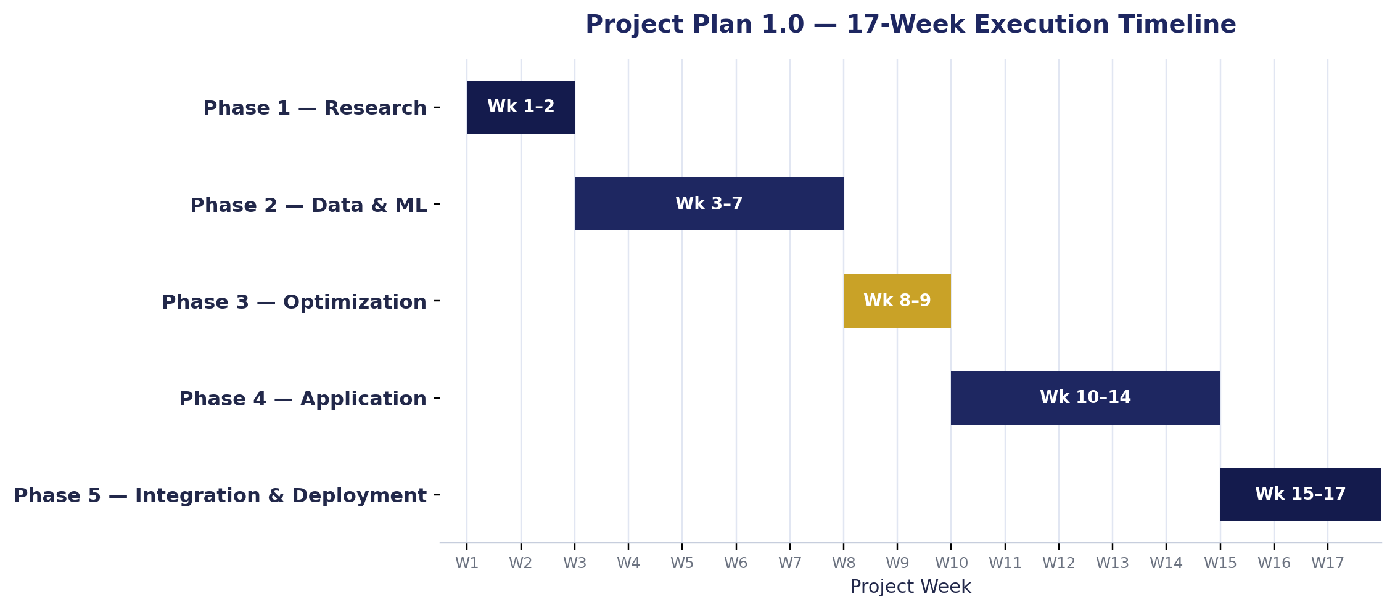
Major Milestones
- M1: Dataset and preprocessing complete
- M2: ML model complete
- M3: Route optimizer complete
- M4: Backend and database complete
- M5: Frontend complete
- M6: Full integration complete
- M7: Testing and deployment complete

5.2 Probable Date of Completion
Mid-December 2026 — approximately 17 weeks from project commencement, subject to confirmation against the department's academic calendar.

6. References

6.1 Core References
- J. C. Yi, G. Anandalingam, and L. A. Sorrell, “An expert system to physician-detailing planning,” Expert Systems with Applications, vol. 25, no. 4, pp. 533–544, 2003. DOI: 10.1016/S0957-4174(03)00093-9.
- J. C. Yi, “An expert system to derive carryover effect for pharmaceutical sales detailing optimization,” 2008.
- J. C. Yi, “Knowledge-based approach to improving detailing plan in multiple product situations using PDE weights,” 2011.
- S. Zhang, J. W. Ohlmann, and B. W. Thomas, “A priori orienteering with time windows and stochastic wait times at customers,” European Journal of Operational Research, vol. 239, no. 1, pp. 70–79, 2014. DOI: 10.1016/j.ejor.2014.04.040.
- B. Keskin et al., “Multi-period orienteering with uncertain adoption likelihood and waiting at customers,” 2020.
- M. Rhee and J. C. Yi, “Physician's interest to meet the sales rep and sample need: Implication to pharmaceutical detailing and sampling efforts,” 2020.
- A. Bouatouche and A. Belkadi, “A hybrid firefly algorithm for the sales representative planning problem,” 2025.
- X. Liu, Y.-L. Chen, L. Y. Por, and C. S. Ku, “A Systematic Literature Review of Vehicle Routing Problems with Time Windows,” Sustainability, vol. 15, no. 15, 12004, 2023. DOI: 10.3390/su151512004.
- A. Paraskevopoulos et al., “Resource constrained routing and scheduling: Review and research prospects,” 2017.
- D. Frits and P. Bertok, “Routing and scheduling field service operation by P-graph,” 2021.
- J. Zhang and T. Van Woensel, “Dynamic Vehicle Routing with Random Requests: A Literature Review,” 2023.
- J.-F. Cordeau, M. Iori, and L. Vezzali, “An updated survey of attended home delivery and service problems with a focus on applications,” 2024.
- A. Shala, K. Fleckenstein, and R. Klein, “A model-based survey on operational planning of technician-based after-sales field services,” 2026.
- A. Ala and F. Chen, “Appointment Scheduling Problem in Complexity Systems of the Healthcare Services: A Comprehensive Review,” 2022.
- “Artificial intelligence for patient scheduling in the real-world health care setting: A metanarrative review,” 2023.

6.2 Technical & Market References
- Google OR-Tools Documentation, Vehicle Routing and Routing with Time Windows.
- Scikit-learn Documentation, Random Forest and Model Evaluation.
- FastAPI Documentation, REST API Development.
- React.js Documentation, Frontend Application Development.
- MySQL Documentation, Relational Database Management.
- Veeva CRM Documentation, Schedule and Map-Based Route Planning for Field Activities.

