Rhythm Render

Games Engines 1 Assignment

Name: John Hinch

Student Number: C21718369

Class Group: TU856

# Description

This is a simple 3D application that demonstrates audio manipulation in Godot through the use of a Global Sound Manager. It features a 2 scene, a scene where the user programmes their sound sequence, and a scene featuring a prerecorded animation that the user can move around using standard controls. During the performance scene the user can also manipulate the volume and pith of the audio playing.

# Instructions For Use

Instructions are fairly simple, the user is presented with an empty 3D environment, along the top-left corner of the screen there is a series of buttons, each corresponding to a guitar chord. Pressing a button will play that sound and add it the sequence. Once the user has determined their sequence, they press the perform button which brings them to the performance scene. There is also a reset button which erases the sequences.

During the performance scene, the user will be presented with a 3D animation of a humanoid figure playing guitar. There are two vertical sliders in top left corner of the screen that the user can use to change the volume and the pitch of the audio sequence. There is also a home button which will return the user to the main scene. The user is able to move around the scene using standard WASD keyboard controls and they can look around the scene using the arrow keys.

# How it Works

Almost all of the sound systems used in this project is handled by a Global Sound Manager, which is a way for the entire project to feature and manipulate the audio of the project. Each button is connected to a specific audio file, which when the button is pressed is added to the sound sequence array contained in the Global Sound Manager.

From there, the performance scene just calls the play_next_sound function in the Global Sound Manager. This function instantiates new Audio Stream Players, and iterates through the sound sequence array.

Within this script there is also the functions for manipulating the audio which are called by the 2D menu

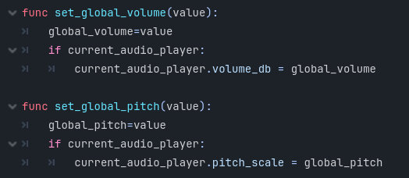

Player movement is handled using a predetermined input map, where when the specific button is pressed it adds to a Vector, then using the built in move and slide function from the Character body 3D library, the player moves in the corresponding direction.

Camera movement is handled in a similar way, using the input map, the camera will rotate in the corresponding direction.

# Video

<https://youtu.be/gOo_L7mV9fU>

# Conclusion

Overall, I am happy with this project. I feel that I have a greater understanding of both the functionality of Godot as well as the workflow used for a Godot project. I know there is a lot that could be added to this project, and I hope to be able to add new features and functionality at a later date