The Smart-Risk Trading Project

A systematic approach to low-risk, risk-managed financial trading for stable and scalable returns.

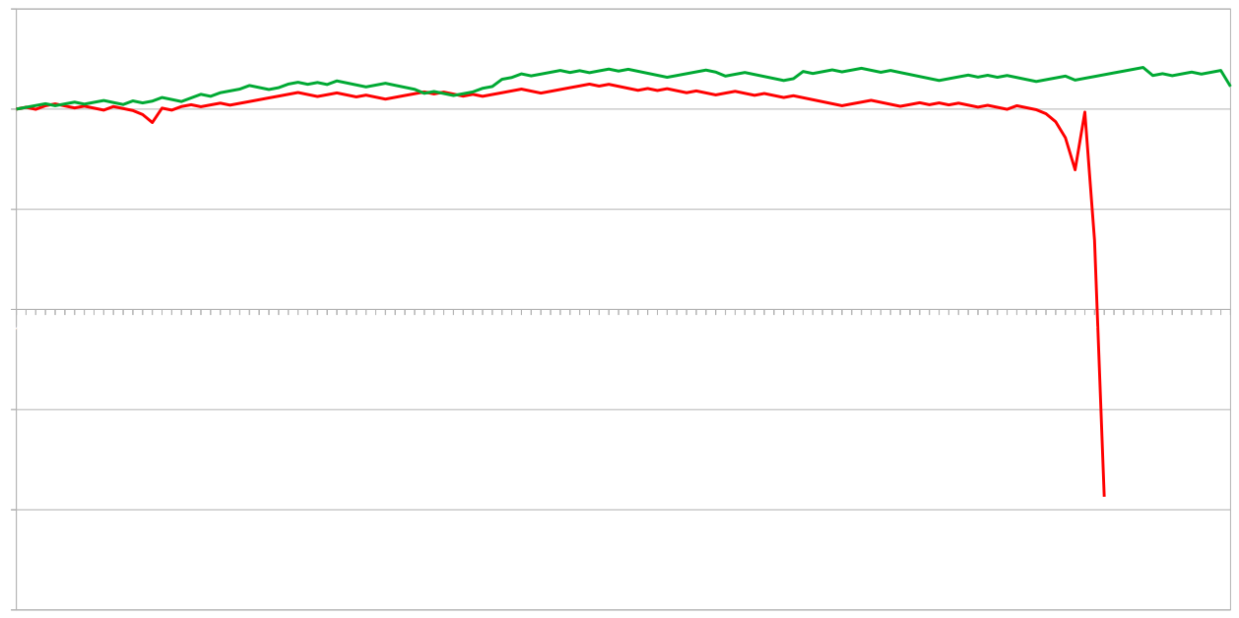
September 2022 – February 2025
TradingGenius & Friends

Table of Contents
The Smart-Risk Trading Project 1
Introduction 3
Terminology: 3
Cost Calculation: 3
Single Martingale Scale: 3
Multiple Martingale Scales: 3
Technical Market Analysis 4
Finding 1: 4
Deflationary Assets show bullish candlecolors. 4
Trading Call Options with an Sophisticated Martingale System on Growing Markets can leaverage a Winerate of >50% for stable return. 5
Recovering losses 6
Finding 2.0: 6
2.1: Limited Losses 6
2.2: Optimized Risk/Reward Ratio 7
Birectional trade actions 9
Double profits and minimize risk contrary options: 9
Opening strictly call options, when the market indicates a long-term bullish ternd, brings shortterm risk of reaching a peak of one or more scales when there is a long consecutive streak of bullish price action. 9
Technical execution 10
Trade action process: 10
Stateful and recoverable system design. 10

Introduction
The Martingale Strategy presents a risky risk management system that allows trading systems to recover from losses if the win rate is above 50% or if there are no losing streaks long enough to exhaust the available balance.
A more effective risk score can be achieved by using multiple independent scales instead of a single scale.
The fundamental finding is that applying this risk management system, can generate profits in deflationary markets. Profits are based on the quantity of trades, and risk correlates sub-exponentially to the peak of the risk management system.
The following concepts are designed for a trading system that trades deflationary assets like gold on a daily timeframe using binary options.

Terminology:
Term | Description
Costs (C) | Required capital to operate a V1 system
Peak (P) | Maximum capacity for one system before failing
Scale (S) | One RiskManagement column that works independent of other scales in a V1 system
PeakSingle (PS) | Peak on one single Scale explicitly
ScaleCount (SC) | Number of Scales in a system
FailedInvestment (FI) | Lost money when the system fails
PeakIndex (PI) | Position in recovery scale
ShadowScale (SS) | A Scale that is traded in the opposite direction

Cost Calculation:

Single Martingale Scale:
C = 2^(P + 1) - 1

Multiple Martingale Scales:
C = (2^(PS + 1) - 1) * SC

Technical Market Analysis

Finding 1:

Deflationary Assets show bullish candlecolors.

When analysing candlestick patterns of the gold market from 2010 until 2024 a clear bullish trend shows in outweighting the number of days where the gold price went down with the days where the gold market had a rising price.

Year | Bullish Candles | Bearish Candles | Bullish Candles % | Bearish Candles % | Max Consecutive Bearish Candles | Total Candles
2010 | 143 | 109 | 56.74 | 43.25 | 7 | 252.0
2011 | 142 | 110 | 56.34 | 43.65 | 6 | 252.0
2012 | 126 | 126 | 50 | 50 | 7 | 252.0
2013 | 112 | 140 | 44.44 | 55.55 | 8 | 252.0
2014 | 124 | 128 | 49.2 | 50.79 | 6 | 252.0
2015 | 107 | 145 | 42.46 | 57.53 | 15 | 252.0
2016 | 127 | 125 | 50.39 | 49.60 | 8 | 252.0
2017 | 143 | 112 | 56.07 | 43.92 | 7 | 255.0
2018 | 125 | 133 | 48.44 | 51.55 | 7 | 258.0
2019 | 129 | 129 | 50 | 50 | 9 | 258.0
2020 | 151 | 108 | 58.30 | 41.69 | 7 | 259.0
2021 | 128 | 130 | 49.61 | 50.38 | 9 | 258.0
2022 | 135 | 123 | 52.32 | 47.67 | 8 | 258.0
2023 | 133 | 124 | 51.75 | 48.24 | 9 | 257.0
2024 | 145 | 112 | 56.42 | 43.57 | 6 | 257.0

Trading Call Options with an Sophisticated Martingale System on Growing Markets can leaverage a Winerate of >50% for stable return.

When simply Buying a Put Option at 1$ every day, estimated profits are for 2010: $34
: Won Trades – Lost Trades
> 143 - 109
34

With single applied Martingale profits: $143
Required capital(for 8 levels): $511
: 2 ^ (P + 1 ) - 1
> 2 ** (8 + 1 ) -1
511
1
2
4
8
16
32
64
128
256

With 2 scales Martingale profits: $143
Required capital(for 2*4 levels): $62
: (2 ^ (PS + 1 ) - 1 ) * SC
> (2 ** (4 + 1 ) -1) * 2
62
1 | 1
2 | 2
4 | 4
8 | 9
16 | 16

Recovering losses

Finding 2.0:
Using a multiscale martingale approach lead to two benefits:

2.1: Limited Losses
When using a single Scale and failing Peak + 1 -times in a row, the complete trading systems halts and potentially destroys 100% of the initial investment. When diving risk to different scales, the lost funds are restricted to the relative portion of the scale that failed against the full Investment.

Lost Capital = Risk on one scale = (Complete Investment / Count of Scales)
or: FailedInvestment = (Costs / ScaleCount) || FI = C / SC

When limiting the risk of the investmant that is lost on the fail of the system, there is also a intriduced upside of being able to see the system as guaranteed profitable as soon as the profit exeeds the FailedInvestment.
Over the long term the FailedInvestment acts like a following stop loss for the Balance of the trading system. In the case of a failure, and unrealised loss on other scales can result in a higher loss then just the FailedInvestment, this problem can be solved by a graceful shutdown process where all the remaining sclaes clear and only shutdown if the risk is back at the initial investment. The longer shutdown process brings the potential upside of minimizing losses, but also introduces the risk of all scales failing because risk is traded on a set of scales that get smalle rand smaller, increasing the risk per finished scale. At the same time, every scale that has no lost positions to recover they can be seen as secured or shut down idealy.

2.2: Optimized Risk/Reward Ratio
The Reason why simple martingale does not work is because the risk corresopnds linearly with the rpofitability in terms of probability. To make more profits the system would need to withstand more trades or riskier investments. When doing more trades, the probability of more consecutive lsoses increases. Under the assumtion that maintaining a syytem required about the risk to generate the intended profits.

The Sopisticated martingale scale compares to the traditional sclae in the following sence.
- For the same peak/“security” the requirement of capital is lower.
- For the same risk/”capital” the suggested secirity is higher.
Let’s take a look at a simple martingale system.
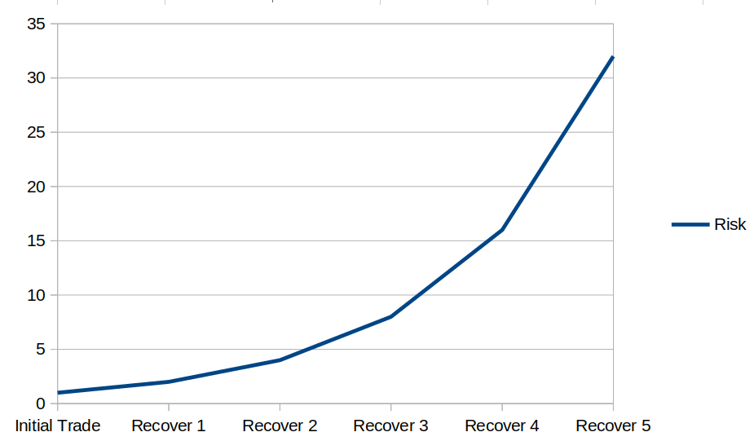
See the exponential Risk of the Single-Martingale Scale.
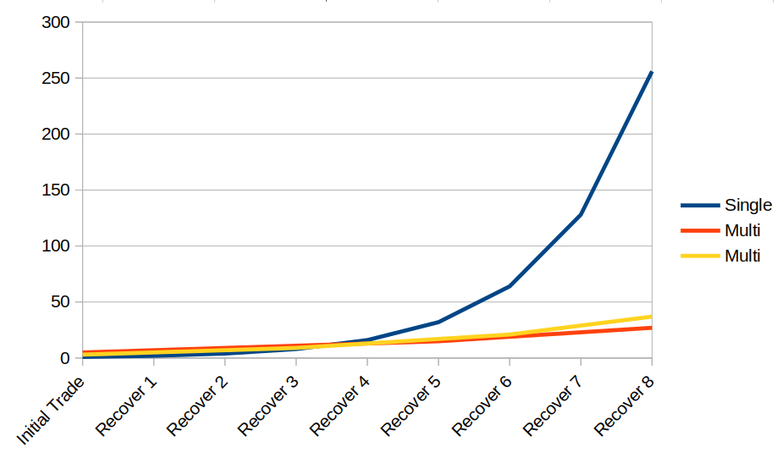
See the sub-exponetnial Risk of the Multi-Martingale Scales.

So finding that using multiple scales over just one scales means that capital can be invested more effectively and with a smaller risk. But this far the system still depends on a strategy that does not capture to many conssecutive losses in a row.

Birectional trade actions

Double profits and minimize risk contrary options:

Opening strictly call options, when the market indicates a long-term bullish ternd, brings shortterm risk of reaching a peak of one or more scales when there is a long consecutive streak of bullish price action.
One advantage that a multiscale with an odd number of ScaleCounts is that patterns that would propose a smaller risk if call and put options would be executed on different scales, and the ShadowSclae would headge against longer priceactions in one price direction. In effect more trade would be executed which increases the profits by generating more transactions and also (almost) guaranteen a win every iteration which means that there is a predictable profit per iteration. The risk of the system against long-term trends is also lowered, but in case the market move sideways for along time in a priceaction that would cause some scales to fail faster there still is a risk of losing a scale. Executed backtest indicate, that characterisics of markets favor the strategy, but with twice the transactions, the probability (eaven if very low) of losing a scale raises. Therefore The bidirectional mode should be viewed as a efature that only should be used if the status of the system allows for it. Technically that feature is easy to deactivate, as it is a single property/argument that can be toggeled every trade iteration.

Technical execution

Trade action process:

Stateful and recoverable system design.
The consequence of losing connectivity to the api is the risk of not continuing to make profits, there is no time correlated risk of losing capital when the system is not active.
All relevant configuration is saved in a statefile.json, as the History of the program is saved in a history.csv file, which allows the system to stop and start at any point in time, while still remaining functional.
Every iteration may be processed in the following order:
- Fetching Price-data
  - A Request to the broker is initialized to check connectivity
  - Market-data is collected to calculate prices for the next trade
- Node indexes are updated
  - The current node-index becomes the last node-index if more then 24 hours have passed and there is no open position
  - Current node-index is read from to file to calculate risk for the next position
  - Last node-index is read to determine the last outcome and the new scale-state
- New position is opened
  - A Request with the order-information is sent to the broker
  - Required data is saved in the statefile for the current node-index to determine a win or loss at the next iteration
- Write outcome to history
  - If all the processes are successful, the result is written to the historyfile
  - If some steps fail, they are written to a log-file
The Server can be executed every 10 Minutes assuming the errorhandling is well buildt, the statefile would allow to read the last tradedate back, to check if the next position should be opened. This setup could be archived with a cron task. It makes sence to write the application in the language that offers access to libraries to interact with the target broker. Independently of that a webapplciation servicing as a dashboard can analyse the statefile, offer insigt of the status and health of the system and or read the historyfile to display it in a way the past trades can be analysed and evaluated.

