The Smart-Risk Trading Project

A systematic approach to low-risk, risk-managed financial trading for stable and scalable returns.

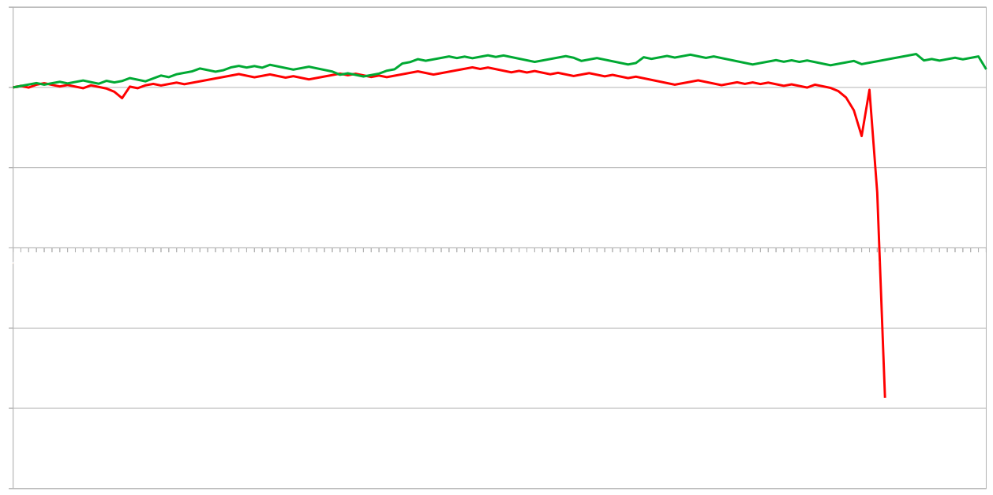
September 2022 – February 2025
TradingGenius & Friends

Table of Contents
The Smart-Risk Trading Project 1
Introduction 3
Terminology: 3
Cost Calculation: 3
Single Martingale Scale: 3
Multiple Martingale Scales: 3
Technical Market Analysis 4
Finding 1: 4
Deflationary Assets show bullish candlecolors. 4
Trading Call Options with an Sophisticated Martingale System on Growing Markets can leaverage a Winerate of >50% for stable return. 5
Recovering losses 6
Finding 2.0: 6
2.1: Limited Losses 6
2.2: Optimized Risk/Reward Ratio 7
Birectional trade actions 9
Double profits and minimize risk contrary options: 9
Opening strictly call options, when the market indicates a long-term bullish ternd, brings shortterm risk of reaching a peak of one or more scales when there is a long consecutive streak of bullish price action. 9
Technical execution 10
Trade action process: 10
Stateful and recoverable system design. 10

Introduction
The Martingale Strategy is a high-risk management system that enables trading systems to recover from losses when the win rate exceeds 50% or when losing streaks are short enough to preserve the available balance.
A more effective risk profile can be achieved by utilizing multiple independent scales instead of relying on a single scale. This approach distributes risks and enhances capital efficiency.
Our key finding is that this risk management system, when applied to deflationary markets, has the potential to generate profits under favorable conditions. Profits are largely influenced by the quantity of trades, while risks grow sub-exponentially relative to the peak of the risk management system.
The concepts described in this paper are specifically designed for trading systems that focus on markets with deflationary trends, on a daily timeframe using binary options.

Terminology:
Term | Description
Costs (C) | Required capital to operate a system.
Peak (P) | Maximum capacity for one system before failure.
Scale (S) | A risk management column that operates independently of other scales.
PeakSingle (PS) | The peak level for a single scale.
ScaleCount (SC) | The total number of scales in a system.
FailedInvestment (FI) | Funds lost if the system fails.
PeakIndex (PI) | Position within the recovery scale.
ShadowScale (SS) | A scale that is traded in the opposite direction to hedge against losses.

Cost Calculation:
The required capital for operating a Martingale-based system can be calculated using the following formulas:
Single Martingale Scale:
C=2(P+1)−1
Multiple Martingale Scales:
C=(2(PS+1)−1)×SC

Technical Market Analysis

Finding 1:

Gold, as a deflationary asset, often exhibits bullish candlestick patterns over time.
An analysis of the gold market from 2010 to 2024 reveals a consistent tendency for bullish candles to outnumber bearish candles in most years. However, exceptions such as 2013 and 2015, where bearish candles dominated, highlight the importance of dynamic risk management.
Year | Bullish Candles | Bearish Candles | Bullish Candles % | Bearish Candles % | Max Consecutive Bearish Candles | Total Candles
2010 | 143 | 109 | 56.74 | 43.25 | 7 | 252.0
2011 | 142 | 110 | 56.34 | 43.65 | 6 | 252.0
2012 | 126 | 126 | 50 | 50 | 7 | 252.0
2013 | 112 | 140 | 44.44 | 55.55 | 8 | 252.0
2014 | 124 | 128 | 49.2 | 50.79 | 6 | 252.0
2015 | 107 | 145 | 42.46 | 57.53 | 15 | 252.0
2016 | 127 | 125 | 50.39 | 49.60 | 8 | 252.0
2017 | 143 | 112 | 56.07 | 43.92 | 7 | 255.0
2018 | 125 | 133 | 48.44 | 51.55 | 7 | 258.0
2019 | 129 | 129 | 50 | 50 | 9 | 258.0
2020 | 151 | 108 | 58.30 | 41.69 | 7 | 259.0
2021 | 128 | 130 | 49.61 | 50.38 | 9 | 258.0
2022 | 135 | 123 | 52.32 | 47.67 | 8 | 258.0
2023 | 133 | 124 | 51.75 | 48.24 | 9 | 257.0
2024 | 145 | 112 | 56.42 | 43.57 | 6 | 257.0

System Adaptability: The system must account for occasional bearish market conditions and ensure that the Martingale strategy does not exhaust capital during extended losing streaks. The use of multiple scales can help mitigate this risk.
Risk Mitigation with Shadow Scales: The ShadowScale feature can hedge against bearish trends, ensuring that, even in years with less bullish dominance, the system can minimize losses and optimize profits.
Scalability: As the data demonstrates a high occurrence of bullish patterns, increasing the number of trades or leveraging higher ScaleCounts can amplify returns in favorable conditions while maintaining manageable risk.

Trading Call Options with a Sophisticated Martingale System
A multi-scale Martingale system offers significant advantages over a single-scale system, especially in terms of risk distribution and capital efficiency. This section demonstrates the differences using concrete calculations.

Profit Calculation Example: 2010 Data
Base Case (Without Martingale):
Profit Calculation:
Trades TradesProfit = Won Trades − Lost Trades
143 − 109 = 34
Net Profit: $34 (assuming $1 per trade).

Single-Scale Martingale System
Estimated Profit: $143
Required Capital (8 levels):
Formula: C = 2 (P+1) −1
Calculation: 2 (8+1)−1 = 511
Capital Progression (Exponential Risk):
1
2
4
8
16
32
64
128
256
High risk due to exponential capital growth. A single loss streak can result in total system failure.

Multi-Scale Martingale System
Estimated Profit: $143
Required Capital (2 scales, 4 levels each):
Formula: C = (2 (PS+1)−1) × SC
Calculation: (2 (4+1)−1) × 2 = 62
Capital Distribution Across Scales (Sub-Exponential Risk):
1 | 1
2 | 2
4 | 4
8 | 9
16 | 16
Lower capital requirement compared to the single-scale system. Risk is distributed across multiple scales, reducing the impact of a single loss streak.

Comparison: Single vs. Multi-Scale Systems
Estimated Profit | $143 | $143
Required Capital | $511 | $62
Risk Distribution | Concentrated (exponential risk). | Distributed (sub-exponential risk).
Failure Impact | Total system loss. | Partial loss (per scale).

Recovering Losses

Finding 2:
Using a multi-scale Martingale approach leads to two key benefits:

2.1: Limited Losses
When using a single-scale system and failing Peak+1-times in a row, the entire trading system halts and potentially destroys 100% of the initial investment. However, by distributing risk across multiple scales, the lost funds are limited to the relative portion of the scale that failed, compared to the total investment.
Formula:
Lost Capital = Complete Investment​ / Count of Scales
or
Failed Investment (FI) = Costs / ScaleCount
(FI = C / SC)

Key Benefits of Limiting Risk:
- By spreading risk across multiple scales, the system reduces the probability of catastrophic loss.
- The system becomes profitable as soon as cumulative profits exceed the Failed Investment on any one scale.

Graceful Shutdown Process
Over the long term, the Failed Investment acts as a dynamic stop-loss for the system's balance. However, in case of a failure, unrealized losses on other scales can lead to higher overall losses.
To mitigate this:
- A graceful shutdown process can be implemented. This process ensures that:
  - Remaining scales clear any outstanding risk.
  - Scales only shut down if the total risk aligns with the initial investment.
The longer shutdown process minimizes losses but increases the risk of additional scale failures as the remaining scales must handle greater risk per completed scale.

Final Safeguards
- Secured Scales: Scales with no pending losses can be treated as secured and shut down early, reducing the overall exposure.
- Incremental Risk Management: By limiting the system’s exposure, the multi-scale Martingale strategy offers a more sustainable path to long-term profitability.

2.2: Optimized Risk/Reward Ratio
The reason why the simple Martingale strategy often fails is that the risk corresponds linearly with the profitability in terms of probability. To generate higher profits, the system must withstand more trades or riskier investments. However, as the number of trades increases, the probability of more consecutive losses also grows.
Under the assumption that maintaining a system requires capital proportional to the intended profits, this highlights the limitations of the single-scale Martingale system.

Comparison: Simple vs. Sophisticated Martingale Systems
The sophisticated multi-scale Martingale system offers a significantly improved risk/reward ratio compared to the traditional single-scale system. This improvement is achieved through:
- Lower Capital Requirements: For the same peak or "security" level, the capital required by the multi-scale system is significantly reduced.
- Higher Security Levels: For the same level of capital investment, the multi-scale system provides greater protection against extended loss streaks.

Visualizing the Risk
The graph below illustrates the exponential risk progression of a single-scale Martingale system:
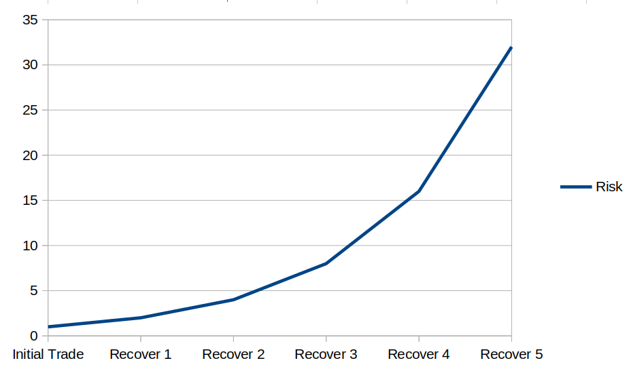
This exponential growth demonstrates why Single-Martingale Scale systems are prone to failure during long losing streaks.
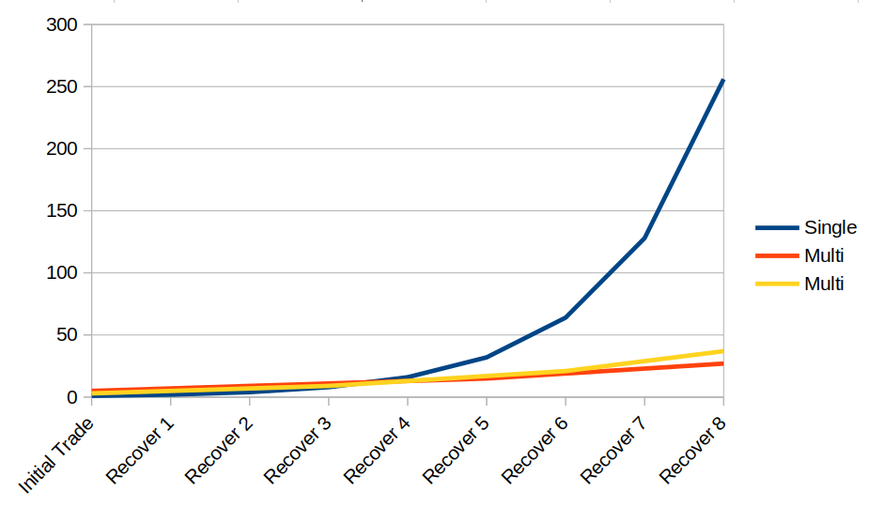
The Multi-Martingale Scales address the flaws of the single-scale approach by distributing risk and maintaining a sub-exponential growth of capital requirements. Which allows for more sustainable trading and greater scalability, even in volatile markets.

Bidirectional Trade Actions

Double profits and minimize risk with contrary options:
Opening strictly call options when the market indicates a long-term bullish trend carries a short-term risk of reaching the peak of one or more scales if there is a long consecutive streak of bullish price action.

Advantages of a Multi-Scale System with Bidirectional Trades
- Risk Reduction with Contrary Options:
A multi-scale system with an odd number of ScaleCounts allows for call and put options to be executed on different scales. This reduces risk by hedging against longer price trends in one direction.
- Increased Trade Volume:
By opening both call and put positions simultaneously, the system:
  - Doubles the number of trades, generating more transactions.
  - Ensures a predictable profit per iteration, as at least one of the trades will typically succeed.
- Lower Long-Term Risk:
The ShadowScale mechanism hedges against extended trends in one direction, further reducing the risk of complete scale failure.

Potential Risks of Bidirectional Mode
While the bidirectional mode offers advantages, it introduces some trade-offs:
- Sideways Markets: If the market moves sideways for an extended period, some scales may fail faster, increasing the probability of scale losses (even if small).

Best Practices for Bidirectional Mode
- Status-Dependent Activation:
The bidirectional mode should only be activated when the system's status allows for it, ensuring there is enough capacity to absorb risks.
- Easy Deactivation:
The feature can be easily toggled off, as it is controlled by a single argument within the trade iteration process. This flexibility ensures the system can quickly adapt to changing market conditions.

Conclusion
The bidirectional trading mode is offering Increased profitability through more transactions. And also enhances risk mitigation with contrary options. However, it will be used cautiously, considering market conditions and the system's overall status.

Technical Execution

Trade Action Process: Stateful and Recoverable System Design
The primary risk of losing connectivity to the API is the temporary inability to execute trades and generate profits. However, there is no time-correlated risk of losing capital when the system is not actively trading.
The system is designed to be stateful and recoverable, with:
- Configuration Persistence: All relevant configuration data is stored in a statefile.
- History Tracking: The application generates log-files.

Processing Workflow
Each iteration of the trading process follows these steps:
- Fetching Price Data:
  - A request is sent to the broker to verify connectivity.
  - Market data is retrieved to calculate prices for the next trade.
- Updating Node Indexes:
  - If more than 24 hours have passed without an open position, the current node index becomes the last node index.
  - The current node index is read from the file to calculate the risk for the next position.
  - The last node index is used to determine the previous trade outcome and update the scale state.
- Opening a New Position:
  - An order request is sent to the broker with the necessary trade information.
  - Trade data is saved to the statefile for future reference (e.g., to determine a win or loss in the next iteration).
- Writing to History:
  - If all processes are successful, the trade result is written to the history-file.
  - If any step fails, details are logged in a separate log file for debugging purposes.

System Execution and Automation
- The statefile ensures the system can read the last trade date to determine if the next position should be opened.
- This setup can be automated using a cron job, allowing for efficient and reliable execution.

Application Development
- The trading application should be developed in a language that supports API interaction with the target broker.
- A web application dashboard can enhance usability by:
  - Analyzing the statefile to provide insights into the system’s status and health.
  - Reading the history-file to display and evaluate past trades in an intuitive format.
This stateful and recoverable design ensures the system remains operational and adaptable, even in the event of connectivity issues or errors.

